BIORATIONAL MANAGEMENT OF BRINJAL SHOOT AND FRUIT BORER Leucinodes orbonalis (LEPIDOPTERA: PYRALIDAE)

A THESIS
BY
MD. FORHAD HOSSAIN
Registration No. 1701332
Session: 2023
Semester: January-June 2024

MASTER OF SCIENCE (M.S.)
IN
ENTOMOLOGY



DEPARTMENT OF ENTOMOLOGY

HAJEE MOHAMMAD DANESH SCIENCE AND TECHNOLOGY UNIVERSITY, DINAJPUR

JUNE 2024
BIORATIONAL MANAGEMENT OF BRINJAL SHOOT AND FRUIT BORER Leucinodes orbonalis (LEPIDOPTERA: PYRALIDAE)

A THESIS
BY
MD. FORHAD HOSSAIN
Registration No. 1701332
Session: 2023
Semester: January-June 2024

Submitted to the
Department of Entomology, Hajee Mohammad Danesh Science and Technology University, Dinajpur in partial fulfilment of the requirements of the degree of

MASTER OF SCIENCE (M.S.)
IN
ENTOMOLOGY



DEPARTMENT OF ENTOMOLOGY

HAJEE MOHAMMAD DANESH SCIENCE AND TECHNOLOGY UNIVERSITY, DINAJPUR

JUNE 2024
BIORATIONAL MANAGEMENT OF BRINJAL SHOOT AND FRUIT BORER Leucinodes orbonalis (LEPIDOPTERA: PYRALIDAE)

A THESIS
BY
MD. FORHAD HOSSAIN
Registration No. 1701332
Session: 2023
Semester: January-June 2024

Approved as to style and contents by

............................................................  Prof. Dr. Hasan Fuad El Taj  Research Supervisor | .....................................................  Prof. Dr. Md. Alamgir Hossain  Research Co-supervisor

..................................................
Prof. Dr. Md. Adnan Al Bachchu
Chairman
Department of Entomology

DEPARTMENT OF ENTOMOLOGY
HAJEE MOHAMMAD DANESH SCIENCE AND TECHNOLOGY UNIVERSITY, DINAJPUR
June 2024

DEDICATED
TO MY
BELOVED PARENTS
AND
HONORABLE Teachers
ACKNOWLEDGMENTS
First of all, I would like to thank Allah (the almighty, the most gracious, and the most merciful) for his blessings in the completion of this thesis.
I cannot remain without thanking my Respected Supervisor, Dr. Prof. Dr. Hasan Fuad El Taj, Professor, Department of Entomology, Hajee Mohammad Danesh Science and Technology University, Dinajpur, 5200. He has been continuously encouraging and guiding me (The author) in the last 1.5 years. I have been extremely lucky to have a supervisor who cared so much about the work, and who responded to my queries and questions so swiftly. His invaluable advice, plentiful experience and valuable suggestions have encouraged me to complete this academic research.
I am also extremely grateful to my reverend Co-supervisor, Professor Dr. Md. Alamgir Hossain, Department of Entomology, Hajee Mohammad Danesh Science and Technology University, Dinajpur for his invaluable counseling, guidance, and encouragement in the completion of this thesis. I have also been exceedingly lucky to have a such co-supervisor.
The Author is delighted to express sincere gratitude to his respected professor Dr. Md. Adnan Al Bachchu, Chairman Department of Entomology, Hajee Mohammad Danesh Science and Technology University, Dinajpur for his cooperation and inspirations during the study.
Also express my earnest gratitude to all the esteemed teachers of the department of Department of Entomology, Hajee Mohammad Danesh Science and Technology University, Dinajpur.
I am also thankful to the Institute of Research and Technology (IRT), Hajee Mohammad Danesh Science and Technology University, Dinajpur for arranging a “Training on Scientific Paper, Thesis Writing, and Statistical Analysis”.
Finally, I am thankful to the employees of Central farm of HSTU. Much appreciation to Md. Ibrahim Ali, for his help during data collection.

June 2024 The Author

ABSTRACT
Brinjal is one of the most important vegetables but frequently attacked by brinjal shoot and fruit borer (BSFB) the major constraint of production. The experiment was conducted during October 2023 to April 2024 in the experimental field of the Department of Entomology, Hajee Mohammad Danesh Science and Technology University, Dinajpur. Potency of four bio-rational insecticides as Cyproflanilide, Azadirachtin, Spinosad and were tested against BSFB in RCBD with three replications. Among the treatments, significantly the highest (71.00) number of healthy shoots were found from the Spinosad treated plots while the lowest (43.00) from the untreated control plots. The lowest (7.67) number of infested shoots were recorded from the Spinosad treated plots but the highest (21.67) were found from the untreated control treatment. Spinosad (T₃) treated plots showed the highest reduction (70.94%) of shoot over the untreated control. Similarly, the highest (52.33) number of healthy fruits were found from the Spinosad treated plants while the lowest (19.33) from the untreated control. The lowest number of infested fruits (8.67) were found from the Spinosad treated plants and provided the highest reduction (71.64%) of infested fruits over the untreated control. Spinosad yielded the highest weight of healthy fruits (4.90 kg/plot), but the untreated control had the lowest (2.00 kg/plot). Similarly, Spinosad treated plants had the lowest (0.66 kg/plot) weight of infested fruits, but untreated control exhibited the highest (2.60kg/plot) infested fruits. Therefore, Spinosad (Tracer-45 SC) could be used in protecting the brinjal from BSFB attack conserving bio-safety and food security.
Key words: Brinjal, bio-rational pesticides, potency, brinjal shoot and fruit borer

CONTENTS
CHAPTER | TITLE |  | PAGE NO
ACKNOWLEDGEMENTS |  |  | i
ABSTRACT |  |  | ii
CONTENTS |  |  | iii
LIST OF TABLES |  |  | iv
LIST OF FIGURES |  |  | v
LIST OF PLATES |  |  | vi
I | INTRODUCTION |  | 1-3
II | REVIEW OF LITERATURE |  | 4-11
III | MATERIALS AND METHODS |  | 12-20
 | 3.1 | Experimental site and soil properties | 12
 | 3.2 | Land preparation and management | 12
 | 3.3 | Crop culture and management | 12
 | 3.4 | Treatments | 13
 | 3.5 | Data collection | 18
 | 3.6 | Data analyses | 18
IV | RESULTS |  | 21-29
 | 4.1 | Effects of different biorational insecicides on shoot infestation | 21
 | 4.2 | Effects of tested bio-rational insecticides on fruit (by number) | 21
 | 4.3 | Effects of tested bio-rational insecticides on fruit (weight basis) | 22
 | 4.4 | Effects of different bio-rational insecticides on yield (kg/plot) | 23
 | 4.5 | Pattern of shoot and fruit infestation by BSFB | 23
 | DISCUSSION |  | 30-33
V | SUMMARY AND CONCLUSION |  | 34-36
 | REFERENCES |  | 37-49

LIST OF TABLES

TABLE | TITLE | PAGE NO.
1. | Tested different bio-rational insecticides | 14
2. | Synopsis of shoot and fruit infestation and their reduction over control in the bio-rational approaches against BSFB | 36

LIST OF FIGURES
FIGURE | TITLE | PAGE NO.
 | Efficacy of four different bio-rational insecticides against brinjal shoot and fruit borer on shoot infestation (by number) | 24
 | Efficacy of four different bio-rational insecticides against brinjal shoot and fruit borer on fruit infestation (by number) | 25
 | Efficacy of four different bio-rational insecticides against brinjal shoot and fruit borer on fruit infestation by weight (kg) | 26
 | Efficacy of four different bio-rational insecticides against brinjal shoot and fruit borer on fruit yield (kg/plot) of brinjal | 27
 | Pattern of shoot infestation per plant during the growing phase (Dates) in the treated plots | 28
 | Pattern of fruit infestation per plant during the growing phase (Dates) in the treated plots | 29

LIST OF PLATES
PLATE | TITLE | PAGE NO.
 | Tested bio-rational insecticides | 17
 | Experimental crop field and application of treatments | 19
 | Shoot and fruit infested by BSFB | 20

Chapter 1
INTRODUCTION
Brinjal (Solanum melongena L.) is an important cosmopolitan delicious economic and popular vegetable crop grown in Bangladesh (Saifullah et al., 2012; Shelton, et al., 2020). It is the most commonly used vegetable of the family Solanacae (Kantharajha and Golegaonkar, 2004). Commercially this crop is cultivated in South and South East Asia especially in Bangladesh, China, India, Sri Lanka, Pakistan, Philippines and Thailand, where hot and humid climates prevail (Hanson et al., 2006; Thapa, 2010). In Bangladesh, brinjal is the most dynamic cultivated vegetable after potato (Ahmad et al., 2009). Since Bangladesh produced 0.39 million MT of brinjal from an area of 28631.509 hectares which is approximately 28.8% of the total vegetables with an average yield of 8.00 t ha-1, but still vegetables deficit country (Anon., 2002; Anon., 2011). Also, the total production of this crop is still very low and far below as compared to international standard like Japan and Turkey (Anonymous, 2010).
However, the major constraint of brinjal production is that the crop is attacked by different insect pests likely by 140 species (Singh and Singh, 2002; Dhandapani et al., 2003; Misra, 2008, Sharma and Tayde, 2017). Among them, brinjal shoot and fruit borer (BSFB), Leucinodes orbonalis Guenee (Lepidoptera: Pyralidae) is the most destructive pest of brinjal (Kumar et al., 2006; Latif et al., 2010; Saimandir and Gopal, 2012; Nusra et al., 2020). The larvae of BSFB can cause severely yield loss which may extent up to 90% (Jagginavar et al., 2009; Kodandaram et al., 2017; Prodhan et al., 2018; Gautam et al., 2019). The larvae bore the petiole, tender shoots, flowers and fruits (AVRDC,1998; Alam et al., 2006; CABI, 2007) but once fruit set, shoot infestations become negligible (Kumar and Dharmendra, 2013) or completely disappear (Naqvi et al., 2009). Flower infestation is very rare, but infested flowers cannot produce fruit (Alam et al., 2006). They also feed on the mesocarp of fruits resulting in fruit damage (Neupane, 2001) and making un-suitable for human consumption (Baral et al., 2006). On an average a larva can infest 4 to 7 fruits during its life span and destroy 80% vitamin C content (Sharma, 2002). Areas having a hot and humid climate are conducive for its distribution and incidence (Srinivasan, 2009).
Farmers of Bangladesh as well as of other Asian countries in most cases solely depend on insecticides for the control of BSFB for quick remedies (Singh and Singh, 2002; Kumar et al., 2006). Survey on insect attack in Bangladesh reported that 98% of the farmers relied exclusively on the use of different types of insecticides, where 60% farmers sprayed their crop 120-140 times or more in a cropping season (Alam et al., 2003; Rashid et al., 2003). Again, Hasanuzzoha (2004) reported that within a cropping season farmers applied insecticides 99 times for brinjal. But indiscriminate use of synthetic chemicals causes serious drawbacks like development of insecticides resistance, pest resurgence, secondary pest outbreak, elimination of beneficial insects, different human health hazards and environmental pollution as well (Ahmad et al., 2009; Patel et al., 2015). Besides, BSFB defies all types of chemical control measures.
Hence, researchers are globally now trying to adopt alternative of detrimental corrosive insecticides to protect crop from insect pest infestation (Prates, 2003; Isman, 2006; Latif et al. 2010). Nowadays, the new generation insecticides molecules could offered several advantages over conventional pesticides like high selectivity, excellent efficacy at low dosage, least harmful to beneficial insects, economical, less prone, biodegradable, compatible with other low risk pesticides, and environmentally safe as well (Pavela, 2007; Kodaram et al., 2010; Stevenson et al., 2017). Besides, the new generation insecticides are bio-rational compound, disrupts the normal growth and development, moulting and metamorphosis of insects and eventually causing to triggers death. They are also relatively safe, available and fit well for sustainable agriculture. But research on the bio-rational insecticides against the BSFB are scanty in Bangladesh (Lathif et al., 2009). So, keeping in view the importance of BSFB a field trial was conducted to evaluate the potential of four bio-rational insecticides viz., Cyproflanilide, Azadirachtin, Spinosad and Buprofezin against the notorious pest BSFB, L. orbonalis on brinjal.

Objective
- To evaluate the potency of four bio-rational insecticides as Cyproflanilide, Azadirachtin, Spinosad and Buprofezin against BSFB.
- To compare the effectiveness among the biorational insecticide.

Chapter II
REVIEW OF LITERATURE
Brinjal (Solanum melongena L.) is an important vegetable grown all over the Bangladesh. Leucinodes orbonalis Guenee is a major pest of eggplant in Bangladesh which may cause serious damage from young to adult stages of crops. The farmers mainly control this insect pests through use of different chemicals without considering negative impact. Scientists are constantly working to create new formulations of pesticides that are safe for humans and less hazardous for the environment. Numerous studies on this topic have been conducted both locally and internationally. The purpose of this chapter is to evaluate some of the information that is now accessible regarding to novel or recently developed pesticides against the BSFB that affects crop production.

Taxonomic position
Kingdom: Animalia
Phylum: Arthropoda
Class: Insecta
Order: Lepidoptera
Family: Pyralidae
Genus: Leucinodes
Species: L. orbonalis

Biology and life history of L. orbonalis
Incubation period of BSFB took place 3-5 days in summer whereas 7-8 days in winter (Rahman, 2006). The egg period varied from 3 to 6 days at different laboratory conditions (Bindu et al., 2013). Larval period ranged from 9 to 18 days at different laboratory conditions as stated by Maravi et al. (2013). Pupal period lasted for 7 to 12 days, adult longevity lasted from 2 to 7 days. Total life cycle period varied from 19 to 44 days. Male-female ratio varied from 1:1.07 to 1:2 at under laboratory conditions (Onekutu et al., 2013).
Distribution
Brinjal shoot and fruit borer is the most important insect pest of brinjal in Asia especially in India, Pakistan, Sri Lanka, Nepal, Bangladesh, Thailand, Philippines, Cambodia, Laos, Vietnam (AVRDC, 1994; Hanson et al., 2006; Thapa, 2010). It is also distributed in Africa, Sahara and South-East Asia (CABI, 2007). Areas having a hot and humid climate are conducive for its distribution and incidence (Srinivasan, 2009). It causes severe damage in South Asia (Thapa, 2010), where yield losses may reach up to 85 to 90 percent (Jagginavar et al., 2009).
Host ranges
BSFB also found to attack shoots and fruits of tomato (Das and Patnaik., 1970), potato (Solarium tuberosum L.), green peas (Pisum sativum L.) and Solanum torvum Swartz (Hill, 1987). Other wild species of Solanum are also attacked by this pest. Lsahaquc and Chaudhury (1983) reported that Solanum nigrum, S. indicum, S. torvum, S. myriacanthum and potato are as alternate host plants of BSFB in Assam.

Nature of damage
The BSFB larvae bore into tender shoots at the vegetative stage, flower and fruit (CABI, 2007). Flower infestation is very rare, but infested flowers cannot produce fruit (Alam et al., 2006). BSF borer infest the petiole and midrib of leaves (AVRDC, 1998). Once fruit setting has been initiated, shoot infestations become negligible (Kumar and Dharmendra, 2013) or completely disappear (Naqvi et al., 2009). The larvae bore inside the fruit and the minute entrance hole is closed by the excreta of feeding larvae (Alam et al., 2006). Larvae feed on the mesocarp of fruit and the feeding and excretion result in fruit rottening (Neupane, 2001). On an average a larva can infest 4 to 7 fruits during its life span (Jayaraj and Manisegaran, 2010).
Management of BSFB
Intercropping
Satpathy and Mishra (2011) cited that the impact of vegetation diversity through intercropping with coriander and fennel as well as the application of antifeedents reduced the infestation of shoot and fruit borer Leucinodes orbonalis Guen on eggplant. Intercropping with coriander and fennel reduced the fruit damage to 12-15% compared with the plots with eggplant monoculture. Intercropping eggplant with coriander reduced the BSF borer infestation more effectively in field conditions (Gupta et al., 1999).

Biological control
Singh and Singh (2002) reported that the natural parasites and extent of parasitism were effective to brinjal shoot and fruit borer (L. orbonalis). Three parasites i.e. Trathala flavoorbitalis, a dipteran fly and a mermethid nematode were recorded as natural enemies of L. orbonalis. The parasitization by T. flavoorbitails ranged from 1.59 to 5.79 percent (average 5.14 %) during 1994 with highest parasitization in September, however, during 1995 the parasitization ranged from 2.30 to 6.81 percent (average 5.56 %) with the highest in September. The parasitization by unidentified dipteran fly ranged from 1.65 to 2.35% (average 1.94 %) during 1994 while from 1.23 to 2.51% (average 1.87%) during 1995. Mermathid nematode parasitized the larvae of shoot and fruit borer to the extent of 9.39% during 1994 but 9.49% during 1995.

Chemical control
Efficacy of five insecticides viz., spiromesifen (100 g.a.i./ha), chlorantraniliprole (20 g.a.i. / ha), novaluron (75 g.a.i. / ha), flubendiamide (25g a.i./ha) and carbosulfan 25% EC (250 g.a.i./ha) were studied against insect pests of brinjal. The percent damage on number basis of fruits in various treatments varied from 3.5-12.2 while it was 20.6% in the control treatment. The treatments like carbosulfan (3.5%) and chlorantraniliprole (6.6%) were most effective whereas flubendiamide 24 proved as less effective (12.2%) over control (20.6%) (Sinha and Vishwa, 2012). Farmers spray 50 to 70 times during the six-month growing season of brinjal in Bangladesh to control this pest (Cork et al., 2001).
Rahman et al., (2009) reported that marshal 20 EC @ 1.5 ml/l performed the best ensuring the lowest shoot and fruit infestation (7.59% and 4.16%, respectively) rendering 78.37% reduction in shoot while 88.06% and 88.99% reduction in fruit by number and by weight. Also the highest healthy fruit yield (25.19 t/ha) as against only 2.09 t/ ha infested fruit yield followed by suntap 50 SP @ 5 mg/ L that kept shoot and fruit infestation level at 10.77% and 11.53 %, respectively which provided only 12.41 t/ ha healthy fruit yield.

Mechanical control
Hand picking and destruction
Collection and destruction of infested shoots and fruits in combination with insecticide treatments reduced BSF borer infestation (Alam et al., 2003).
Pheromones
Alamin et al. (2022) conducted an experiment with three types trap such as BARI water trap, Bangalore open water trap and Indian funnel trap with RCBD. Among the pheromone traps significantly the highest (169.0) number of male moths were caught by Bangalore open trap but the lowest (19.67) in Indian funnel trap. The lowest infested shoot (5.83%), fruits (12.48 %) and healthy fruits (72.12%) were recorded in Bangalore open trap when the traps were installed below plant the canopy level.
Alam et al. (2003) stated that removal of damaged shoots and use of pheromone traps resulted in a significant reduction in further development into adults in subsequent generations and reduced the brinjal shoot and fruit infestation. They also reported that, the marketable fruit yield was greater in pheromone treated plots than in check plots.
Chakraborthi (2001) reported that the integrated approach including pheromones in the management of brinjal shoot and fruit borer was found highly effective in minimizing the shoot and fruit borer infestation.
The percent intensity of damage and bored holes on fruits was less in plots where pheromone traps were installed (Nandagopal et al., 2010) in compare with control treatment.
Sex pheromone is the substances secreted to the outside by an individual and perceived by a second individual from the same species, in which they release a specific behavioral reaction, recognition among others and male annihilation technique (MAT) using sex pheromones is considered to be one of the most important components of IPM on BSF borer (Cork et al., 2001). Chatterjee (2009) experienced that he module with three components i.e. pheromone trap, timely mechanical control and application of azadex (neem based insecticides) against BSFB and found that this combination was most effective in reduction of shoot damage (76.59%). The sex pheromone confused the male adult for mating and thus preventing fertilized egg production by trapping significant number of male moths, which resulted in reduction of larval and adult population build up (Rahman and Razzab, 2009).
Again, some scholars experienced that t pheromone traps settled below crop canopy level caught more male moth of BSFB (Uddin et al., 2008; Rahman et al., 2009 Niranjana et al., 2017). Similarly, Mazumder and Khalequzzaman (2010) cited that application of pheromones in the management of BSFB was found highly effective and reduced shoot and fruit infestation and recorded higher fruit yield in brinjal.
Light trap
Light traps are a very effective way of catching moths with less effort and nominal cost (Fiedler and Schulze, 2004). Light traps sampling should be done throughout the night in order to get maximum catch and avoid bias (Jan and Linsenmair, 2006). This traps are helpful to define the ETL (economic threshold level) and suggested an appropriate time for pest management (Ramamurthy et al., 2010).
Physical control
Temperature
The impact of weather parameters on fruit infestation revealed that, maximum temperature and minimum temperature had negatively correlated with the pest population of BSF borer, while relative humidity showed its positive significance (Malik and Rishi, 2013). As the Environmental temperature increases and humidity decreases, fecundity increases and the duration of the life cycle of BSF borer decreases (Anon., 2003).
Integrated Pest Management
Spraying of chemical at two days intervals, mechanical control and using pheromone traps performed the best in all respects ensuring the lowest shoot (6.27%) and fruit (3.19 %) infestation (Rahman et al., 2009). The highest reduction of shoot (79.65%) and fruit (89.03%) infestation occurred to compare with control. Integrated Pest Management (IPM) practice banking on removal of brinjal shoot and fruit borer infested shoots and fruits, mass trapping with sex pheromone and judicious use of pesticides to allow proliferation of natural enemy population and gave effective control of shoot and fruit borers (Duara et al., 2003). The IPM strategy based on sex pheromones for managing the L. orbonalis has reduced pesticide usage and enhanced the activities of natural enemies in Indo-Gangetic plains of South Asia (Srinivasan, 2012).
Chemical control by bio-rational insecticides
A field experiment was conducted by Latif et al. (2009) to evaluate the efficacy of flubendiamide as an IPM component for the management of brinjal shoot fruit borer by eight IPM packages and found mechanical control + potash @100 kg/ha + field sanitation in combination with flubendiamide 24WG applied showed the better performance by reducing 80.63% fruit infestation over control.
Patial, A., Mehta, P. K. Sood, A. K. 2007. Developmental biology
of brinjal shoot fruit borer, LeucinodesorbonalisGuenee in
mid-hills of Himachal Pradesh. Entomon, 32(2):137-141.
Pramanik, P., Mondal,P Chatterjee, M. 2012.Studies on biology
of brinjal fruit shoot borer, Leucinodesorbonalis(Guenee)
under laboratory condition. International Journal of Bio-resource
Stress Management, 3(3):336-340.
Radhakrishore, R. K., Singh, T. K. Shah, M . A. S. 2010. Biology
of brinjal shoot fruit borer, LeucinodesorbonalisGuen
(Lepidoptera: Pyralidae). National Journal of Life Sciences,
7(1) :77-79.
Rahman, A. K.M.Z. 1997. Screening of 28 brinjal line for resistance/
tolerance against the brinjal shoot fruit borer. Entomology
Division, Bangladesh Agricultural Research Institute, Joydebpur,
Gazipur, Bangladesh. Annual Research Report. pp 130.
Rahman, M.M. 2006. Vegetable IPM in Bangladesh. Department of
Entomology. Bangabhu Sheikh Mujibur Rahman Agricultural
UniversityGazipur, Ba n gladesh (Available at : h tt p: //
ipmworld.umn.edu/chapters/rahman.htm Retrieved on February
2, 2012).
Sa
Patial, A., Mehta, P. K. Sood, A. K. 2007. Developmental biology
of brinjal shoot fruit borer, LeucinodesorbonalisGuenee in
mid-hills of Himachal Pradesh. Entomon, 32(2):137-141.
Pramanik, P., Mondal,P Chatterjee, M. 2012.Studies on biology
of brinjal fruit shoot borer, Leucinodesorbonalis(Guenee)
under laboratory condition. International Journal of Bio-resource
Stress Management, 3(3):336-340.
Radhakrishore, R. K., Singh, T. K. Shah, M . A. S. 2010. Biology
of brinjal shoot fruit borer, LeucinodesorbonalisGuen
(Lepidoptera: Pyralidae). National Journal of Life Sciences,
7(1) :77-79.
Rahman, A. K.M.Z. 1997. Screening of 28 brinjal line for resistance/
tolerance against the brinjal shoot fruit borer. Entomology
Division, Bangladesh Agricultural Research Institute, Joydebpur,
Gazipur, Bangladesh. Annual Research Report. pp 130.
Rahman, M.M. 2006. Vegetable IPM in Bangladesh. Department of
Entomology. Bangabhu Sheikh Mujibur Rahman Agricultural
UniversityGazipur, Ba n gladesh (Available at : h tt p: //
ipmworld.umn.edu/chapters/rahman.htm Retrieved on February
2, 2012).
Sa
Patial, A., Mehta, P. K. Sood, A. K. 2007. Developmental biology
of brinjal shoot fruit borer, LeucinodesorbonalisGuenee in
mid-hills of Himachal Pradesh. Entomon, 32(2):137-141.
Pramanik, P., Mondal,P Chatterjee, M. 2012.Studies on biology
of brinjal fruit shoot borer, Leucinodesorbonalis(Guenee)
under laboratory condition. International Journal of Bio-resource
Stress Management, 3(3):336-340.
Radhakrishore, R. K., Singh, T. K. Shah, M . A. S. 2010. Biology
of brinjal shoot fruit borer, LeucinodesorbonalisGuen
(Lepidoptera: Pyralidae). National Journal of Life Sciences,
7(1) :77-79.
Rahman, A. K.M.Z. 1997. Screening of 28 brinjal line for resistance/
tolerance against the brinjal shoot fruit borer. Entomology
Division, Bangladesh Agricultural Research Institute, Joydebpur,
Gazipur, Bangladesh. Annual Research Report. pp 130.
Rahman, M.M. 2006. Vegetable IPM in Bangladesh. Department of
Entomology. Bangabhu Sheikh Mujibur Rahman Agricultural
UniversityGazipur, Ba n gladesh (Available at : h tt p: //
ipmworld.umn.edu/chapters/rahman.htm Retrieved on February
2, 2012).
Sa
ahman, M.M. 2006. Vegetable IPM in Bangladesh. Department of
Entomology. Bangabhu Sheikh Mujibur Rahman Agricultural
UniversityGazipur, Ba n gladesh (Available at : h tt p: //
ipmworld.umn.edu/chapters/rahman.htm Retrieved on February
2, 2012)
ahman, M.M. 2006. Vegetable IPM in Bangladesh. Department of
Entomology. Bangabhu Sheikh Mujibur Rahman Agricultural
UniversityGazipur, Ba n gladesh (Available at : h tt p: //
ipmworld.umn.edu/chapters/rahman.htm Retrieved on February
2, 2012)
ahman, M.M. 2006. Vegetable IPM in Bangladesh. Department of
Entomology. Bangabhu Sheikh Mujibur Rahman Agricultural
UniversityGazipur, Ba n gladesh (Available at : h tt p: //
ipmworld.umn.edu/chapters/rahman.htm Retrieved on February
2, 2012)
ahman, M.M. 2006. Vegetable IPM in Bangladesh. Department of
Entomology. Bangabhu Sheikh Mujibur Rahman Agricultural
UniversityGazipur, Ba n gladesh (Available at : h tt p: //
ipmworld.umn.edu/chapters/rahman.htm Retrieved on February
2, 2012)
Treatments of intercropping with fennel reduced the fruit damage to 12–15% the neem-based product as Neemarin were found to be more effective in controlling L. orbonalis (Satpathy and Mishra, 2011). Akter et al. (2017) conducted a field study and experienced that Tracer 45 SC performed the best in reducing 85.60% shoot infestation over control. Yadav et al. (2015) conducted an experiment found that the minimum per cent shoot infestation by brinjal shoot fruit borer from Profenofos 50 EC followed by Indoxacarb 14.5 SC while maximum in NSKE 5%.
Akter et al. (2015) conducted a field study to find out the effectiveness of five management options. Results indicated that Tracer 45 SC performed the best in reducing 85.60% shoot infestation over control, which was followed by Proclaim 5 SG (76.62%), Bacillus thuringiensis (66.41%) and mechanical control (22.02%). The highest yield of 11.20 t ha-1 and highest benefit cost ratio of 5.32 were recorded in Tracer 45 SC treated plots. Tripura et al. (2017) conducted to evaluate some bio-pesticides against brinjal shoot and fruit borer (BSFB) under field conditions in Meghalaya, India. Among the bio-pesticides, Beauveriaand Bt were found effective treatments in reducing shoot infestation. Yadav et al. (2015) conducted an experiment and found that the minimum per cent shoot infestation by brinjal shoot and fruit borer, (Leucinodes orbonalis Guen.) was recorded in Profenofos 50 EC followed by Indoxacarb 14.5 SC and maximum in NSKE 5%. Minimum per cent fruit infestation was also recorded in Indoxacarb 14.5 SC followed by Profenofos while maximum in NSKE 5 per cent.

Chapter III

MATERIALS AND METHODS

3.1. Experimental site and soil properties
The experiment was conducted during October 2023 to April 2024 in the field laboratory of the Department of Entomology, Hajee Mohammad Danesh Science and Technology University, Dinajpur. The experimental site was located at the southern site of Central Mosque of the University. The land of the experimental site was a medium high land belonging the Agro-ecological zone 1 (AEZ-1) named Old Himalayan Piedmont Plain (UNDP and FAO, 1988). The soil was sandy loam in texture having p^{H} 5.52 with electrical conductivity (EC) 2.0 mS/m and medium inorganic matter.
3.2 Land preparation
The experiment was laid out in a Randomized Complete Block Design (RCBD) with three replications. BARI begun 9 variety was used in this experiment. At first the land was ploughed and cross-ploughed several times with a power tiller to obtain a good tilth that was followed by laddering and spading. The stubbles of the crops and uprooted weeds were removed from the field and the land was then leveled prior to seedling transplanting. The unit plot size was 3 m× 3 m having 2 m space between the blocks and 1.5 m between the plots. The distances between rows were maintained 1 m and between the plants 60 cm.

3.3 Crop culture and management
Cow dung and fertilizers were applied @ 15 tons of cow dung and 115, 72 and 75 kg of N, P₂O5 and K₂O, respectively per hectare (Rashid, 1993; Tripura et al., 2017). The half of cow dung and P₂O₅ were applied as basal dose during land preparation. The remaining cow dung, P₂O₅ and one-third of K₂O were applied in the field at transplanting of brinjal seedlings. The entire dose of N and the rest of K₂O were applied as top dressing. The first top dressing of urea (one third) was applied at 15 days after transplanting. One-third of N and one-third of P₂O₅ were applied at the time of flower initiation while rest of urea and MP at the time of fruit initiation. Seeds of the variety BARI begun-9 were collected from the Horticultural Research Center (HRC) of Bangladesh Agricultural Research Institute (BARI), Joydebpur, Gazipur. A small seed bed measuring 5m×1 m was prepared and seeds were sown in the nursery bed at the experimental field of the Entomology Department, HSTU, on early October, 2023. Forty days old healthy seedlings (3/4 leaf stage) of brinjal were transplanted in the experimental plots. For experimental purpose all fields were kept insecticide free before application of treatments.

3.4 Treatments
For conducting this experiment four different bio-rational insecticides (Plate 1) as treatments were used to evaluate the potency of the tested insecticides against the BSFB. The bio-rational insecticides were sprayed (Table 1) at 10 days intervals using hand sprayer fitted with a hollow cone nozzle and operated at optimum bar pressure while spraying. First spray was done at vegetative growth stage just after started of shoot infestation. Subsequently two sprays were applied on 10 days of intervals of crop in the fruiting stage. Only water was applied to untreated control plots during spraying schedule. Precautions were taken to avoid drift to the adjacent plots. Application was done at 4 pm, because less pollinator was active in this time.

Table 1. Tested different bio-rational insecticides
Treatments | Trade name and formulation | Common name | Dose  (mlL⁻¹) | Name of registration holder
T₁ | Cyproflanilide 10% DC (C₂₈H₁₇BrF₁₂N₂O₂) | A novel diamide insecticide | 2 ml | Auto Crop Care Ltd.
T₂ | Bioneem plus 1.0 EC | Azadirachtin | 2 ml | Ispahani Agro Ltd.
T₃ | Tracer 45 SC | Spinosad | 0.4 ml | Auto Crop Care Ltd.
T₄ | Award 40 SC | Buprofezin | 0.4 ml | Square Pharma. Ltd.
T₅ | Untreated control | - | - | -

Cyproflanilide: A novel anthranilic diamide insecticide, cyproflanilide targets ryanodine receptors in insect muscles, causing paralysis and death. It is particularly effective against lepidopteran pests, including the brinjal shoot and fruit borer, and has a favourable environmental profile due to its low toxicity to non-target organisms (Sparks et al., 2021).

Azadirachtin: Extracted from the neem tree (Azadirachta indica), azadirachtin acts as an antifeedant, insect growth regulator, and repellent. It disrupts hormonal balance in insects, inhibiting their growth and reproduction, thereby reducing pest populations. Azadirachtin is noted for its minimal environmental impact and safety for humans and beneficial insects (Isman, 2006).

Spinosad: Derived from the fermentation of the soil bacterium Saccharopolyspora spinosa, spinosad affects the nervous system of insects, causing hyperexcitation, paralysis, and death. It is effective against a wide range of insect pests and has a favorable safety profile for non-target species, including beneficial insects (Sparks et al., 1999).

Buprofezin: It is an insect growth regulator that disrupts the moulting process of insects, inhibiting their development and reproduction. It is particularly effective against homopteran pests such as whiteflies, scale insects, and leafhoppers. 's low toxicity to non-target organisms, including mammals, birds, and beneficial arthropods, and its minimal environmental impact make it a suitable choice for sustainable pest management strategies (Grafton-Cardwell et al., 2008).
Integrating these biorational insecticides into the pest management strategies for brinjal in Bangladesh offers a sustainable and effective solution for controlling the brinjal shoot and fruit borer. This approach reduces reliance on chemical pesticides, promotes environmental health, and ensures the production of safer, high-quality brinjal. Further research and field trials are essential to optimize application techniques and maximize the efficacy of these biorational insecticides, ensuring their practical feasibility and effectiveness in the local agricultural context.

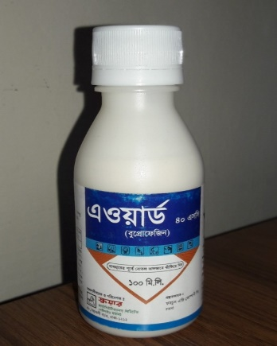 | 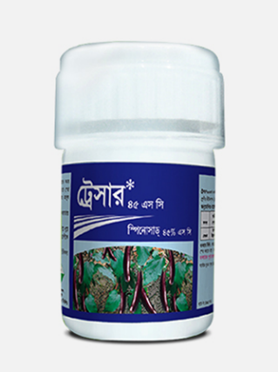
Buprofezin (Award 40 SC) | Spinosad (Tracer 45 SC)
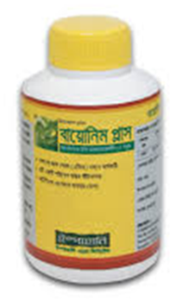 | 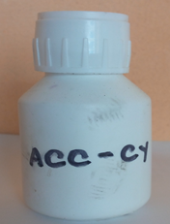
Azadirachtin (Bioneem plus) | Cyproflanilide 10 DC (ACC-CY)

Plate 1: Tested bio-rational insecticides

3.5 Data collection
Data were collected on the number of infested shoots plant⁻¹, number of healthy shoots five plant⁻¹, number of insects infested fruits five plant⁻¹, number of healthy fruits five plant⁻¹, healthy fruits plot⁻¹, infested fruits plot⁻¹, total yield plot⁻¹, yield increase over control due to treatments application. Number of healthy shoots and fruits were determined by direct counting. Percent infested shoots and fruits, and shoots and fruits infestation reduction over control were determined by following formulae:
Shoot infestation (%) by number = $\frac{Number \left(No.\right)of IS}{No. of HS + No. of IS }$ × 100 (Yousafi et al., 2015)

Fruit infestation (%) by number = $\frac{Number \left(No.\right)of IF}{No. of HF + No. of IF }$ × 100 (Yousafi et al., 2015)

Shoot infestation (%) reduction over control = $\frac{Control-Treatment}{Control }$ × 100 (Faruk et al., 2021)

Fruit infestation (%) reduction over control = $\frac{Control-Treatment}{Control }$ × 100 (Faruk et al., 2021)

3.6 Data analysis
Data on healthy and infested shoot, healthy and infested, percentage of infestation, yield (kg/plot) were analyzed by using SPSS software for analysis of variance (ANOVA). Mean separation was performed by using Duncan Multiple Range Test (DMRT) (Gomez & Gomez, 1984).

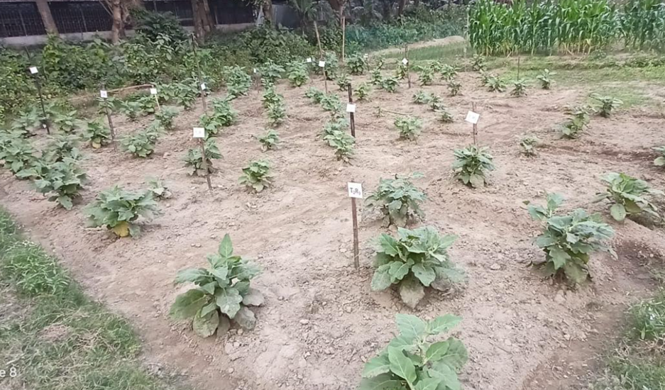

Brinjal plants in the experimental field
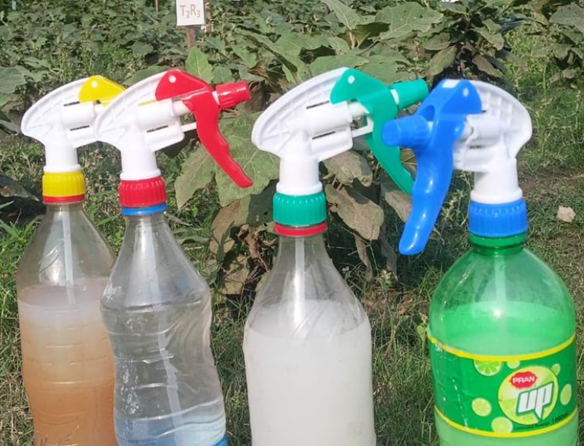

Application of four treatments

Plate 2: Experimental crop field and application of treatments

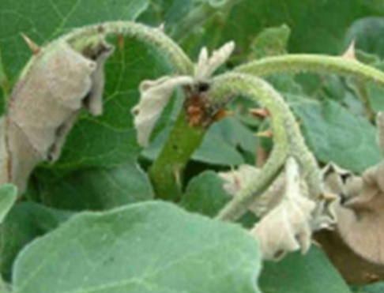
Infested shoot by BSFB

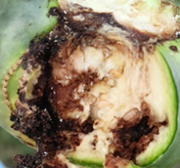

Infested fruit by BSFB

Plate 3: Shoot and fruit infested by BSFB in the experimental field

Chapter IV
RESULTS

4.1 Effects of different biorational insecticides on shoot infestation

Treatments by different bio-rational pesticides had potential effects against brinjal shoot and fruit borer on healthy and infested shoots of brinjal (Figure 1). Among the treatments, significantly (P < 0.05, df = 4, F = 13.55) the highest (71.00) number of healthy shoots were found from the Spinosad treated plot which was statistically similar with the other treatments. Due to treatments of bio-rational pesticides no statistical variations was observed. Conversely, the lowest (43.00) number of healthy shoots were found from the untreated control.

Again, significantly (P < 0.05, df = 4, F = 22.43) the lowest (7.67) number of infested shoots were found from the Spinosad treated plants (Figure 1) followed by Buprofezin (10.00) which was statistically different with the other treatments. On the contrary, the highest (21.67) number of infested shoots were found from the untreated control. Statistically (P < 0.05, df = 4, F = 73.75) the highest infested shoot (33.61%) was observed in the untreated control whereas the lowest (9.8%) infested shoot was found in Spinosad treated plant followed by Buprofezin (12.61%) and statistically different with other treatments. All of the treatments considerably decreased the percentage of shoot infestation, however the Spinosad (T₃) treated plot showed the highest reduction (70.94%) over the untreated control.

4.2 Effects of tested bio-rational insecticides on fruit (by number)
The number of healthy and infested fruits of brinjal was significantly affected by treatments of bio-rational insecticides against the brinjal shoot and fruit borer (Figure 2). Significantly (P < 0.05, df = 4, F = 22.41) the highest (52.33) number of healthy fruits were found from the Spinosad treated plants which was found statistically different with the other treatments. On the contrary, the lowest (19.33) number of healthy fruits were recorded from the untreated control.

Remarkably (P < 0.05, df = 4, F = 16.12) the lowest infested fruits (8.67) were found from the Spinosad treated plants followed by Cyproflanilide 10 DC with the highest (9.33) number infested fruits which statistically different other treatments. As disparate to this, the untreated control had the highest number of infested fruits (21.67) by BSFB. Again, due to the treatments of bio-rational pesticides, significantly (P<0.05, df=4, F=26.48) the highest infested fruits (52.90%) were recorded in the untreated control while the lowest (15.00%) infested fruits were recorded in Spinosad treated plant which statistically similar with other treatments. All of the treatments decreased the percentage of infested fruits, however the Spinosad (T3) treated plot showed the highest reduction (71.64%).

4.3 Effects of tested bio-rational insecticides on fruit (weight basis)

Treatments with various bio-rational based insecticides may have had an enormous impact on the weight of infested and healthy fruits of brinjal against the brinjal shoots and fruit borer (Figure 3). However, among the treatments Spinosad yielded the highest weight of healthy fruits (4.90 kg/plot), which was statistically different from the other treatments and the difference was found significant (P < 0.05, df = 4, F = 6.97). On the other hand, the untreated control treatments had the lowest (2.00 kg/plot) weight of fruit.

Once more, the Spinosad treated plants had the lowest (0.66 kg) weight of infested fruits, which was statistically similar to the other treatments and this was statistically (P<0.05, df=4, F=42. 22) significant (Fig. 3). In contrast to the other treatments, the untreated control treatments exhibited the highest (2.60kg) level of infestation in their fruits.

Significantly (P<0.05, df=4, F=86.22), the untreated control treatment had the highest (56.5%), infested fruits whereas the Spinosad treated plant had the lowest infested shoot (12.5%), which was statistically distinct from the other treatments. Each treatment significantly reduced the percentage of fruit infestation (kg); however, as compared to the control, the Spinosad (T₃) treated plot showed the most reduction (77.87%).

4.4 Effects of different bio-rational insecticides on yield (kg/plot)

The effects of all the treatments on brinjal production were evaluated in terms of the total amount of fruit harvested, the healthy fruit yield, and the amount of infested fruit harvested during the duration of the crop in each treatment (Figure 4).

Based on the yield, the Spinosad treated plot had the highest yield (5.56 kg plot⁻¹), while plots treated with Azadirachtin and Cyproflanilide showed the statistically similar in yield. Conversely, untreated control provided the statistically similar yield.
4.5 Pattern of shoot and fruit infestation by BSFB
The different treatments of bio-rational pesticides performed differently in respect of shoot infestation on brinjal throughout the growing season by BSFB (Fig. 5). Among the treatments the highest (2.53) number of shoot infestation plant⁻¹ was recorded on 27 February (late February) 2024 from untreated control treatment. On the contrary, the lowest (0.20) number of shoot infestation plant⁻¹ was recorded on 29 March 2024 from Spinosad treated plot followed by Azadirachtin (0.26).
The different treatments of bio-rational pesticides performed differently in respect of fruit infestation on brinjal throughout the growing season by BSFB (Fig 6). Among the treatments the highest (2.20) number of fruit infestation plant⁻¹ was recorded on 29 March (late March) 2024 from untreated control treatment. Conversely, the lowest (0.133) number of fruit infestation plant⁻¹ was recorded on 29 March i.e. late March 2024 from Spinosad and Cyproflanilide treated plots.

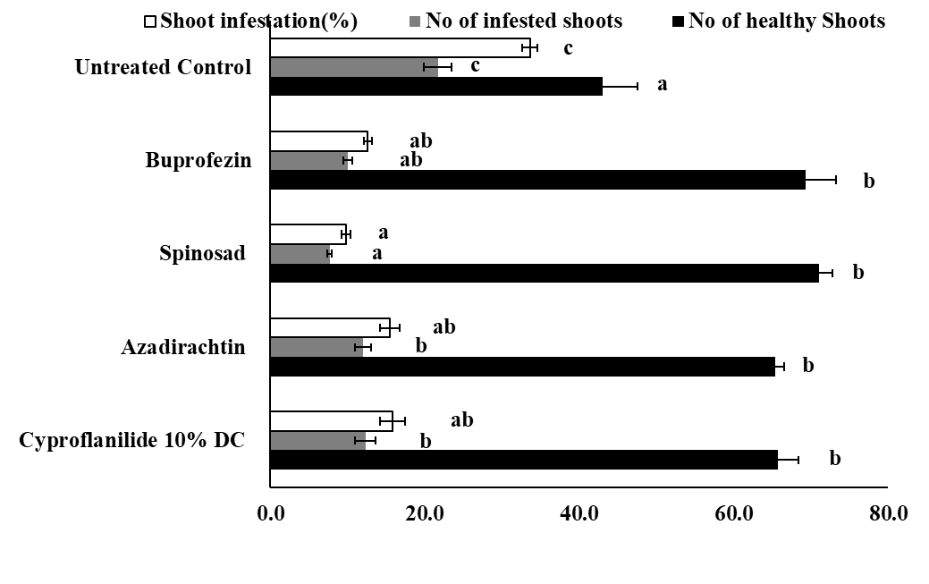
Number of shoots/ plots

Figure 1: Efficacy of four different bio-rational insecticides against brinjal shoot and fruit borer on shoot infestation (by number)

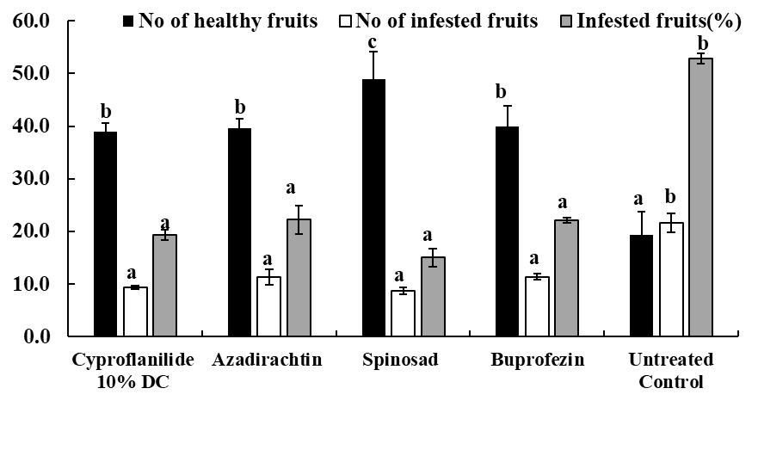
Number of fruits/ plots
Figure 2: Efficacy of four different bio-rational insecticides against brinjal shoot and fruit borer on fruit infestation (by number)

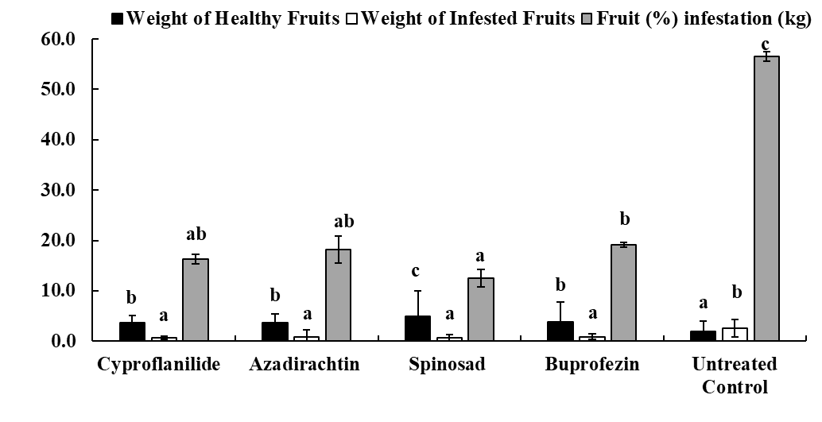
Weight of fruits (kg/ plot)

Figure 3: Efficacy of four different bio-rational insecticides against brinjal shoot and fruit borer on fruit infestation by weight (kg)

Yield (Kg/plot)

Figure 4. Efficacy of four different bio-rational insecticides against brinjal shoot and fruit borer on fruit yield (kg/plot) of brinjal

No. of shoot infestation
Dates

Figure 5: Pattern of shoot infestation per plant during the growing phase (Dates) in the treated plots

No. of fruit infestation

Dates

Figure 6: Pattern of fruit infestation per plant during the growing phase (Dates) in the treated plots

Chapter V

DISCUSSION

Brinjal (Solanum melongena L.) is an economically important delicious and popular vegetables grown all over the country. But its yield is severely affected due to many factors of which the most crucial is the direct damage by brinjal shoot and fruit borer (BSFB), Leucinodes orbonals. As a schedule key pest BSFB causes enormous yield loss continuously during its cultivation. To combat economic losses, growers in our country practiced randomly synthetic insecticides against this pest for quick knockdown but serious drawbacks. To overcome the situation, bio-rational insecticides are relying as alternative to detrimental insecticides against different pests, especially BSFB (Awal et al., 2015; Tripura et al., 2017; Khanal et al. 2021). Hence, in this study, four insect bio-rational insecticides as Cyproflanilide, Azadirachtin, Spinosad, were evaluated against the BSFB on brinjal. The outcome evident that all the treatments were found potential in reducing the pest infestation as compared to the untreated control.

Results revealed that the tested bio-rational insecticides had profound effects on healthy and infested shoots against the BSFB (Fig. 1). The highest (71.00) number of healthy shoots were found from the Spinosad treated plot while the lowest (43.00) in the untreated control. Present findings are comparable with the results of Tripura et al. (2017). They cited that shoot infestation was minimum in spinosad 45 SC treated plot. Again, Spinosad (T₃) treated plot showed the highest reduction (70.94%) of shoot infestation over the untreated control. The comparison of the present results with the existing findings suggests that Tracer 45 SC (Spinosad) was able to exceed the standard level near close to 80.00% reduction in shoot infestation over control and the findings was comparable with the that of Adiroubane and Raghuraman (2006). Present findings are also comparable with the result of Akter et al. (2017). They experienced that Tracer 45 SC performed the best in reducing 85.60% shoot infestation over control against BSFB. In another field experiment conducted during kharif 2006 and found among the tested different insecticides, the lowest mean shoots as well as fruit infestation (7.47 and 9.88%) was recorded in the plots treated with Spinosad 2.5 SC (Patra et al., 2009).
The applied pesticides had promising effects on healthy fruits and consequently offered lowest infested fruits against the BSFB (Fig. 2). Novel innovative research proven that the diverse pesticides i.e. IGRs, bacterial extracts etc. have been tried by several researchers with a good degree of success against the BSFB (Patra et al., 2009; Mamun et al. 2014; Singh and Sachan, 2015). All tested insecticidal treatments showed the promising effects but Spinosad (T₃) treated plot at 0.4 ml/L water showed the highest (71.64%) reduction of infested fruits as compared to untreated control. Present findings are also comparable with the observations as stated by Akter et al. (2017) and Awal et al. (2017). They opined that highest number of healthy fruits were recorded from Spinosad treated plots. Also, Spinosad treated plots showed the highest reduction of infested fruits while compared to untreated control treatments. These results are also similar with the report of Awal et al. (2014 and 2015) and Puranik et al. (2002) where they found the highest healthy fruits of brinjal plot⁻¹ was found from Spinosad treated plants. Parallel results were also opined by Awal et al. (2015) using Spinosad against BSFB on brinjal crop.

The results obtained in the present study suggest that the application of all treatments especially Spinosad (Tracer-45 SC) performed the best in ensuring higher healthy fruit yield in terms of number and weight as well as total fruit yield of brinjal as compared to untreated control. Results of efficacy of Spinosad are in conformity with the findings of earlier workers who reported that among the treatments, Spinosad was found to be most effective in reducing shoot and fruit infestation as well as highest yield of brinjal against BSFB (Abdullah et al., 2014; Gowrish et al., 2015). This results are also similar with the report of Awal et al. (2014) where they found the highest weight of healthy fruits of brinjal plot⁻¹ were weighed from the Spinosad treated plants. Parallel results were also cited by Akter et al. (2017). They concluded that the highest weight of healthy fruits of brinjal plot⁻¹ was found from Spinosad treated plots among the applied all treatments.
Spinosad an incredible insecticide is highly effective on diverse pest species including lepidopteran, dipteran, thysanopteran pests and some coleopteran, homopteran, hymenopteran, and orthopteran species (Thompson and Hutchins, 1999). Results of efficacy of Spinosad are in conformity with the findings of earlier workers (Dandale et al. 2001; Akter et al. 2017). They reported that among the applied treatments, Spinosad was found to be most effective in reducing shoot and fruit infestation of brinjal. Higher efficacy of Spinosad against brinjal shoot and fruit borer was reported by many workers (Lathif et al. 2009; Singh and Sachan, 2015). Spinosad (Tracer 45 SC) were relatively safe for natural enemies and ecosystems, hence, would be fit well into integrated pest management (IPM) against BSFB on effective brinjal production (Awal et al., 2015).
The shoots and fruits of brinjal plant were found to be infested by BSFB throughout the growing season, although the level of infestation varied (Fig. 5 and 6). On late February, untreated control plots exhibited the highest shoot infestation while minimum infested shoots per plant from Spinosad. This aligns with findings from previous studies where untreated plots consistently showed higher susceptibility to BSFB larvae during early plant growth stages (Ghodake et al., 2024). This results are comparable with those of Ghodake et al., (2024). They cited that Azadirachtin treatment proved effective, showing minimal shoot damage per plant, reflecting its potential in managing BSFB at early growth stages. Islam et al., 2019 found that the lowest fruit infestation was calculated in Spinosad treated plot whereas untreated plot showed the highest result. The finding of that study are similar with the present study. Plant age had significant effect
(r2=0.87) on fruit infestation. Again, Mannan et al. (2015) reported that the fruit infestation reached the highest level (38.56%) in 14th week of transplanting.

Generally, shoot and fruit borer larvae of are controlled by non-judicious broad- spectrum use of detrimental pesticides (Mukherjee, 2003) that boost up unlimited residual effects in ecosystem, a major limitation (Rashid et al., 2004; Patel et al., 2015). Bio-rational pesticides especially spinosad undoubtedly have as an alternative vital role in insect pest management programs especially for BSFB in Bangladesh. Nowadays, global food security is a critical issue with safe crop protection especially under global climatic change. The outcome of using spinosad might be provided immense benefits in our nation for sustainable management of BSFB, could assure bio-safety and food security.

Therefore, it may be concluded here that the all the tested bio-rational insecticides were found effective but Spinosad (Tracer 45 SC) found very effective and could be used in protecting the brinjal crop against BSFB for biosafety and food security.

Chapter V

SUMMARY AND CONCLUSION

Brinjal is a popular vegetable crop grown all over Bangladesh is attacked by brinjal shoot and fruit borer the major constraint of brinjal production. The experiment was conducted during October 2023 to April 2024 in the field laboratory of the Department of Entomology, Hajee Mohammad Danesh Science and Technology University, Dinajpur. Potency of four bio-rational insecticides as Cyproflanilide, Azadirachtin, Spinosad and were tested against BSFB maintained three replications.
Among the treatments, significantly the highest (71.00) number of healthy shoots were found from the Spinosad treated plot while the lowest (43.00) were found from the untreated control. The lowest (7.67) number of infested shoots were found from the Spinosad treated plots. On the contrary, the highest (21.67) number of infested shoots were found from the untreated control. Spinosad (T₃) treated plot showed the highest reduction (70.94) of shoot infestation over the untreated control.
Similarly, the highest (52.33) number of healthy fruits were found from the Spinosad treated plants. On the contrary, the lowest (19.33) number of healthy fruits were recorded from the untreated control. Remarkably the lowest infested fruits (8.67) were found from the Spinosad treated plants while the untreated control had the extreme number of damaged fruits (21.67). Again, the highest infested fruits (52.9%) were calculated in control but the lowest (15.00%) infested fruit was found in Spinosad treated plant. Spinosad (T3) treated plot showed the highest reduction (71.64%) of infested fruits followed by cyproflanilide (63.52) as compared to the control.

Among the treatments Spinosad yielded the highest weight of healthy fruits (4.90 kg/plot), but the untreated control groups had the lowest weight of fruit (2.38 kg/plot). Similarly, Spinosad treated plants had the lowest (0.66 kg) weight of infested fruits, the untreated control group exhibited the greatest (2.60kg) level of infestation in the fruits. Significantly the control group had the highest fruit infestation (56.5%) kg, whereas the Spinosad-treated plant had the lowest shoot infestation (12.5%) kg, which was statistically distinct from the other treatments. Each treatment significantly reduced the percentage of fruit infestation (kg). However, as compared to the control, the Spinosad (T3) treated plot showed the most reduction (70.94%), followed by Buprofezin (62.45). Based on the yield, the Spinosad 45 SC treated plot had the highest yield (5.56 kg plot⁻¹), while plots treated with azadirachtin, cyproflanilide showed the statistically similar in yield. Conversely, untreated control provided the statistically similar yield.
Spinosad are relatively safe for natural enemies, least mammalian toxicity and eco-friendly and would be fit well into integrated pest management (IPM). Therefore, it may be concluded that Spinosad (Tracer 45 SC) could be used in protecting the brinjal crop against BSFB conserving bio-safety and food security.

Table 2: Synopsis of shoot and fruit infestation and their reduction over control in the bio-rational approaches against BSFB

Treatments | Shoot infestation (%) | Fruit infestation (%) by number | Fruit infestation by weight | Shoot infestation  reduction over control (%) | Fruit infestation reduction over control (%) | References
Tracer 45 SC | 2.5 | 8.43% | 7.45% | 85.6 | (88.80% | Akter et al. (2017)
Proclaim 5 SG | 4.00% | 25.92% | 23.1 | 76.62% | 65.58% | Akter et al. (2017)
Mechanical control | … | ….. | … | 22.02 | ….. | Akter et al. (2017)
Untreated control | 17.37 | 75.3 | 70.63% |  |  | Akter et al. (2017)
Tracer 45 SC | …. | 0.82% |  | 84.41 |  | Awal et al. (2017)
Bactoil (Bt) | … | 2.76% |  | 59.36 |  | Awal et al. (2017)
Proclaim-5 SG | .. | 1.82% |  | 64.36 |  | Awal et al. (2017)
Untreated control | … | 7.02% |  |  |  | Awal et al. (2017)
Tracer 45 SC | 6.25% | 6.98 | 9.32 | 75.98 |  | Islam et al. 2019
Azadirachtin 1% EC | 17.14 | 25.12 | 20.78 | 34.13 |  | Islam et al. 2019
Emamectin Benzoate 5 SG | 10.09 | 19.83 | 15.47 | 61.22 |  | Islam et al. 2019
Untreated control |  | 40.63 | 27.5 |  |  | Islam et al. 2019
Voliam flexi 300SC | 5.98 | 6.21 |  | 64.47 | 64.08 | Faruk et al. (2021)
Tracer 45 SC | 2. 62 | 2.96 |  | 84.43 | 82.88 | Faruk et al. (2021)
Ripcord 10EC | 7.12 | 7.42 |  | 57.69 | 57.09 | Faruk et al. (2021)
Untreated control | 16.83 | 17.29 |  |  |  | Faruk et al. (2021)
Cyproflanilide 10% DC | 15.8 | 19.3 | 16.3 | 52.92 | 63.52 | Present study
Azadirachtin | 15.5 | 22.2 | 18.2 | 53.83 | 58.03 | Present study
Tracer 45 SC | 9.8 | 15.0 | 12.5 | 70.94 | 71.64 | Present study
 | 12.6 | 22.1 | 19.1 | 62.45 | 58.22 | Present study
Untreated control | 33.6 | 52.9 | 56.5 |  |  | Present study

REFERENCES
(Lepidoptera: Pyralidae). National Journal of Life Sciences,
(Lepidoptera: Pyralidae). National Journal of Life Sciences,
(Lepidoptera: Pyralidae). National Journal of Life Sciences,
2, 2012)
2, 2012)
2, 2012)
2, 2012)
2, 2012).
2, 2012).
2, 2012).
7(1) :77-79.
7(1) :77-79.
7(1) :77-79.

Abdullah, M.D., Mamun, A.L., Islam, K.S., Jahan, M. and Das, G. 2014. Effect of spinosad and sex pheromone alone and in combination against the infestation of brinjal shoot and fruit borer, Leucinodes orbonalis Guen. International Journal of Research in Biological Sciences. 4(1): 20-24.
Adiroubane D. and K. Raghuraman, 2006. IPM in brinjal shoot and fruit borer management. Journal of Biopesticides. 1(2): 124-129.
Ahmad K.S. 2009. Studies on shoot leaf characters of brinjal plants their quantitative relationships with brinjal shoot fruit borer. Journal of Bangladesh Agricultural University. 7: 29-32.
Akter, S., Alam, M.Z., Rahman, M.M. Aka,A.M. 2017. Evaluation of some management options against brinjal (SolanummelongenaL.) shoot fruit borer (Leucinodes orbonalis Guenee). The Agriculturists. 15(1): 49-57.
Alam, S.N., Rashid, M.A., Rouf, F.M.A., Jhala, R.C., Patel, J.R., Satpathy, S., Shivalingaswamy, T.M., Rai, S., Wahundeniya, I., Cork, A., Ammaranan, C. and Talekar, N. S. 2003. Development of an integrated pest management strategy for eggplant fruit shoot borer in South Asia. Shanhua, Taiwan: AVRDC-the world vegetable center. Technical Bulletin no. 29. AVRDC publication no. 03-548. pp. 56.
Alam, S.N., Hossain, M.I., Rouf, F.M.A., Jhala, R.C., Patel, M.G., Rath, L.K., Sengupta, A., Baral, K., Shylesha, A.N., Satpathy, S., Shivalingaswamy, T.M., Cork, A. & Talekar, N. S. 2006. Implementation and promotion of an IPM strategy for control of eggplant fruit and shoot borer in South Asia. Technical Bulletin no. 36. AVRDC Publication number 06-672. AVRDC-The World Vegetable Center, Shanhua, Taiwan, p. 74.
Al-Amin, M., Hossain, M.A., El Taj, H.F. and Alim, M.A. 2022. Performance of different designed pheromone traps and their placement heights in capturing Leucinodes orbonalis Guenee (Lepidoptera: Pyralidae). Munis Entomology and Zoology. 17(1): 589-599.
Anonymous, 2003. Eggplant integrated pest management an ecological guide. FAO inter-country programme for integrated pest management in vegetables in South and Southeast Asia. Bangkok, Thailand. 177p.
Anonymous. 2002. Statistical Pocket book of Bangladesh2002. Bangladesh Bureau of Statistics. Government of the people Republic of Bangladesh, Dhaka, Bangladesh, pp.184
Anonymous. 2010. The total production of this crop is still very low and far below as compared to international standards like Japan and Turkey. Journal of Agriculture and Rural Development. 12(3): 112-115.
Anonymous. 2011. www.en.wikipedia.org/wiki/Bacillus thuringiensis.
Atwal, A.S. and Dhaliwal, G.S. 2005. Agricultural Pests of South Asia and their Management. 5th Edition. Kalyani Publishers, New Delhi, India.
AVRDC, 1994. Eggplant entomology. Control of eggplant fruit and shoot borer. Progress Report. Asian Vegetable Research and Development Center, (AVRDC), Shanhua. Taiwan. Pp. 88.
AVRDC. 1998. Annual Reports. Asian Vegetable Research and Development Center, Shanhua. Taiwan. 148 p.
Awal, A., Rahman, M.M., Alam, M.Z. and Khan, M.M.H. 2015. Diversity and equitability of insect pests and natural enemies in brinjal field treated with insecticides. Jahangirnagar University J. Biol. Sci. 4(1):71-80.
Awal, A., Rahman, M. M., Alam, M. Z., Khan, M. M. H., Kabir, A. K. M. R. and Uddin, M. S. 2014. Efficacy of seven insecticides on the larvae of brinjal shoot and fruit borer, Leucinodes orbonalis Guenee under laboratory condition. J. Patuakhali Sci. and Tech. Univ. 5(1): 37-43.
Baral, K., Roy, B.C., Rahim, K.M.B., Chatterjee, H., Mondal, P., Mondal, D., Ghosh, D. & Talekar, N.S. 2006. Socio-economic parameters of pesticide use and assessment of impact of an IPM strategy for the control of eggplant fruit and shoot borer in West Bengal, India. Tech. Bull., 37. AVRDC publication number 06-673. AVRDC- The World Vegetable Center. Shanhua, Taiwan, pp. 36.
BBS (Bangladesh Bureau of Statistics). 2016. Statistical Year Book of Bangladesh. Bangladesh Bureau of Statistics, Planning Division, Ministry of Planning, Govt. of the Peoples Republic of Bangladesh, Dhaka, Bangladesh. pp. 150.
Bindu, S.P., Pramanik, A., and Padhi G.K. 2013. Studies on biology and physical measurements of shoot and fruit borer (Leucinodes orbonalis Guenee) of brinjal in West bengal, India. Global Journal of Biology, Agriculture & Health Sciences. 4(1): 215-219.
CABI (Centre for Agriculture and Bioscience International). 2007. Crop Protection Compendium. CAB International. (Available at: http://www. cabicompendium.org/cpc
Chakraborti, S. 2001. A biorational approach for the management of brinjal fruit and shoot borer, Leucinodes orbonalis Guenee. Journal of Entomological Research, 25 (1): 73-76.
Chatterjee H. 2009. Pheromones for the management of brinjal fruit and shoot borer, Leucinodes orbonalis Guenee. Karnataka J. Agric. Sci., 22(3): (594-596).
Cork, A., Alam, S.N., Das, A., Das, C.S., Ghosh, G.C., Farman, D.I., Hall, D.R., Maslen, N. R., Vedham, K., Phythiam, S.J., Rouf, F.M.A. and Srinivasan, K. 2001. Female sex pheromone of brinjal fruit and shoot borer, Leucinodes orbonalis: Trap optimization. Journal of Chemical Ecology, 27(9):1867-1877. http://dx.doi: 10.1023/A: 1010416927282.PMid:11545376
Dandale, H.G., N.G.V Rao, S.N. Tikar and S.A. Nimbalkar. 2001. Efficacy of spinosad against cotton bollworms in comparison with some synthetic pyrethroids. Pestology. 25 (3): 24-28.
Darmadi-Blackberry, I., M.L. Wahlqvist, A. Kouris-Blazos, B. Steen, W. Lukito, Y. Horie and K. Horie, 2004. Legumes: the most important dietary predictor of survival in older people of different ethnicities. Asia Pacific Journal Clinical Nutre. 13(2): 217-20.
Das, M.S., and Patnaik, B.H. (1970). A new host of the brinjal shoot and fruit borer Leucinodes orbonalis Guen, and its biology.
Dhandapani, N., Shelkar, U.R. and Murugan, M. 2003. Bio-intensive pest management in major vegetable crops: An Indian perspective. J. Food, Agri. Environ. 1 (2): 330-339. DOI: 10.3329/jbau.v7i1.4794.
Duara B., Deka S.C., Baruah L.H., and Barman N., 2003. Bioefficacy of synthetic pyrithroids against Brinjal shoot and fruit borer, Leucinodes orbonalis Guenee. Pesticide Research Journal. 15(2): 155-156.
Faruq, M.O., Latif, M.A., Khan, M.M.H., Das, G.P., and Uddin, M.R. (2021). Management of brinjal shoot and fruit borer (Leucinodes orbonalis Guenee) using Selected Insecticides in Farmer’s Fields at Bandarban Hill Tracts, Bangladesh. International Journal for Asian Contemporary Research, 1, 106-112.
Fiedler K., and Schulze C.H., 2004. Forest modification affects diversity, but not dynamics of specious tropical pyraloid moth communities. Biotropica. 36: 615-627.
Gautam, M., Kafle, S., Regmi, B., Thapa, G. and Paude, S. 2019. Management of brinjal fruit and shoot borer (Leucinodes orbonalis Guenee) in Nepal. Acta Scientific Agriculture, 3(9): 188-195. DOI: 10.31080/ASAG.2019.03.0632
Ghodake, R. D., Hole, U. B., Kharbade, S. B., Bagde, A. S., & Galande, S. M. (2024). Efficacy of bio-rational pesticides for the management of Leucinodes orbonalis Guenee, infesting Brinjal.
Gomez, K. A. and Gomez, A. A. 1984. Statistical Procedures for Agricultural Research.
Gowrish, K.R., Ramesha, B. and Ushakumai, R. 2015. Biorational management of major pests of brinjal. Indian Journal of Entomology. 77(1): 51-55.
Grafton-Cardwell, E. E., Godfrey, L. D., Meyerdirk, D. E., Nakasuji, F. and Beede, R. H. 2008. is an insect growth regulator that disrupts the molting process of insects, inhibiting their development and reproduction. It is particularly effective against homopteran pests such as whiteflies, scale insects, and leafhoppers. 's low toxicity to non-target organisms, including mammals, birds, and beneficial arthropods, and its minimal environmental impact make it a suitable choice for sustainable pest management strategies. Journal of Economic Entomology. 101(2): 365-375.
Gujar, G.T. and Yadav, T.D. 1978. Feeding of Callosobruchus maculatus (F.) (Bruchidae: Coleoptera) reared on different foods and temperature. Journal of Stored Products Research. 22: 71-75.
Gupta S.C., Singh P.P., and Kumar A., 1999. Effect of intercropping with spices on the incidence of Leucinodes orbonalis Guenee in brinjal and its economics. Shashpa. 6: 45–48.
Hanson, P.M., Yang, R.Y., Tsou, S.C.S., Ledesma, D., Engle, L. & Lee, T.C., 2006. Diversity of eggplant (Solanum melongena) for superoxide scavenging activity, total phenolics and ascorbic acid. Journal of Food Compos and Analysis. 19: 594-600.
Hasanuzzoha, M. 2004. Environment friendly use of pesticides in field crop protection in Bangladesh pre/post safety measures for farmers, Ph.D. Thesis. IPM Laboratory, Institute of Biological Sciences, University of Rajshahi, Bangladesh, pp. 366.
Hill, D.S. 1987. Agricultural insect pests of the tropics and their control. Cambridge University Press.
Islam, W. and Khan, A.R. 2000. Bruchid research in Bangladesh. Pakistan Journal of Biological Sciences 3:10–19.
Isman, M. B. 2006. Extracted from the neem tree (Azadirachta indica), azadirachtin acts as an antifeedant, insect growth regulator, and repellent. It disrupts hormonal balance in insects, inhibiting their growth and reproduction, thereby reducing pest populations. Azadirachtin is noted for its minimal environmental impact and safety for humans and beneficial insects. Pest Management Science, 62(8), 651-659.
Jagginavar, S.B., Sunitha, N.D. and Biradar, A.P. 2009. Bioefficacy of Flubendiamide 480C against brinjal fruit and shoot borer, Leucinodes orbonalis Guen. Kamtaka J. Agric. Sci., 22: 712-713.
Jan B. and Linsenmair K.E., 2006. Feasibility of light-trapping in community research on moths: Attraction radius of light, completeness of samples, nightly flight times and seasonality of South-Asian hawkmoths (Lepidoptera: Sphingidae). Journal of Research on the Lepidoptera. 99: 18-36.
Jayaraj, J. and Manisegaram, S., 2010. Management of fruit and shoot borer in brinjal. The Hindu Sci-Tech. Agri. College and Res. Inst. Madurai.
Kantharajha, A. & Golegaonkar, P. 2004. Somatic embryogenesis in eggplant. Scientia Horticulturae, 99: 107-117.
Khanal, D., Pandey, R. Dhakal, R., Neupane, N., Shrestha, A., Joseph, M. N., Paudel, A. and Pandey, M. 2021. Efficacy of bio-rational pesticides for the management of Leucinodes orbonalis Guenee in Rupandehi, Nepal. Helyion. 7(11): doi: 10.1016/j.heliyon.2021.e08286
Kodandaram, M.H., halder, J., rai, A.B. And swamy, T.M.S., 2010. Dose optimization of Chlorantraniliprole (Rynaxypyr) 18.5SC: A novel anthranilic diamide insecticide for control of brinjal fruit and shoot borer, Leucinodes orbonalis. Proceedings 4th Indian Horticulture Congress held on 18-21 November, New Delhi, India, pp. 368.
Kodandaram, M.H., Rai A.B., Sharma, S.K. & Singh, B. 2017. Shift in the level of susceptibility and relative resistance of brinjal shoot and fruit borer Leucinodes orbonalis (Guen.) to diamide insecticides. Phytoparasitica, 45: 151-154.
Kumar, N.K.K., Kumari, B.K., Singh, H.S., Ranganath, H.R., Shivakumara, B. and Kalleshwaraswamy, C.M. 2006. Pheromone trapping protocols for brinjal shoot fruit borer, Leucinodes orbonalis Guenee (Lepidoptera: Pyralidae): evaluation of trap design, quantity dispenser. Journal of Horticultural Sciences, 1 (1): 39-43.
Kumar, S. & Dharmendra, S. 2013. Seasonal incidence and economic losses of brinjal shoot and fruit borer, Leucinodes orbonalis Guenee. Agricultural Science Digest. 33: 98-103.
Lahaquc, A., & Chaudhury, M. (1983). Solanum nigrum, S. indicum, S. torvum, S. myriacanthum and potato as alternate host plants of BSFB in Assam. Indian Journal of Entomology. 45(4): 434-436.
Latif, M.A., Rahman, M.M., Alam M.Z. and Hossain, M.M. 2009. Evaluation of flubendiamide as an IPM component for the management of brinjal shoot and fruit borer, Leucinodes orbonalis Guenee. Mun. Ent. Zool. 4(1): 257 – 267.
Latif, M.A., Rahman, M.M. and Alam, M. Z. 2010. Efficacy of nine insecticides against shoot and fruit borer, Leucinodes orbonalis Guenee (Lepidoptera: Pyralidae) in eggplant. Journal Pesticides Science, 83: 391-397.
Malik Y.P., and Rishi P., 2013. Seasonal incidence of brinjal fruit and shoot borer Leucinodes orbonalis Guenee on different germplasms of brinjal in central Uttar Pradesh. Trends in Bioscience. 6 (4): 389-394.
Mamun, M.A.A., Islam, K.S., Jahan, M. and Das, G. 2014. Comparative potency of three insecticides against the infestation of brinjal shoot and fruit borer, Leucinodes orbonalis Guen. Scholars Academic Journal of Biosciences. 2(6): 364-369.
Mannan, M.A., K.S. Islam and M. Jahan. 2015. Brinjal shoot and fruit borer infestation in relation to plant age and season. Bangladesh J. Agril. Res. 40(3): 399-407.
Maravi, M.S., Dubey, V.K., and Paikra, M.K. 2013. Biology of Leucinodes orbonalis Guenee on Brinjal (Solanum melongena). Crop Indian Horticulture Journal. 3(3/4): 91-94.
Mazumder, F. & Khalequzzaman, M. 2010. Eggplant shoot and fruit borer Leucinodes orbonalis Guénee male moth catch in sex pheromone trap with special reference of lure elevation and ipm. Journal of Bio-sciences, 18: 9-15.
Misra, H. P. 2008. New promising insecticides for the management of brinjal shoot fruit borer, Lecinodes orbonalis Guenee. Pest Management in Horticultural Ecosystems, 14: 140-147.
Mukherjee, I. 2003. Pesticide residues in vegetables in and around Dehli. Environmental Monitoring and Assessment. 3(7): 265-271.
Nandagopal V., Prasad T.V., Dharmrajsinh J., Gedia M.V., Koradia V.G. And Patel H.V., 2010. Evaluation of pheromone traps against brinjal fruit and shoot borer, Leucinodes orbonalis Guenee. Indian Journal of Entomology. 72(1): 7- 10.
Naqvi, A.R., Pareek, B.L. & Mitharwal, B.S. 2009. Seasonal incidence of shoot and fruit borer, Leucinodes orbonalis Guenee infesting in hyper arid regions of Rajhistan. Journl of Insect Science, 22: 195-198.
Neupane, F.P. 2001. Crop Pest and Their Management (4th ed.) (Nepali language). Sajha Prakashan, Pulchwok. Lalitpur, Nepal. Pp. 582.
Niranjana, R.F., Devi, M. and Sridhar P.R. 2017. Comparison of pheromone traps against brinjal shoot and fruit borer, Leucinodes orbonalis (Lepidoptera: Crambidae). AGRIEAST Journal of Agricultural Sciences. 11 (1): 1-7.
Nusra, F., Paranagama, P.A., Amarasinghe, L.D. and Udukala, D.N. 2020. Pheromone baited biopesticide for control of Leucinodes orbonalis Guenee in brinjal plant. Frontiers in Bioscience. Elite. 12: 35-47.
Onekutu, A., Omoloye, A.A., and Odebiyi, J.A. 2013. Biology of the eggfruit and shoot borer (EFSB), Leucinodes orbonalis Guenee (Crambidae) on the garden egg, Solanum gilo Raddi. Journal of Entomology. 10: 156-162.
Patel, L.C., Konar, A. & Sahoo, C.S. 2015. Biophysical screening of brinjal genotypes against fruit and shoot borer, Leucinodes orbonalis (Guenee). The Bioscan, 10: 905-909.
Patel, L.C., Konar, A. and Sahoo, C.S. 2015. Biophysical screening of brinjal genotypes against fruit shoot borer, Leucinodes orbonalis (Guenee). The Bioscan, 10: 905-909.
Patra, S., Chatterjee, M.L., Shanowly, M., Samanta, A. 2009. Field evaluation of some new insecticides against brinjal shoot and fruit borer, Leucinodes orbonalis (Guen.). Pesticide Research Journal. 21(1): 58- 60.
Pavela, R. 2007. Possibilities of botanical insecticide exploitation in plant protection. Pest Technology. 1(1): 47-52.
Prodhan, M.Z., Hasan, H., Chowdhury, M.T., Alam, M.M.I., Rahman, M.S., Azad, M.L., Hossain, M.J., Naranjo, S.E. and Shelton, A.M. 2018. Bt brinjal (Solanum melongena L.) in Bangladesh: Fruit production control of brinjal fruit shoot borer (Leucinodes orbonalis Guenee), effects on non-target arthropods economic returns. PloS One, 13 (11): e0205713.
Rahman M.M., and Razzab M.A., 2009. Evaluation of some selected options for managing brinjal shoot and fruit borer in two intensive brinjal growing areas, World Journal of Zoology. 4 (3): 169-175.
Rahman, M.M., Ali, M.R. and Hossain, M.S. 2009. Evaluation of combined management options for managing brinjal shoot and fruit borer. Academic Journal of Entomology. 2 (2): 92-98.
Rahman, M.M. 2006. Vegetable IPM in Bangladesh. Department of Entomology. Bangabhu Sheikh Mujibur Rahman Agricultural University Gazipur, Bangladesh.
Rahman, M.M., Ali, M.R. & Hossain, M.S. 2009. Evaluation of combined management options for managing brinjal shoot and fruit borer. Academic Journal of Entomology. 2 (2): 92-98.
Ramamurthy V.V., Akhtar M.S., Patankar N.V., Menon P., Kumar R., Singh S.K., Ayri S., Kumar S., Parveen S., and Mittal V., 2010. Efficiency of different light sources in light traps in monitoring insect diversity. Munis Entomology & Zoology. 5: 109-114.
Rashid, M.A., Alam, S.N., Rouf, F.M.A. & Talekar, N.S. 2004. Socio-economic parameters of eggplant pest control in Jessore District of Bangladesh. Shanhua, Taiwan: AVRDC-the world vegetable centre. AVRDC Publication No. 03-556. 29.
Rashid, M.A., Alam, S.N., Rouf, F.M.A. and Talekar, N.S. 2003. Socio-economic parameters of eggplant protection in Jessore District of Bangladesh. Technical Bulletin 29. AVRDC- The World Vegetable Center, Shanhua, Taiwan, 37 pp.
Rashid, M.M. 1993. Begun Paribarer Shabji. In: Shabji Biggan. First Edn. Bangla Academy, Dhaka, Bangladesh. 526 pp.
Saifullah, M., Guffar, M.A., Ahmad, S. & Bhuya, M.A.J. 2012. Utilization of indigenous vegetables for sustainable vegetable production in Bangladesh. International Symposium on Sustainable Vegetable Production in Southeast Asia, Salatiga, Indonesia, August 2012.
Saimandir, J. & Gopal, M. 2012. Evaluation of synthetic and natural insecticides for the management of insect pest control of eggplant (Solanum melongena L.) and pesticide residue dissipation pattern. American Journal of Plant Sciences. 3: 214-227.
Satpathy S., and Mishra D.S., 2011. Use of intercrops and antifeedants for management of eggplant shoot and fruit borer Leucinodes orbonalis (Lepidoptera: Pyralidae). International Journal of Tropical Insect Science. 31(1–2): 52–58.
Sharma J.H., Tayde A.R. 2017. Evaluation of bio-rational pesticides, against brinjal fruit and shoot borer, Leucinodes orbonalis Guen. On brinjal at Allahabad Agroclimatic region. Int. J. Curr. Microbiol. Appl. Sci. 6(6):2049-2054.
Sharma, D.R. 2002. Bioefficacy of certain insecticide and biopesticides against major pest of brinjal under field condition. M.Sc. thesis. Indian Agric. Res. Inst. New Delhi, India, pp. 160.
Shelton, A.M., Sarwer, S.H., Hossain, M.J., Brookes, G., and Paranjape, V. 2020. Impact of Bt brinjal cultivation in the market value chain in five districts of Bangladesh. Frontiers in Bioengineering and Biotechnology. 8: 541115.
Singh M, Sachan SK. 2015. Comparative efficacy of some biopesticides against shoot and fruit borer, Leucinodes orbonalis Guenee in brinjal. Plant Archives. 15(2): 805-808.
Singh, Y. P. and Singh P.P. 2002. Natural parasites and extent of parasitism to shoot and fruit borer (Leucinodes orbonalis) of brinjal (Solanum melongena) at medium high altitude hills of Meghalaya. Indian Journal of Entomology. 64 (2): 222-226.
Sinha S.R., and Vishwa N., 2012. Evaluation of new insecticides against insect pests of brinjal. Annals of Plant Protection Sciences. 20 (2): 287-289.
Southgate, B. J. 1978. The importance of the Bruchidae as pests of grain legumes, their distribution and control, pp.219Ð229. In S. R. Singh, H. F. VanEmden, and T. A. Taylor.
Sparks, T.C., Crouse, G.D., Durst, G., & Watson, G.B. (1999). Derived from the fermentation of the soil bacterium Saccharopolyspora spinosa, spinosad affects the nervous system of insects, causing hyperexcitation, paralysis, and death. It is effective against a wide range of insect pests and has a favorable safety profile for non-target species, including beneficial insects. Pesticide Science. 55(10): 1044-1050.
Sparks, T.C., Watson, G.B., Loso, M.R., Geng, C., Babcock, J.M., Thomas, J.D., ... & Nugent, B.M. (2021). A novel anthranilic diamide insecticide, cyproflanilide targets ryanodine receptors in insect muscles, causing paralysis and death. Journal of Pest Science. 48(3): 321-335.
Srinivasan, R. 2009. Insect and mite pests on eggplant: a field guide for identification and management. AVRDC Publication No. 09-729. AVRDC-The World Vegetable Center, Shanhua, Taiwan. 64p.
Srinivasan, R. 2012. Integrating bio-pesticides in pest management strategies for tropical vegetable production. Journal of Biopesticides. 5: 36-45.
Stevenson, P.C., Isman, M.B., & Belmain, S.R. (2017). Nowadays, the new generation insecticide molecules could offer several advantages over conventional pesticides like high selectivity, excellent efficacy at low dosage, least harmful to beneficial insects, economical, less prone, biodegradable, compatible with other low-risk pesticides, and environmentally safe as well. Frontiers in Plant Science, 8, Article 17.
Thapa, R.B. 2010. Integrated management of brinjal fruit and shoot borer, Leucinodes orbonalis Guen: An overview. Journal of the Institute of Agriculture and Animal Science. 30 & 32: 1-16.
Thompson G, Hutchins S. Spinosad Pesticide Outlook. 1999; 10(2): 78-81.
Tripura, A., Chatterjee, M.L. Pande, R. and Patra, S. 2017. Biorational management of brinjal shoot and fruit borer (Leucinodes orbonalis guenee) in mid hills of Meghalaya. Journal of Entomology and Zoology Studies. 5(4): 41-45.
Tripura, A., Lalruatsangi, K., Chatterjee, M.L. and Patra, S. 2017. Seasonal incidence of shoot and fruit borer (Leucinodes orbonalis Guenee) of brinjal in mid-hills of Meghalaya. Indian Journal of Hill Farming. 30 (2): 335-340.
Uddin, A. B. M. N., Alam, S. N. and Alam, M.Z. 2008. Effect of different pheromone trap designs and installation height in the brinjal field for catching brinjal shoot and fruit borer moth. Bangladesh Journal of Entmology. 18 (1): 11- 21.
Viana, P.A., & Prates, H.T. (2003). Desenvolvimento e mortalidade larval de Spodoptera frugiperda em folhas de milho tratadas com extrato aquoso de folhas de Azadirachta indica. Bragantia, 62, 69-74.
Xie M.Z. 1984. Observation of the parasitic wasp of Anomis flava (F.) in the field of Hibiscus cannabinus. Nat. Enem. Insects. 6(2): 68-70.
Yadav, D.K., N.N. Singh, V.K. Mishra S.K. Singh. 2015. Bioefficacy of certain newer insecticides against brinjal shoot fruit borer, (Leucinodes orbonalis Guen.) J. Ent. Res. 39 (1): 25-30.
Yamamoto, I. 1990. Chemical ecology of bruchids and legumes, pp. 53-62. In K. Fujii and A.M.R. Gateho AMR (eds.), Economics, ecology and convolution. Khuwre Academic Publishers, London.
Yousafi, Q., Azal, M. and Aslam, M. 2015. Management of brinjal shoot and fruit borer, Leucinodes orbonalis Guenee, with selected insecticides. Pakistan Journal of Zoology, 47 (5): 1413-1420.

