STUDIES OF PHYSICOCHEMICAL PROPERTIES AND FOOD NUTRIENTS OF SELECTED SEVEN FINE RICE VARIETIES

A THESIS
BY
SADIA SARMIN
Student ID: 1701060
Session: 2022-2023
Thesis Semester: January-June 2024

MASTER OF SCIENCE (M.S.)
IN
AGRICULTURAL CHEMISRTY



DEPARTMENT OF AGRICULTURAL CHEMISTRY
HAJEE MOHAMMED DANESH SCIENCE AND TECHNOLOGY UNIVERSITY, DINAJPUR
JUNE 2024
STUDIES OF PHYSICOCHEMICAL PROPERTIES AND FOOD NUTRIENTS OF SELECTED SEVEN FINE RICE VARIETIES

A THESIS
BY
SADIA SARMIN
Student ID: 1701060
Session: 2022-2023
Thesis Semester: January-June 2024

Submitted to the Department of Agricultural Chemistry
Hajee Mohammed Danesh Science and Technology University, Dinajpur
In partial fulfilment of the requirements for the degree of

MASTER OF SCIENCE (M.S.)
IN
AGRICULTURAL CHEMISRTY



DEPARTMENT OF AGRICULTURAL CHEMISTRY
HAJEE MOHAMMED DANESH SCIENCE AND TECHNOLOGY
UNIVERSITY, DINAJPUR

JUNE 2024
STUDIES OF PHYSICOCHEMICAL PROPERTIES AND FOOD NUTRIENTS OF SELECTED SEVEN FINE RICE VARIETIES

A THESIS
BY
SADIA SARMIN
Student ID: 1701060
Session: 2022-2023
Thesis Semester: January-June 2024

Approved as to style and contents by

_____________________________
Professor Dr. Md. Jahidul Islam
Supervisor

_________________________________
Professor Dr. Bikash Chandra Sarker
Co-supervisor

____________________________
Professor Dr. Md. Jahidul Islam
Chairman of the Examination Committee &Chairman

DEPARTMENT OF AGRICULTURAL CHEMISTRY
HAJEE MOHAMMAD DANESH SCIENCE AND TECHNOLOGY UNIVERSITY, DINAJPUR
JUNE 2024

Dedicated
To
My Beloved Parents
ACKNOWLEDGEMENT
The author like to acknowledge the immeasurable grace and profound kindness of almighty “Allah” the supreme ruler of the universe, who enabled the author to make her dream a reality, a successful completion of the present piece of work and submission of this thesis.
The author wish to expresses her deepest gratitude, sincere appreciation and heartfelt indebtedness to her reverend teacher and research supervisor, Professor Dr. Md Jahidul Islam, Chairman of Department of Agricultural Chemistry, HSTU, Dinajpur for his valuable suggestions, constant guidance, meaningful suggestions, affection feelings and encouragements throughout the entire research work.
The author also wishes to express her immense gratitude and deep sense of respect to her respected co-supervisor, Professor Dr. Bikash Chandra Sarker, Department of Agricultural Chemistry, HSTU, Dinajpur for his valuable advices, scholastic guidance, incisive criticisms and all out assistance for completion of this thesis.
The author is happy to express sincere gratitude to Professor Dr. Md Abdul Hakim, Department of Agricultural Chemistry, HSTU, and Mst. Ayesa Siddika, Lecturer and Mst. Nasrin Jahan, Lecturer, Department of Agricultural Chemistry, HSTU for his helpful suggestions, co-operations, encouragement during the research work.
The author is also expressing her cordial appreciation to all laboratory and office staffs to the Department of Agricultural Chemistry, HSTU, Dinajpur who directly or indirectly help to complete this work.
Finally, the author express her boundless gratitude, deep sense of respects, indebtedness, ever gratefulness to her beloved parents, younger brother and other relatives for their great sacrifice, endless prayers, blessing and support to the completion of this study.

The Author June, 2024
ABSTRACT
In order to include aromatic rice in the human diet, it is critical to have knowledge about its nutritional content and health benefits. This study examined the nutritional quality features of seven aromatic rice accessions produced in Bangladesh, including proximate composition and mineral concentrations. The accessions studied were Chinigura, Badshabogh, Raduni Pagol, Katari Bogh, Kalijira, BRRI dhan50 and BRRI dhan34. The proximate composition result showed that though the Kalizira local variety showed the highest value for moisture content (13.05%), protein (9.81%) and potassium (245.10 mg/100 g) content while contain lowest fiber, carbohydrate and Sulphur content. BRRI Dhan34 recorded the highest ash (1.55%), fat (0.75%), sodium (239.23 mg/100 g), and phosphorous content (110.64 mg/100 g), while it had the lowest value for the calcium, starch, and sulphur content. The Badshabogh recorded the highest amount of carbohydrate (86.17%), amylose (25.42 mg/100 g), and Magnesium content (951.55 mg/100 g) but had minimum ash, protein, and fat content. BRRI dhan50 had the highest amylose, iron (116.44 mg/100 g), but low in Magnesium content. Radunipagol had the highest fiber (3.96%), starch (28.77%), and calcium (1192.48 mg/100 g), content but lower in ash and sodium content. Chinigura had the top sulphur content (2235.45 mg/100 g). Katari Bogh variety showed the average performance among the studied traits. The nutritional attributes examined in this study were comparable to well-known aromatic rice varieties, indicating their nutritional acceptability. This finding indicated that we could classify these rice varieties as export-quality rice, possessing distinct nutritional qualities that make them desirable for both farmers and consumers in the domestic as well as international market. Among the tested varieties, Randhuni Pagal exhibited the highest content of fiber, starch, calcium, and zinc. BRRI Dhan 34 demonstrated superior levels of ash, fat, sodium, and potassium. Both BRRI Dhan 50 and Bandshavog showed commendable amylose and iron content. In addition to carbohydrates, Bandshavog was noted for its optimal magnesium content. Kalijira stood out for its excellent moisture, protein, and potassium levels. Lastly, Chinigura was distinguished by having the highest sulphur content.

CONTENTS
CHAPTER | TITLE | PAGE NO.
 | ACKNOWLEDGEMENT | i
 | ABSTRACT | ii
 | LIST OF CONTENT | iii-v
 | LIST OF TABLES | vi
 | LIST OF PICTURES | vii
 | LIST OF FIGURES | vii
CHAPTER I | INTRODUCTION | 1-4
CHAPTER II | REVIEW OF LITERATURE | 5-15
2.1 | Description of the kingdom of rice | 5
2.2 | History of aromatic rice | 5
2.3 | Aromatic Rice in Bangladesh | 7
2.4 | Major volatile compound associated with aromatic odour | 8
2.5 | Physical and nutritional attributes of aromatic rice | 9
CHAPTER III | MATERIALS AND METHODS | 16-25
3.1 | Experimental location | 16
3.2 | Rice Sample collection | 16
3.3 | Apparatus used | 18
3.4 | Measurement of length, breadth and weight of rice grain | 18
3.5 | Assessment of moisture content | 18
3.6 | Ash content determination | 19
3.7 | Protein content estimation from rice sample by modified kjeldahl method | 19
3.8 | Fat Content Determination | 20
3.9 | Crude fiber Determination | 20
3.10 | Carbohydrate Determination | 21
3.11 | Starch content determination | 21
CONTENTS (Contd.)
CHAPTER | TITLE | PAGE NO.
3.12 | Determination of iron (IІ) by redox titration (PSU Beaver, PA, April 2004) | 22
3.13 | Estimation of calcium (Ca) by complexometric method of titration using Na²⁻ EDTA as a complexing agent (Page et al, 1982). | 22
3.14 | Estimation of zinc (Zn) by complexometric method of titration using Na²⁻ EDTA as a complexing agent (Page et al, 1982). | 23
3.15 | Statistical analysis | 25
CHAPTER IV | RESULTS AND DISCUSSION | 26-43
4.1 | Length of individual grain of the studied aromatic rice varieties | 26
4.2 | Breadth of individual grain of the studied aromatic rice varieties | 27
4.3 | Grain weight of the studied aromatic rice varieties | 28
4.4 | Moisture content in different aromatic rice varieties | 29
4.5 | Ash content in different aromatic rice varieties | 29
4.6 | Protein content in different aromatic rice varieties | 31
4.7 | Fat content in different aromatic rice varieties: | 31
4.8 | Fiber content in different aromatic rice varieties | 36
4.6 | Carbohydrate content in different aromatic rice varieties | 36
4.10 | Calcium (Ca) content in different aromatic rice varieties | 37
4.11 | Magnesium (Mg) content in different aromatic rice varieties | 38
4.12 | Sodium (Na) content in different aromatic rice varieties | 38

CONTENTS (Contd.)
CHAPTER | TITLE | PAGE NO.
4.13 | Potassium (K) content in different aromatic rice varieties | 39
4.14 | Phosphorus (P) content in different aromatic rice varieties | 39
4.15 | Sulphur (S) content in different aromatic rice varieties | 39
4.16 | Starch content in different aromatic rice varieties | 40
4.17 | Amylose content in different aromatic rice varieties | 41
4.18 | Zinc (Zn) content in different aromatic rice varieties | 42
4.19 | Iron (Fe) content in different aromatic rice varieties | 43
CHAPTER V | SUMMARY AND CONCLUSIONS | 44-45
5.1 | Summery | 44
5.2 | Conclusion | 45
5.3 | Recommendation | 45
 | REFERENCES | 46-53

LIST OF TABLES
SL | TITLE | PAGE NO.
2.1 | List of aromatic rice varieties in the world | 6
2.2 | Principal Cultivars of Aromatic Rice Cultivated in a Particular Area of Bangladesh | 7
4.1 | Protein, fat, fiber and carbohydrate content of the selected aromatic rice varieties. | 30
4.2 | Ca, Mg, Na, K, P and S carbohydrate content of the selected aromatic rice varieties. | 37

LIST OF PICTURES
SL | TITLE | PAGE NO.
2.1 | Rice Grain | 5
3.1 | Rice Sample collection | 17

LIST OF FIGURES
SL | TITLE | PAGE NO.
4.1 | Length of individual grain of the different aromatic rice varieties | 26
4.2 | Breadth of individual grain of the different aromatic rice varieties | 27
4.3 | weight of the different aromatic rice varieties | 28
4.4 | Moisture content in different aromatic rice varieties | 29
4.5 | Ash content in different aromatic rice varieties | 30
4.6 | Starch content in different aromatic rice varieties | 40
4.7 | Amylose content in different aromatic rice varieties | 41
4.8 | Zn content of the selected aromatic rice varieties | 42
4.9 | Fe content of the selected aromatic rice varieties | 43

CHAPTER I

INTRODUCTION
Rice (Oryza sativa L.) is a staple cereal grain that is crucial for ensuring food security for more than half of the global population (Liang et al. 2021). It provides more than 21% of the total caloric needs of humans and can provide up to 76% of the caloric intake of people living in Southeast Asia (Zhao et al. 2020). Aromatic rice varieties command a greater premium on the rice market compared to non-aromatic ones. In recent years, the cultivation of high-quality and fragrant rice has become increasingly popular in Bangladesh due to its significant demand for both domestic consumption and export purposes (Das and Baqui 2000). East Asia was the first region in Southeast and South Asia to cultivate rice. Rice originated in Western Asia and was brought to Europe and then to the United States through European colonialism (Lockard 2009). According to Chinese records, rice farming has been practiced for more than 10,000 years (Tang and Xuan 2010).
Rice is the primary source of energy, protein, thiamine, riboflavin, niacin, iron (Fe), and calcium (Ca) in the Asian diet (Rohman et al. 2014). Rice serves as the primary source of essential micronutrients, including zinc, iron, calcium, selenium, and vitamins, for the population of Bangladesh, particularly those residing in urban rural areas. Regrettably, rice does not provide minerals sufficiently. The content of Fe and Zn in it is limited, and furthermore, there is a considerable loss of minerals, especially Fe, during the process of rice milling. Rice also includes phytic acid (PA), which is a significant anti-nutritional component that hinders the absorption of divalent minerals (Jianfen et al. 2008). It creates compounds with mineral ions, such as Fe, Zn, and Ca, which eventually impacts their ability to be used by living organisms (Mendoza 2002). Phytic acid can also create complexes with proteins, which reduces the ability to digest and absorb proteins in seeds (Ojo 2020). In addition to having a modest amount of protein and fat, rice is a good source of carbohydrates and the vitamin B complex, which includes thiamin, riboflavin, and niacin (Mohidem et al. 2022). The primary carbohydrate in rice is starch, which is made up of amylopectin and amylose. Just 7% of rice grains contain all the essential amino acids, 12% are water, and 75%–80% are carbohydrates (Bao 2019). Because of the increased content of lysine (about 4%) in its protein, which is highly digestible (93%) and has excellent biological value (74%), the protein efficiency ratio (2.02% - 2.04%) and protein efficiency ratio. There are traces of iron (Fe), copper (Cu), zinc (Zn), manganese (Mn), and magnesium (Mg), as well as minerals including calcium (Ca), magnesium (Mg), and phosphorus (P) (Arsha et al. 2021). Rice is regarded as the queen of grains because of its superior nutritional value and increased digestibility (Anjum et al. 2007). Approximately 80% of freshly harvested rice grains are made up of carbohydrates, such as starch, glucose, sucrose, and dextrin, among others (Razzaq et al. 2020).
The prevalence of malnutrition in Bangladesh is significantly high. In Bangladesh, 36.2% of children under the age of 5 are experiencing stunted growth, 15% are suffering from acute malnutrition, and 33% have a lower weight than expected for their age (Sunanda and Jahida 2017). Birla et al. (2017) reported that consuming rice two or three times a day, it is expected to provide a certain level of nutritional and mineral content to suit our dietary needs. These selected high-yielding varieties (HYVs) are typically cultivated during specific seasons. BR6, BRRI dhan36, BRRI dhan35, BRRI dhan64, BR16, BRRI dhan28, BRRI dhan47, BRRI dhan50, and BRRI dhan74 are commonly grown during the Boro season, which spans from November to May each year. Conversely, BR11, BRRI dhan33, BRRI dhan49, BRRI dhan53, and BRRI dhna62 are typically cultivated during the Aman season, which occurs from July to December annually.
Rice can be categorized into aromatic and non-aromatic varieties based on their aroma. When aromatic rice is cooked, it releases a distinct fragrance. The Indian sub-continent harbours a wide range of aromatic rice varieties (Bisne and Sarawgi 2008). The fragrant rice varieties command a higher price in both local and international markets due to their exceptional grain quality and delightful aroma (Verma et al. 2012). The attribute that is most sought in aroma is rated the highest, followed by flavour and elongation after cooking, according to Bhattacharjee et at. (2002). Aromatic rice varieties have the ability to grow and produce satisfactory yields in a wide range of areas. However, their qualitative characteristics are most effectively displayed when they are cultivated in their native region. The manifestation of fragrance and other desirable characteristics is heavily influenced by environmental elements that have not yet been adequately determined. Comprehension of these parameters is essential for the production of the highest-grade aromatic rice (Singh et al. 2000).
Bangladeshi farmers grow a diverse range of high-quality rice varieties. Certain ones are very attractive because of their fragrance. Chinigura, Badshabhog, Kataribhog, Kalizira, Tulsimla, Dulabhog, Basmati, Banglamoti (BRRI dhan50), BRRI dhan34, BRRI dhan37, BRRI dhan38, and Binadhan-13 are some of the most prevalent rice types. Most fine rice varieties are from Bangladesh, although the Bangladesh Rice Research Institute (BRRI) and the Bangladesh Institute of Nuclear Agriculture (BINA) have introduced a few new aromatic fine rice types (Laila et al. 2022; Adhikari et al. 2018; Kamruzzaman et al. 2012; Mannan et al. 2012). Most aromatic rice varieties have modest yields, but their higher price and low cultivation costs lead to a larger profit margin compared to other types (Biswas et al. 2023). Black rice is an ancestral species mostly grown in Asia and consumed as unpolished rice. It is known for its high fiber content, which is attributed to its black husk. Milling is a procedure that involves the removal of the outer layers of the grains, revealing the white kernels within. During the parboiling process, rice is initially soaked, and then the nutrients from the husk are absorbed before the hulling stage. Black rice's excellent nutritional value, combined with its unique colour, contributes to its popularity. Black rice is black in colour due to the presence of anthocyanin pigments. When cooked, it transforms to a deep purple colour. In addition to colours, it serves as a reservoir of minerals and many essential amino acids (Vishwakarma et al. 2018).
The nutraceutical properties of black rice mostly manifest in its ability to prevent lifestyle conditions such as diabetes, cardiovascular diseases, and cancer (Sun et al. 2010). However, the process of milling and polishing black rice results in the loss of vitamins, minerals, other nutrients, dietary fiber, and important fatty acids. The use of black rice is advantageous due to its high mineral, vitamin, and fiber content. It has a hypo-cholesterolemic impact, helps normalise blood pressure, and improves various indications of cardiovascular disease. Consuming un-milled black rice that is organically produced has significant advantages (Singh et al. 2018).
Black rice offers significant nutritional benefits compared to white rice, including elevated levels of protein, fibre, vitamins, minerals (such as iron), and a variety of essential amino acids. Nevertheless, the extent of variation is contingent upon the specific location of cultivation. The distinctive phytochemical features of black rice have led to a decreased likelihood of developing chronic illnesses. Medical research has demonstrated that black pigmented rice husk contains a high concentration of antioxidants and possesses anti-inflammatory qualities. It inhibits the presence of low-density lipoprotein molecules by removing free radicals. These chemicals provide protection against infections and also demonstrate potent antioxidant properties (Okonogi et al. 2018).
Despite rice being a widely grown cereal in Bangladesh and having a significant impact on the nutritional well-being of the population, previous study in the country has primarily concentrated on aspects such as crop production, macronutrients like protein and starch, and sensory characteristics. Micronutrient malnutrition is a significant concern in Bangladesh, alongside protein energy malnutrition. Additionally, there is a growing prevalence of diabetes and urban obesity in poor countries (Khor 2003). Malnutrition is a recognized health issue, and its resolution primarily relies on food-based interventions rather than alternative preventative or therapeutic methods. While not appropriate for treatment reasons, a food-based strategy is the most preferable and sustainable method for preventing malnutrition. In order to implement food-based interventions to prevent malnutrition, it is essential to have knowledge on the nutrient composition of foods. Aromatic rice is commonly utilized for the preparation of delicacies like polau and biriani, which are typically offered during festive events. The demand for fragrant rice has significantly risen in recent years, both for domestic consumption and for export purposes (Singh et al. 2000). But adequate research has not been conducted for assessing the grain quality and nutritional value of popular aromatic rice. Considering the above-mentioned facts, the present investigation was carried out to know the following objectives-
- To know the desired prominent nutritive value of the selected aromatic rice varieties.
- To assess the main mineral profiling of the selected aromatic rice varieties.
- To select the best aromatic rice on the basis of food nutrient and quality.

CHAPTER II
REVIEW OF LIERATURE
The review of literature pertaining to the present study entitled “Investigation of food nutrient and aroma quality of different fine rice varieties of Bangladesh”.
2.1 Description of the kingdom of rice:
Kingdom | Plantae-Plants
Subkingdom | Tracheobionta-Vascular plants
Super division | Spermatophyta-Seed plants
Division | Magnoliophyta-Flowering plants
Class | Liliopsida-Monocotyledons
Subclass | Commelinidae
Order | Cyperales
Family | Poaceae-Grass family
Genus | Oryza L.-rice
Species | Oryza sativa L. - rice

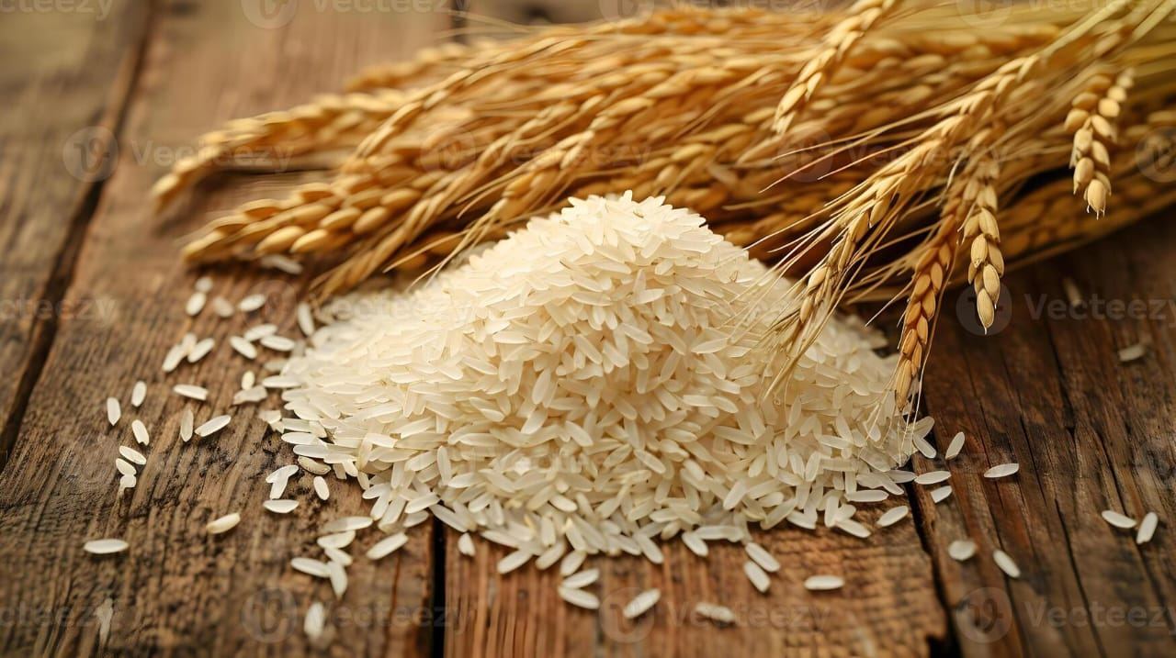
Picture 2.1: Rice grain
2.2 History of aromatic rice
The aromatic or scented or fragrant rice varieties are a special group, which carved out its niche owing to their unique aroma and other cooking quality traits. The first reference to the existence of aromatic rice can be traced to the documents of Susrutha (c. 400 BC), the great Indian pioneer in medicine and surgery (Siddiq et al. 2012). The scented rice genotypes are largely grouped into three categories: the basmati, jasmine, and other scented rice group. The basmati types of rice cultivars originated in India and Pakistan and are characterized by exquisite aroma and extra-long elongation after cooking (Siddiq et al. 2012). In addition to these two large aromatic groups, many more small aromatic groups can be found that are specific to particular regions in the world, including Sadri from Iran and Della from the United States, to name a few (Table 2.1).
Table 2.1 List of aromatic rice varieties in the world
S. No. | Aromatic variety | Location | Characteristics
1 | Basmati | India and Pakistan | Extremely fragrant variety
2 | Jasmine rice | Thailand | Floral aroma
3 | Bahra | Afghanistan
4 | Sadri, Domsiah, Hashemi | Iran | Strong aroma
5 | Della, Texamati and Kasmati | USA | Combines the qualities of basmati with that of traditional American long-grain rice
6 | MRQ74 | Malaysia | Popular aromatic landrace
7 | Ambemohar | Maharashtra, India | Popular for its quick-cooking characteristics and its beautiful aroma
8 | Mullan Kazhama | Wayanad, Kerala, India | Unconventional taste and aroma
9 | Gobindo Bhog | West Bengal, India | Small-grained fragrant rice
10 | Seeraga Samba | Tamil Nadu, India | Slender rice with a sublime scent
11 | Mushk Budji | Kashmir, India | Short-grain rice with a resplendent aroma
12 | Radhuni Pagol | West Bengal, India | Fragrant rice
13 | Chak Hao Amubi | Manipur, India | Fragrant variety of sticky black rice
14 | Kalijira and Chiniguri | West Bengal, India | - Tiny aromatic rice cooks in only 10 min  - Potential source of antitumor agent
15 | Joha rice | Assam, India | Unique aroma, superfine kernel,  good cooking qualities and excellent  palatability
16 | Gandhakasala rice  Jeerakasala rice | Wayanad, Kerala, India | Disease-resistant properties, high  nutritional value, fine taste and  cooking properties
17 | Tulaipanji | West Bengal, India | Non-sticky and friable due to high amylose content
18 | BR5, BRRI dhan34, BINAdhan-13 | Bangladesh | Small-grained fragrant rice
19 | BRRI dhan37, BRRI dhan38, BRRI dhan50, BRRI dhan70,  BRRI dhan80 | Bangladesh | Long, slender-grained fragrant rice
The aromatic rice occupies a special place among the diverse subspecies of rice owing to their exquisite aroma. Aromatic rice includes basmati from India and Pakistan, jasmine from Thailand and sadri from Iran (Figure 18.1). Aromatic rices fetch a premium price in the domestic as well as overseas markets due to their unique special quality characteristics and their being a rich source of nutrients. The basmati varieties, often described as the “prince of rice” are reported to have low glycemic index and be a rich source of Fe and Zn.
2.3 Aromatic Rice in Bangladesh
Aromatic rice varieties are the immense gift of Mother Nature to Bangladesh, which has major market potentials in other countries. There are many varieties of aromatic rice varying from small grain to long grain and slender types are cultivated in Bangladesh (Table 2.2), though they are not classified by any international standard grade.
Table 2.2 Principal Cultivars of Aromatic Rice Cultivated in a Particular Area of Bangladesh
Local name | Location
Badshabhog | Dinajpur and Kustia
Banshful | Naogaon
Chinigura | Mymensingh and Dhaka
Dadkhani | Natore and Rajshahi
Kalajira | Sherpur and Mymensingh
Kataribhog | Dinajpur
Tulshimala | Chittagong
All aromatic rice varieties in Bangladesh are grown without chemical fertilizer (Das and Baqui 2000; Anik and Talukder 2002; Tama et al. 2015). All the Bangladeshi aromatic rice cultivars belong to special aromatic, specialty, or gourmet class of rice. All these cultivars are of traditional type, photoperiod-sensitive, and are normally transplanted during Aman season in the lowland rainfed ecosystem. Most of them are the main cultivars of a particular region of Bangladesh, which are popularly grown in a specific location (Table 2.2). This is believed to be due to the variations in agro-ecological conditions (Shahidullah et al. 2010). Bangladeshi aromatic rice could find significant markets in both domestic and international trade, which fetch premium prices and thus deserve special treatment. In the 19th century, Bangladesh Rice Research Institute (BRRI) developed quite a good number of aromatic rice varieties. BR-16 (Shahibalam), BR-36, BR-38, BR-39, and BR-6 are the fine quality aromatic rice with slender grains and have attractive qualities in the export trade. Some of them have slightly pleasant aroma, while BR-5 (Dolhabhog), BR-34, and BR-38 aromatic rice are considered excellent among cultivars with small to medium grain size, have fine aroma, and generally used by consumers for polao and biryani type preparations. BRRI Dhan-34 is locally known as Khashkhani. BR-26 rice is also an important aromatic rice type with long slender grain that has soft and slightly sticky consistency qualities that should have demand in the East Asian markets (viz. Japan and Korea) (Verma et al. 2018; Das and Baqui 2000; Anik and Talukder 2002).
In Bangladesh, Kalijira rice (very small grain type) is considered the “prince of rice.” Kalijira and Kataribhog ((long and slender type) are important aromatic cultivars predominant in Mymensingh and Dinajpur, respectively. Chinigura, very small grain aromatic rice, is another important aromatic cultivar predominant among the Bangladeshi aromatic rice cultivars and is grown in more than 70% area in the northern districts of Naogaon and Dinajpur. For regular consumption, local cultivars such as Banshful, Bau-pagal, Kataktara, Kataribhog, and Nizershail are among those that are currently grown. The cultivars Kalajira and Badshabhog of northern Bangladesh are known for more scented varieties. On cocking, these cultivars emits very strong aroma. In addition, different organs such root, stem, leaf, and flowers of such cultivars also emit fragrance in their cultivated field. Kataribhog, a long and slender grain aromatic rice cultivar, is also scented but to a lesser degree (Das and Baqui 2000; Shahidullah et al. 2010).
The international trade of Bangladeshi aromatic rice is growing very rapidly. High demand of such aromatic rice in both local and foreign trade has increased to a great extent for domestic consumption and foreign export in recent years, which fetches premium prices especially in the markets of the EU and USA at a great comparative advantage.
2.4 Major volatile compound associated with aromatic odour
Buttery et al. (1982) isolated and identified 2-acetyl-l-pyrroline as an important compound contributing to the aromatic odour. They suggested that 2-acetyl-l-pyrroline was a major contributor to the popcorn-like aroma in several of the Asian aromatic rice varieties. Weber et al. (2000) reported 2-acetyl-lpyrroline in Basmati 370, an aromatic rice from Pakistan, and positively correlated the 2-acetyl-l-pyrroline concentration with the characteristic aroma of aromatic rice. The concentration of 2-acetyl-1- pyrroline was lower in aged aromatic rice. Gaur et al. (2018) reported that aromatic rice had higher levels of alcohol (mainly n-pentanol, l-octen-3-ol, menthol and estragol), aldehydes and ketones (e.g. n-pentanal, n-heptanal and n-nonanal), acids and other compounds. Aromatic rice had 15 times more 2-acetyl-1-pyrroline than nonaromatic rice.
Since 1983, 2-acetyl-1pyrroline is regarded as the solely most important compound in rice, especially fragrant or aromatic rice. Apart from 2-acetyl-1-pyrroline, other key-marker volatile compounds were also counted as important compounds that affect the quality of aromatic rice, including hexanal and 2-pentylfuran (Setyaningsih et al. 2019).
2.5 Physical and nutritional attributes of aromatic rice
Physiological characters of the plant are inherent characters determining the crop yield which plays an important role in variety selection. Development of rice cultivars with a high yielding ability is one of the most fundamental approaches for dealing with the expected increases in the world demand. Keeping the quality of aroma and other grain quality in aromatic fine rice is a big challenge as yield is inversely related to protein and aroma content (Asante 2017).
Kernel length, breadth and L/B ratio are considered important traits especially in quality rice (Nirmaladevi et al. 2015). For commercial purposes, the rices are classified according to the kernel length as short-grain, medium-grain, long grain and long-slender-grain (Prom-U-Thai and Rerksaem 2020). The scented rice varieties fall in all the four categories, but the long-slender-grain type scented rice varieties fetch the maximum premium in the world market (Singh et al. 2000).
Ninety-two rice (Oryza sativa L.) genotypes were evaluated by Nirmaladevi et al., (2015) to estimate the genetic variability, heritability and correlation coefficients for 14 physicochemical and cooking quality traits. The experiment was conducted in a complete randomized block design with 3 replications. Highly significant (P < 0.01) differences were observed for all 14 quality characters studied. Among the traits, head rice recovery (%), water uptake, gel consistency and alkali spreading value exhibited high estimates of genotypic coefficient of variation (GCV) and phenotypic coefficient of variation (PCV). Highest broad sense heritability and genetic advance was obtained for head rice recovery (89% and 29%), milling (84% and 21%), water uptake (90% and 24%), amylose content (93% and 29%) and gel consistency (90% and 31%) which suggested that these traits would respond to selection owing to their high genetic variability and transmissibility
Amylose content of rice is considered to be one of the most important constitutional indices of rice cooking and processing behavior (Yin et al. 2023), as it determines the hardness of cooked rice, gloss of the final product and rice-water ratio. Waxy or glutinous rice which lacks in amylose, does not expand in volume, is sticky and remains firm when cooked. In contrast, the non-waxy or non-glutinous rice characterized by intermediate amylose, cooks moist and tender and does not become hard upon cooking, and hence preferred (Ahmed et al.2020). Most of the aromatic rices, both Basmati or non-Basmati, possess intermediate amylose (Kaur et al. 2011; Kamath et al. 2008; Kaur et al. 2014). Rice with high amylose content cook dry and hard.
Ahmed et al. (2020) documented that among different parts of rice, rice bran consists of high protein and energy. Brown rice is the most nutritious and consists of different types of fat (monounsaturated, polyunsaturated, and saturated), carbohydrates, protein, fiber, vitamins, and minerals. Rice loses some nutrients during milling process. Rice quality is a general concept which covers many characteristics ranging from physical to biochemical and physiological properties of rice. The eating and cooking quality (ECQ) of the rice grain is one of the most serious factors in many rice-producing areas of the world. The ECQs are important determinants of cooked rice quality. The ECQs are composed of several physical and chemical characteristics of starch in the endosperm, viz., amylose content (AC), gel consistency (GC), viscosity, aroma, gelatinization temperature (GT), and texture of cooked rice. Aroma of cooked rice is the most important feature of high-quality rice. Fragrance of rice is a combination of more than 100 volatile compounds, and among those, one chemical, 2-acetyl-1-pyrroline (2AP), is considered as the main contributor. Choice of grain size, shape, aroma, and appearance of rice varies from one group of consumers to another.
Grain quality attribute tests based on physicochemical, textural, pasting, and in vitro digestion properties of eight different rice cultivars were studied. Basmati varieties showed higher values of amylose content, iodine absorption, blue value, hardness, cohesiveness, pasting temperature, and set back, whereas swelling power, solubility, adhesiveness, peak viscosity, and breakdown values were found to be higher in non-basmati varieties. The release of maltose from basmati rice flour (23.12–25.86 mg/g rice flour) was found to be slower as compared to non-basmati ones (27.43–28.36 mg/g rice flour). Amylose content showed significant correlations with different quality parameters at 5% level of significance (Kaur et al. 2014).
Kaur et al. (2011) evaluated the physical, chemical and cooking properties of some newly developed basmati and non-basmati varieties of rice were studied, which showed significant variations within different quality parameters. The longer kernel length, intermediate amylose content, higher elongation after cooking, more water uptake ratio and strong aroma were found to be the distinctive features of evolved basmati rice cultivars like the traditional ones. There was significant correlation found between some of the important quality parameters of rice, such as paddy length breadth ratio showed a positive correlation with kernel length breadth ratio (r= 0.908), density (r= 0.801), cooked kernel length (r= 0.836) and a negative correlation with bulk density (r= −0.84). Amylose content showed a negative correlation with gel consistency (r= −0.974), solid loss in gruel (r= −0.856) while it is positively correlated with cooked kernel length (r= 0.937), elongation ratio (r= 0.829) and water uptake (r=0.786) at 5% level of significance.
Mia et al. (2012) conducted a field experiment to evaluate the morpho-physiological and biochemical attributes in relation to yield potentials of fine aromatic rice varieties in Bangladesh. Two aromatic fine rice cultivars, Ukunmadhu and Kataribough (local land races), one hybridized variety BRRIdhan-32 and one mutant variety Binasail were used in the experiment. The results revealed that rice varieties BRRIdhan-32 and Binasail showed the greater number of branches of panicle, grain size, grain yield and harvest index as compared to aromatic varieties. On the other hand, aromatic rice showed taller plant stature, more tiller, plant biomass and larger panicle but lower number of primary and secondary branches, grain size, yield and harvest index. The biochemical attributes namely chlorophyll and soluble protein content were higher at vegetative stage as compared to panicle initiation and flowering stages. The aromatic rice Kataribhough and Ukonmondhu contained higher amount of total free amino acid as compared to that of Binasail and BRRIdhan32. Other biochemical parameters namely nitrate reductase activity (NRA), total sugar and free amino acid contents were higher at flowering stage compared to those contained at tillering and panicle initiation stages. Physico-chemical properties of grain viz. length, breadth, L/B ratio, nitrogen (%) and protein (%) were significantly higher in fine rice as compared to aromatic rice. From the results it may be concluded that the high yielding varieties were more efficient in transfer of photosynthate to the grain i.e. economic yield and that is why BRRIdhan32 recorded the highest yield. Poor yield in Ukonmodhu and Kataribhough was due to low harvest index indicating minimum translocation of assimilates to the grains.
John and Raman (2023) carried out a study to understand the overall quality of five traditional and popularly consumed rice varieties of Kerala. The major traits affecting the eating and cooking quality of rice such as amylose content (AC), gel consistency (GC) and gelatinization temperature (GT) were determined and correlated with the expression of the starch-synthesis-related genes (SSRGs). The Wx is a major SSRG, which modulates the amylose content and the eating as well as cooking qualities of rice. The rice varieties including, Jaya, Matta and Rakthashali were found to have intermediate amylose content (Wxª allele) while Kuruva and Pokkali were found to have high Amylose Content (Wxª allele). The glycemic index (GI) of all varieties was found to be in the range of 51.0–58.6. Among the screened rice varieties, Pokkali was found to have the lowest glycemic index and digestibility with appreciable eating and cooking qualities. Pokkali rice, with its low GI (51.0), could be a recommended variety for diabetes management. Furthermore, the rice eating and cooking qualities, and plant breeding techniques coordinated by the expression of the starch synthesis-related gene (Wx), could be a novel approach to improve the valuable germplasm.
Zohoun et al. (2018) elucidate the effect of different parboiling steaming time on the physicochemical and nutritional quality of rice, four varieties, NERICA1, NERICA7, IR841, and WITA4, were soaked at the same initial temperature (85°C) and steamed for 5, 15, 25, 35, and 45 min. NERICA7 steamed for 25 min recorded the highest head rice yield (71.9%). Non-parboiled IR841 recorded the shortest cooking time (17.0 min), while NERICA1 steamed for 35 min recorded the longest cooking time (26.1 min). NERICA1 steamed for 45 min was the hardest (63.2 N), while non-parboiled IR841 was the softest (28.7 N). NERICA7 recorded higher peak and final viscosities across all steaming times compared to the other varieties. NERICA7 steamed for 35 and 45 min recorded the lowest total starch (77.3%) and the highest protein (13.2%) content, respectively. NERICA7 steamed for 25 and 45 min recorded the highest phosphorus (0.166%), magnesium (572 mg/kg), and potassium (2290 mg/kg) content, respectively. We conclude that, depending on desired physicochemical and nutritional properties, specific varieties and steaming times can be selected to achieve those outcomes.
Garg et al. (2022) conducted a field experiment to evaluate the physicochemical properties of soil in response to organic and inorganic nutrient management with aromatic rice cultivars during kharif season of 2021 at National Seed Project Farm, IGKV, Raipur (C.G.). The experiment comprised four aromatic rice varieties viz. V1: Gandhari, V2: Srimanta, V3: Bharati and V4: JR-16 and three nutrient management practices viz. N1: Control, N2: State recommended dose of NPK fertilizer (60:40:20 NPK kg/ha) and N3: 33% RDN through FYM + 16 kg PSB + 20 kg Azospirillium. Experiment was laid out in factorial randomized block design, replicated four times and consisting of 12 treatment combinations. The results revealed that pH, EC and OC were not affected due to varieties but the OC in soil enhanced due to organic nutrient management. Available N, P, K, Fe status of soil not affected due to varieties but were significantly affected due to organic and inorganic nutrient management. Available Mn, Cu and Zn were influenced remarkably due to varieties and but had no affect due to different nutrient management except for Zn.
Halim et al. (2023) conducted a study to determine the effects of heat treatment on the physicochemical properties and tissue structure of Mahsuri Mutan, Basmati 370 and MR219 rice varieties. Physicochemical properties, such as alkali digestion value, water uptake ratio, solids in cooking water, high kernel elongation ratio and amylose contents, were determined. In this study, Mahsuri Mutan and Basmati 370 showed superior high kernel elongation as compared to their respective rice progenies. This study also found that heat treatment directly affected the increasingly high kernel elongation for both populations. The heat treatment showed significant difference in all the physicochemical traits of the varieties studied. Heat treatment also affected the very long branch chains of starch, such as amylose. The hexagon structure in Mahsuri Mutan produced a greater elongation effect on its kernel. The findings from this study could be useful to breeders in the selection and development of a new high kernel elongation rice variety.
The experiment was conducted by Meena et al. (2010) to know the physical and cooking properties of ten aromatic rice varieties. Among the varieties milling and head rice out-turn ranged from 72.48 to 80.94 and 65.11 to 81.85 per cent respectively. The grain length varied from 4.30 to 7.80 mm, breadth 1.84 to 2.27 mm, L/B ratio 2.02 to 4.22 and grain width 1.54 to 1.88 mm, 1000 grain weight 11.36 to 20.18 g, and bulk density 0.76 to 0.89 (g / ml). Cooking time ranged from 15 to 20 minutes, percent increase in weight 127 to 210, per cent increase in volume 128 to 257, water uptake ratio 15.85 to 39.93, kernel elongation ratio 1.25 to 1.53, per cent curled grain 17 to 61 and dispersed solids 2.63 to 8.46 per cent respectively. Per cent increase in volume and weight, water uptake ratio, and kernel elongation ratio were positively correlated with sensory mean score whereas percent curled grains, and cooking time were negatively correlated with sensory mean score.
Shandhi (2014) studied some chemical properties and analysis of fatty acids by GC-MS of extracted oil from the bran collected from the Kurigram district of Bangladesh. The rice bran and the bran oil of this area are not much studied. The studies find out some significant properties and nutritional values of this area’s rice bran and bran oil. The bran was rich in carbohydrates (38.78%), fats (20.30%), fiber (1.42%), and proteins (9.45%). Moisture and ash content were found 9.49% and 20.5% respectively. The important minerals were found by wet and dry tests like Fe, Zn, Ca, Mg, K, Na, etc. The higher saponification (110.13 mg KOH/g) value of the oil indicated that it could be used as raw materials in good quality soap. It was determined by refluxing the oil with alcoholic KOH solution followed by titration with standard acid. The low iodine (46.25 I2/100g) value of the oil indicated that it could be used for cooking purposes and the oil was stable and consisted of polyunsaturated fatty acids mainly oleic and linoleic acid. From the fatty acid analysis by GC-MS, it was found that the oil had a high content of fatty acids such as oleic acid, linoleic acid, palmitic acid, stearic acid, etc. These acids have high biological importance for human health.
Verma and Srivastav (2017) analysed six aromatic and two non-aromatic rice accessions grown in India for their nutritional quality attributes including proximate composition, mineral contents and fatty acids. The result on proximate composition showed that Govind Bhog had the highest moisture (13.57%) and fat (0.92%) content, which signifies its tasty attribute. Badshah Bhog exhibited the highest fibre content (0.85%), carbohydrate content (82.70%) and food energy (365.23 kCal per 100 g). Among the minerals, the higher Ca (98.75 mg/kg), Zn (17.00 mg/kg) and Fe (31.50 mg/kg) were in Gopal Bhog, whereas the highest Na (68.85 mg/kg) was in Badshah Bhog, the highest K (500.00 mg/kg) was in Swetganga, Khushboo and Sarbati. The highest contents of unsaturated fatty acids viz. oleic acid (49.14%), linoleic acid (46.99%) and linolenic acid (1.27%) were found in Sarbati, whereas the highest content of saturated fatty acids viz. myristic acid (4.60%) and palmitic acid (31.91%) were found in Govind Bhog and stearic acid (6.47%) in Todal. The identified aromatic rice accessions Gopal Bhog, Govind Bhog and Badshah Bhog and non-aromatic rice accession Sarbati were found nutritionally superior among all eight tested accessions. The nutritional quality-oriented attributes in this study were competent with recognized prominent aromatic and non-aromatic rice accessions as an index of their nutritional worth and recommend to farmers and consumers which may be graded as export quality rice with good unique nutritional values in international market.

CHAPTER IIІ
MATERIALS AND METHODS
This chapter focuses on the materials and methodologies employed in conducting the current research. The materials and procedures were employed to ascertain the biochemical and mineral components of various rice cultivars cultivated in Dinajpur.
3.1 Experimental location
The experiment was carried out at the laboratory of the Department of Agricultural Chemistry, Hajee Mohammad Danesh Science and Technology University, Dinajpur, from July to November, 2023.
3.2 Rice Sample collection
Seven different types of aromatic rice, namely Chinigura, Badshabogh, Radunipagol, Katari Bogh, Kalijira Local, BRRI dhan50, and BRRI dhan34 were collected from Bahadur Bazar, Sadar, Dinajpur. The rice grains served as the raw sample for various biochemical and mineral analyses. Subsequently, the samples were pulverized into a fine powder using a blender and then further processed with a mortar and pestle. They were then stored in a desiccator until they were ready for analysis.
The rice samples were subsequently dehydrated in an oven at 60ºC until a consistent weight was achieved for elemental analysis. The desiccated samples were ultimately pulverized using a carbide mortar and pestle, and then stored in polyethylene bags within desiccators until further investigation. To minimize the inaccuracy in the analysis, at least 3 pellets were created for each sample.

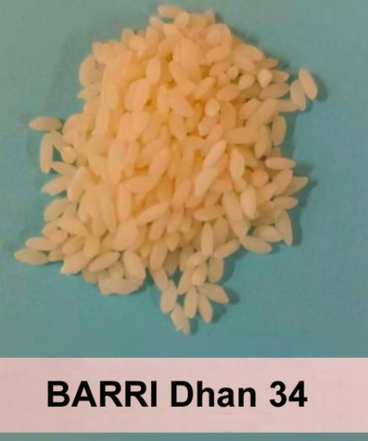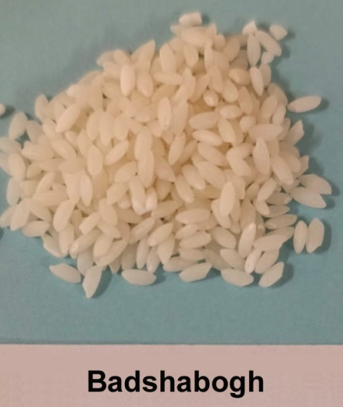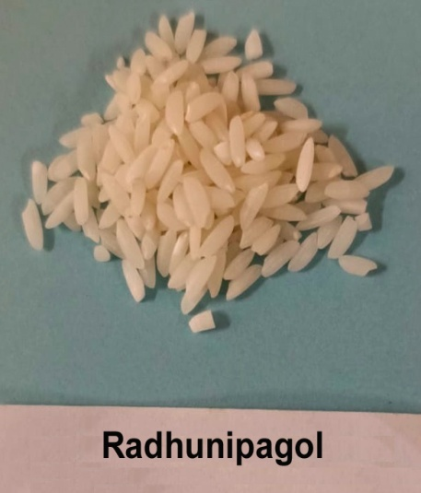
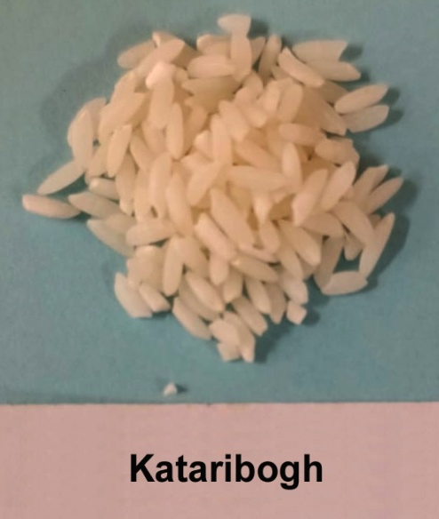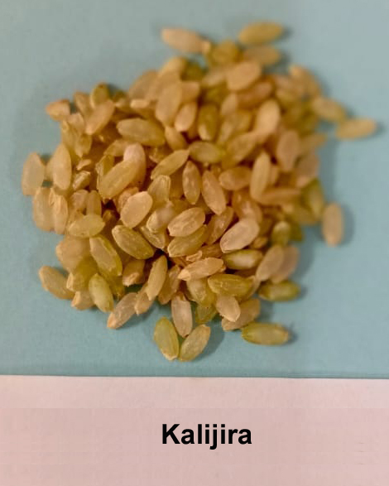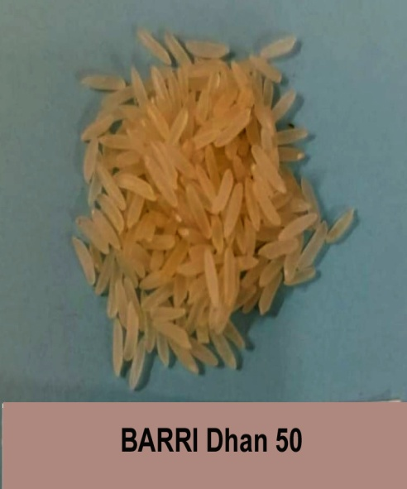
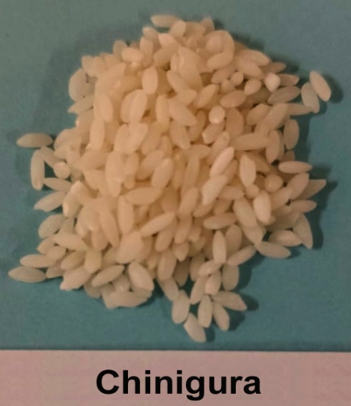
Picture 3.1: Rice Sample collection

3.3 Apparatus used
- Blender
- Measuring cylinder
- Oven
- Beakers
- Filter papers
- Electric balance
- Burette with stand
- Glass rod
- Pipette
- Electric heater
- Conical flask
- Glass tube
- Volumetric flasks
- Spectrophotometer
3.4 Measurement of length, breadth and weight of rice grain
Ten rice grain sample was taken randomly from each variety. For analyzing length and breadth ratio, the cumulative measurements of rice were measured in mm (n = 10) by using Vernier Calliper’s and measured in mm. Breadth of grain was measured by Dail Chalkiness measuring machine. Weight of 10 grain was measured with help of electric balance.
3.5 Assessment of moisture content
The moisture content was determined using the Standard Official Methods of Analysis of the AOAC, specifically procedure 14:004. This process entailed subjecting the rice samples to a temperature of 100⁰C until they reached a consistent weight, and then determining the moisture content by measuring the weight loss of the dried samples. The crucible had a complete cleansing process by being cleaned and dried in an oven at a temperature of 100⁰C for a duration of 30 minutes. Subsequently, it was left to cool within desiccators. After undergoing the cooling process, the objects were measured using a weighing balance and their respective weights were recorded as (W₁). Next, 2.0 g of the finely pulverised rice samples were placed into the crucibles and measured to obtain the weight, denoted as W₂. Subsequently, the sample and crucible were introduced into the oven and subjected to a drying process at a temperature of 100°C for a duration of 4 hours. Afterward, they were allowed to cool and weighed at the same temperature for a period of 30 minutes until consistent weights were achieved, yielding the value of W₃.
Then, the moisture content of the rice sample was calculated from the equation:
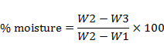
Where,
W₁ = Initial weight of empty crucible,
W₂ = Weight of crucible + sample before drying and
W₃ = Final weight of crucible + sample after drying.
3.6 Ash content determination
The total ash content was determined using the AOAC technique from 1970.
Procedure
An exact measurement of 5 g of the sample was taken using a pre-weighed crucible (W₁). The crucible was subjected to a temperature of 650⁰C in a furnace for a maximum duration of 4 hours. Next, the crucible was cooled in desiccators and then weighed (W₂). The ash content was determined using the following equation.
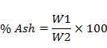
3.7 Protein content estimation from rice sample by modified kjeldahl method
A) Digestion
0.1g rice sample that had been dried in an oven was placed in a digestive flask. A mixture containing 10 g of potassium sulphate (K₂SO₄), 0.1g of copper sulphate (CuSO₄), 1g of selenium powder, and 25 mL of concentrated sulphuric acid (H₂SO₄) was boiled until the solution turned transparent. Subsequently, the flask was subjected to a cooling process.
B) Distillation
After the process of digestion, approximately 300mL of distilled water and 125 mL of a 40% NaOH solution were added to it. Subsequently, the flask was promptly connected to the distillation apparatus and subjected to continuous heating. Meanwhile, a 250 mL conical flask was placed at the base of the condenser. The flask contained 25 mL of a solution with 4% boric acid and 4-5 drops of a mixed indicator. Approximately 150 mL of distillate was gathered and subsequently titrated using 0.2 normal (N) solutions of H₂SO₄.
Calculation:
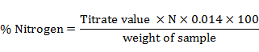
% Protein= % Nitrogen × 6.25

3.8 Fat Content Determination
The rice sample was subjected to Soxhlet extraction for a duration of 4 hours to evaluate the total fat content. The extraction process involved utilizing methanol and ethanol as solvents. A total of 250 mL of clean boiling flasks were dried in an oven at a temperature range of 105 to 110⁰ C for approximately 30 minutes, and subsequently cooled in a desiccator. Precisely 2.0 g of samples were carefully measured and placed into thimbles that were labelled. The desiccated boiling flasks were weighted accordingly and filled with approximately 300 mL of petroleum ether (with a boiling point ranging from 40 to 60⁰C). The extraction thimbles were securely sealed with cotton wool. Subsequently, the Soxhlet apparatus was constructed and permitted to undergo reflux for a duration of 6 hours. The thimble was extracted cautiously, and the petroleum ether was collected from the upper container and transferred to another container for future use. Subsequently, the flask was subjected to a drying process at a temperature range of 105 – 110⁰C for a duration of 1 hour, until it reached a state of near absence of petroleum ether. Following the drying process, the object was next cooled in a desiccator and subsequently weighed.
Then, % fat in the rice sample was computed using the formula below:
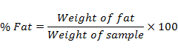
3.9 Crude fiber Determination
The determination of crude fibre was conducted using the AOAC, 1970 method (method 14:020). A rice sample weighing approximately 2.0 g was subjected to hydrolysis in a beaker using petroleum ether. Subsequently, it was heated under reflux for a duration of 30 minutes with a solution consisting of 1.25% H₂SO₄ per 100 mL of solution, totaling 200 mL. The solution was strained through a filter paper onto a fluted funnel. Following the filtration process, the samples were rinsed with hot water until their acidity was completely neutralized. Next, the remaining substance was moved to a beaker and heated for a further 30 minutes with a 200 ml solution containing 1.25% NaOH per 100 mL. The samples that had been boiled were rinsed with boiled distilled water. The leftovers were passed through a Gooch filter crucible, subjected to drying at a temperature of 100⁰C for a duration of 2 hours in an oven, subsequently chilled, and finally washed.
The percentage crude fiber in the rice sample was calculated as per the formula
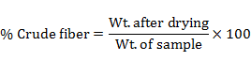
3.10 Carbohydrate Determination
The rice sample's total percentage carbohydrate content was calculated using the difference method, as reported by Onyeike et al. 1995. This approach entails summing the values of crude protein, fat, crude fibre, moisture, and ash constituents of the sample, and then subtracting this sum from 100. The obtained number is the proportion of carbohydrates in the sample, expressed as a percentage. Thus:
% Carbohydrate= 100 – (% moisture + %crude fibre+% protein+%lipid+% ash).
3.11 Starch content determination
The starch content was assessed using the Lane and Eynon (1923) method, with certain modifications. A conical flask was used to hold 1 g of rice powder that had been dried in an oven. Then, 50 mL of cold water were added to the flask. The flask's contents should be left to stand for one hour, while stirring occasionally. The mixture was subsequently filtered, and the remaining solid was rinsed with 50 cc of distilled water. The specimen underwent hydrolysis using a 10% hydrochloric acid solution for a duration of 2.5 hours while being subjected to reflux. Subsequently, the substance was rendered chemically inert by treating it with a solution of sodium hydroxide that had been diluted, and then the resulting mixture was separated by filtration.
The liquid that passed through the filter was moved into a flask with a capacity of 100 mL, and the volume was adjusted to reach the desired level. The final destination was marked by a brick-red hue.
The starch content was calculated by the following formula:
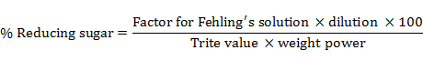
% Starch= % reducing sugar × 0.9
3.12 Determination of iron (IІ) by redox titration (PSU Beaver, PA, April 2004)
Procedure:
At first 0.5g of the rice sample was taken placed into a clean 125 mL Erlenmeyer flask.
After that 50 mL of the Sulphuric Acid was added to the flask.
Then swirled the flask until the iron compound was dissolved.
Then titrated the iron compound with the Potassium Permanganate solution to the colorimetric endpoint.
After that a total of three trials was performed.
Finally calculated the % iron in the unknown compound for each trial.
1mL 1N KMnO₄ solution ≡ 0.05585g Fe²⁺
3.13 Estimation of calcium (Ca) by complexometric method of titration using Na₂-EDTA as a complexing agent (Page et al. 1982).
Procedure:
First 5 mL of rice solution was taken in a 250 mL conical flask.
Next to it 20 mL distilled water was added into the conical flask and shake thoroughly.
After that added 10 drops of each masking agent of
a) Hydroxylamine hydrogen chloride
b) Potassium ferocyanide
c) Triethanolamine (TEA)
Then 5 mL NaOH buffer solution was added and shake thoroughly.
Next 5-6 drops calcon indicator was added into the conical flask (depending on the concentration of the indicator solution) and shaked the flask thoroughly.
Then titrated against 0.01 M Na₂-EDTA solution from burette.
After that continued the titration until pink color of the solution completely turns to pure blue color.
Then repeated the experiment at least 3 times.
Then a blank experiment was conducted also by taking all the reagents as above except calcium stock solution and taken 5 mL more distilled water into conical flask instead of calcium solution.
Finally tabulated the data and calculate the amount of calcium present in the prepared solution.
Calculation:
Actual amount of Na₂-EDTA required for titration= Actual titration reading - blank titration reading = X mL
We know,
1mL 1M Na₂-EDTA= 1mL 1M Ca= 40.08 mg Ca
1mL 0.01M Na₂-EDTA= 40.08×0.01 mg Ca
X mL 0.01M Na₂-EDTA= 40.08×0.01×X mg Ca =Y mg Ca
Now,
5 mL calcium stock solution contains = Y mg Ca mg of Ca/100g = Y×20 mg Ca
3.14 Estimation of zinc (Zn) by complexometric method of titration using Na₂-EDTA as a complexing agent (Page et al. 1982).
Procedure
At first 5 mL of rice solution was taken in a 250 mL conical flask.
Then 20 mL distilled water was added into the conical flask and shaked thoroughly.
Next 5 mL NH₃-NH₄ buffer solution was added and shaked thoroughly.
Then added 10 drops of each masking agent of
a) Hydroxylamine hydrogen chloride
b) Potassium ferocyanide
c) Triethanolamine (TEA)
d) Sodium tungstate.
After that 5-6 drops EBT indicator was added into the conical flask (depending on the concentration of the indicator solution) and shaked the flask thoroughly.
Then titrated against 0.01 M Na₂-EDTA solution from burette.
Continued the titration until pink color of the solution completely turns to pure blue color.
Then repeated the experiment was done at least 3 times.
Next to it, a blank experiment was also conducted by taking all the reagents as above except zinc stock solution. Take 5 ml more distilled water into conical flask instead of zinc solution.
Finally tabulated the data and calculate the amount of zinc present in the prepared solution.
Calculation:
Actual amount of Na₂-EDTA required for titration
= Actual titration reading - blank titration reading =X mL
We know,
1 mL 1M Na₂-EDTA= 1 mL 1M Zn= 65.38 g Zn
1 mL 0.01M Na₂-EDTA= 65.38 ×0.01 g Zn
X mL 0.01M Na₂-EDTA= 65.38 ×0.01×X g Zn =Y g Zn
Now,
5 mL Zinc stock solution contains = Y g Zn g of Zn/100g = Y×20 g Zn

3.15 Statistical analysis
Collected data on different parameters were statistically analyzed by One-way Analyses of variance (ANOVA). The means were adjudged by Duncan’s Multiple Range Test by using the Statistical Tool for Agricultural Research (STAR) software developed by IRRI, Philippine.
CHAPTER IV
RESULTS AND DISCUSSION

This chapter presents the tabulated findings of an experiment undertaken to ascertain the biochemical and mineral components of various fragrant rice cultivars cultivated in Bangladesh. The data has been displayed in tabular form. This chapter has presented sufficient analysis and potential explanations when appropriate.
4.1 Length of individual grain of the different aromatic rice varieties
The grain length of the studied aromatic rice varieties showed significant variation among them. The maximum grain length was recorded from the Katari bogh variety (1.025 mm) followed by BRRI dhan50 (0.96 mm), Radunipagol (0.81 mm). The BRRI dhan34 variety recorded the lowest grain length among the studied varieties (0.49 mm) (Figure 4.1). Grain length variation among aromatic rice varieties in Bangladesh is influenced by genetic diversity, which determines the inherent characteristics of each variety. The microclimate of different regions in Bangladesh contributes to these variations by providing unique growing conditions. Lastly, human preferences and market demands have historically driven the cultivation of certain grain lengths, leading to the prominence of specific aromatic rice varieties with distinct characteristics. Aromatic rice in Bangladesh varied in grain length, breadth, weight (Shahidullah et al. 2010).
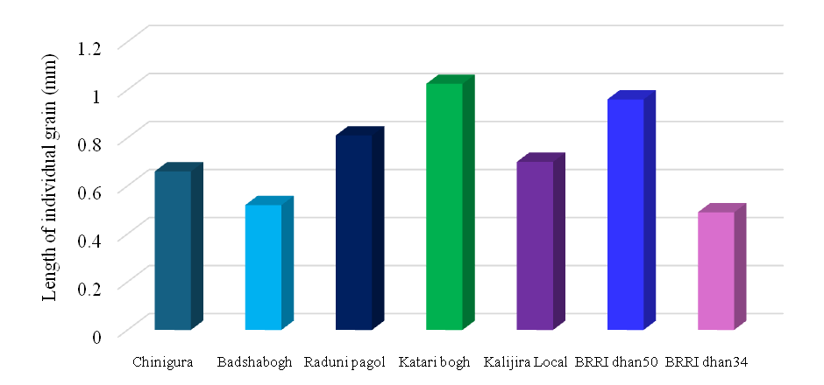

Name of Aromatic Rice varieties
Figure 4.1: Length of individual grain of the different aromatic rice varieties
4.2 Breadth of individual grain of the different aromatic rice varieties
The grain breadth of the studied aromatic rice varieties showed significant variation among them. The maximum grain breadth was recorded from the Katari bogh variety (0.55 mm) followed by Kalijira Local (0.49 mm), BRRI dan50 (0.41 mm) and Radunipagol (0.39 mm). The BRRI dhan34 variety recorded the lowest grain length among the studied varieties (0.21 mm) (Figure 4.2). Grain breadth among aromatic rice varieties in Bangladesh varies due to genetic differences that affect the size and shape of the rice kernels. Environmental factors such as soil quality, water availability, and climate conditions also play a significant role in influencing grain breadth. Additionally, traditional cultivation practices and selective breeding by local farmers have led to variations in grain characteristics. Each aromatic rice variety has been optimized over generations for specific traits, including grain breadth, to meet cultural and culinary preferences. Studies have shown that grain length, breadth, and weight are influenced by genetic factors, with high heritability and genetic advance observed in certain traits like grain length and 1000 grain weight. Genetic divergence analyses have revealed distinct clusters of aromatic rice genotypes based on grain characteristics, with some varieties showing specific traits like smaller kernels or long-slender grains. Additionally, the physical and chemical properties of grains, including length, breadth, and weight, are significantly affected by transplanting dates, with specific varieties like BRRI dhan38 exhibiting superior traits such as high 1000-grain weight and grain length (Islam et al. 2018).

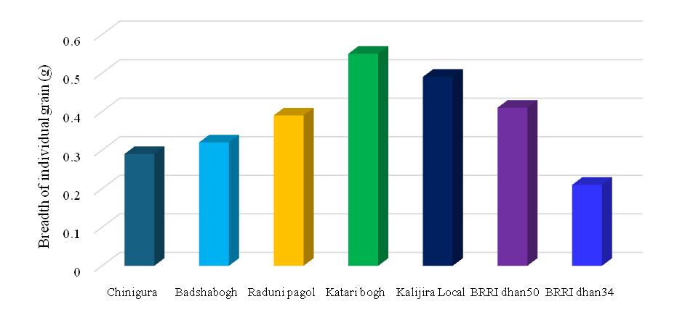
Name of Aromatic Rice varieties
Figure 4.2: Breadth of individual grain of the different aromatic rice varieties
4.3 Grain weight of the different aromatic rice varieties
The grain weight of the studied aromatic rice varieties showed significant variation among them. The maximum mean grain weight was recorded from the Radhuni Pagol variety (0.058 g) followed by BRRI dhan50 (0.018 g), Kalijira local (0.0119 g). The Chinigura variety recorded the lowest mean grain weight among the studied varieties (0.0066 g) (Figure 4.3). Mean grain weight varies among aromatic rice varieties in Bangladesh due to several factors. Firstly, genetic diversity plays a significant role, as different varieties possess distinct genetic makeups influencing grain size and weight. Secondly, environmental conditions such as soil type, water availability, and climatic factors like temperature and sunlight can affect grain development and weight. Thirdly, agricultural practices, including the use of fertilizers, pest control, and irrigation techniques, can impact the growth and final grain weight of different rice varieties. Additionally, post-harvest handling and storage conditions can lead to variations in grain weight due to factors like moisture loss or gain. Lastly, selective breeding practices aiming to enhance specific traits, such as aroma and taste, may inadvertently influence grain weight among different varieties. Islam et al. (2016) stated that aromatic rice genotypes in Bangladesh exhibit significant variability in grain traits such as length, breadth, and weight, crucial for quality and yield.
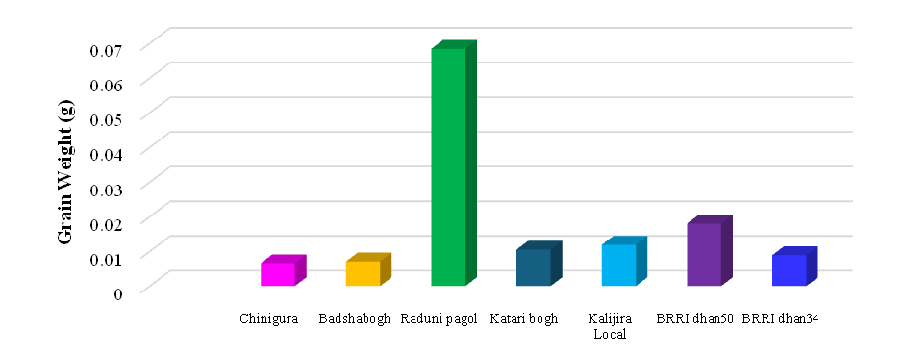
Name of Aromatic Rice varieties
Figure 4.3: Grain weight of the different aromatic rice varieties

4.4 Moisture content in different aromatic rice varieties
The studied rice varieties showed significant variation for moisture content among them. The rice variety Kalijira Local has the highest moisture content, measuring 13.05%. The rice variety Katari bogh had the lowest moisture content of 4.96% (Figure 4.4), which is below the safe moisture content of 14% for storing processed rice. However, it is still within the acceptable range of around 12% recommended for long-term storage to prevent insect infestation and microbial growth. Different aromatic rice varieties have distinct genetic makeups, which affect their physiological and biochemical properties. These genetic traits determine how the rice plants absorb and retain moisture. The physical structure of the rice grain, such as the thickness of the husk and the composition of the endosperm, can vary among varieties. These structural differences influence the moisture absorption and retention capacity of the grains. The moisture content of selected aromatic rice varieties ranged from 7.10 to 9.08 g (Meena et al. 2009).
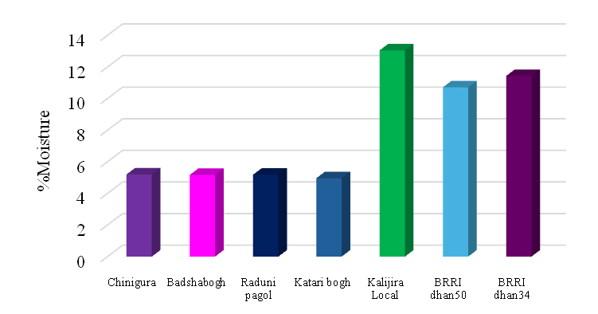
Name of Aromatic Rice varieties
Figure 4.4: Moisture content in different aromatic rice varieties
4.5 Ash content in different aromatic rice varieties
There was notable variance in the ash content among the rice cultivars that were investigated. The rice variety BRRI dhan34 had the highest ash content of 1.55% (Figure 4.5). The rice variety Chinigura had the lowest ash content of 0.30%, which is statistically similar to the ash content of Badshabogh and Radhuni Pagol (0.37%), and Katari bogh (0.39%). Different aromatic rice varieties have unique genetic profiles that can influence their mineral uptake and overall ash content. Genetic factors determine how effectively a plant can absorb and accumulate minerals from the soil. The mineral content of the soil where the rice is grown plays a crucial role. Different soils have varying levels of essential minerals like potassium, phosphorus, magnesium, calcium, and trace elements, which contribute to the ash content of the rice. Rahman et al. (2017) reported an ash percentage of 6.88%, while Asaduzzaman et al. (2013) found that the Kalijira rice variety's ash level was 0.923 g/100 g.
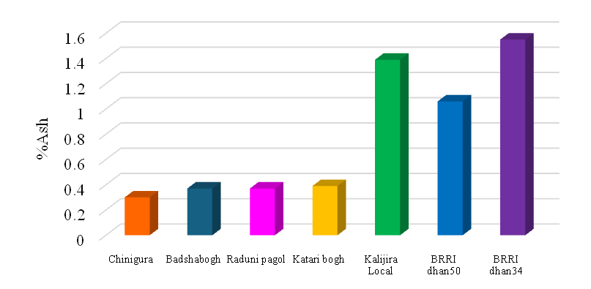
Name of Aromatic Rice varieties
Figure 4.5: Ash content in different aromatic rice varieties

Table 4.1: Protein, fat, fiber and carbohydrate content of the selected aromatic rice varieties
Variety Name | %Protein | %Fat | % Fiber | %Carbohydrate
Chinigura | 8.06±0.08 | 0.53 ± 0.03 | 3.48 ± 0.07 | 85.91± 0.16
Badshabogh | 7.80 ± 0.04 | 0.48 ± 0.04 | 2.74 ± 0.03 | 86.17 ± 0.14
Radunipagol | 8.00 ± 0.04 | 0.66± 0.05 | 3.96 ± 0.10 | 85.79 ± 0.15
Katari bogh | 7.90 ± 0.08 | 0.59± 0.04 | 3.45 ± 0.07 | 86.15 ± 0.15
Kalijira Local | 9.81 ± 0.10 | 0.71± 0.06 | 1.98 ± 0.02 | 75.05 ± 0.13
BRRI dhan50 | 8.92 ± 0.09 | 0.55 ± 0.09 | 2.44 ± 0.06 | 78.76 ± 0.09
BRRI dhan34 | 8.99 ± 0.07 | 0.75 ± 0.04 | 2.84 ± 0.07 | 77.28 ± 0.12
*(± Indicate the standard deviation of the mean)

4.6 Protein content in different aromatic rice varieties
There was notable variance in the protein content among the rice cultivars that were investigated. The rice variety Kalizira local had the highest protein content at 9.81%, while Badshabogh had the lowest protein content at 7.80% (Table 4.1). Badshabogh's protein level is statistically similar to Katari bogh's (7.90) and Radunipagol's (8.00). The biochemical pathways involved in protein synthesis can differ among rice varieties, leading to variations in the types and amounts of proteins produced and stored in the rice grains. Different rice varieties have distinct genetic compositions, which influence their nutritional content, including protein levels. Each variety has a unique set of genes that control protein synthesis and accumulation in the grains. Growing conditions such as soil type, climate, water availability, and agricultural practices can significantly impact the protein content of rice. For example, rice grown in nutrient-rich soils may have a higher protein content than that grown in poorer soils (Zhiyuan et al. 2016). Rahman et al. (2017) found a protein value of 7.35% in Shampakatari, which is nearly identical. Asaduzzaman et al. (2013) found the protein level of Kalijira rice to be 8.833%.
4.7 Fat content in different aromatic rice varieties
The studied rice varieties showed significant variation for fat content among them. The fat content varied from 0.75% to 0.48%, as shown in Table 4.1. The BRRI dhan 34 sample exhibited the highest fat content, while Badshaghbogh had the lowest values. Different aromatic rice varieties, such as Kalijira, Chinigura, and Kataribhog, have distinct genetic makeups that influence their biochemical composition, including fat content. Specific genes regulate the synthesis and storage of fats in rice grains, leading to inherent differences among varieties. Again, temperature, humidity, and rainfall patterns during the growing season can impact the development and biochemical composition of rice grains. Variations in these climatic factors can cause differences in fat accumulation between varieties. The degree of milling and polishing can have a significant impact on rice's fat content. Moreover, aromatic rice varieties are frequently less polished to preserve their fragrance, which may result in a higher fat content compared to highly polished non-aromatic varieties. Similarly, the biochemical pathways involved in lipid biosynthesis and accumulation can vary among different rice varieties. Some varieties may naturally accumulate more lipids due to more active biosynthetic pathways. Oko et al. (2011) reported that the fat content of various rice cultivars ranged from 0.5% to 3.5%.

4.8 Fiber content in different aromatic rice varieties:
The Malaysian FCD measured fiber as total crude fiber (Tee et al. 1997). The current research assessed fiber as total dietary fiber, which includes both soluble and insoluble fiber. The total dietary fiber level in the seven rice cultivars varied between 1.98% (Kalijira local) and 3.96% (Radunipagol) (Table 4.1). Different rice varieties have distinct genetic makeups, which influence their nutrient composition, including fiber content. Due to their genetic traits, certain varieties naturally breed to have higher fiber levels. Aromatic rice varieties, such as Kalijira, Chinigura, and Kataribhog, each have unique characteristics, including differences in fiber content. Selective breeding, which aims to enhance specific qualities like aroma, taste, and texture, often results in these differences, inadvertently affecting fiber levels. The fiber content, ranged from 1.00% to 2.50% (Oko et al. 2011)
4.9 Carbohydrate content in different aromatic rice varieties
The studied rice varieties showed significant variation for carbohydrate content among them. The carbohydrate composition of all the accessions varied from 86.17% (Badshabogh) to 75.05% (Kalijira Local). All rice accessions, with the exception of Kalijira Local, displayed a rather high carbohydrate content. Nevertheless, the carbohydrate content of all the rice accessions exceeded 70.00% (Table 4.1). Different rice varieties possess distinct genetic compositions, influencing their carbohydrate content. Genetic diversity among aromatic rice varieties can lead to differences in starch composition and structure, affecting overall carbohydrate levels. Soil type, climate, water availability, and agricultural practices can impact carbohydrate accumulation in rice grains. Variations in these environmental conditions across different regions in Bangladesh can lead to differences in the carbohydrate content of aromatic rice varieties. Milling, polishing, and storage conditions can alter the carbohydrate content of rice. The extent of processing can remove different amounts of bran and germ, which contain various carbohydrate components. In their study, Oko et al. (2011) determined that the carbohydrate content of various rice cultivars ranged from 51.50% to 86.92%
Table 4.2: Ca, Mg, Na, K, P and S carbohydrate content of the selected aromatic rice varieties
Variety Name | Ca  (mg/100g) | Mg  (mg/100g) | Na  (mg/100g) | K  (mg/100g) | P  (mg/100g) | S  (mg/100g)
Chinigura | 1184.63 ±5.92 | 718.37 ± 3.59 | 123.15 ± 0.62 | 123.15 ± 0.62 | 56.39 ± 2.38 | 2235.45 ± 4.40
Badshabogh | 784.57 ± 4.09 | 951.55 ± 4.96 | 183.82 ± 1.84 | 122.55 ± 1.23 | 46.25 ± 2.37 | 2043.84 ± 4.72
Radunipagol | 1192.48 ± 6.20 | 723.13 ± 3.75 | 185.95 ± 1.42 | 123.97 ± 0.95 | 56.28 ± 1.15 | 1945.36 ± 5.21
Katari bogh | 1167.38 ± 5.84 | 825.90 ± 4.13 | 121.16 ± 0.93 | 121.16 ± 0.93 | 44.30 ±1.72 | 2076.14 ± 9.47
Kalijira Local | 786.53 ± 4.94 | 596.21 ± 3.75 | 220.59 ± 1.10 | 245.10 ± 1.23 | 73.93 ± 1.14 | 1970.77 ± 5.15
BRRI dhan50 | 782.05 ± 1.96 | 592.80 ± 1.48 | 231.71 ± 1.16 | 243.90± 1.22 | 106.01 ± 1.73 | 1955.28 ± 4.69
BRRI dhan34 | 767.08 ± 3.84 | 697.75 ± 3.49 | 239.23 ±2.39 | 239.23 ± 2.39 | 110.64 ± 1.28 | 1657.80 ± 4.28
*(± Indicate the standard deviation of the mean)
4.10 Calcium (Ca) content in different aromatic rice varieties
The calcium content of the rice varieties showed statistically significant variation among them. The rice variety Chinigura had the highest calcium level, 1184.63 mg/100 g, which was statistically equivalent to Radunipagol. The rice variety BRRI dhan34 had the lowest calcium content of 767.08 mg/100 g (Table 4.2). The availability of calcium in the soil can vary significantly across different regions of Bangladesh. Soil types, pH levels, organic matter content, and the presence of other minerals and nutrients all affect how much calcium is available for plant uptake. Some soils may naturally have a higher calcium content, leading to higher calcium levels in the rice grown there. Each rice variety has a unique genetic makeup that influences its ability to absorb and accumulate calcium. Different varieties have varying efficiencies in nutrient uptake due to their root structure, growth patterns, and metabolic processes. Tamanna et al. (2013) study observed the calcium level of the Chinigura rice variety at 0.02 mg per 100 g, whereas our findings revealed a calcium content of 310.6 mg per 100 g.
4.11 Magnesium (Mg) content in different aromatic rice varieties
Statistically significant variation was observed for the magnesium content among the rice varieties. The rice variety Badshabogh had the highest recorded zinc value of 951.55 mg/100 g, while the rice variety BRRI dhan50 had the lowest recorded zinc content of 592.80 mg/100 g, which is statistically similar to Kalijira Local (Table 4.2). Several factors, including genetic differences, soil composition, agricultural practices, environmental conditions, and post-harvest processing, contribute to the variation in magnesium (Mg) content among different aromatic rice varieties in Bangladesh. In the Kalijira variety, Rahman et al. (2017) discovered a zinc level of 131 mg/100 g.
4.12 Sodium (Na) content in different aromatic rice varieties
Table 4.2 demonstrated that there was a statistically significant variance in the sodium content among the different rice cultivars. The rice variety BRRI Dhan34 had the highest sodium content, measuring 239.23 mg/100 g. On the other hand, the rice variety Kataribogh had the lowest sodium level, with a recorded value of 121.16 mg/100 g, which is statistically similar to Chinigura. Different rice varieties have unique genetic makeup, which influences their nutrient composition, including sodium content. Varieties developed through breeding programs may exhibit variations in sodium content due to the selection criteria used during breeding. Environmental factors such as soil composition, water quality, and climate can influence rice plants' uptake of nutrients, including sodium. Different regions in Bangladesh cultivate aromatic rice varieties, and variations in these factors can lead to differences in sodium content. Post-harvest processing methods, including milling and polishing, can affect the nutrient composition of rice. Variations in processing techniques employed for different aromatic rice varieties may result in differences in sodium content. Rahman et al. (2017) study revealed that the Kalijira variety has a zinc content of 131 mg/100 g.

4.13 Potassium (K) content in different aromatic rice varieties:
In Table 4.2, the potassium content of the rice varieties showed statistically significant variation among them. It was found that the rice variety Kalizira local had the highest potassium content, with a recorded value of 245.10 mg/100 g, which is statistically similar to BRRI Dhan50 (243.90 mg/100 g). On the other hand, the rice variety Kataribogh had the lowest potassium level, with a recorded value of 121.16 mg/100 g, which is statistically similar to all other varieties except BRRI dhan 34. Different rice varieties have distinct genetic makeup, leading to variations in nutrient uptake and accumulation, including potassium. Breeders select for specific traits, and inadvertently, the potassium content may differ among varieties. Environmental conditions like temperature, rainfall, and sunlight can impact the growth and nutrient uptake of rice plants, including potassium. Variations in environmental conditions across different regions or seasons can contribute to differences in potassium content among rice varieties. Rahman et al. (2017) study revealed that the Kalijira variety has a Kcontent of 131 mg/100 g.
4.14 Phosphorus (P) content in different aromatic rice varieties
There was a statistically significant variance in the phosphorus content among the different rice varieties. The rice variety BRRI dhan 34 had the highest phosphorus content (110.64 mg/100 g), statistically similar to BRRI dhan 50 (106.01 mg/100 g). On the other hand, the rice variety Kataribogh had the lowest phosphorus level (44.30 mg/100 g), which is statistically similar to Badshahbogh (Table 4.2,). Different rice varieties have unique genetic traits, including their ability to absorb and accumulate nutrients like phosphorus. Varieties with genetic predispositions for higher phosphorus uptake may naturally have higher levels of this nutrient. Agricultural practices, such as fertilization techniques, irrigation methods, and crop management strategies, can influence the availability of phosphorus to rice plants. Grown under optimal nutrient management practices, varieties are likely to have a higher phosphorus content.
4.15 Sulphur (S) content in different aromatic rice varieties
The Sulphur content of the rice varieties showed statistically significant variation among them. According to the data presented in Table 4.2, the rice variety Chinigura exhibited the greatest sulphur content, measuring 2235.45 mg/100 g. This value was determined to be significantly different from the sulphur content of other rice varieties. Conversely, the rice variety BRRI dhan 34 exhibited the lowest sulphur content, (1657.80 mg/100 g), which is likewise statistically distinct from other varieties.
4.16 Starch content in different aromatic rice varieties
The starch content of the rice varieties showed statistically significant variation among them. According to Figure 4.6, the rice variety Radunipagol had the highest starch content, at 28.77% and the rice variety BRRI dhan34 has the lowest starch content, at 14.13%. Each rice variety has a unique genetic makeup that determines its starch composition. Genes control the synthesis and accumulation of starch in rice grains, leading to variations among different varieties. People have selectively bred aromatic rice varieties like Kalijira, Kataribhog, and Chinigura for their unique aroma, flavor, and texture, which also influences their starch content and composition. The climate, soil type, and water availability in different regions of Bangladesh significantly impact rice growth and starch accumulation. Temperature, humidity, and sunlight exposure can influence the enzymatic activities involved in starch synthesis. For instance, regions with higher temperatures might accelerate the starch production process, leading to variations in the final starch content of the rice grains. According to Asaduzzaman et al. (2013), the Kalijira rice variety had a starch content of 68.07 g/100 g.
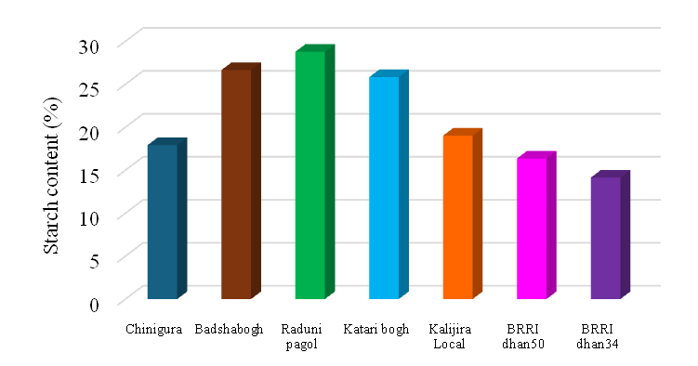
Name of Aromatic Rice Varieties
Figure 4.6: Starch content in different aromatic rice varieties

4.17 Amylose content in different aromatic rice varieties
There was a statistically significant variance in the amylose content among the different rice cultivars. In Figure 4.7, it was found that the rice variety Badshabogh had the highest amylose content, (25.42 mg/100 g), which is statistically similar to BRRI dhan50 (25.19 mg/100 g). On the other hand, the rice variety Chinigura had the lowest amylose level (16.84 mg/100 g), which is statistically similar to Radhunipagol. Different aromatic rice varieties have distinct genetic makeup, which influences their amylose content. Varieties with higher amylose content typically have specific genetic traits that contribute to starch composition. Growing conditions, including soil type, climate, temperature, and water availability, can impact the amylose content of rice. Varieties adapted to specific environmental conditions may exhibit differences in starch composition. Post-harvest processing methods, such as milling and polishing, can influence the final amylose content of rice grains. Varieties may respond differently to these processing techniques, resulting in varying amylose levels in the final product. According to research findings, the amylose content of various aromatic rice varieties differs significantly. Studies have shown that different rice varieties exhibit diverse amylose content levels. For instance, high-amylose basmati varieties like At-306 and low-amylose basmati varieties like At-405 have distinct amylose content ranges, affecting their physicochemical properties (Shao et al. 2022).
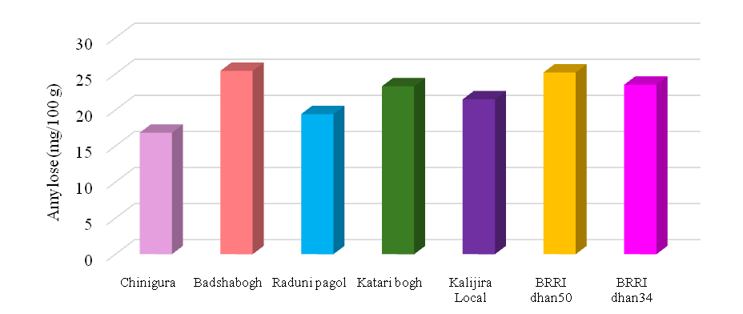
Name of Aromatic Rice Varieties
Figure 4.7: Amylose content in different aromatic rice varieties

4.18 Zinc (Zn) content in different aromatic rice varieties:
The zinc content of the rice varieties showed statistically significant variation among them. The rice variety Radunipagol had the highest recorded zinc value of 48.13 mg/100g, while the rice variety BRRI dhan34 had the lowest recorded zinc content of 20.19 mg/100g (Figure 4.8). Different rice varieties have varying capacities to uptake and accumulate zinc. Genetic makeup plays a significant role in determining how efficiently a rice plant can absorb zinc from the soil and transport it to the grains. Genetic differences often select certain varieties with naturally higher zinc accumulation traits for breeding purposes. In the Kalijira variety, Rahman et al. (2017) discovered a zinc level of 131 mg/100g.
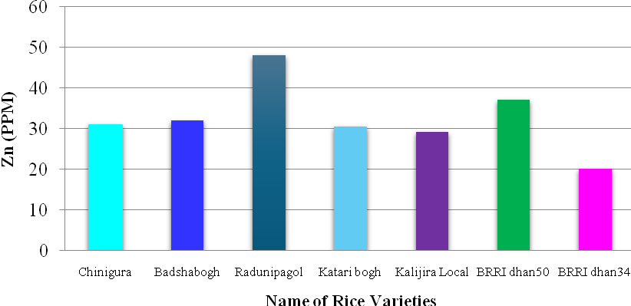
Zn (mg/100g)
Name of Aromatic Rice Varieties
Figure 4.8: Zn content of the selected aromatic rice varieties

4.19 Iron (Fe) content in different aromatic rice varieties:
The figure 4.1 showed the iron content of the different rice varieties in the present study. The rice variety BRRI dhan50 had the highest iron level of 116.44 mg/100g, whereas the rice variety Katari bogh had the lowest iron content of 0.73 mg/100g (Figure 4.9). Tamanna et al. (2013) and found that the Chinigura rice variety had an iron level of 0.029 mg/100g. The iron content in rice is primarily influenced by the absorption of iron from the soil, as well as the transit and deposit of iron within the rice plant. Related genes primarily regulate the specific cultivars or genotypes of rice, which determine the highly variable iron content (Meng et al. 2005).
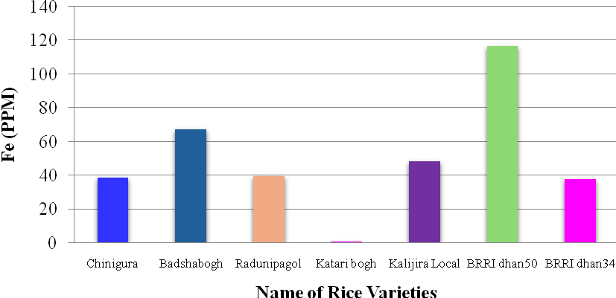
Fe (mg/100g)
Name of Aromatic Rice Varieties
Figure 4.9: Fe content of the selected aromatic rice varieties
CHAPTER V
SUMMARY AND CONCLUSIONS
5.1 Summery
The experiment was carried out at the laboratory of the Department of Agricultural Chemistry, Hajee Mohammad Danesh Science and Technology University, Dinajpur, from July to November 2023 to find out their nutritional value by investigating the starch, moisture, amylose, ash, protein, fiber, minerals (Na, K, S, Ca, Mg, P, Fe and Zn), and carbohydrate content. The varieties were Chinigura, Badshabogh, RaduniPagol, Katari Bogh, and Kalijira Local, BRRI dhan50 and BRRI dhan34. The rice varieties were collected in Bahadur Bazar, Sadar, and Dinajpur. A minimum of three pellets were made from each sample to reduce the error in the analysis.
The results showed that the maximum grain length was recorded from the Katari bogh variety (1.025 mm) and the BRRI dhan34 variety recorded the lowest grain length among the studied varieties (0.49 mm). The maximum grain breadth was recorded from the Katari bogh variety (0.55 mm) and the BRRI dhan34 variety recorded the lowest grain length among the studied varieties (0.21 mm). The maximum mean grain weight was found in the Radhuni Pagol variety (0.058 g) and the Chinigura variety showed the lowest mean grain weight among the studied varieties (0.0066 g). Among aromatic rices, there were differences in proximate composition and mineral content. The rice accessions offered a noteworthy quantity of nutrients. Though the Kalizira local variety showed the highest value for moisture content (13.05%), it also contains the maximum value for protein content (9.81%) and potassium content. It also recorded the lowest carbohydrate content. BRRI Dhan34 recorded the highest ash (1.55%), fat (0.7500%), sodium (239.23 mg/100 g), and phosphorous content (110.64 mg/100 g), while BRRI Dhan34 estimated the lowest value for the calcium, fiber, zinc, starch, and sulphur content. The Badshabogh variety recorded the highest amount of carbohydrate (86.17%), amylose (25.42 mg/100 g), and zinc content (951.55 mg/100 g). It also gave the minimum value for protein and fat content. BIRRI dhan50 had the highest iron level (116.44 mg/100 g), but the lowest zinc content. The Chinigura variety had the highest calcium (1184.63 mg/100 g) and sulphur content (measuring 2235.45 mg/100 g), but the lowest amylose content. Of the varieties, the Radhunipagol had the highest starch content (28.77%).
5.2 Conclusion
The used rice varieties showed variation in physiochemical properties. The Kalizira local variety demonstrated the highest moisture content (13.05%) and protein content (9.81%). On the other hand, BRRI Dhan34 recorded the highest values for ash (1.55%) and fat (0.7500%), highest sodium (239.23 mg/100 g) and phosphorus (110.64 mg/100 g) contents. The Badshabogh variety stood out for its high carbohydrate content (86.17%), amylose content (25.42 mg/100 g), and zinc content (951.55 mg/100 g). Conversely, the BIRRI dhan50 variety had the highest iron level (116.44 mg/100 g), though it had lower zinc content compared to others. The Chinigura variety showed the highest calcium (1184.63 mg/100 g) and sulfur content (2235.45 mg/100 g), but it had the lowest amylose content. Among the varieties tested, the Radhuni Pagol variety had the highest starch content (28.77%).
5.3 Recommendation
- For breeding programs, the data highlights the need to develop rice varieties that offer a balanced nutritional profile, combining desirable traits such as high protein and mineral content with optimal carbohydrate levels.
- For consumers, understanding these nutritional differences can guide them in selecting rice varieties that meet specific dietary needs.
- Further research is recommended to explore the health benefits associated with these nutritional profiles and the impact of environmental conditions on these parameters.

REFERENCES
Adhikari, A, Sarkar, MAR, Paul, SK and Saha, KK. 2018. Impact of nutrient management on the yield performance of some aromatic fine rice (Oryza sativa L.) varieties in Boro season. Archives of Agriculture and Environmental Science, 3(2): 245-251.
Ahmed, F, Abro, TF, Kabir, MS and Latif, MA. 2020. Rice quality: Biochemical composition, eating quality, and cooking quality. The Future of Rice Demand: Quality Beyond Productivity, 3-24.
Ahmed, F, Abro, TF, Kabir, MS and Latif, MA. 2020. Rice quality: Biochemical composition, eating quality, and cooking quality. The Future of Rice Demand: Quality Beyond Productivity, 3-24.
Ahuja, U, Ahuja, SC, Thakrar, R and Singh, RK. 2008. Rice–a nutraceutical. Asian Agri-History, 12(2): 93-108.
Anik, AR and Talukder, RK. 2002. Economic and financial profitability of aromatic and fine rice production in Bangladesh. Bangladesh Journal of Agricultural Economics, 25(2): 103-113.
Anjum, FM, Pasha, I, Bugti, MA and Butt, MS. 2007. Mineral composition of different rice varieties and their milling fractions. Pakistan Journal of Agricultural Science, 44(2): 332-336.
Arsha, RS, Rasane, P and Singh, J. 2021. Rice: Bioactive compounds and their health benefits. The Pharma Innovation Journal, 10(5): 845-853.
Asaduzzaman, M, Haque, ME, Rahman, J, Hasan, SK, Ali, MA, Akter, MS and Ahmed, M. 2013. Comparisons of physiochemical, total phenol, flavanoid content and functional properties in six cultivars of aromatic rice in Bangladesh. African Journal of Food Science, 7(8): 198-203.
Asante, MD. 2017. Breeding rice for improved grain quality. Advances in International Rice Research. InTech, 69-89.
Babu, PD, Subhasree, R, Bhakyaraj, R and Vidhyalakshmi, R. 2009. Brown rice-beyond the color reviving a lost health food-a review. Magnesium, 187(13.10): 67-72.
Bao, J. 2019. Rice starch. In Rice (pp. 55-108). AACC International Press.
Bhattacharjee, P, Singhal, RS and Kulkarni, PR. 2002. Basmati rice: a review. International journal of food science & technology, 37(1): 1-12.
Birla, DS, Malik, K, Sainger, M, Chaudhary, D, Jaiwal, R and Jaiwal, PK. 2017. Progress and challenges in improving the nutritional quality of rice (Oryza sativa L.). Critical Reviews in Food Science and Nutrition, 57(11): 2455-2481.
Bisne, R and Sarawgi, AK. 2008. Agro-morphological and quality characterization of badshah bhog group from aromatic rice germplasm of Chhattisgarh. Bangladesh Journal of Agricultural Research, 33(3): 479-492.
Biswas, P, Ghosh, M, Pal, S, Bandopadhyay, PK and Saha, A. 2023. Effect of organic and inorganic nutrient sources on growth, yield and economics of aromatic rice (Oryza sativa) in Gangetic delta of West Bengal. Indian Journal of Agronomy, 68(1): 93-96.
Buttery, RG, Ling, LC and Juliano, BO. 1982. 2-Acetyl-1-pyrroline: an important aroma component of cooked rice.23:958-959.
Das, T and Baqui, MA. 2000. Aromatic rices of Bangladesh. Aromatic rices, 184-187.
Dolson, L. 2009. What you need to know about complex carbohydrates. http://lowcarb diets.about.com/od/nutrition/a/starch.htm
Frei, M and Becker, K. 2004. On rice, biodiversity & nutrients. University of Hohenheim, Stuttgart. Available at https://www.greenpeace.org/usa/wp-content/uploads/legacy /Global/usa/report/2007/7/rice-biodiversity-nutrients.pdf
Garg, S, Sengar, SS, Kashyap, CD and Tomar, A. 2022. Physico-chemical properties of soil under organic and inorganic nutrient management planted with aromatic rice in a Vertisol. The Pharma Innovation Journal, 11(8): 2020-2024.
Gaur, A, Wani, SH, Sah, SK and Shikari, AB. 2018. Biochemical, Genetic and Genomic Perspectives of Flavor and Fragrance in Rice. In Science and Technology of Aroma, Flavor, and Fragrance in Rice (pp. 289-312). Apple Academic Press.
Halim, AABA, Rafii, MY, Osman, MB, Chukwu, SC and Oladosu, Y. 2023. Physicochemical Properties and Tissue Structure of High Kernel Elongation Rice (Oryza sativa L.) Varieties as Affected by Heat Treatment. Foods, 12(11): 2207.
Islam, MZ, Akter, N, Chakrabarty, T, Bhuiya, A, Siddique, MA and Khalequzzaman, M. 2018. Agro-morphological characterization and genetic diversity of similar named aromatic rice (Oryza sativa L.) landraces of Bangladesh. Bangladesh Rice J, 22(1): 45-56.
Islam, MZ, Khalequzzaman, M, Bashar, MK, Ivy, NA, Haque, MM and Mian, MAK. 2016. Variability assessment of aromatic and fine rice germplasm in Bangladesh based on quantitative traits. The scientific world journal, 2016(1): 2796720.
Jianfen, L, Han, BZ, Han, L, Nout, MJR and Hamer, RJ. 2008. Iron, zinc and phytic acid content of selected rice varieties from China. Journal of the Science of Food and Agriculture, 87: 504-510.
John, D and Raman, M. 2023. Physicochemical properties, eating and cooking quality and genetic variability: a comparative analysis in selected rice varieties of South India. Food Production, Processing and Nutrition, 5(1): 49.
Joint, FAO and Consultation, WE. 1998. Carbohydrates in human nutrition (FAO Food and Nutrition Paper 66). Rome, Italy: FAO.
Kamath, S, Stephen, JC, Suresh, S, Barai, BK, Sahoo, AK, Radhika Reddy, K and Bhattacharya, KR. 2008. Basmati rice: Its characteristics and identification. Journal of the Science of Food and Agriculture, 88(10):1821-1831.
Kamruzzaman, M, Islam, AKM, Rahman, MA and Sarkar, TK. 2012. Effect of field drying on head rice recovery and grain breakage of aromatic rice. International Journal of Biological Research, 12(1):36-39.
Kaur, S, Panesar, PS and Bera, MB. 2011. Studies on evaluation of grain quality attributes of some basmati and no basmati rice cultivars. Journal of Food Quality, 34(6): 435-441.
Kaur, S, Panesar, PS, Bera, MB and Kumari, S. 2014. Physicochemical, textural, pasting, and in vitro digestion properties of some basmati and non-basmati rice cultivars. International Journal of Food Properties, 17(5): 1055-1066.
Khor, GL. 2003. Update on the prevalence of malnutrition among children in Asia. Nepal Med Coll J, 5(2): 113-22.
Kline, K., Yu, W and Sanders, B. G. 2004. Vitamin E and breast cancer. The Journal of nutrition, 134(12):3458S-3462S.
Laila, N, Paul, NC, Imran, S, Sarkar, MAR, Sarkar, SK and Paul, SK. 2022. Assessing the influence of integrated nutrient management on growth performance of aromatic fine rice. Archives of Agriculture and Environmental Science, 7(2): 174-184.
Lane, JH and Eynon, L. 1923. Determination of reducing sugars by means of Fehling’s solution with methylene blue as internal indicator. Journal of the Society of Chemical Industry, 42:32-36.
Liang, S, Wu, W, Sun, J, Li, Z, Sun, X, Chen, H, Chen, S, Fan, L, You, L and Yang, P. 2021. Climate-mediated dynamics of the northern limit of paddy rice in China. Environmental Research Letters, 16(6):064008.
Lloyd, BJ, Siebenmorgen, TJ and Beers, KW. 2000. Effects of commercial processing on antioxidants in rice bran. Cereal Chemistry, 77(5): 551-555.
Lockard, CA. 2009. Southeast Asia in world history. Oxford.
Mannan, MA, Bhuiya, MSU, Akhand, MIM and Rana, MM. 2012. Influence of date of planting on the growth and yield of locally popular traditional aromatic rice varieties in Boro season. Journal of Scientific foundation, 10(1): 20-28.
Meena, SK, Vijayalakshmi, D and Ravindra, U. 2009. Nutrient composition and sensory characteristics of selected varieties of aromatic rice (Oryza sativa L.). Journal of Dairying, Foods and Home Sciences, 28(2): 137-141.
Meena, SK, Vijayalakshmi, D and Ravindra, U. 2010. Physical and cooking characteristics of selected aromatic rice varieties. Journal of Dairying, Foods and Home Sciences, 29(3,4): 227-231.
Mendoza, C. (2002). Effect of genetically modified low phytic acid plants on mineral absorption. International journal of food science & technology, 37(7): 759-767.
Mia, MAB, Das, MR, Kamruzzaman, M and Talukder, NM. 2012. Biochemical traits and physico-chemical attributes of aromatic-fine rice in relation to yield potential. American Journal of Plant Sciences, 3:1788-1795.
Mohidem, NA, Hashim, N, Shamsudin, R and Che Man, H. 2022. Rice for food security: Revisiting its production, diversity, rice milling process and nutrient content. Agriculture, 12(6): 741.
Nirmaladevi, G, Padmavathi, G, Suneetha Kota, SK and Babu, VR. 2015. Genetic variability, heritability and correlation coefficients of grain quality characters in rice (Oryza sativa L.). SABRAO Journal of Breeding and Genetics 47(4):424-433.
Ojo, MA. 2020. Phytic acid in legumes: A review of nutritional importance and hydrothermal processing effect on underutilised species. Food Res, 5:22-28.
Okonogi, S, Kaewpinta, A, Junmahasathien, T and Yotsawimonwat, S. 2018. Effect of rice variety and modification on antioxidant and anti-inflammatory activities. Drug Discoveries & Therapeutics, 12(4): 206-213.
Onyeike, EN, Olungwe, T and Uwakwe, AA. 1995. Effect of heat-treatment and defatting on the proximate composition of some Nigerian local soup thickeners. Food chemistry, 53(2): 173-175.
Page, AL, Miller, RH and Keeney, DR. 1982. Methods of soil analysis. Part 2. Chemical and Microbiological Properties. 2nd. Amer. Soc. of Agronomy. Madison, Wisconsin, USA.
Prom-U-Thai, C and Rerkasem, B. 2020. Rice quality improvement. A review. Agronomy for sustainable development, 40(4): 28.
Qureshi, AA, Sami, SA and Khan, FA. 2002. Effects of stabilized rice bran, its soluble and fiber fractions on blood glucose levels and serum lipid parameters in humans with diabetes mellitus Types I and II. The Journal of nutritional biochemistry, 13(3):175-187.
Rahman, AA, Islam, AM, Arefin, MA, Rahman, MR and Anwar, MP. 2017. Competitiveness of winter rice varieties against weed under dry direct seeded conditions. Agricultural Sciences, 8(12):1415-1438.
Razzaq, A, Ali, A, Safdar, LB, Zafar, MM, Rui, Y, Shakeel, A and Yuan, Y. 2020. Salt stress induces physiochemical alterations in rice grain composition and quality. Journal of food science, 85(1): 14-20.
Rohman, A, Helmiyati, S, Hapsari, M and Larasati Setyaningrum, D. 2014. Rice in health and nutrition. International food research journal, 21(1).
Setyaningsih, W, Majchrzak, T, Dymerski, T, Namieśnik, J and Palma, M. 2019. Key-marker volatile compounds in aromatic rice (Oryza sativa) Grains: An HS-SPME extraction method combined with GC× GC-TOFMS. Molecules, 24(22): 4180.
Shahidullah, SM, Hanafi, MM, Ashrafuzzaman, M, Ismail, MR, Salam, MA and Khair, A. 2010. Biomass accumulation and energy conversion efficiency in aromatic rice genotypes. Comptes Rendus. Biologies, 333(1): 61-67.
Shandhi, SP. 2024. Study on Proximate Composition of Rice (Oryza sativa) Bran and Chemical Properties with Fatty Acid Content of its’ Extracted Oil Collected from the Northern Region of Bangladesh. Research square. https://doi.org/10.21203/rs.3.rs-3155343/v2
Siddiq, EA, Vemireddy, LR and Nagaraju, J. 2012. Basmati rices: genetics, breeding and trade. Agricultural Research, 1:25-36.
Singh, RK, Singh, US, Khush, GS and Rohilla, R. 2000. Genetics and biotechnology of quality traits in aromatic rices. Aromatic rices, 5:47-70.
Singh, S, Razak, MA, Sangam, SR, Viswanath, B, Begum, PS and Rajagopal, S. 2018. The impact of functional food and nutraceuticals in health. In Therapeutic Foods (pp. 23-47). Academic Press.
Sun, Q, Spiegelman, D, van Dam, RM, Holmes, MD, Malik, VS, Willett, WC and Hu, FB. 2010. White rice, brown rice, and risk of type 2 diabetes in US men and women. Archives of internal medicine, 170(11): 961-969.
Sunanda, D and Jahida, G. 2017. Different forms of malnutrition among under five children in Bangladesh: a cross-sectional study on prevalence and determinants. BMC Nutrition, 3(1):2-12.
Tama, RAZ, Begum, IS, Alam, MJ and Islam, S. 2015. Financial profitability of aromatic rice production in some selected areas of Bangladesh. International Journal of Innovation and Applied Studies, 12(1): 235–242.
Tang, S and Xuan, S. 2010. Domestication of rice in China and its cultural heritage. Rice: origin, antiquity and history, Science Publishers, New Hampshire, 85-114.
Verma, DK and Srivastav, PP. 2017. Proximate composition, mineral content and fatty acids analyses of aromatic and non-aromatic Indian rice. Rice Science, 24(1): 21-31.
Verma, DK, Mohan, M, Yadav, VK, Asthir, B and Soni, SK. 2012. Inquisition of some physicochemical characteristics of newly evolved basmati rice. Environment and Ecology, 30(1): 114-117.
Verma, DK, Srivastav, PP and Nadaf A. 2018. Aromatic rice from different countries: an overview. Science and Technology of Aroma, Flavour and Fragrance in Rice, 93-140.
Vishwakarma, RK, Shivhare, US, Gupta, RK, Yadav, DN, Jaiswal, A and Prasad, P. (2018). Status of pulse milling processes and technologies: A review. Critical reviews in food science and nutrition, 58(10):1615-1628.
Washington, DC. 1970. AOAC (Association of Official Analytical Chemists), “Official Methods of Analysis,” 10th Edition, pp. 154-170.
Weber, D, Rohilla, R and Singh, US. 2000. Chemistry and biochemistry of aroma in scented rice. Singh, Singh and Khush (eds), Aromatic Rices, Oxford & IBH Publ, 29-46.
Yin, X, Chen, X, Hu, J, Zhu, L, Zhang, H and Hong, Y. 2023. Effects of distribution, structure and interactions of starch, protein and cell walls on textural formation of cooked rice: A review. International Journal of Biological Macromolecules, 127403.
Zhao, L, Xie, L, Zhang, Q, Ouyang, W, Deng, L, Guan, P and Li, X. 2020. Integrative analysis of reference epigenomes in 20 rice varieties. Nature communications, 11(1): 2658.
Zohoun, EV, Tang, EN, Soumanou, MM, Manful, J, Akissoe, NH, Bigoga, J and Ndindeng, SA. 2018. Physicochemical and nutritional properties of rice as affected by parboiling steaming time at atmospheric pressure and variety. Food Science & Nutrition, 6(3):638-652.

