INVESTIGATION OF COMPARATIVE PHYTOCHEMICAL PROPERTIES AND FOOD VALUES OF FIG AT DIFFERENT MATURITY STAGES

A THESIS
BY
WAHIDA TABASSUM
STUDENT NO. 1701275
THESIS SEMESTER: JANUARY-JUNE 2024

MASTERS OF SCIENCE (M.S.)
IN
AGRICULTURAL CHEMISTRY



DEPARTMENT OF AGRICULTURAL CHEMISTRY
HAJEE MOHAMMED DANESH SCIENCE AND TECHNOLOGY
UNIVERSITY, DINAJPUR

JUNE 2024
INVESTIGATION OF COMPARATIVE PHYTOCHEMICAL PROPERTIES AND FOOD VALUES OF FIG AT DIFFERENT MATURITY STAGES

A THESIS
BY
WAHIDA TABASSUM
STUDENT NO. 1701275
THESIS SEMESTER: JANUARY-JUNE 2024

Submitted to the Department of Agricultural Chemistry
Hajee Mohammed Danesh Science and Technology University, Dinajpur
In partial fulfillment of the requirements for the degree of

MASTER OF SCIENCE (M.S.)
IN
AGRICULTURAL CHEMISTRY



DEPARTMENT OF AGRICULTURAL CHEMISTRY
HAJEE MOHAMMED DANESH SCIENCE AND TECHNOLOGY
UNIVERSITY, DINAJPUR

JUNE 2024
INVESTIGATION OF COMPARATIVE PHYTOCHEMICAL PROPERTIES AND FOOD VALUES OF FIG AT DIFFERENT MATURITY STAGES

A THESIS
BY
WAHIDA TABASSUM
STUDENT NO. 1701275
THESIS SEMESTER: JANUARY-JUNE 2024

Approved as to the style and content by:

____________________________
Professor Dr. Bikash Chandra Sarker
Supervisor

______________________________
Professor Dr. Md. Abdul Hakim
Co-supervisor

_________________________________
Professor Dr. Md. Jahidul Islam
Chairman of the Examination Committee
and
Chairman
DEPARTMENT OF AGRICULTURAL CHEMISTRY
HAJEE MOHAMMAD DANESH SCIENCE AND TECHNOLOGY
UNIVERSITY, DINAJPUR
JUNE 2024
DEDICATED
TO
MY BELOVED PARENTS
AND
TEACHERS
ACKNOWLEDGEMENTS
All admirations and praises are solely due to Almighty God whose endless kindness mercy absolutely enabled the author to pursue her study in agriculture discipline and to complete M.S. course and this research work successfully for the degree of M.S. in Agricultural Chemistry. The author expresses her sincere appreciations, deep and sincere gratitude and profound indebtedness to her reverend Supervisor Professor Dr. Bikash Chandra Sarker, Department of Agricultural Chemistry, Hajee Mohammad Danesh Science and Technology University (HSTU), Dinajpur for his valuable suggestions, scholastic guidance, constructive instructions, affectionate feelings and inspirations throughout the period of the research work and during the preparation of this thesis.
From the core of her heart, the author humbly desires to express her deepest and profound gratitude and immense indebtedness to the Co-Supervisor Professor Dr. Md. Abdul Hakim, Department of Agricultural Chemistry, for his critical advises and valuable comments as well as constructive criticisms during the research period and in the preparation of the dissertation. The author is happy to express sincere gratitude to her teachers Professor Dr. Md. Jahidul Islam, Chairman, Department of Agricultural Chemistry, Aysha Siddiqa, Lecturer, and Mst. Nasrin Zahan, Lecturer, Department of Agricultural Chemistry, HSTU, for their cooperation and inspirations during the research work.
The author has the pleasure to express her cordial appreciation to all of her well wishes to M.S. students of this University, HSTU, Dinajpur for their encouragement, inspirations and help during her M.S. research work. The author is also indebted to all laboratory and office staffs of the Department of Agricultural Chemistry, HSTU, Dinajpur, who directly or indirectly helped her to complete this work.
I also indebted to all laboratory and office staffs of the Department of Agricultural, Chemistry. I also thank all of my friends and Abdur Rahim, Administrative Officer, Md. Abdul Wadud, Senior Laboratory Technician to help me in my research work.
Last but not least the author express her heartfelt gratitude to her beloved parents, others family members, friends who always sacrificed and all sorts of support their causes of happiness for her higher study and constant inspirations throughout her academic careers.

The Author
ABSTRACT

Fig (Ficus carica L.) fruit is one of the most important agricultural and medicinal products of the tropic and subtropics areas. An exploration laboratory experiment was conducted during March to July 2023 to investigate the antioxidant, nutritional and phytochemical characteristics of three stages of fig fruit. The evaluation was done collecting fig fruits at three different stages, such as green, pre-mature and mature stages. The food quality attributes like size, moisture, ash, fat, fiber, protein, fiber, vitamin-C, acidity, total sugars, reducing and non-reducing sugars, carbohydrate, chlorophyll-a, chlorophyll-b, Ca, Mg, P, total phenol, reducing power and energy content. The green stage of fig had the highest ash content (1.3%), fat content (0.12%), protein content (3.20%), vitamin C content (9.90 mg/100 g), chlorophyll-a content (2.35 mg/100 g), chlorophyll-b content (2.35%), Ca content (20 mg/100 g), Mg content (12.13 mg/100 g) and P content (22 mg/100 g) but the lowest amount of reducing sugar content (0.82%) and non-reducing content (3.99%), total sugar content (4.81%), total phenol content (3.90 mg/100 g) and reducing power(31.14 mg/100 g). The pre-mature stage of fig had highest fiber content (6.57%), acidity content (0.64%), carbohydrate content (15.93%), total phenol content (5.10 mg/100 g), reducing power content (53.53 mg/100 g) and energy content (72.83 mg/100 g) as well as lowest moisture content (81.00%). The mature stage of fig had highest percent of moisture content (90.00%), reducing sugar content (1.54%), non-reducing sugar content (8.52%) and total sugar(10.06%) as well as lowest content of ash ( 0.99%), fat content (0.07%), protein content (1.68%), vitamin-C content (4.93 mg/100 g), acidity content (0.48%), carbohydrate content (6.85%), chlorophyll-a content (1.03 mg/100 g), chlorophyll-b content (0.89 mg/100 g), Ca content (14.90 mg/100 g), Mg content (6.02%), P content (16.33 mg/100 g) and energy content (34.72 mg/100 g). Among three stages, green stage was better having higher nutrients compared to pre-mature and mature stages. It is inferred that green stage of fig is better for diabetic patient because of low sugar content, higher protein, vitamin C and food minerals.

CONTENTS
CHAPTER | TITLE | PAGE NO.
 | ACKNOWLEDGEMENTS | i
 | ABSTRACT | ii
 | CONTENTS | iii-v
 | LIST OF TABLES | vi
 | LIST OF FIGURES | vii
CHAPTER 1 | INTRODUCTION | 1-3
CHAPTER 2 | REVIEW OF LITERATURE | 4-19
2.1 | Fig (Ficus carica L.) | 4
2.2 | Taxonomy of Fig | 4
2.3 | Origin and Distribution of Fig | 5
2.4 | Importance of Fig in Our Food Regimen | 6
2.5 | Functional Properties and Phytocochemicals | 7
2.5.1 | Functional Food | 7
2.5.2 | Functional Foods from Plant Sources | 7
2.6 | Phytocochemicals | 8
2.7 | Antioxidants | 10
2.8 | Anti-microbial Activity and Anti-fungal Activity | 10
2.9 | Medicinal and Health Benefits | 10
2.10 | Diabetes Benefits | 12
CHAPTER 3 | MATERIALS AND METHODS | 20-35
3.1 | Experimental Site | 20
3.2 | Test plant Sample | 20
3.3 | Sample Collection | 20
3.4 | Duration of Work | 21

CONTENTS (Contd.)
CHAPTER | TITLE | PAGE NO.
3.5 | Sample Preparation | 21
3.6 | Morphological Analysis of Raw Fig | 22
3.6.1 | Measurement of the Length and Width of Fruit | 22
3.6.2 | Weight of Fig Fruits (g) | 22
3.7 | Physicochemical Analysis of Raw Fig | 22
3.7.1 | Determination of Moisture Content | 22
3.7.2 | Determination of Ash Content | 22
3.7.3 | Determination of Fat | 23
3.7.4 | Determination of Protein from Plant Sample by Modified Kjeldahl Method Principle | 23
3.7.5 | Determination of Crude Fiber | 26
3.7.6 | Determination of Vitamin C | 27
3.7.7 | Determination of Acidity Content | 28
3.7.8 | Determination of Sugar | 29
3.7.8.1 | Determination of Total Sugars | 30
3.7.8.2 | Determination of Reducing Sugars | 30
3.7.8.3 | Determination of Non-reducing Sugars | 30
3.7.9 | Determination of Total Carbohydrate | 31
3.7.10 | Determination of Chlorophyll Pigments | 31
3.7.11 | Determination of Calcium | 31
3.7.12 | Determination of Magnessium | 33
3.7.13 | Determination of Phosphorus | 33
3.7.14 | Determination of Total Phenolic Content (TPC) | 35
3.7.15 | Determination of Reducing power | 35
3.7.16 | Determination of Energy Estimation | 35
3.8 | Statistical Analysis | 35
CHAPTER 4 | RESULTS AND DISCUSSION | 36-47
4.1 | Physical Analysis of the of Fig Fruit | 36
4.2 | Weight of Fruit | 36
4.3 | Moisture | 37

CONTENTS (Contd.)

CHAPTER | TITLE | PAGE NO.
4.4 | Ash | 37
4.5 | Fat | 38
4.6 | Protein | 38
4.7 | Fiber | 39
4.8 | Vitamin C | 40
4.9 | Acidity | 40
4.10 | Reducing Sugar | 41
4.11 | Non-reducing Sugar | 41
4.12 | Total Sugar | 42
4.13 | Carbohydrate | 43
4.14 | Chlorophyll-a | 43
4.15 | Chlorophyll- b | 44
4.16 | Nutritional Composition of the Different Stages of Fig Fruits | 45
4.17 | Calcium | 45
4.18 | Magnesium | 45
4.19 | Phosphorus | 45
4.20 | Total Phenol | 46
4.21 | Reducing Power | 46
4.22 | Energy | 47
CHAPTER 5 | SUMMARY AND CONCLUSION | 48-49
 | REFERENCES | 50-62

LIST OF TABLES
TABLE NO | TITLE | PAGE NO
1 | Uses of Different Parts of Fig | 6
2 | Physical Parameters of Fig Fruits at Three Stages | 36
3 | Nutritional Composition of the Different Stages of Fig Fruits | 45

LIST OF FIGURES
FIGURE NO | TITLE | PAGE NO
1 | Freshly Collected Three Stages of Fig Fruit | 20
2 | Sample Preparation | 21
3 | Determination of Ash Content by Muffle Furnace | 23
4 | Determination of Protein Using Auto N- analyzer | 26
5 | Determination of Vitamin C | 28
6 | Determination of Calcium | 32
7 | Moisture (%) of Different Stages of Fig | 37
8 | Ash (%) of Different Stages of Fig | 38
9 | Fat (%) of Different Stages of Fig | 38
10 | Protein (%) of Different Stages of Fig | 39
11 | Fiber (%) of Different Stages of Fig | 39
12 | Vitamin C (%) of Different Stages of Fig | 40
13 | Acidity (%) of Different Stages of Fig | 41
14 | Reducing Sugar (%) of Different Stages of Fig | 41
15 | Non reduicing Sugar (%) of Different Stages of Fig | 42
16 | Total Sugar (%) of Different Stages of Fig | 42
17 | Carbohydrate (%) of Different Stages of Fig | 43
18 | Chlorophyll-a (%) of Different Stages of Fig | 44
19 | Chlorophyll-b (%) of Different Stages of Fig | 44
20 | Total Phenol (mg/100 g FW) of Different Stages of Fig | 46
21 | Reducing Power (mg/100 g FW) of Different Stages of Fig | 47
22 | Energy (Kcal/g FW) of Different Stages of Fig | 47

CHAPTER 1
INTRODUCTION
Fig (Ficus carica L.), which belongs to the Moraceae family, is considered to be one of the oldest cultivated fruit species and an important minor crop worldwide for both fresh and dry consumption (Duenas et al. 2008; Bey and Louaileche 2015). The world production of figs is about one million tons, and it is mostly concentrated in the Mediterranean area (Veberic et al. 2008). The fruits of fig have a great commercial value (Irget et al. 2008). The world production of figs is about 11.117.452 tons per year with an area of 358.493 hectares. During peak fruits ripening period fruits are sold by households to earn money for purchasing of items such as salt, sugar, soaps and stationery materials. It's important to eat a wide variety of fruits and vegetables since they are rich in nutrients, fiber, phytocochemicals, and antioxidants. In theory, these compounds might improve human health (Yahia 2017). Figs vary in color from dark purple to green (Solomon et al. 2006).
Fig plays an important role in nutrition being an important source of fibers, sugars, vitamins, polyphenols such as flavonoids, anthocyanins, and other nutraceuticals (Lim 2012, Barolo et al. 2014). As reported in ancient texts, figs have largely used in traditional medicine to improve the health of the elderly and as a prevention or remedy against various diseases (Shamkant et al. 2014). Generally, fruits with dark peel contain higher levels of these compounds resulting in higher antioxidant activity compared to fruits with green peel (Solomon et al. 2006). Dried figs have ability to the potentially promote health due to the presence of high levels of polyphenols (Vallejo et al. 2012). These physiological and nutritional traits are strongly linked to fruit and are typically controlled by the genotype, ripening stage, environmental factors and orchard management techniques (Behzad et al. 2011).
Fig is a nutritious fruit with a large amount of iron and fiber. Eating them as a vegetable may also help individuals to consume enough fiber daily. Fresh or dried fig can be eaten, but people should be aware that dried figs have a higher calorie and sugar content. Because figs are safe to consume, people can utilize them to treat a number of ailments. Ficus carica extract has recently been evaluated for its hepatoprotective effects in rats exposed to the hepatotoxic drug rifampicin (Tanwar et al. 2014).
Fig has been identified to cure disorders of endocrine system (diabetes), gastrointestinal tract (ulcer and vomiting), respiratory system (liver disease, asthma and cough), reproductive system (menstruation pain) and infectious diseases (skin disease, scabies and gonorrhea). The fruits, root and leaves of fig trees are known for quite a number of therapeutic properties such as their use in traditional medicine for the treatment of cardiovascular, respiratory (sore throats, coughs, and bronchial problems) and gastrointestinal (colic, indigestion, loss of appetite, and diarrhoea) disorders and as anti-inflammatory and antispasmodic remedy (Mawa et al. 2013; Amessis-Ouchemoukh et al. 2017). The interior portion of fig is a white, inner ring containing a seed mass bound with jelly-like flesh (Badgujar et al. 2014). Fig seeds vary greatly in size such as large, medium, small, or minute and their number is from 30 to 1600 per fruit (Lansky et al. 2008; Badgujar et al. 2014).
Antioxidant compounds, such as phenolic, organic acids, vitamin E, and carotenoids scavenge free radicals, thus inhibiting the oxidative mechanisms that may lead to degenerative illnesses (Silva et al. 2004). Phenolic compounds are common plant secondary metabolites which have not only physiological functions in plants but also positive effects for human health, because they can act as antioxidants. Figs are commonly known as a fruit, but are actually a type of flower. The fig fruit develops from a closed inflorescence, which encloses hundreds of tiny unisexual flowers. These flowers bloom inside the fig, and the small fruits inside the flowers are what people consume. For millennia F. carica has been applied in folk medicine to treat a series of illnesses related to digestive, endocrine, reproductive, and respiratory systems; gastrointestinal tract; urinary system infection, and skin diseases (Badgujar 2014; Shi et al. 2018).
Fig is high in trace and macroelements, along with a wide range of biologically active phytochemical constituents, including anthocyanins, carotenoids, flavonoids, polyphenols, phenolic acids, triterpenoids, glycosides, polysaccharides, reducing compounds, and vitamins C, K and E. Ascorbic acid has an essential function in human health including the prevention of chronic human diseases such as scurvy, oxidative stress-induced DNA mutations, certain tumors, myocardial infarction, atherosclerosis, glaucoma, and renal disease (Rodrıguez-Ruiz et al. 2017) .
Phytochemical components with high antioxidant potential in terms of chelating metal ions, metal reduction, and free radical scavenging can protect natural frameworks from oxidative stress. Because of their high phytochemical potential and substantial antioxidant ability, these plants exhibit a variety of biological activities such as antibacterial, hepatoprotective, antidiabetic, renal-protective, antiobesity, antidiabetic, cardioprotective and anticancer activity. The phytochemical investigations of Ficus fruit have uncovered the occurrence of ceramides, cerebrosides, steroids, pentacyclic triterpenes, flavonoids and phenolic compounds (Bankeu et al. 2011). The processing of figs generates many byproducts. These by-products are derived from fresh figs that were abandoned owing to inadequate or excessive ripening, spoilage, or poor table fruit quality, but are still edible. If the fig coproduct is not used, it represents a considerable economic loss because it is abundant in nutrients and bioactive compounds that may be separated and used as a value-added ingredient. Fig coproducts are rich in minerals, dietary fiber, vitamins and amino acids (Veberic et al. 2008 and Solomon et al. 2006). Bioactive compounds such as anthocyanins pigments, flavonoids, and other phenolic substances with antioxidant potential have recently increased attention in fruit composition. Figs are also an incredible source of soluble crude fiber (Yemis et al. 2012). The research concerning the biological activities of Ficus, their therapeutic properties, and prospects as functional ingredients and food products. Figs are an excellent source of bioactive components including vitamins, minerals, organic acids, amino acids, dietary fibers and an array of phytochemical components, including carotenoids and polyphenolic compounds. However, figs are under appreciated in terms of health benefits compared to other fruits. The phytochemical composition of fruits is a discriminating factor in understanding the health benefits of fruits in the diet.
People in Bangladesh are not fully aware of health giving benefits associated with this inimitable fruit. Therefore, present study was planned to investigate the nutritional value and phytocochemicals of fig fruit at three stages in order to understand the effect and chemical composition of fig fruit. Considering the above facts the present investigations was undertaken with the following objectives:

Objectives
- To investigate the phytochemical composition of fig fruits collected at three stages (green, pre-mature and mature).
- To determine minerals and phenolic compounds of fig fruits to expand the knowledge of potentialities for health benefits.

CHAPTER 2
REVIEW OF LITERATURE

2.1 Fig (Ficus carica)
Moraceae family member Ficus carica L. has milky latex in all parenchymatous tissue and unisexual blooms, as well as anatropous ovules and clustered drupes or achenes. It is a member of the enormous diversity of Ficus species (Barolo et al. 2014). Acene is the correct term for the Fig's ultimate product, which is located inside the Fig or siconio, and may be referred to as achenes (Vallejo et al. 2012). An evergreen tree native to southwest Asia, the fig (Ficus carica L.) is often planted in the Mediterranean area (Petkova et al. 2019).
The fig is well-known across the world as a fruit that can be eaten, but it is really a syconium, which is an irregularly shaped container containing an inner out flower cluster (Arsalan et al. 2020). Moraceae genus Ficus (Ficus carica) includes the common place fig (Ficus carica), anjeer (Iran, Pakistan), and dumur fig (Ficus carica) (Bengali). In height, it may reach a height of 6.9–10m, (23–33 ft), with a white, smooth aril. These plants have savory leaves that range in length from 12–25 centimeters (4.7– 9.8 in), width from 10–18 centimeters (3.9–7.1 in), and have 3–5 lobes. Many unisexual blooms adorn the inflorescence, which contains a fleshy pit known as the syconium. (Kodandaram et al. 2014).

2.2 Taxonomy of Fig
Kingdom Plantae
Subkingdom Viridiplantae
Superdivision Embryophyta
Division Tracheophyta
Subdivision Spermatophytina
Class Magnoliopsida
Superorder Rosanae
Order Rosales
Family Moraceae
Genus Ficus L.
Species Ficus carica L.

(Moraceae of North America Update, database (version 2011)
2.3 Origin and Distribution of Fig
Around the world, the tropics and subtropics are home to more than 800 different kinds of trees, shrubs, hemiepiphytes, climbers and creepers (Stover et al. 2007). According to the Middle Eastern and Mediterranean diets, figs have been safe guarded as a weight loss food from ancient times and are considered a symbol of good health in these regions (Arvaniti et al. 2019). It has been warned that the fig was originally grown in the East Mediterranean area, which then spread to the West Mediterranean region (Veberic et al. 2016). The United Nations' (FAOSTAT 2019) reports, fig fruit production in the arena is steady. There are 289,818 hectares of land under fig tree cultivation across the world, and 1,315,588 t of fig wood are expected to be produced there. Using Egypt, Morocco, Iran, Algeria, and Spain as a reference, Turkey is the leading worldwide producer in 2019, putting out 310,000 metric tons. Because of this, the Mediterranean and Near Eastern regions remain of paramount importance in fig production. The primary European supplier of figs is Spain (51,600 metric tons), as measured by employing Greece (19,730 metric tons) and Italy (11,830 metric tons) (FAOSTAT 2019). Turkey, Greece, Egypt, Morocco, Spain, Brazil, and other nations have warm, husky summers and mild winters (Soni et al. 2014).

Nutraceutical components present in figs reduce heart disease and cancer cell proliferation (Allegra et al. 2017). Laxative effects of fresh and dried figs, plus the syrup's. Figs are good for eye, liver, and heart health (Gani et al. 2018). Figs are used as an expectorant and fig juice and honey may cure diarrhoea (Soni et al. 2014). Due to their antioxidant and antibacterial properties, dried fig macerates are popular (Debib et al. 2018).

The Mediterranean meal plan has been shown to improve health and well-being in those who adhere to it, notably with the assistance of preventing pathophysiological disorders linked to coronary heart disease and cancer. Natural acids, vitamins E and carotenoids all act as antioxidants by removing free radicals from the body. This prevents the oxidative processes that might lead to degenerative diseases from taking place (Vinson et al. 2005).

As with antioxidative properties, the phenolic compounds contained in figs have antimutagenic or anticarcinogenic, antiinflammatory or antibacterial properties. Phenolic compounds (Eberhardt et al. 2000). For four hours after consumption, antioxidants in figs may protect plasma lipoproteins from oxidation and significantly boost plasma antioxidant capacity (Vinson et al. 2005).
2.4 Importance of Fig in Our Food Regimen
Gani et al. (2018) reported that figs are good for eye, liver, and heart health. Soni et al. (2014) described that figs are used as an expectorant and fig juice and honey may cure diarrhoea. Dried fig macerates are popular due to their antioxidant and antibacterial properties, (Debib et al. 2018). By removing free radicals from the body natural acids, vitamin E and carotenoids all act as antioxidants. This prevents the oxidative processes that might lead to degenerative diseases from taking place. Experiments with fruit from F. Carica may be consumed fresh, dried, or made into jam. Figs are an excellent source of minerals, vitamins, CHO, and dietary fiber, in addition to having a small amount of fat and cholesterol and providing a broad range of important amino acids. Ana et al. (2011) described that figs also have a small amount of fat and cholesterol. Similarly antioxidative properties, the phenolic compounds contained in figs have antimutagenic or anticarcinogenic, antiinflammatory or antibacterial properties. Phenolic compounds (Eberhardt et al. 2000). Many researchers reported that, figs have also been used historically as laxatives and as treatments for heart disease, lung disease, antispasmodic disorders, and inflammatory disorders (Guarrera 2005).

Table 1. Uses of different parts of fig

Uses | Part
Cardiovascular | Fig
Antidiarrheal | Fig , leaf and root
Indigestion | Fig , leaf and root
Loss of appetite | Fig , leaf and root
Colic treatment | Fig
Metabolic | Fig
Cough | Leaf
Respiratory | Fig
Antispasmodic | Fig
Anti-inflammatory | Fig
Antiplatelet, inflammatory, and gut motility | Fig
Antioxidant | Fig
Laxative | Fig
Prevention of nutritional anemia | Leaf
Anthelmintic | Leaf
Irritant potential | Leaf
Nutritive diet | Fig
Various drug preparations | Fig
Tuberculosis | Leaf
Anticancer | Fig
Mild laxative, expectorant, and diuretic | Fig
(Shukranul et al., 2013)

2.5 Functional Properties and Phytochemicals

2.5.1 Functional Food
Nicoletti (2012) reported that the potential of helpful substances to alleviate disorder, promote fitness, and reduce fitness care expenses. A piece of writing titled "Japan Explores the Boundary between Food and Medicine" appeared in Nature during 1993, coining the term "functional food." Dietary or food ingredients defined as "functional" are those that may provide a fitness benefit beyond the standard vitamins they provide. It can be said that the entire, enriched, fortified or higher components that assure fitness blessings beyond the availability of essential vitamins while consumers are consumed at effective levels as part of numerous weight reduction plans on a daily basis (Rama 2019).

2.5.2 Functional Foods from Plant Sources
Boffetta et al. (2010) reported that vegetative diet may abate the risk of long-term illness, including cancer, according to epidemiological, in vivo, in vitro, and clinical trial data. For the World Cancer Research Fund, excessive intake of vegetables and greens has a protective effect against some types of lung and stomach cancers. A negative relationship between the intake of fruits and vegetables and chronic illness, as well as certain types of malignancies, has been evaluated in various epidemiological studies. Schreiner et al. (2006) evaluated that protective effects of phytochemicals have been corroborated by other researchers. Phytochemicals are becoming more important in the field of health and fitness (Srivastava 2011). In the US, Nutrition Labeling Education Act food labels has been passed, which mandates the labeling of vitamins for the majority of components, as well as the inclusion of disorder- or health-related information on the labels of food products (Marietta et al. 2016). Hyperlipidemia as well as atherosclerosis are the causing factor of cardiovascular disease and demise in the majority of developed and developing nations today. An important risk factor for cardiovascular disease development is an elevated plasma cholesterol level (Félix-Redondo et al. 2013). It is vital to maintain the normal frame's capabilities by lowering the extended serum to safe levels. Researchers are increasingly interested in food additives such as anthocyanin and other phenolic compounds because they may have health benefits, including a reduction in heart disease and cancer, in part because of their antioxidant activity (Seeram et al. 2002). In light of the predicted $109 billion worth of beneficial food and beverage industry (Watkins 2008), various reassessments of phytochemicals are taking place. It is not rare to find polyphenols in liquid form owing to their beneficial physiological effects on physical fitness (Ina et al. 2002).

2.6 Phytochemicals
Zhang et al. (2015) evaluated that the bioactive, non-nutritive plant molecules found in plant sources, known as phytochemicals, have been linked to a reduction in the risk of many common but chronic illnesses. Ingredients derived from plants are thought to have a wide range of Phytochemicals and bioactive compounds, which have piqued the curiosity of researchers. When combined with complementary phytochemicals from unique reassessments (Shahidi 2008) claims that their synergistic effects can be achieved by using an aggregate of phytochemicals found in supply substances. These elements are crucial for bringing out the best in purposeful additives and indeed the desire for a healthy diet. It is believed that more than 5,000 different phytochemicals have been found, but a significant proportion of those compounds are still a mystery. These compounds' identities must be unearthed before we can fully comprehend the positive effects they have on our health. In spite of this, there is compelling evidence that phytochemicals in fruits and vegetables may have much higher benefits than now recognized since free radicals are implicated in the genesis of a wide range of incurable illnesses.

Shukranul et al. (2013) investigated that flowering and fruiting parts of the fig Traditional Chinese Medicine (TCM) practitioners use Ficus carica to treat many conditions such as digestive problems like colitis and indigestion as well as respiratory concerns such as bronchitis or sore throat, as well as cardiovascular and inflammatory disorders (. Experiments with fruit from Ficus Carica may be consumed fresh, dried, or made into jam. Figs are an excellent source of minerals, vitamins, CHO, and dietary fiber, in addition to having a small amount of fat and cholesterol and providing a broad range of important amino acids. Figs also have a small amount of fat and cholesterol (Ana et al. 2011). Many researchers mentioned that, figs have also been used historically as laxatives and as treatments for heart disease, lung disease, antispasmodic disorders, and inflammatory disorders (Guarrera 2005). The treatment for bleeding consists of using freshly squeezed Ficus carica and honey (Shukranul et al. 2013).

It can be said that the entire, enriched, fortified or higher components that assure fitness blessings beyond the availability of essential vitamins while consumers are consumed at effective levels as part of numerous weight reduction plans on a daily basis (Rama 2019). The potential of helpful substances to alleviate disorder, promote fitness, and reduce fitness care expenses (Nicoletti 2012).

A vegetative diet may abate the risk of long-term illness, including cancer, according to epidemiological, in vivo, in vitro, and clinical trial data. For the World Cancer Research Fund, excessive intake of vegetables and greens has a protective effect against some types of lung and stomach cancers (Boffetta et al. 2010). Phytochemicals are becoming more important in the field of health and fitness (Srivastava 2011).

Analytical approaches for determining flavonoid content in a variety of plants were supported by use of the aluminum chloride advanced production, which is the most often used method (Grubesic et al. 2007).

There are a number of antioxidants that may be responsible for preventing various illnesses linked to free radicals. Starting with initiating, propagating, and concluding, the process is connected to the loose radical mediated oxidative procedure. Numerous meals and the body as a whole both contribute for antioxidant production (Alam et al. 2020).

Compounds called phenolics are dietary nutrients that are found in abundance throughout the plant world. Many different chemical structures may be found in phenolics. Throughout the last few decades, their sensory qualities (shadeation and astringency) have been studied in food and drinks (Monagas et al. 2005).

2.7 Antioxidants
There are a number of antioxidants that may be responsible for preventing various illnesses linked to free radicals. Starting with initiating, propagating, and concluding, the process is connected to the loose radical mediated oxidative procedure. Numerous meals and the body as a whole both contribute for antioxidant production (Alam et al. 2020). According to Wu et al. (2018) the fig extracts are high in anthocyanins but also have adequate antioxidant potential (DPPH IC50 = 4.06 mg/mL, ABTS IC50 = 3.7 mg/mL). The anthocyanins showed a certain degree of heat tolerance and a positive shade balance in an acidic environment. Herbal pigments mostly in dried calyx of a fig called anthocyanins have been shown to have antioxidant properties as well as liver-protective properties. A study by Wang et al. (2004) examined the antioxidant bioactivity in the first hepatocytes of rats and the resulting hepatotoxicity. A significant reduction in lactate dehydrogenase leaking and malondialdehyde production, as well as lower levels of hepatic enzyme indicators such as alanine and aspartate aminotransferases, were reported in the presence of low quantities of fig anthocyanin (0.10 mg/mL and 0.20 mg/mL). In malignant cell lines, antioxidative activities were also recommended (Akim et al. 2011).
2.8 Anti-microbial Activity & Anti-fungal Activity
When tested against oral microorganisms, Ficus carica's methanol extract showed a strong antibacterial effect (MICs ranged from 0.156 to 5 mg/mL; MBCs ranged from 0.31 to 5 mg/mL). The synergistic effects of methanol extract with ampicillin or gentamicin on oral microorganisms indicated that figs might be used as a natural antibacterial agent, according to the results (Mi-Ran Jeong et al. 2009). Ficus carica latex extracts were tested for antibacterial properties in vitro against five bacterial species and seven traces of fungus using the disc-diffusion technique. Microsporum canis and ethyl acetate extracts were both highly inhibited by methanolic extract (75%), whereas Candida albicans was completely inhibited (100 percent) by a MIC of 500 g/mL and Cryptococcus neoforman was only marginally affected (Houda et al. 2010).
2.9 Medicinal and Health Benefits
Traditional medicine uses fig roots to treat ringworms and leucoderma and the pleasant, antipyretic, aphrodisiac, purgative and paralyzing properties of the final product have been shown to be helpful in inflammations and paralysis (Ross and Kasum 2002). The antiviral, bactericidal, hypoglycemic and anthelmintic properties of F. carica have been established (Wang et al. 2004; Solomon 2006; Jeong et al. 2009). Many traditional natural medicines have been made from fig latex, with the majority of them aiming to treat viral skin diseases (Houda et al. 2010). Coumarins made up roughly 91% of the active components found in the latex of Ficus carica, according to one investigation. They found that Ficus carica latex has powerful anti-bacterial properties against a wide range of bacteria species (Mi-Ran et al. 2009). Ficus carica latex's anti-inflammatory and antioxidant properties may be due to the presence of steroids and flavonoids, as well as its ability to scavenge free radicals, which are more prevalent in darker fruits than in lighter ones, according to recent studies. Hemorrhoids have traditionally been treated using the leaves of Ficus carica (Vaya and Mahmood 2006).
Diba et al. (2017) conducted an experiment to evaluate the proximate composition, physical character, minerals (Fe, Zn, Ca and P) and sensory properties of early, mid and late maturity stages of Ficus sur fruits (FSF). CRD design with 5 treatments were used to carry out the experiment. The study showed that harvesting at early maturity stage Ficus sur fruits would be best for most sensory preferences and physical characteristics for the moment late maturity stage is better for most of the nutrient contents analyzed.
Palmeira et al. (2019) described that the fig peel is superior to the corresponding pulp as it relates to nutritional and phenolic profiles as well as bioactivities, endorsing the urgency in valorising and exploiting this usually discarded industrial by-product.
Sandhu et al. (2023) reported that the intake of figs regularly in the diet, alone or with other dried fruits, increases select micronutrient intake and is associated with higher diet quality, respectively.
Sumanth et al. (2022) published that fig fruits harvested at full ripe stage had higher fruit weight, fruit length, fruit diameter, fruit volume, moisture content, TSS, total sugars, reducing sugars and non-reducing sugars whereas, lower firmness, specific gravity, titrable acidity, ascorbic acid and crude fibre content were recorded in figs harvested at commercial ripe stage. Fruits harvested at commercial ripe stage also had maximum shelf life than full ripe stage.
Şen et al. (2017) conducted an experiment to evaluated the fresh, semi-dried (shriveled) and fully sun-dried fig (Ficus carica L. 'Sarılop') fruit from the same orchard during four consequent crop years in order to assess the effect of yearly conditions on physical and compositional properties. The study showed fruit samples contained mainly fructose and glucose however low concentrations of sucrose were determined in some dried fruit samples. The major impact of yearly conditions was found on the ratio of defected fruit (sunscald, crack and brown-neck). Yearly differences were significant also with regard to fruit weight, total soluble solids, and sugar composition of fig fruit.
Mehraj et al. (2013) published that the both of exotic edible fig cultivars are able to cultivate in Bangladesh condition. But in consideration of quality Egyptian fig is better to cultivate.
Ara et al. (2020) reported that Majority of the respondents know (68%) about edible fig (Teen) and all of them are willing to eat and cultivate fig as fruit. Lack of quality seedlings was rated as most important problem which could be mitigated by seedling production and distribution at reasonable price through different horticulture centers. If quality seedlings could be confirmed, fig could be cultivated commercially in Kolaroa and Kaligonj upazilla of Satkhira district.

2.10 Diabetes Benefits
Since ancient times diabetes mellitus (DM) is one of the most common chronic diseases in the world, with a rapidly increasing incidence. Fig plants and their active compounds have been used to treat diabetes and related chronic disorders. An ethnobotanical survey of medicinal plants conducted by Barkaoui et al. (2017) indicated that the fruits and leaves of figs are used by practitioners to treat diabetes complications in Morocco (Barkaoui et al. 2017). Furthermore, a study by Mazhin et al. (2016) showed that the addition of a fig leaf decoction, compared to oral hypoglycemic drugs, significantly decreased 2h postprandial glycemia in patients with T2DM (type 2 diabetes mellitus) (Mazhin et al. 2016). In another study, the effect of fig was compared with the oral drug metformin in people with T2DM (Mazhin et al. 2016) and this showed that metformin decreased blood sugar levels by 27.6% and figs decreased blood sugar levels by 13.5% after 2 months of treatment. Shah et al. (2019) study concluded that figs decrease blood sugar/glucose levels significantly and, when compared to metformin, this change is about half that of metformin.
Zocchi et al. (2017) indicate that abscisic acid (ABA) can improve glucose homeostasis. Figs are an intermediate source of ABA. Avocado have ~2.0 mg/kg ABA, whereas many fruits contain only ~0.3 mg/kg ABA while figs contain ~0.72 mg/kg ABA. A study conducted by Atkinso et al. (2019) showed that two fig fruit extracts (FFEs), each administered at two different ABA doses to healthy human adults, significantly reduced postprandial glycemia at the higher dosages tested. Furthermore, they showed that peak insulin concentrations were significantly reduced by FFE-containing test drinks compared to reference drinks (Atkinso et al. 2019). Zangara (2018) reported similar findings with a fig fruit extract standardized on ABA in healthy subject. The glucose- and insulin-lowering action demonstrated in healthy individuals may be clinically important for people with hyperinsulinemia and insulin resistance to lower their risk of T2DM. To test this idea, Leber et al. (2020) studied fig fruit extract of ABA in diet-induced obesity (DIO) and db/db diabetes mouse models, and found improved glucose tolerance, insulin sensitivity, and fasting blood glucose. Furthermore, they showed a decrease in systemic inflammation in response to fig fruit extracts of ABA.
Galán et al. (2024) described that low temperatures would be an appropriate alternative to phosphine treatments for pest control in dried figs. Treatments of 1 day at −18 °C, 2 days at −10 °C, and 7 days at −5 °C reduced pest incidence, with up to 100% efficiency, during the subsequent storage of dried figs.
Wang et al. (2023) illustrated that efficacy of the UAE technique in isolating FCPS with biological functionality and FCPS could potentially serve as a beneficial organic antioxidant source and functional food, carrying important implications for future studies.
Gutiérrez-Soto et al. (2024) evaluated that Macrolepiota sp. CS185 produces antifungal metabolites at different times and could be a suitable candidate to control fig fruits’ post-harvest fungi issues.
Slatnae et al. (2011) conducted the differences in analyzed compounds in fresh and dried figs are significant. The differences between the sun-dried and oven-dried fruits were determined in organic acids, sugars, chlorogenic acid, catechin, epicatechin, kaempferol-3-O-glucoside, luteolin-8-C-glucoside and total phenolic contents. The results indicate that properly dried figs can be used as a good source of phenolic compounds.
Hssaini et al. (2019) conducted an experiment to evaluate 135 local fig clones and foreign varieties were screened for their total phenolics, flavonoids, anthocyanins, proanthocyanidins, soluble sugars, titrable acidity, total soluble solids, and skin color. Radical scavenging activity was determined using DPPH, ABTS, and β-carotene blanching tests. High concentrations of total phenolics and anthocyanins were found in dark figs that showed the highest antioxidant capacity.
Bey et al. (2016) reported that sun-drying led to a decrease of weight and moisture content, an increase of sugar content, but not affect acidity. Phenolic acid contents decreased after sun-drying by about 29%, except cinnamic and gallic acids that were increased.
Bey et al. (2015) selected nine varieties of fig (3 dark and 6 light varieties) to evaluate their phytochemical profile and antioxidant activities. The antioxidant activity was evaluated using four methods, including 2,2-diphenyl-1-picryl-hydrazyl radical, hydrogen peroxide, superoxide scavenging effects and phosphomolybdenum assay. The results showed that the fig varieties with a dark skin contain higher amounts of total phenolics, total flavonoids, anthocyanins, flavonols and proanthocyanidins than the lighter varieties. And also revealed that the antioxidant activities of the dark varieties were markedly better than those of the light ones.
Kojić et al. (2011) investigated influence of ethanol/water solvent (50-80%, v/v) and the temperature of extraction (25 80 °C) on the extractability of total phenols, total flavonoids and total proanthocyanidins from different fig fruits. The highest extraction yield of phenolic compounds was found in fig variety Crnica while the lowest one was found in fig variety Bjelica. According to the results obtained that fig fruit extracts can be considered as a natural source of phenolic compounds with good antioxidant activity.
Wojdyło et al. (2016) evaluated that Polyphenols and triterpenoids in figs were identified by LC-PDA-QTof/MS and quantified by UPLC-PDA-FL; besides, the sugar profile, the antioxidant capacity (ORAC) and the in vitro hypoglycaemic potential via inhibition of α-amylase and α-glucosidase. The content of total polyphenols ranged from 715 (‘Verdal’ brevas) to 186 mg/100 g dry matter (‘Campera’). Betulinic acid was the main triterpenoid (content ranging from 57 to 97%), followed by oleanolic acid.
Abbasi et al. (2017) indicated that application of aqueous extract of fig fruit can offer better treatment outcome rather than Hydrocortisone 1% in mild to moderate atopic dermatitis. There have been no immediate side effect from its use every days for two weeks.
Soltana et al. (2016) investigated the composition of the oil extract from achenes of “Kholi” variety of Ficus carica, grown in Tunisia. Results indicated that the fig achenes’ oil is a rich source of bioactive molecules. The predominant fatty acid was linolenic acid. Fig achenes oil of Ficus carica could be potentially useful in food and pharmaceutical applications.
Cruz et al. (2022) reported that Ficus genera fruit are rich in phenolics compounds. Antioxidant and antimicrobial activities were the most reported. Proximate and mineral compositions were described in Ficus species.
Cruz et al. (2023) evaluated the influence of heat treatment (HT) and high-intensity ultrasound (HIUS) on the chemical profile of the Amazon fig (Ficus subapiculata, Moraceae) juices. The HT treatment presented higher efficiency to extract the antioxidant compounds from fig juices. The HIUS treatments with constant energy density also improved the tolerance of the antioxidant compounds, especially in conditions of higher potency and reduced time.
Rasool et al. (2023) reported that fig is a rich source of nutrients and bioactive compounds. Different parts of fig, including the leaves, fruits, seeds and latex. The fig parts are a rich source of bioactive compounds and phytochemicals including antioxidants, phenolic compounds, polyunsaturated fatty acids, phytosterols and vitamins. These different parts of fig are used in different food industries such as the bakery, dairy land beverage industries. ig by-products are additive-based products which contain high phytochemicals fatty acids, polyphenols and antioxidants. Due to the high bioactive compounds, these products performed a vital role against various diseases including cancer, diabetes, constipation, cardiovascular disease (CVD) and the gastrointestinal tract (GIT).
Harzallah et al. (2016) evaluated differences between phytochemical composition and antioxidant properties of juices of peel, pulp and total fruit of figs from three different varieties grown in Tunisia Mediterranean coast and corresponding to three different colors (green, purple and black) as well as the effect of maturation stage on the amounts of phytochemical composition including total phenols content (TPC), total flavonoids content (TFC), total ortho-diphenols content (TOPC), total tannins content total (TTC) and total anthocyanins content (TAC). Black peel juice acted as the greatest antioxidant by having the highest DPPH and RP activities followed by the juice of black fig total fruit. The antioxidant capacities observed were attributed to higher total phenolic, flavonoid and anthocyanin contents according to the chemometric results.
Andreu et al. (2023) evaluated the effect of variety on the key nutritional and functional compounds (organic acids and sugars, dietary fiber, macro- and micro- elements, antioxidant activity and total phenols) and antioxidant activity on edible and non-edible fruit part (pulp and peel, respectively) from breba and fig fruits. The study showed that higher values of key components were found in non-edible than edible fruit part. Sugars content was higher in figs than in breba, while the percentage of total dietary fiber was higher in breba than in fig. Higher values of total phenolic content were found in peel than pulp fruit part. Mineral content is more correlated with the non-edible part than with edible fruit part. Higher amounts of organic acids and dietary fiber appears in peel than in pulp.
Gündeşli et al. (2021) evaluated phytochemicals from fresh fruits of fig (Ficus carica l.) at different maturity stages. The results showed that epicatechin (7.809 mg/100 g FW) was dominant phenolic compound in the fruits of this variety, followed by myricetin (2.632 mg/100 g FW), kaempferol (2.396 mg/100 g FW) and quercetin (0.655 mg/100 g FW). The current findings indicate that the fig variety explored has a high antioxidant activity and is rich sources of anthocyanins and phenolic content.
Ajmal et al. (2016) conducted an experiment to characterize leaf, peel and pulp of locally grown black variety of common fig (Ficus carica) followed by exploring its hypoglycemic potential through animal modeling. Results showed that fig components are good sources of fiber, protein and minerals. Regarding extraction efficiency, aqueous extract exhibited the highest recovery (8.17%) followed by methanolic (7.65%) and ethanolic (7.30%) fractions, respectively. The leaf extract of fig was effective in reducing the blood glucose level as compared to other treatments in both trials from 98±4.25 to 90.90±4.38 and 100±4.13 to 93.46±4.29 mg/dL, respectively. The results might be due to reduced cell damage that improved the insulin concentrations (Trial I) in experimental group i.e. 7.12, 5.23 & 3.56% by feeding leaf, peel and pulp extract, respectively, and similar trends were observed in trial II. Conclusively, fig leaf should be included in dietary regimens in addition to fig fruit due to health promoting potential that can combat lifestyle related disorders.
According to the Food and Agriculture Organization of the United Nations in 2006, the area planted with fig reached 400,000 hectares, with a production of more than one million metric tons per year (Stover et al. 2007). Turkey and Egypt are the countries with the highest production of figs and represent 43% of world production, followed by Algeria, Morocco and Iran. The fig production of these five countries represents 71% of the total production. Turkey is the main exporter of figs followed by Austria, Spain, Italy and the Netherlands and the main importing countries of figs are France, Germany, Austria and the United Kingdom (FAOSTAT 2016; Mendoza-Castillo et al. 2017).
In relation to the nutritional demand of the cultivation of fig, the advances in the investigation are limited. Its importance lies in the fact that management practices such as adequate doses, appropriate fertilization sources, efficient application methods and the time of application (timing of application) are important strategies for improving crop nutrition and fertilizer use (Fageria and Baligar 2005). One of the fundamental factors that allow to obtain high yields and, therefore, profitability of the agricultural production, is the fertilization, which must be adjusted and recommended to each species based on its curves of nutrient extraction (Pineda-Pineda et al. 2008). The production systems in controlled environments or protected agriculture make possible to make more efficient use of the natural resources and inputs used. Under these production systems, it is possible to make a daily fertilization, depending on the crop cycle, the substrate and the irrigation water (Vargas-Canales et al. 2014).
The aforementioned debate is incomplete if we don’t look at our lifestyle. Currently, the lifestyle matters a lot in a variety of ways e.g. ease of life, less eventful with lavish/relish palatability. These all factors cumulatively resulted in diversified eating habits (Ibrahim et al. 2010). The metabolic reactions occurring in the body leads to production of some toxic metabolites like free radicals and indeed energy uptake and lack of physical exercise further worsen the health status of individuals. The widespread prevalence of various ailments including coronary heart diseases, diabetes mellitus, cancer insurgence, degenerative disorders, and lack of body inherent defense mechanism are often attributed to the lifestyle changes. The plants and their metabolites offer protections against such maladies if incorporated in the diet. They possess anticarcinogenic, hypocholesterolimic, hypoglycemic and other beneficial properties. Their consumption is also linked with improved immunity to protect against oxidative stress and allied disorders. Some of these phytochemicals dense plants are bitter or astringent in their nature and usually receive less attention of the consumers and their acceptability is limited. However, these plants offer wide range of protection against various ailments (Snee et al. 2011).
Natural products have the potential to be used as therapeutic drugs for humans and livestock (Soni et al. 2014). Now there is a special interest of the researchers, producers, health authorities and the food, nutraceuticals and pharmaceuticals in the study of the earth and the tropical fruit products to isolate the phytochemicals for the use of supplements nutraceuticals, dietary supplements and new food products and pharmaceuticals (Ancos et al. 2015). The increase in the awareness of health has been one of the most important factors to stimulate the rapid global growth of the industry of functional foods and nutraceuticals (Basu et al. 2007). In recent years, the dissemination of modern health services requested a huge threat to indigenous practices due to its therapeutic effect potential quickly. However, even in the era of modern computing concept pharmacology, traditional medicinal plants are an important source and as a tool for the treatment of various diseases in developing countries (Karunamoorthi et al. 2014). Since time immemorial, mankind depends in large measure on the plants as therapeutic agents to prevent phytosanitary/cure of several diseases. But, however, in the modern era, the pharmaceutical industry has prospered with the adoption of modern scientific techniques and biotechnological tools, and developed several medications that could save lives, which offers a speedy recovery. Subsequently, preventive and curative plant in veterinary quotas in the last few years, the health of the aware people have begun to realize the side effects and health risks of chronic persistent undesirable conventional medicines. These fruits, fig, Ficus carica L., which is distributed in tropical and subtropical regions is, without a doubt, of great importance as a source of foodstuffs intended for human consumption (Al-Jowari et al. 2011).
Kebal et al. (2024) reported that the use of figs in traditional healing and shows the potential of using fig extracts in natural medicines and functional foods. Deng et al. (2024) conducted an experiment to evaluate that the ultrasonic-assisted extraction (UAE) process of frosted figs pectin (FFP) using response surface methodology (RSM), and further investigated the effect of ultrasonic power on the structural characteristics and antioxidant activities of FFPs. From the research results, it could be seen that different ultrasonic power had certain changes in its spatial structure and properties, and the structural changes also affected the biological activity of FFP. The study of the effects of ultrasonic power on the physicochemical properties and biological activity of FFP lays the foundation for the development and application of FFP in food additives and natural drug carriers.
Hajam and saleem (2022) reported that the traditional and industrial use of fig (Ficus carica) in medicine as remedies for health problems and its biological activities. It describes various ways of traditional use to treat various ailments like, inflammation, gastric problems and cancer. Phytochemical studies on fruits and leaves of fig plant have explored that they are rich in phenolics, organic acids and volatile compounds.
Salehi et al. (2021) evaluated that the phytochemistry, pharmacological mechanisms and activities of ficus genus are overviewed in this manuscript: antimicrobial, antidiabetic, anti-inflammatory and analgesic activity, antiseizure and anti-Parkinson's diseases, cytotoxic and antioxidant. Health-promoting effects, recent human clinical studies, safety and adverse effects of ficus plants also are covered. The medical potential and long-term pharmacotherapeutic use of the genus ficus along with no serious reported adverse events, suggests that it can be considered as being safe.

CHAPTER 3
MATERIALS AND METHODS

This chapter describes the methodology used to carry out the present research work. The materials and methods used to investigate the antioxidant, nutritional and physicochemical characteristics of the three stages of Fig.
3.1 Experimental Site
The research work was performed to investigate the antioxidant, nutritional and phytochemical characteristics of three stages of fig in the laboratory of the Department Agricultural Chemistry, Hajee Mohammad Danesh Science and Technology University, Dinajpur.
3.2 Test Plant Sample
Samples of three stages of the local fig variety were used for the study purpose.
3.3 Sample Collection
The fresh fig fruit sample was collected from a tree located on the HSTU Campus in Dinajpur. Because of the wide range of colors available, fig fruits were carefully selected. Fig fruits were collected at three stages: green, pre-mature stage, mature stage. The first green fruit samples were collected during the months of March, pre-mature fruit samples were collected in May and mature fruit samples were collected in July, 2023. Then samples are immediately and carefully transferred to the laboratory for analysis.
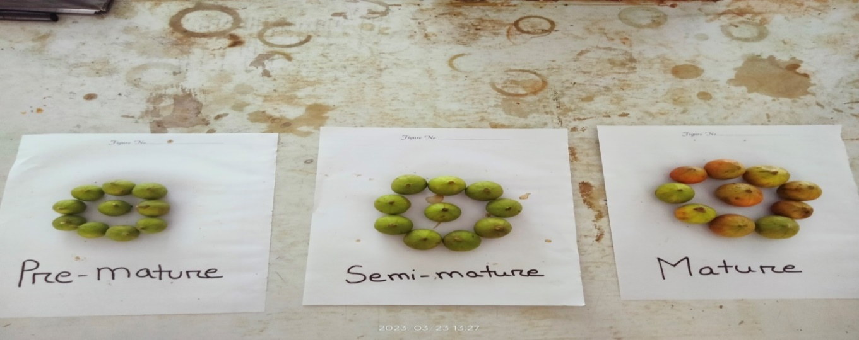
Green Stage | Pre-mature Stage | Mature Stage

Figure 1. Freshly collected three stages of fig fruit

3.4 Duration of Work
The experiment was conducted for a period of months from March to July 2023 approximately.
3.5 Sample Preparation

The fresh fig fruits were washed with clean water then moisture was removed with tissue paper. The fruit was graded according to its firmness, cleanliness, size, maturity, soundness, color, weight, form and absence of extraneous materials, insect damage and mechanical harm. Next, blending was done using a blender and juice was stored in bottles (refrigeration conditioned) for further use and chemical analysis. All experiments were conducted at room temperature and carried out in three replications.

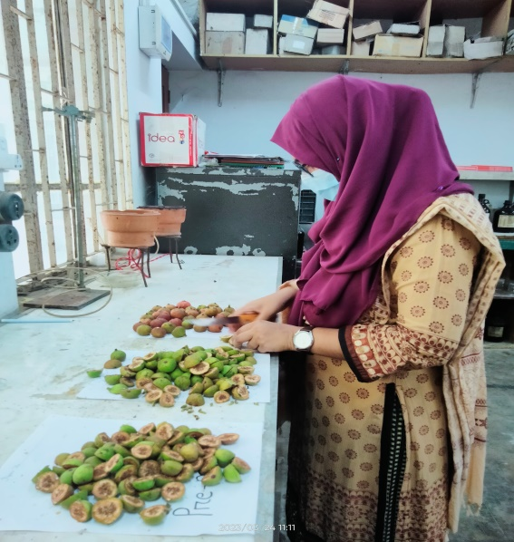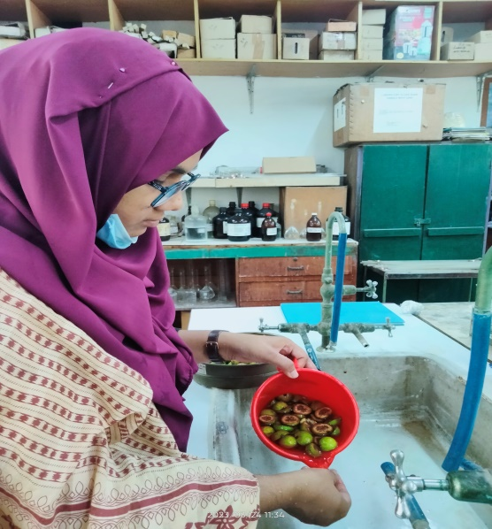
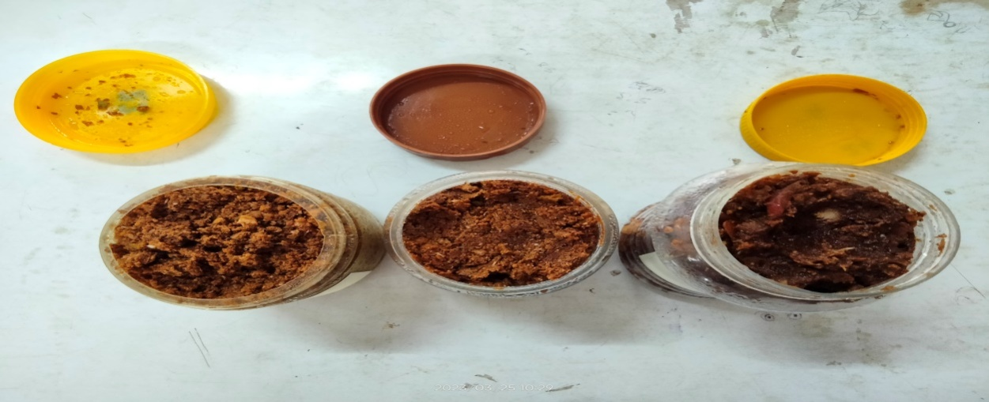
Figure 2. Sample preparation

3.6 Morphological Analysis of Raw Fig
The fruit was analyzed at the Laboratory of Agricultural Chemistry, and Central Laboratory Hajee Mohammad Danesh Science and Technology University, Dinajpur. Morphological analysis was carried out using fruit samples from each of the three stages of fruit.
3.6.1 Measurement of the Length and Width of Fruit
The length of the fruit was measured with a meter scale and the width was measured with a measuring tape and the average size of the fruit.
3.6.2 Weight of Fig Fruits (g)
Fruit samples were weighed using a digital balance and readings for fruit weight (g) were noted.
3.7 Physicochemical Analysis of Raw Fig
3.7.1 Determination of Moisture Content
By using the standard protocol of the Association of Official Analytical Chemists (AOAC), moisture content was calculated (AOAC 2016).
Procedure
Exactly 5.0 g sample was taken in a previously dried crucible. Then the crucible was dried in an oven at 100-105ºC for 24 hrs or more till constant weight. After drying the crucible was removed from the oven and cooled in a desiccators. The crucible was removed from the desiccators and weighed soon after reaching room temperature.
% Moisture = $\frac{Loss of weight}{Weight of sample}×100$
    - Determination of Ash Content
Ash content was prepared by muffle furnace. Asbestos content was assessed using (AOAC, 2016) recommended procedures. The ash content is the inorganic residue that remains following the breakdown of organic materials. Pre-dried, dry crucibles were used to weigh 10 grams of dried jam. Afterwards, it was reduced to charcoal by the fire. The charcoal was then placed in a muffle furnace and heated at roughly 600°C for four hours until all of the charcoal was dissolved. Afterwards, the furnace was opened and the crucible was removed. It was thoroughly dried out in a desiccator and then weighed once it had dried out.

Figure 3. Determination of ash content by muffle furnace

3.7.3 Determination of Fat
Principle: To determine fat content, food samples were dissolved in organic solvents (such as chloroform or methanol) and the filtrate was separated using filtering. The filtrate was placed into separating funnels, and the separated material was then dried to measure the extract and ultimately, the fat content was determined. A soxhlet apparatus was used to determine the crude fat content of the samples according to AOAC (2016) procedures.
    - Determination of protein from plant sample by modified kjeldahl method Principle:
The modified kjeldahl method is used to determine the total nitrogen consisting of organic and ammonium forms. It is a wet oxidation procedure, where complex form of nitrogen in plant protein is converted to nitrogen. Three steps are involved in this method.
- Digestion
- Distillation
- Titration
Apparatus required
- Kjeldahl flask
- Kjeldahl digestion stand
- Conical flask
- Volumetric flask
- Measuring cylinder
- Burette
- Distillation apparatus
- Electrical Balance
Chemical required:
- Sulphuric acid
- Potassium sulphate
- Copper sulphate
- Selenium powder
- Sodium hydroxide
- Boric acid
Preparation of different reagents:
1. 4% Boric acid solution: 20 g Boric acid (H₃BO₃) was taken in a 250 mL beaker and about 150 mL distilled water was added to it then heated until the solution was clear and cooled. The solution cooled was transferred into a 500 mL volumetric flask and was made volume up to the mark with distilled water.
2. Mixed indicator: 0.5 g bromocresol green and 0.1 g methyl red was taken in a 150 mL beaker and 30-40 mL ethanol was added to it and dissolved. Then the solution was transferred into a 100 mL volumetric flask and the volume was made up to the mark with ethanol.
3. 40% sodium hydroxide (NaOH) solution: 400 g NaOH plate was taken in a 500 mL beaker and about 300 mL distilled water was added to it and stirred with a glass rod until dissolved the NaOH and cooled the solution. Then the solution was transferred into a litre volumetric flask and the volume was made up to the mark with distilled water.
4. Standard (0.2 N) sulphuric acid solution: About 200 mL distilled water was taken in a 1000 mL volumetric flask and 5.6 mL conc. sulphuric acid was added to it and made the volume up to the mark with distilled water.
Procedure:
Digestion
1.0 g previously oven dried sample was taken in a digestion flask. 10 g potassium sulphate (K₂SO₄), 0.1 g copper sulphate (CuSO₄), 1.0 g selenium powder and 25 mL conc. H₂SO₄ was added to it and heated until the solution became clear. Then the flask was cooled.
Distillation
After digestion about 300 mL distilled water and 125 mL 40% NaOH solution were added to it. Then the flask was attached quickly to the distillation set and heated the flask continuously. In the meantime a 250 mL conical flask (containing 25 mL of 4% boric acid and 4-5 drops of mixed indicator) was placed at the zet of the condenser. About 150 mL distillate was collected and then titrated with 0.2 N H₂SO₄ solutions.
Titration
The micro burette was filled with 0.01 N HCl until the blue color disappeared. The blank distillation was carried out and titrated.
Calculation:
% Nitrogen $\frac{Titre value ×N ×0.014 ×100}{Weight of sample }$
% Protein Nitrogen 6.25
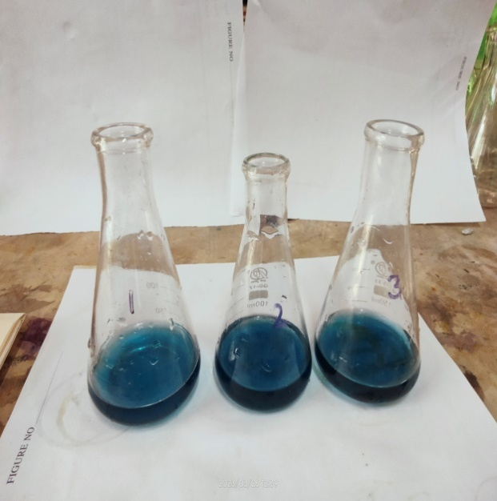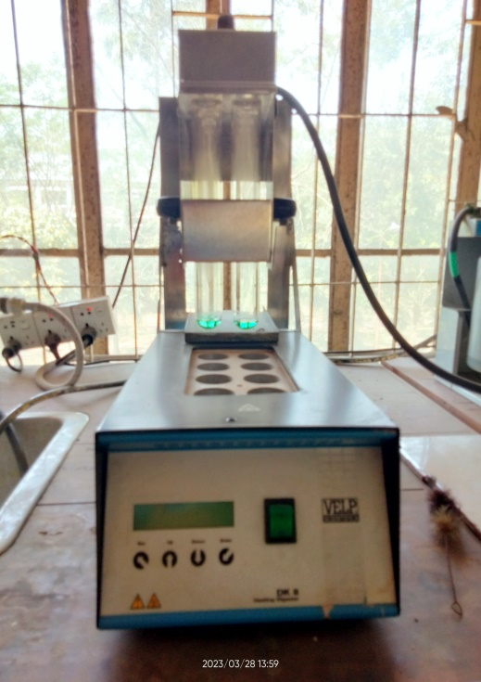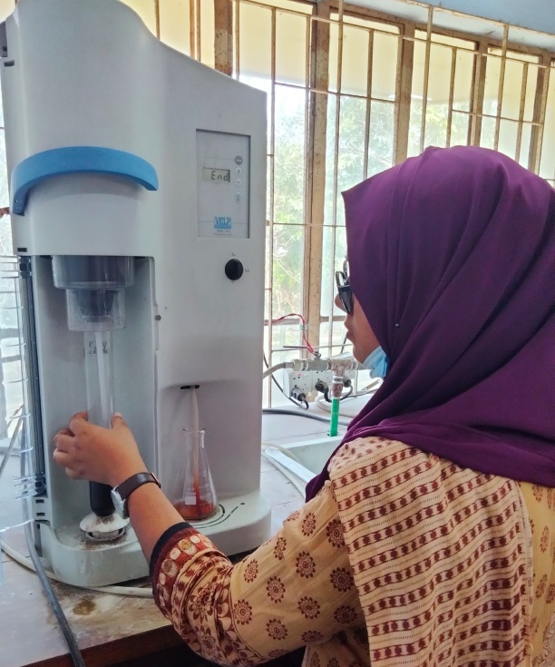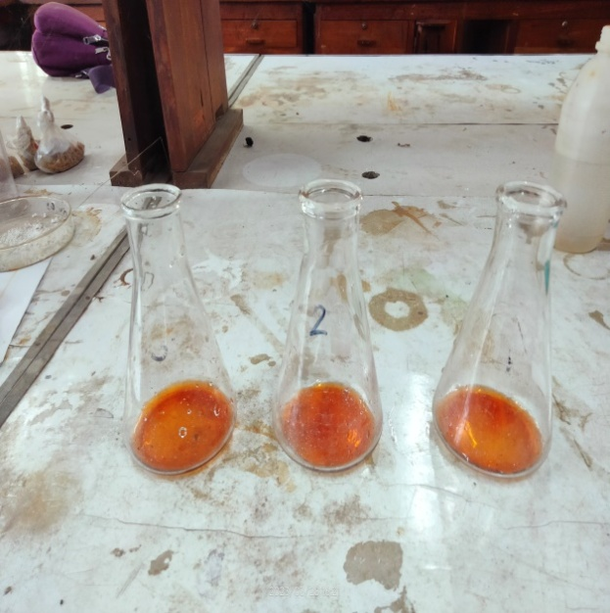
Figure 4. Determination of protein using block digester and auto N- analyzer

3.7.5 Determination of Crude Fiber
Principle: Cellulose, hemicellulose, and lignin make up the majority of crude fiber, a water-insoluble carbohydrate component. Fig fruit samples were digested in a weak acid solution (1.25 percent H₂SO₄) for 30 minutes, followed by a weak alkali solution (1.25 percent NaOH) for 30 minutes, all at constant volume, and the ash in the residue is subtracted to arrive at an estimate. The AOAC (2016) technique was used to determine the crude fiber content. Afterwards, the residue was heated in a muffle furnace (550- 600°C, 4-6 hours) until it was reduced to white ash.
3.7.6 Determination of vitamin C
Vitamin C or L-Ascorbic acid was determined following by the method of Ranganna (1979).
Chemical required:
• Metaphosphoric acid solution: 30 g Metaphosphoric acid dissolved in 80 mL glacial acetic acid then this solution transferred to a 1000 mL volumetric flask and volume up to the mark with distilled water.
• Dye solution: 260 mg 2, 6 di-chlorophenol Indophenol and 210 mg NaHCO3 dissolved in 1000 mL distilled water.
• Standard Vitamin C solution: 100 mg Vitamin C (L-ascorbic acid) dissolved in 1000 mL metaphosphoric acid solution.
Standardization of dye solution:
Exactly 5 mL of standard vitamin C solution was taken in a 100mL conical flask and titrated with dye solution from Burette.
Dye factor $\frac{0.5}{Titrate value}$
Preparation of sample:
Exactly 10 g of fruit sample blended with about 50 mL metaphosphoric solution then it was filtered with white thin cloth and was transferred into a 100 mL volumetric flask and made the volume up to the mark with metaphosphoric acid solution.
Titration with unknown solution:
Exactly 10 mL of fruit sample was taken in a conical flask and titrated with dye solution from Burette.
Vitamin C $\frac{Titratevalue×dyefactor×volumeofsamplemadeup×100}{volumeofsampleused×weightofsample×100}$

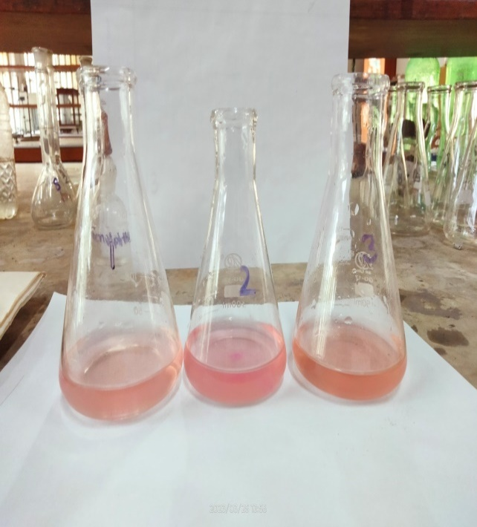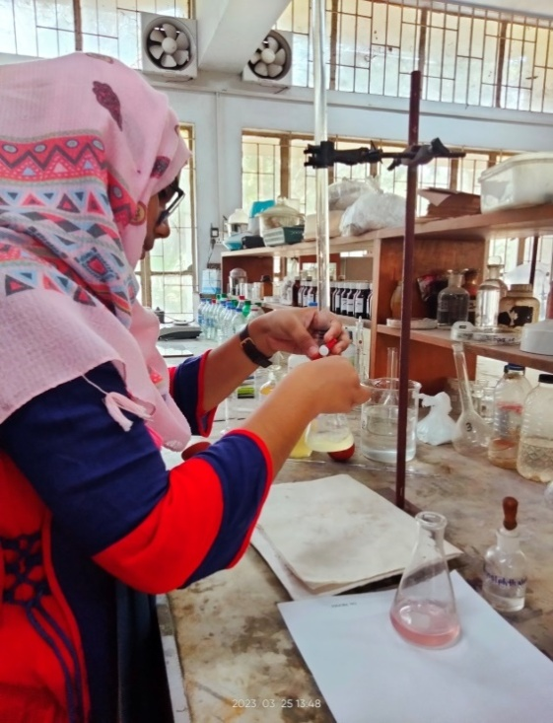

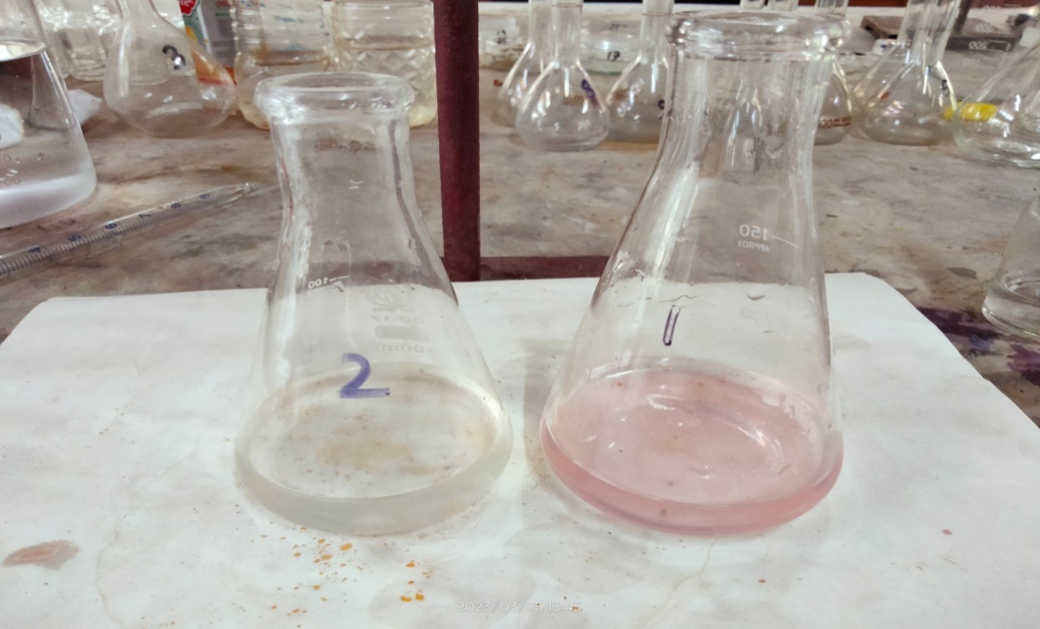

Figure 5. Determination of vitamin C

3.7.7 Determination of Acidity Content
Titratable acidity of fig pulp was determined by the method of Ranganna (1979). The following reagents were used for the determination of titratableacidity.
- Standard NaOH/H₂SO₄ solution (0.1 N).
- Phenolphthalein Indicator.

Preparation of Sample:
Exactly 10 g of fig pulp was taken in a 250 mL beaker 20-25 mL distilled water was added to it and it was blended with a blender then it was filtered with thin cloth then it was transferred in a 100 mL volumetric flask and volume up to the mark with distilled water.
Procedure:
Exactly 10 mL of sample was taken in a conical flask. 2-3 drops of Phenolphthalein Indicator was added to it and titrated with standard NaOH solution from Burette. At the end point pink colour will be appear.
%Titratable acidity =$\frac{T X N X V1 X E X 100}{V2 X W X 1000}$
Where,
T=Titrate value.
N=Normality of NaOH/H₂SO₄.
V₁= Volume made up.
V₂= Volume of extract (used)
E= Equivalent weight of acid /alkali.
W= Weight of sample
The determination of acidity was followed by Srivastava and Sanjeev (2000).
3.7.8 Determination of Sugar
Chemical required:
Fehling A: 69.28 g copper sulphate was dissolved in distilled water. Diluted to 1000 mL filter and stored in amber colored bottle.
Fehling B: 346 g Rochelle salt (potassium sodium tartarate) and 100 g NaOH was dissolved in distilled water. Diluted to 1000 mL filtered and stored in amber colored bottle.
Potassium oxalate solution: 10% potassium oxalate solution was prepared. This reagent was used to remove the excess lead used in clarification.
Lead acetate solution: 20% neutral lead acetate solution was prepared.
Methylene blue Indicator: 1% of methylene blue solution was prepared in distilled water.
      - Determination of Total Sugars
An aliquot of 50 mL of the clarified, de-leaded filtrate was pipetted to a 100 mL volumetric flask. 5 mL concentration HCl allowed standing at room temperature for 24 hours. It was neutralized with conc. NaOH solution followed by 0.1 N NaOH solutions. The volume was made up to the mark and transferred to 50 mL burette having an offset tip and performed the titration on Fehling‟s solution similar to the procedure described in the determination of reducing sugar (AOAC. 2000).
% Total sugar = $\frac{Fehling factor×Dilution×100 }{Weight of sample × Titre }$

3.7.8.2 Determination of Reducing Sugars
It was determined according to the method described by Haq (2012) and Santini et al. (2014) with slight modification. Twenty gram of the fig pulp was crushed in a mortar and pestle then transferred into a 200 mL volumetric flask. The volume was adjusted to 150 mL by adding purified water. After a few minutes to allow the sugar dissolution, 10 mL of lead acetate solution and the minimum amount of potassium oxalate solution were added. The volume of the resulting solution was adjusted to 200 mL, and the solution was shaken, filtered and transferred in a burette for the titration. Five mL of Fehling solution A, 5 mL of Fehling solution B and 40 mL of purified water were transferred in a flask. The solution was heated up to boiling point and the solution was added drop by drop till the nearly complete de-coloration of the Fehling reagent. Two drops of methylene blue was added, and the boiling continued for 3 minutes. The solution from the burette was added till the blue coloration of the indicator disappeared and the solution turned into a red color. Reducing sugar was calculated using the following equation:
% Reducing sugar =$\frac{Fehling factor × Dilution × 100}{Titre ×weight or volume of sample }$
3.7.8.3 Determination of Non-reducing Sugars
% nonreducing sugar % total sugar % reducing sugar

    - Determination of Total Carbohydrate
Total carbohydrate content was determined (Hedge and Hofreiter 1962) by the following procedure. The fresh pineapple fruit sample (100 mg) was taken in a boiling tube and hydrolyzed by keeping it in a boiling water bath for 3.0 h with 5 mL of 2.5 N HCl and cooled to room temperature. It was neutralized with solid sodium carbonate until the effervescence ceases. The volume was made up to 100 mL and centrifuged. The supernatant was collected and aliquots were taken. 4 mL anthrone reagent was added to the aliquots and heated for 8 min in a boiling water bath. It was rapidly cooled and the green to dark green color was read at 630 nm.

    - Determination of Chlorophyll Pigments
Procedure:
About 100 mg fresh sample was taken in a test tube of which 10 mL acetone was added to it and was shaken with a shaker machine for 6 hrs. The absorbance was measured from supernatant at 663 nm, 646 nm, and 470 nm wavelength using UV-VIS spectrophotometer.
Chlorophyll measurement:
For 80% Acetone was done using the following formula,
Chlorophyll _{a} = 12.21 A₆₆₃ – 2.81 A ₆₄₆ (mg /g fresh weight).
Chlorophyll _{b} = 20.13 A ₆₄₆ -5.03 A ₆₆₃ (mg /g fresh weight).
    - Determination of Calcium (Ca)
Chemicals required
- Disodium EDTA
- Sodium Hydroxide (NaOH 10%)
- Calcon Indicator
- Methanol.
- Masking agent:
  - Hydroxylamine hydrogen chloride
  - Potassium ferocyanide
  - Triethanolamine(TEA)

Procedure
Exactly 5 mL of plant extract solution was taken in a 250 mL conical flask. 20 mL distilled water was added into the conical flask and shaken thoroughly.10 drop of each masking agent was added a) Hydroxylamine hydrogen chloride b) Potassium ferocyanide and c) Triethanolamine (TEA). 5 mL NaOH buffer solution was added and shaken thoroughly and then added 5-6 drops calcon indicator into the conical flask and shaken the flask thoroughly. Then it was titrated against 0.01 M Na2-EDTA solution. The titration was continued until pink color of the solution completely turns to pure blue color. The titration was repeated at least 3 times to minimize the error. A blank titration was also conducted by taking all reagent as above except calcium stock solution. 5 mL more distilled water was taken into conical flask instead of calcium solution. Tabulated the data and calculated the amount of calcium by the following formula:
1 mL 1M EDTA ≡ 1mL 1M Ca = 40.08 mg Ca
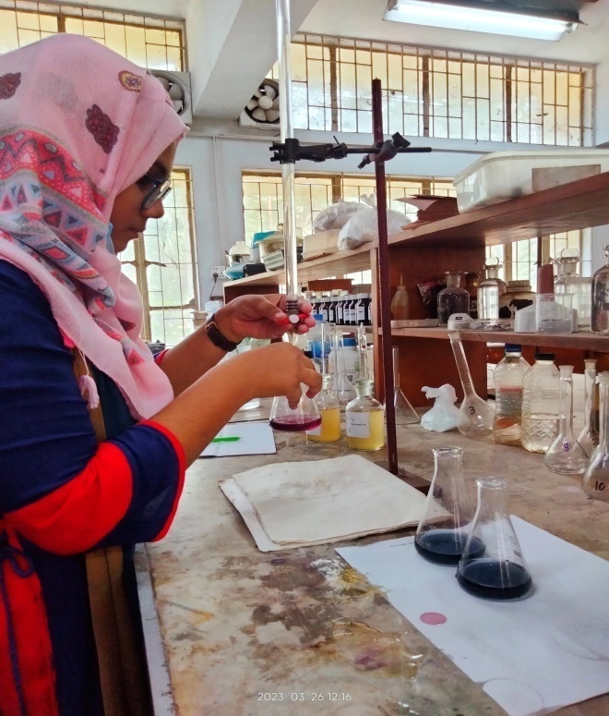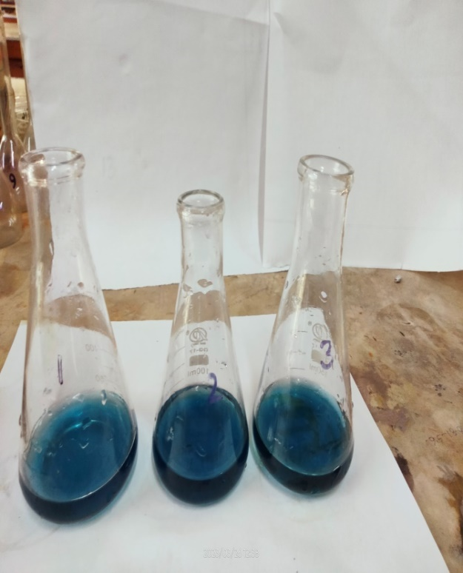

Figure 6. Determination of calcium

3.7.12 Determination of Magnesium
Chemicals required
- Disodium EDTA
- Ammonia ammonium buffer
- EBT Indicator
- Methanol
- Masking agent:
  - Hydroxylamine hydrogen chloride
  - Potassium ferocyanide
  - Triethanolamine (TEA)
  - Sodium tungstate
Procedure
Exactly 5 mL of plant extract solution was taken in 250 mL conical flask. 20 mL distilled water was added into the conical flask and shake thoroughly. 10 drops of each masking agent of (a) Hydroxylamine hydrogen chloride (b) Potassium ferocyanide (c) Triethanolamine (TEA) (d) Sodium tungstate was added. Ammonia ammonium buffer solution and was shaken thoroughly. Add 5-6 drops EBT indicator into the conical flask (depending on the concentration of the indicator solution) and shake the flask thoroughly. Then titrate against 0.01 M Na₂-EDTA solution from burette. The titration was continued until pink color of the solution completely turns to pure blue color. The experiment was repeated at least 3 times. A blank experiment was also conducted by taking all the reagents as above except plant extract solution. Take 5 mL more distilled water into conical flask instead of extract solution. The data was tabulated and calculated the amount of calcium present in the prepared solution.
Formula of Calculation:
1 mL 1M EDTA ≡ 1mL 1M Mg = 24.305 mg M
3.7.13 Determination of Phosphorus
The hypothetical reaction is as follows.
H₃PO₄ + 12H₂MoO₄ -----------> H₃P(Mo₃O₁₀)₄ + 12H₂O

Preparation of Different Reagents
a) Preparation of phosphorus standard series solution: Phosphorus standard solutions was prepared which containing 0.05 ppm P, 0.1 ppm P, 0.2 ppm P, 0.3 ppm P, 0.4 ppm P, 0.5 ppm P and 0.6 ppm P from 2 ppm P standard solution in seven different 100 mL volumetric flask by pipetting 2.5 mL, 5 mL, 10 mL, 15 mL, 20 mL, 25 mL and 30 mL, respectively. The volume was made up to the mark with distilled water in each flask. Then, 4 mL sulphomolybdic acid was added followed by 5-6 drops stannous chloride solution.
b) Preparation of sulphomolybdic acid solution (2.5%): 25 g of ammonium molybdate tetra hydrate (AR grade) was dissolved exactly in 200 mL distilled water and warm it at 60 0C until the solution become clear. Then, exactly 275 mL of concentrated H₂SO₄ (P and as free, AR grade) was diluted to 750 mL with distilled water. After cooling, ammonium molybdate solution was added slowly with constant stirring to H₂SO₄ solution. The volume was made up to 1000 mL mark with distilled water.
c) Preparation of stannous chloride solution: Approximately 5.0 g of stannous chloride was dissolved in 10 mL of concentrated HCl with warming if necessary to dissolve. Diluted the solution to 100 mL with hot distilled water giving about 0.2 M Sn²⁺ ion.
Procedure:
a. Development of molybdophosphoric blue color:
Exactly 5 mL of fig fruit extract solution was taken in a 100 mL volumetric flask. 4 mL of sulphomolybdic acid solution was added to it followed by the addition of distilled water up to 2/3rd volume of the flask. The solution was mixed thoroughly after the addition of 5-6 drops of stannous chloride solution. The volume was made up to the mark with distilled water. The full color was developed intensity within 3-4 minutes and then, read the colored solution instantly in a spectrophotometer at 660 nm wavelength. A blank solution also prepared by taking all the reagents as described except phosphorus solution.
b. Preparation of standard or calibration curve:
A standard or calibration curve was prepared by plotting the absorbance (optical density) of light in Y axis and concentrations of the solutions in X axis in a graph paper. By plotting the spectrophotometer reading on the standard curve, the concentration of test sample (fig fruit extract solution) was easily obtained, X ppm P = X µg P/mL
    - Determination of Total Phenolic Content (TPC)
The Folin-Ciocalteu reagent technique described with minor changes was used to determine the TPC of the extracts (Al-Owaisi et al. 2014). Based on the FolinCiocalteu technique provided by Vergani et al. (2016) with minor adjustments, the Fig jam's total polyphenol content was determined. Falconer tubes were filled with 1.5 mL of FC, and the mixture was incubated for 3 minutes at room temperature. The mixture was then treated with 1.5 cc of 7.5% Na2CO3 for 60 minutes. C2H5OH was used as the blank to measure the absorbance at a wavelength of 765 nm using a UV-VIS spectrometer (UV 2600, Shimadzu Corporation, USA). This compound's total phenolic content (TPC) was determined and is expressed as milligram gallic acid equivalents (GAE/g).

Determination of Reducing power

A spectrophotometric method was used for the measurement of reducing power. Different concentrations of extracts were mixed with 2.5 mL phosphate buffer (0.2 M, pH 6.6) and 2.5 mL of 1% potassium ferricyanide (10 mg mL-1). The mixture was incubated at 50°C for 20 min, then rapidly cooled, mixed with 2.5 mL of 10% trichloroactic acid and centrifuged at 6500 rpm for 10 min. The supernatant (2.5 mL) was mixed with distilled water (2.5 mL) and then ferric chloride (0.5 mL, 0.1%) was added and allowed to stand for 10 min. The absorbance was read spectrophotometrically at 700 nm (Oyaizu 1986). The result expressed as Ascorbic acid equivalent (AAE mg/100 g).
    - Determination of Energy Estimation
The quantity of energy that included in the fig was calculated by first determining how much protein, fat, and carbohydrates were contained in the sample, and then using the following equation to the results (Baer et al. 1997). Energy = (Protein × 4.1) + (Fat × 9.2) + (Carbohydrate × 4.1)
3.8 Statistical analysis:
The data was collected on different parameters under the experiment were statistically analyzed to compare treatment means and standard deviation using the Excel- software program.

CHAPTER 4
RESULTS AND DISCUSSION

The current study on ‘Chemical nutrients and proximate analysis of fig at three stages’ was carried out from March to July 2023. The results obtained from the research were presented and discussed in this chapter under the following headings:
  - Physical analysis of the of Fig fruit
The fruits were cleaned. All experiments were conducted at room temperature and carried out in three replications.
  - Weight of fruit
There was a significant differences in weight of fruits among the three different stages. The average weight of the fig samples is shown in Table 4.1. The findings revealed that the weight of fruit varied from cultivar to cultivar. Figure 4.1 shows that the highest value of 14.74 g was found in the mature stage and the lowest value of 6.72 g was obtained in the green stage. The weight of the pre-mature was 13.02 g. The lowest length (2.19 cm) was found in the green stage and highest length (2.74 cm) was found in mature stage.
Table 2. Physical parameters of fig fruits at three stages fresh weight basis

Stage | Weight/ fresh fruit  (g) | Length/ fresh fruit  (cm) | Diameter/ fresh fruit  (cm)
Green Stage | 6.72b±0.27 | 2.19c±0.10 | 2.37b±0.06
pre-mature | 13.02a±1.09 | 2.52b±0.10 | 2.9a±0.10
Mature | 14.74a±1.25 | 2.74a±0.13 | 3.0a±0.40
Standard Error | 0.794 | 0.102 | 0.179
LSD | 1.942 | 0.249 | 0.437
± indicated the SD of samples, n=3

4.3 Moisture
A variability in moisture content in fig fruit was observed. The moisture content of fig fruit at three stages is revealed in Figure 7. There was a significant variation observed in moisture content among the three stages. The highest moisture content of fig was obtained from the mature stage (90%) and the lowest moisture obtained from the pre-mature stage (81%). The present finding was in good agreed with the result of Bey et al. (2016).

Figure 7. Moisture (%) of different stages of fig
4.4 Ash (%)
A significantly difference in ash content among the stages was found. The percentage ash content of different varieties was found in the range of 0.99% to 1.34%. The maximum value of ash was found in the green stage (1.34%) and the minimum value was found in the mature stage (0.99%) (Figure 8).

Figure 8. Ash (%) of different stages of fig
4.5 Fat
A Statistically significant variation was observed in fat content among the three growth stages. Figure 9 indicated that the highest fat value was found in the green stage (0.12%) and the lowest value was obtained in the mature stage (0.07%).

Figure 9. Fat (%) of different stages of fig
4.6 Protein
Figure 10 showed that significant different in protein among three stages. Changes in protein in different samples are shown in Figure 10. The highest protein content (3.20%) was found in the green stage of fig and the lowest protein content (1.68%) was found in the mature stage of fig. The result showed that as maturity increases, protein content decreases.

Figure 10. Protein (%) of different stages of fig
4.7 Fiber
The amount of fiber contained in the fig fruit collected at three stages is shown in Figure 11. A notable difference in fiber content was observed across the three stages. The highest fiber content was found in the pre-mature stage (6.57%) and the lowest value of fiber content was found in the mature stage (3.90%).

Figure 11. Fiber (%) of different stages of fig
4.8 Vitamin C
Vitamin-C content varied from 4.93 mg/100 g to 9.90 mg/100 g which is presented in Figure 12. A significant variation in vitamin C was noted across the three stages. The highest amount of vitamin C was found in the green stage and the lowest result was found in the mature stage. The amount of green stage was 9.90 mg/100 g and the amount of mature stage was 4.93 mg/100 g. In this study, vitamin C ranged from 4.93 mg/100 g to 9.90 mg/100 g which was lower than the findings of (Arsalan et al. 2020) vitamin C ranged from 25.10 mg/100 g to 40.35 mg/100 g.

Figure 12. Vitamin C (mg/100 g ) of different stages of fig
4.9 Acidity
A significant statistical difference in acidity content was evident among the three stages. The results of this research revealed that acidity varied from 0.48% to 0.64%. Figure 13. showed that the highest acidity was found in the pre-mature stage (0.64%) and the lowest value was found in the mature stage (0.48%).

Figure 13. Acidity (%) of different stages of fig
4.10 Reducing sugar
The reducing sugar content at three stages of the fig samples is illustrated in Figure 14. There was a sigificant variation in reducing sugar content across the three stages. The reducing sugar content was found to be the highest at the mature stage (1.54%) and the lowest value was recorded at the green stage (0.82%).

Figure 14. Reducing sugar (%) of different stages of fig
4.11 Non reducing sugar
A statistically significant difference in non-reducing sugar content was observed across the three stages. Non-reducing sugar content showed slightly significant variation among the fig samples which is shown in Figure 15. The highest non-reducing sugar content was found in the mature stage which is 8.52% and the lowest was recorded in the green stage which value is 3.99%.

Figure 15. Non reducing sugar (%) of different stages of fig
4.12 Total sugar
Figure 16 shows the results of the variation in the total sugar content among the stages. A significant variation in total sugar content was noted among the three stages of growth. The range of total sugar was between 4.81% and 10.06%. The green stage had the lowest total sugar content (4.81%) and the mature stage had the highest total sugar content (10.06%).
Figure 16. Total sugar (%) of different stages of fig

4.13 Carbohydrate
There was statistically significant fluctuation in carbohydrate content among three growth stages. Changes in total carbohydrates at different stages are shown in Figure 17. The maximum carbohydrate value was found in the pre-mature stage (15.93%), and the minimum value was found in the mature stage (6.85%).

Figure 17. Carbohydrate (%) of different stages of fig
4.14 Chlorophyll-a
The chlorophyll-a content of fig fruits at three different stages is shown in Figure 18. A marked variation in chlorophyll-a content was observed among the three stages of growth. Data indicated that the chlorophyll-a content in the green stage (2.35%) was much higher than that of the mature stage (1.03%).

Figure 18. Chlorophyll-a (%) of different stages of fig
4.15 Chlorophyll- b
Significant variation in chlorophyll-b content was noted among the three stages. The results of this research revealed that chlorophyll-b varied from 0.89% to 2.35%. Figure 19 showed that the highest chlorophyll-b value was found in the green stage (2.35%) and the lowest value was found in the mature stage (0.89%).

Figure 19. Chlorophyll-b (%) of different stages of fig

4.16 Nutritional composition of the different stages of fig fruits
Table 3. Nutritional composition of the different stages of fig fruits
Stages | Calcium  mg/100 g (FW) | Magnesium  mg/100 g (FW) | Phosphorus  mg/100 g (FW)
Green stage | 20a±0.4 | 12.13a±0.24 | 22a±0.22
Pre-mature stage | 14.96b±0.23 | 9.07b±0.14 | 20.03b±0.18
Mature stage | 14.9b±0.31 | 6.02c±0.12 | 16.33c±0.26
Standard Error | 0.263 | 0.143 | 0.180
LSD | 0.642 | 0.350 | 0.441
N.B. ± indicated the SD of samples, n=3
4.17 Calcium
The changes in calcium content of different varieties are shown in Table 4.2. The highest content was (20 mg/100 g) at the green stage and the lowest (14.90 mg/100 g) was found at the mature stage.
4.18 Magnesium
The magnesium content of fig fruits collected at different stages is shown in Table 4.2. Results showed that the maximum (12.13 mg/100 g) was in the green stage and the lowest (6.02 mg/100 g) was in the mature stage.
4.19 Phosphorus
The phosphorus content was markedly different in the fig fruit collected at different stages, as shown in Table 4.2. The highest phosphorus content (22 mg/100 g) was found in the green stage and the lowest (16.33 mg/100 g) was in the mature stage. It was evident that phosphorus content varied due to different stages and maturities. As maturity increases, phosphorus content decreases.

4.20 Total Phenol
A statistically significant difference in total phenol content was observed across the three stages. Total phenol content varied from 5.10 mg/100 g to 3.90 mg/100 g as presented in Figure 20. The highest content of total phenol was present in the pre-mature stage (5.10 mg/100 g) and the lowest was in the green stage (3.90 mg/100 g).

Figure 20. Total phenol (mg/100 g FW) of different stages of fig

4.21 Reducing Power
The reducing power of fig fruit samples at different stages is illustrated in Figure 4.15. A considerable variation in reducing power content was noted across the three stages. The results of this research revealed that reducing power varied from 31.14 mg/100 g to 53.53 mg/100 g. Figure 21 showed that the highest reducing power was found in the pre-mature stage (53.53 mg/100 g) and the lowest value was found in the green stage (31.14 mg/100 g).

Figure 21. Reducing power (mg/100 g FW) of different stages of fig
4.22 Energy
Figure 22 shows the results of the variation in energy content among the fig fruit at different stages. A notable difference in energy was observed among the three stages. The range of energy was between 34.72 Kcal/g and 72.83 Kcal/g. The fig fruit of the mature stage had the lowest energy content (34.72 Kcal/g) and the pre-mature stage had the highest energy content (72.83 Kcal/g).

Figure 22. Energy (Kcal/g FW) of different stages of fig

CHAPTER 5
SUMMARY AND CONCLUSION

Fig fruit is a nutritious fruit that is high in trace and macroelements. The research work was accomplished in the laboratory of the Department of Agricultural Chemistry, Hajee Mohammad Danesh Science and Technology University, Dinajpur, for the exploration and evaluation of nutritional value evaluation of the three stages of fig. This study investigates the phytochemical characterization of three stages of fig on the basis of its antioxidant, nutritional and physicochemical characteristics. The parameters including shape and size, ash, fiber content, fat content, protein content, acidity, total sugar, vitamin C and carbohydrate profile percentage are varied in different stages of fig were quantitatively determined. Basic quality parameters like ash, fiber content, fat content, protein content, acidity, total sugar, vitamin C and carbohydrate profile percentage are varied in three different stages of fig. From the data recorded in the current study, it can be observed that the different nutritional percentage have a variance for different stages of fig maturity. On the basis of biochemical analysis, the green stage was found as the highest vitamin C (9.90 mg/100 g) and protein content (3.22%). This stage had lower percent of reducing sugar (0.82%) and non-reducing sugar (3.99%). Mature stage of fig had a good source of total sugar (10.06%), reducing sugar (1.54%) and non reducing sugar (8.52%) but contained lower amount of fiber (3.90%). The lowest source of vitamin C (4.93mg/100 g) was found in mature stage of fig. The highest Ca content (20 mg/100 g) and Mg content (12.13 mg/100 g) were found in green stage. This was also noticed that the highest phosphorus content (22 mg/100 g) was found in green stage of fig. The highest acidity (0.64%) and fiber content (6.57%) was found in pre-mature stage of fig while the lowest carbohydrate content (6.85%) was found in mature stage of fig fruit. Green stage of fig had highest source of ash content (1.34%) and also riches in fat content (0.12%) but the lowest fat content (.07%) was in mature stage of fig.
Now, it may be concluded from the above study that fig fruit collected at three stages were markedly different to each other in shape, size, weight and circumference. Among three stages, green stage was better having higher nutrients compared to pre-mature and mature stage of fig fruit. Thus, green stage can serve as a source of mineral nutrients, protein and lower carbohydrate and sugar content which might be suitable for diabetic patient to address the health issues and nutrient securities.
Currently, more than half of the population in our nation is affected by malnutrition. In these kinds of circumstances, fig fruit might be an excellent source of the nutrients and energy since it is readily accessible in the rural parts of Bangladesh. The comparative nutrient status might help fulfill the demand for food nutrients and increase its use in consumption and the food processing industry.

REFERENCES

Abbasi S, Kamalinejad M, Babaie D, Shams S, Sadr Z, Gheysari M, Askari VR and Rakhshandeh H. 2017. A new topical treatment of atopic dermatitis in pediatric patients based on Ficus carica L. (Fig): A randomized, placebo-controlled clinical trial. Complementary Therapies in Medicine, 35: 85-91.
Ajmal M, Arshad MU, Saeed F, Ahmed T, Khan AU, Bader-ul-Ain H and Suleria HAR. 2016. Exploring the Nutritional Characteristics of Different Parts of Fig in Relation to Hypoglycemic Potential. Pakistan Journal of Life and Social Sciences, 14:115–122.
Akim AM, Ling LC, Rahmat A and Zakaria ZA. 2011. Antioxidant and anti-proliferative activities of fig juice on caov-3, mcf-7, mda-mb-231 and hela cancer cell lines. African Journal of Pharmacy and Pharmacology, 5(7): 957-965.
Alam M, Biozid MS, Faruk M, Abeden MJ, Ferdous KU, Nitul IA and Islam MR. 2020. Anti-oxidant activity of methanolic extract of aquatic flowering plant Nymphaea capensis leaf. Research Square, 1-14.
Allegra A, Alfeo V, Gallotta A and Todaro A. 2017. Nutraceutical content in 'Melanzana' and 'Dottato' fig fruit (Ficus carica L.). Acta Horticulturae, 1173: 319-322.
Amessis-Ouchemoukh N, Ouchemoukh S, Meziant N, Idiri Y, Hernanz D, Stinco CM, Rodríguez Pulido F J, Heredia F J, Madani K and Luis J. 2017. Bioactive metabolites involved in the antioxidant, anticancer and anticalpain activities of Ficus carica L., Ceratonia siliqua L. and Quercus ilex L. extracts. Industrial Crops and Products, 95: 6-17.
Ana B and Gold LS. 2011. Endogenous mutagens and the causes of aging and cancer. Mutation Research, 250: 3–16.
Andreu CT, Sendra E, Hernández F and Cano-Lamadrid M. 2023. Nutritional and functional compounds and antioxidant activity of edible and non-edible fruit part of brebas and figs (Ficus carica L.) among different varieties. Scientia Horticulturae, 318(12): 112069.
AOAC. 2016. Official Methods of Analysis, Association of official Analytical Chemists. International 17th Edition. Washington, D.C.
Ara R, Khan SAKU and Islam M M 2020. Farmers’ Perception on Fig (Ficus carica) Cultivation in Kolaroa and Kaligonj Upazilla of Satkhira. Bangladesh journal of extension education, 32: 28-38.
Aref HL, Salah KB, Chaumont JP, Fekih A, Aouni M and Said K. 2010. In vitro antimicrobial activity of four Ficus carica latex fractions against resistant human pathogens (antimicrobial activity of Ficus carica latex). Pakistan Journal of Pharmaceutical Sciences, 23: 53–8.
Arsalan K, Falak NS, Qamar Z, Muhammad Z, Huzaifa I and Hamid N. 2020. Preparation and Development of Fig Fruit Jam Blended with Different Level of Apple Pulp. Pakistan Journal of Scientific and Industrial Research, 63(2): 105-112.
Arvaniti OS, Samaras Y, Gatidou G, Thomaidis NS and Stasinakis AS. 2019. Review on fresh and dried figs: Chemical analysis and occurrence of phytochemical compounds, antioxidant capacity and health effects. Food Research Institute, 119: 244–267.
Al-Jowari SA, Al-Obaidi SA and Yousif WH. 2011. Effect of Aqueous Extract of Fig (Ficus carica) Fruit on Some Hematological Parameters in Female Rabbits. Baghdad Science Journal, 8(1): 59-65.
Ancos BD, Coca CC, Peña DG and Moreno CS. 2015. Bioactive compounds from vegetable and fruit by-products. Biotechnology of Bioactive Compounds: Sources and Applications, First Edition. Published in 2015 by John Wiley & Sons, Ltd.
Atkinson, FS, Villar A, Mulà A, Zangara A, Risco E, Smidt CR, Hontecillas R, Leber A and Bassaganya-Riera J. 2019. Abscisic Acid Standardized Fig (Ficus carica) Extracts Ameliorate Postprandial Glycemic and Insulinemic Responses in Healthy Adults. Nutrients, 11: 1757.
Badgujar SB, Patel VV, Bandivdekar AH and Mahajan RT. 2014. Traditional uses, phytochemistry and pharmacology of Ficus carica : a review. Pharmaceutical Biology, 52(11): 1487-1503.
Bankeu JJK, Khayala R and Lenta BN. 2011. Isoflavone dimers and other bioactive constituents from the figs of Ficus mucuso. Journal of Natural Products, 74(6): 1370–1378.
Barkaoui M, Katiri A, Boubaker H and Msanda F. 2017. Ethnobotanical Survey of Medicinal Plants Used in the Traditional Treatment of Diabetes in Chtouka Ait Baha and Tiznit (Western Anti-Atlas), Morocco. Journal of Ethnopharmacol, 198: 338–350.
Barolo M, Mostacero NR and López SN. 2014. Ficus carica L. (Moraceae): An ancient source of food and health. Food Chemistry, 164: 119-127.
Basu SK, Thom JE and Acharya SN. 2007. Prospects for Growth in Global Nutraceutical and Functional Food Markets: A Canadian Perspective. Australian Journal of Basic and Applied Sciences, ISSN1991-8178. ©2007, INSI net Publication.
Bey BM and Louaileche H. 2015. A comparative study of phytochemical profile and in vitro antioxidant activities of dark and light dried fig (Ficus carica L.) varieties. Journal of Phytopharmacol, 4 (1):41-48.
Bey MB, Meziant L, Fauconnier M and Richard G. 2016. Effects of sun‐drying on physicochemical characteristics, phenolic composition and in vitro antioxidant activity of dark fig varieties. Food Processing and Preservation, 41(5): 1-8.
Bhatia H, Sharma YP and Manhas RK. 2018. Traditionally used wild edible plants of district Udhampur, J&K. India Journal of Ethnobiol Ethnomed, 1:1–13.
Boffetta P, Couto E, Wichmann J, Ferrari P, Trichopoulos D, Bueno-de-Mesquita HB and Trichopoulou A. 2010. Fruit and vegetable intake and overall cancer risk in the European Prospective Investigation into Cancer and Nutrition (EPIC). Journal of the National Cancer Institute, 102(8): 529-537.
Cruz JM dos A, Ramos AS, Corrêa RF, Sanches EA, Campelo PH, Kinupp VF and Bezerra J de A. 2023. Thermal Treatment and High-Intensity Ultrasound Processing to Evaluate the Chemical Profile and Antioxidant Activity of Amazon Fig Juices. Processes, 11(2): 408.
Cruz JM dos A, Ramos AS, Corrêa RF, Sanches EA, Campelo PH, Kinupp VF and Bezerra J de A. 2022. Ficus spp. fruits: Bioactive compounds and chemical, biological and pharmacological properties. Food Research International, 152: 110928.
Deng RX, Zheng YY, Liu DJ, Liu JY, Zhang MN, Xi GY, Song LL and Liu P. 2024. The effect of ultrasonic power on the physicochemical properties and antioxidant activities of frosted figs pectin. Ultrason Sonochem, 106: 106883.
Debib A, Tir-Touil MA, Meddah B, Hamaidi-Chergui F, Menadi S and Alsayadi MS. 2018. Evaluation of antimicrobial and antioxidant activities of oily macerates of Algerian dried figs (Ficus carica L.). International Food Research Journal, 25(1): 351-356.
Dhanavath S and Katta S. 2016. Proximate and mineral composition of amLa-papaya jam incorporated with honey. International Journal of Agricultural Science and Research (IJASR), 6(6): 317-328.
Diba D, Bultosa G and Tolesa GN. 2017. Effect of maturity stages on nutritive quality and sensory properties of Fig fruits Botswana Journal of Agriculture and Applied Sciences, 12 (1): 15-22.
Duenas M, Perez-Alonso JJ, Santos-Buelga C and Escribano-Bailon T. 2008. Anthocyanin composition in fig (Ficus carica L.). Journal of Food Composition and Analysis, 21(2): 107-115.
Eberhardt MV, Lee CY and Liu RH. 2000. Antioxidant activity of fresh apples. Nature, 405: 903-904.
FAOSTAT. 2016. (Organizacion de las Naciones Unidas para la Agricultura y la Alimentacion, estadisticas). Base de Datos Estadisticos de La FAO. http://faostat.fao.org.
FAOSTAT. 2015. Food Agriculture Organization of the United Nations, Statistics Division (2015 onwards). Crops: Visualize data. URL. http://faostat3.fao.org/browse/Q/QC/E.
FAOSTAT. 2019. Available from: http://www.fao.org/faostat/en/#data/QCL. Félix-Redondo FJ, Grau M and Fernández-Bergés D. 2013. Cholesterol and cardiovascular disease in the elderly. Facts and gaps. Aging and disease, 4(3): 154
Fageria NK and Baligar VC. 2005. Enhancing nitrogen use efficiency in crop plants. Advances in Agronomy, 88 (05): 97–185.
Félix-Redondo FJ, Grau M and Fernández-Bergés D. 2013. Cholesterol and cardiovascular disease in the elderly. Facts and gaps. Aging and disease, 4(3): 154.
Galán AJ, Serradilla MJ, Corrales ML, Moyano SR, Galván AI, Vila LMT and Martín A. 2024. Low-temperature treatments as an alternative to conventional pest control in dried figs and their effect on overall fruit quality. Journal of Stored Products Research, 105(1):102238.
Gani G, Fatima T, Qadri T, Beenish JN and Bashir O. 2018. Phytochemistry and pharmacological activities of fig (Ficus carica): a review. International Journal of Research in Pharmacy and Pharmaceutical Sciences, 3(2): 80-82.
Gozlekci S. 2011. Pomological traits of fig (Ficus carica L.) Genotypes Collected in the West Mediterranean Region in Turkey. The Journal of Animal & Plant Sciences, 21 (4):646–52.
Grubesic R, Vokovic J, Kremer D and Knezevic S. 2007. Flavonoid content assay: prevalidation and application on plantago L. Species. Acta Chimica Slovenica, 54: 397–406.
Guarrera PM. 2005. Traditional phytotherapy in Central Italy (Marche, Abruzzo, and Latium). Fitoterapia, 76(1): 1–25.
Gündeşli MA, Kafkas NE, Güney M and Ercişli S. 2021. Determination of Phytochemicals from Fresh Fruits of Fig (Ficus carica L.) at Different Maturity Stages. Acta Scientiarum Polonorum Hortorum Cultus, 20: 73–81.
Gutiérrez-Soto G, López-Sandin I, Hernández Ochoa JS, Hernadez-Luna CE, Contreras-Cordero JF and Hernández-Martínez CA. 2024. Antagonistic Activity of Macrolepiota sp. CS185 against Post-Harvest Fungi of Fig Fruits (Ficus carica L.). Microbiology Research, 15(1):371-384.
Hajam TA and Saleem H. 2022. Phytochemistry, biological activities, industrial and traditional uses of fig (Ficus carica): A review. Chemical Biology Interactions, 1368(1): 110237.
Hodge JE and Hofreiter BT. 1962. Determination of reducing sugars and carbohydrates. Methods in Carbohydrate Chemistry, 380-394.
Harzallah A, Bhouri AM, Amri Z, Soltana H and Hammami M. 2016. Phytochemical Content and Antioxidant Activity of Different Fruit Parts Juices of Three Figs (Ficus carica L.) Varieties Grown in Tunisia. Industrial Crops and Products, 83: 255–267.
Houda LA, Karima BH, Salah JP, Chaumont AF, Mahjoub A and Khaled S. 2010. In vitro antimicrobial activity of four Ficus carica latex fractions against resistant human pathogens (antimicrobial activity of Ficus carica latex). Pakistan journal of pharmaceutical sciences, 23 (1): 53-58.
Hssaini L, Charafi J and Hanine H. 2019. Comparative analysis and physio-biochemical screening of an ex-situ fig (Ficus carica L.) collection. Horticulture, Environment and Biotechnology, 60(5): 671–683.
Ibrahim TA, El-Hefnawy HM and El-Hela AA. 2010. Antioxidant potential and phenolic acid content of certain cucurbitaceous plants cultivated in Egypt. National Production Research, 24(16): 1537-1545.
Ina K, Sakata K, Tomita L and Isemura M. 2002. Ten components and their function. Kawasaki, Japan.
Irget ME, Aksoy U, Okur B, Ongun AR, and Tepecik M. 2008. Effect of calcium based fertilization on dried fig (Ficus carica L. Cv. Sarılop) yield and quality. Scientia Horticulturae, 118 (4): 308–13.
Jeong MR, Kim HY and Cha JD. 2009. Antimicrobial activity of methanol extract from Ficus carica leaves against oral bacteria. Journal of Bacteriology and Virology, 39(2): 97–102.
Jeong MR, Kim HY and Cha JD. 2009. Antimicrobial Activity of Methanol Extract from Ficus carica Leaves Against Oral Bacteria Journal of Bacteriology and Virology, 39(2): 97 – 102.
Kebal L, Djebli N, Pokajewicz K, Mostefa N and Wieczorek PP. 2024. Antioxidant Activity and Effectiveness of Fig Extract in Counteracting Carbon Tetrachloride-Induced Oxidative Damage in Rats. Molecules, 29(9): 1-23.
Kodandaram R, Mounika J and Jyothi KS. 2014. Utilization of an Underexploited Fruit FIG (Ficus carica) as a Preserved Product. Journal of Agroecology and Natural Resource Management, 1: 78-81.
Kojić AB, Planinić M, Tomas S, Jokić S, Mujić I, Bilić M and velic D. 2011. Effect of Extraction Conditions on the Extractability of Phenolic Compounds from Lyophilised Fig Fruits (Ficus Carica L.). Food and Nutrition Sciences, 61(3): 195-199.
Lansky EP, Paavilainen HM, Pawlus AD and Newman RA. 2008. Ficus spp. (fig): ethnobotany and potential as anticancer and anti-inflammatory agents. Journal of Ethnopharmacology, 119(2): 195-213
Leber A, Hontecillas R, Tubau-Juni N, Zoccoli-Rodriguez V. Goodpaster B and Bassaganya-Riera J. 2020. Abscisic Acid Enriched Fig Extract Promotes Insulin Sensitivity by Decreasing Systemic Inflammation and Activating LANCL2 in Skeletal Muscle. Scientific Report, 10 : 1–9.
Li J, An Y and Wang L. 2020. Transcriptomic Analysis of Ficus carica Peels with a Focus on the Key Genes for Anthocyanin Biosynthesis. International journal of molecular sciences, 21(4):1245.
Lianju W, Weibin J, Kai M, Zhifeng L and Yelin W. 2003. The production and research of fig (Ficus carica L.) in China. Acta Horticulturae, 605 (605): 191–6.
Liu F, Yang Z, Zheng X, Luo S, Zhang K and Li G. 2011. Nematicidal coumarin from Ficus carica L. Korean society of applied entomology, Taiwan entomological society and Malaysian plant protection society. Journal of Asia-Pacific Entomology, 14 (1): 79–81.
Marietta AB, Welshimer KJ and Anderson SL. 2016. Knowledge, attitudes, and behaviors of college students regarding the 1990 Nutrition Labeling Education Act food labels. Journal of the American Dietetic Association, 99(4): 445-449.
Mawa S, Husain K and Jantan I. 2013. Ficus carica L. (Moraceae): phytochemistry, traditional uses and biological activities. Evidence-Based Complementary and Alternative Medicine, 1-8.
Mazhin SA, Zaker MA, Shahbazian HB, Azemi ME and Madanchi N. 2016. Ficus carica Leaves Decoction on Glycemic Factors of Patients with Type 2 Diabetes Mellitus: A Double-Blind Clinical Trial. Jundishapur Journal of Natural Pharmaceutical Products, 11(1): e25814.
Mehraj H, Sikder RK, Haider MN, Hussain MS and Uddin AFM J. 2013. FIG (Ficus carica L.): A new fruit crop in bangladesh. International journal of business, social and scientific research, 1(01): 01-05.
Mendoza-Castillo VM, Vargas-Canales JM, Calderon-Zavala G, Mendoza-Castillo MDC, and Santacruz VA. 2017. Intensive production systems of fig (Ficus carica L.) under greenhouse conditions. Experimental Agriculture, 53(03): 339–50.
Monagas M, Bartolome B and Gomez CC. 2005. Updated knowledge about the presence of phenolic compounds in wine. Critical reviews in food science and nutrition, 45(2): 85-118.
Nicoletti M. 2012. Nutraceuticals and botanicals: overview and perspectives. International Journal of Food Sciences and Nutrition, 63(1): 2-6.
Nicoli MC, Anese M and Parpinel M. 2006. Influence of processing on the antioxidant properties of fruit and vegetables. Trends in Food Science and Technology, 10(3): 94-100.
Nunes SP, Behzad AR, Hooghan B, Sougrat R, Karunakaran M, Pradeep N, Vainio U and Peinemann K. 2011. Switchable pH-Responsive Polymeric Membranes Prepared via Block Copolymer Micelle Assembly. ACS Nano, 5( 5): 3516–3522.
Osvald A and Stirn LZ. 2008. A vehicle routing algorithm for the distribution of fresh vegetables and similar perishable food. Journal of Food Engineering, 85(2): 285-295.
Palmeira L, Pereira C, Dias MI, Abreu MV, Corrêa CG, Pires TCSP, Alves MJ, Barros L and Ferreira ICFR. 2019. Nutritional, chemical and bioactive profiles of different parts of a Portuguese common fig (Ficus carica L.) variety Nutritional, chemical and bioactive profiles of different parts of a Portuguese common fig (Ficus carica L.) variety. Food Research International, 126: 108572.
Patil VV, Bhangale SC, and Patil VR. 2010. Studies on immunomodulatory activity of Ficus carica. International Journal of Pharmacy and Pharmaceutical Sciences, 2 (4): 97–9.
Petkova N, Ivanov I and Denev P. 2019. Changes in phytochemical compounds and antioxidant potential of fresh, frozen, and processed figs (Ficus carica L.). Department of Organic Chemistry and Inorganic Chemistry, University of Food Technologies, Bulgaria. International Food Research Journal, 26(6): 1881- 1888.
Pineda-Pineda J, Avitia-Garcıa E, Castillo-Gonzalez AM, Corona-Torres T, Valdez-Aguilar LA and Gomez-Hernandez J. 2008. Macronutrimental extraction in red raspberry. Terra Latinoamericana, 26 (4): 333–340.
Rama V. 2019. Consumption of functional foods and knowledge about them by people of different ages in kosovo. Knowledge International Journal, 35(3): 939-942.
Rangana S. 1979. Manual Analysis of Fruits and Vegetables Product. Tata McGraw Hill
Rasool IF, Aziz A, Khalid W, Koraqi H, Siddiqui SA, AL-Farga A, Lai W and Ali A. 2023. Industrial Application and Health Prospective of Fig (Ficus carica) By-Products. Molecules, 28(3): 960.
Rodr´ ıguez-Ruiz M, Mateos RM, Codesido V, Corpas FJ and Palma JM. 2017. “Characterization of the galactono-1,4 lactone dehydrogenase from pepper fruits and its modulation in the ascorbate biosynthesis. Role of nitric oxide,” Redox Biology, 12: 171–181.
Ross JA and Kasum CM. 2002. Dietary flavonoids: bioavailability, metabolic effects, and safety. Annual Review of Nutrition, 22: 19-34.
Sadia H, Ahmad M, Sultana S, Abdullah AZ, Teong LK, Zafar M and Bano A. 2014. Nutrient and mineral assessment of edible wild fig and mulberry fruits. Fruits, 69 (2): 159–66.
Saeed MA, and Sabir AW. 2005. Trace elements in the fruit of Ficus carica L. and their nutritional importance. Hamdard Medicus (Pakistan), 48: 113–7.
Salehi B, Prakash MA, Nigam M, Karazhan N, Shukla I, Kiełtyka-Dadasiewicz A, Sawicka B, Głowacka A, Abu-Darwish MS, Hussein TA, Gadetskaya AV, Cabral C, Salgueiro L, Victoriano M, Martorell M, Docea AO, Abdolshahi A, Calina D and Sharifi-Rad J. 2021. Ficus plants: State of the art from a phytochemical, pharmacological, and toxicological perspective. Phytotherapy Research, 35(3):1187-1217.
Sandhu AK, Islam M, Edirisinghe I and Burton-Freeman B. 2023. Phytochemical Composition and Health Benefits of Figs (Fresh and Dried): A Review of Literature from 2000 to 2022. Nutrients, 15(11): 2623.
Schreiner M and Huyskens-Keil S. 2006. Phytochemicals in fruit and vegetables: health promotion and postharvest elicitors. Critical reviews in plant sciences, 25(3): 267-278.
Seeram NP, Schutzki R, Chandra A and Nair MG. 2002. Characterization, quantification, and bioactivities in anthocyanins in Cornus species. Journal of Agricultural and Food Chemistry, 50: 2519–2523.
Şen F, Aksoy U, Özer KB, Can HZ, Köseoğlu İ and Konak R. 2017. Impact of yearly conditions on major physical and chemical properties of fresh, semi-dried and sun-dried fig (Ficus carica L. 'Sarılop') fruit. International Society for Horticultural Science, 1173: 309-314.
Shah M, Dureshehwar M, Abdul S AA, Adnan S and Hina. 2019. A Diabetes Mellitus Can Be Treated and Prevented by Figs. International Journal of Research in Pharmacy and Biosciences, 6: 33–36.
Shahidi F. and Ambigaipalan P. 2015. Phenolics and polyphenolics in foods, beverages and spices: Antioxidant activity and health effects – A review. Journal of Functional Foods, 18: 820-897.
Shamkant B, Patel VV, Bandivdekar AH and Mahajan RT. 2014. Traditional uses, phytochemistry and pharmacology of Ficus carica: A review. Pharmaceutical Biology, 52: 1487-1503.
Shi Y, Mon AM, Fu Y, Zhang Y, Wang C, Yang X and Wang Y. 2018. The genus Ficus (Moraceae) used in diet: Its plant diversity, distribution, traditional uses and ethnopharmacological importance. Journal of Ethnopharmacology, 226: 1-196.
Shukranul M, Khairana H and Ibrahim J. 2013. Ficus carica L. (Moraceae): Phytochemistry, Traditional Uses and Biological Activities. Hindawi Publishing Corporation Evidence-Based Complementary and Alternative Medicine, 1-8.
Silva EM, Souza JNS, Rogez H, Rees JF and Larondelle Y. (2004). Antioxidant activities and polyphenolic contents of fifteen selected plant species from the Amazonian region. Food Chemistry, 101(3): 1012-1018.
Slatnar A, Klancar U, Stampar F and Veberic R. 2011. Effect of Drying of Figs (Ficus carica L.) on the Contents of Sugars, Organic Acids, and Phenolic Compounds. Agricultural Food Chemistry, 59(21):11696-11702.
Snee LS, Nerurkar VR, Dooley DA, Efird JT, Shovic AC and Nerurkar PV. 2011. Strategies to improve palatability and increase consumption intentions for Momordica charantia (bitter melon): a vegetable commonly used for diabetes management. Nutrition, 10: 78.
Solomon A, Golubowicz S, Yablowicz Z, Grossman S, Bergman M, Gottlieb HE and Flaishman MA. 2006. Antioxidant activities and anthocyanin content of fresh fruits of common fig (Ficus carica L.). Journal of Agricultural and Food Chemistry, 54(20): 7717-7723.
Soltana H, Tekaya M, Amri Z, El-Gharbi S, Nakbi A. Harzallah A, Mechri B and Hammami MB. 2016. Characterization of fig achenes’ oil of Ficus carica grown in Tunisia. Food Chemistry, 196: 1125-1130.
Soni N, Mehta S, Satpathy G and Gupta RK. 2014. Estimation of nutritional, phytochemical, antioxidant and antibacterial activity of dried fig (Ficus carica). Journal of Pharmacognosy and Phytochemistry, 3(2): 158-165.
Srivastava AK. 2011. An Overview of Designer Functional and Health Foods. Chemical Analysis of Value-Added Dairy Products and Their Quality Assurance, p5.
Srivastava AK and Singh IS. 2000. Genetic variability in jackfruit. IPGRI Newsletter for Asia, the Pacific and Oceania, 3(1): 22-23.
Stover E, Aradhya M, Ferguson L and Crisosto C. 2007. The fig: Overview of an ancient fruit. HortScience, 42 : 1083–1087.
Sumanth MV, Srinivasulu B, Swarajya LK, Krishna VPS and Padmaja VV. 2022. Study of physico-chemical parameters and shelf life of fresh fruits of fig (Ficus carica L.) cv. Deanna harvested at different maturity stages. The Pharma Innovation Journal, 11(9): 285-288.
Tanwar B, Andallu B and Modgil R. 2014. Influence of processing on physicochemical, nutritional and phytochemical composition of Ficus carica L. (fig) products. Journal of Dairying, Foods and Home Sciences, 33: 37–43.
Vallejo F, Marín JG and Tomás-Barberán FA. 2012. Phenolic compound content of fresh and dried figs (Ficus carica L.). Food Chemestry, 130: 485–492.
Vaya J and Mahmood S. 2006. Flavonoid content in leaf extracts of the fig (Ficus carica). BioFactors, 28(3-4):169-75.
Vargas-Canales, JM, Castillo-Gonzalez AM, Pineda-Pineda J, Ramırez-Arias JA and Avitia-Garcıa E. 2014. Nutrient extraction of tomato (Solanum lycopersicum L.) in mixtures of volcanic rock with fresh and recycled sawdust. Revista Chapingo Serie Horticultura, 20 (1): 71–88.
Veberic R and Mikulic-Petkovsek M. 2016. Phytochemical Composition of Common Fig (Ficus carica L.) Cultivars. In Nutritional Composition of Fruit Cultivars; Academic Press: Cambridge, MA, USA, 235–255.
Veberic R, Colaric M and Stampar F. 2008. “Phenolic acids and flavonoids of fig fruit (Ficus carica L.) in the northern Mediterranean region,” Food Chemistry, 106 (1): 153–157.
Vergani L, Vecchione G, Baldini F, Voci A, Ferrari PF, Aliakbarian B and Perego P. 2016. Antioxidant and hepatoprotective potentials of phenolic compounds from olive pomace. Chemical Engineering Transactions, 49: 475-480.
Vinson JA, Zubik L, Bose P, Samman N and Proch J. 2005. Dried fruits: excellent in vitro and in vivo an-tioxidants. Journal of the American College of Nutrition, 24(1): 44-50.
Wang CJ, Wang JM, Lin WL, Chu CY, Chou FP and Tseng TH. 2000. Protective effect of Hibiscus anthocyanins against tert-butyl hydroperoxide-induced hepatic toxicity in rats. Food and chemical toxicology, 38(5): 411-416.
Wang G, Wang H, Song Y, Jia C, Wang Z and Xu H. 2004. Studies on anti-HSV effect of Ficus carica leaves. Zhong Yao Cai, 27: 754-6.
Watkins C. 2008. The Market for Functional Foods. Inform. 6: 378-380.
Wojdyło A, Nowicka P, Carbonell-Barrachina ÁA and Hernández F. 2016. Phenolic compounds, antioxidant and antidiabetic activity of different cultivars of Ficus carica L. fruits. Journal of Functional Foods, 25: 421-432.
Wu HY, Yang KM and Chiang PY. 2018. Fig anthocyanins: Antioxidant properties and stability to heat and pH. Molecules, 23(6): 1357.
Yahia EM. 2017. The contribution of fruit and vegetable consumption to human health. Fruit and Vegetable Phytochemicals, 3-51.
Yemis O, Bakkalbas E and Artik N. 2012. Changes in pigment profile and surface colour of fig (Ficus carica L.) during drying. International Journal of Food Science and Technology, 47(8): 1710–1719.
Zangara, A. 2018. Effect of a Novel Ficus carica (Fig) Fruit Extract Standardized in Abscisic Acid on the Glycemic and Insulinemic Responses in Healthy Human Subjects. Diabetes, 67: 791.
Zhang YJ, Gan RY, Li S, Zhou Y, Li AN, Xu DP and Li HB. 2015. Antioxidant phytochemicals for the prevention and treatment of chronic diseases. Molecules, 20(12): 21138-21156.
Zocchi E, Hontecillas R, Leber A, Einerhand, A, Carbo A, Bruzzone S, Tubau-Juni N, Philipson N, Zoccoli-Rodriguez V and Sturla L. 2017. Abscisic Acid: A Novel Nutraceutical for Glycemic Control. Frontiers Nutrition, 4: 24.

