Exploring the Genomic Analysis and Growth-Promoting Abilities of Endophytic Bacterium Serratia sp. strain HSTU-BF1R4: Enhancing Tomato Plant Growth Performance in Field

A THESIS BY

Md. Shah Mokhdum Badsha Student ID: 2205035
Session: 2022-2023

MASTER OF SCIENCE (M.S.) IN
BIOCHEMISTRY AND MOLECULAR BIOLOGY



Exploring the Genomic Analysis and Growth-Promoting Abilities of Endophytic Bacterium Serratia sp. strain HSTU-BF1R4: Enhancing Tomato Plant Growth Performance in Field

A THESIS BY
Md. Shah Mokhdum Badsha Student ID: 2205035
Session: 2022-2023

Submitted to the Department of Biochemistry and Molecular Biology, Hajee Mohammad Danesh Science and Technology University, Dinajpur-5200
In partial fulfillment of the requirement for the degree of

MASTER OF SCIENCE (M.S.) IN
BIOCHEMISTRY AND MOLECULAR BIOLOGY

Exploring the Genomic Analysis and Growth-Promoting Abilities of Endophytic Bacterium Serratia sp. strain HSTU-BF1R4: Enhancing Tomato Plant Growth Performance in Field

A THESIS BY

Md. Shah Mokhdum Badsha Student ID: 2205035
Session: 2022-2023
Approved as to style and contents by

Supervisor

Prof. Dr. Md. Yeasin Prodhan
Professor Department of Biochemistry and
Molecular Biology
Co-supervisor

Dr. Md. Azizul Haque
Associate Professor Department of Biochemistry and
Molecular Biology

Professor Dr. Mst. Nur-E-Nazmun Nahar
Chairman
Examination Committee and Chairman Department of Biochemistry and Molecular Biology

HAJEE MOHAMMAD DANESH SCIENCE AND TECHNOLOGY

ACKNOWLEDGEMENTS
All the praises and gratitude are due to the omnipotent Almighty Allah, who has kindly enabled the author to complete the research and thesis successfully with knowledge for the degree of Master of Science in Biochemistry and Molecular Biology from Hajee Mohammad Danesh Science and Technology University (HSTU), Dinajpur within the appointed time.

The author wishes to convey his cordial respect and pleasant appreciation to his respected supervisor Dr. Md. Yeasin Prodhan, Associate professor, Department of Biochemistry and Molecular Biology, Hajee Muhammad Danesh Science and Technology University (HSTU), Dinajpur, Bangladesh, for his scholastic supervision, precious suggestion, and continuous encouragement during the entire period of this research work.

The author is extremely delightful to express his heartfelt respect, and profound appreciation to his benevolent research co-supervisor, Dr. Md. Azizul Haque, Associate professor, Department of Biochemistry and Molecular Biology, Hajee Mohammad Danesh Science and Technology University, Dinajpur. for his valuable assistance and indispensable guidance throughout the period of this research work.

The author thankful to The World Academy Sciences (TWAS), Swedish International Agency (SIDA) and UNESCO for funding advanced collaborative research project Grant award_ 22- 020 RG/BIO-OTH/AS_CG. To Dr. Md. Azizul Haque(co-supervisor).

The author thankful to honorable Chairman and all the other respected teachers in the Department of Biochemistry and Molecular Biology, Hajee Mohammad Danesh Science and Technology University, Dinajpur for their valuable teaching, sympathetic co-operation and inspiration throughout the period of the study. Also, cordial thanks to all the stuffs of the Dept. of Biochemistry and Molecular Biology of HSTU lab for their cooperation to complete the research work.

The author also thankful to his respected elder brothers Al-Amin Hossain Shitol & Gautam Debnath for help to strain isolation.

The author expresses his sincere appreciation to his beloved parents, well-wisher’s, classmates, senior and junior brothers and sisters for their inspiration, help and encouragement throughout the study.

The Author June, 2023 HSTU, Dinajpur

ABSTRACT

Endophytic bacteria that reside within plants without causing any harm to the host have a variety of beneficial effect on plant growth and productivity. This study was aimed to isolate and characterization of new endophytic bacteria as well as to observe its growth effect on tomato plant in fields. Therefore, bacteria isolate from eggplant roots were characterized by biochemical and genomic analysis. The genome of Serratia sp. HSTU-BF1R4 consists of one single 5134367 bp chromosome, with an average 59.6% GC content and 4922 predicted protein coding DNA sequences (CDS), 86 RNAs. The isolated bacterium exhibited an array of growth- promoting attributes, including the presence of genes responsible for nitrogen fixation, siderophore production, 1-aminocyclopropane-1-carboxylate (ACC) deaminase activity, indole-3-acetic acid (IAA) synthesis sulfur metabolism, phosphate metabolism, and other growth-promoting genes. Additionally, it displayed significant stress tolerance capabilities. Genomic analysis such as Average Nucleotide Identity (ANI), DNA-DNA Hybridization (DDH), whole-genome phylogenetic tree analysis, conclusively indicated that the strain belonged to a new species of Serratia. The application of Serratia sp. in seed gemination HSTU-BF1R4 increase germination percentage, seeding length, shoot &root length compare to Tc. The foliar application of Serratia sp. HSTU-BF1R4 on tomato plants significantly improved their growth such as root length, shoot length, leave length, branch no, flower no and fruits no compare to Tc. This research introduces a new endophytic bacterium with promising agricultural applications. The strain's remarkable growth-promoting traits and stress tolerance abilities present an exciting avenue for sustainable and eco-friendly agricultural practices. Also, the genetic insights into Serratia sp. strain will increase valuable knowledge to the field of microbiology

TABLE OF CONTENTS

Chapter |  | Title | Page No
 |  | ACKNOWLEDGEMENTS | i
 |  | ABSTRACT | ii
 |  | LIST OF CONTENTS | iii
 |  | LIST OF TABLES | viii
 |  | LIST OF FIGURES | ix
 |  | LIST OF ABBREVIATIONS | x
I | INTRODUCTION |  | 1-4
 |  | Objectives | 4
II | REVIEW OF LITERATURE |  | 5-10
 | 2.1 | Endophytic bacteria | 5-6
 | 2.2 | Plant growth promoting (PGP) traits | 6-9
 | 2.3 | Whole genome sequence | 9-10
III | MATERIALS AND METHODS |  | 11-32
 | 3.1 | Bacterial sample source collection and isolation | 11
 | 3.2. | Morphological & Biochemical characterization | 11
 | 3.3 | Biochemical characterization | 12
 | 3.3.1 | Catalase test | 12
 | 3.3.2 | Oxidase test | 12
 | 3.3.3 | Methyl Red (MR) Test | 12
 | 3.3.4 | Voges-Proskauer (VP) | 13
 | 3.3.5 | Triple Sugar Iron (TSI) test | 13
 | 3.3.6 | Citrate Utilization Test (CIU) | 14

 | 3.3.7 | Motility Indole Urease (MIU) Test | 14
 | 3.3.8 | Urease test | 15
 | 3.3.9 | Fermentation of sugar: lactose, maltose, sucrose, dextrose | 15
 | 3.4.1 | DNA extraction, Library preparation, whole genome sequencing | 16
 | 3.4.2 | DNA Extraction | 16
 | 3.4.2.1 | DNA concentration measurement | 17
 | 3.4.3 | Library Preparation | 17
 | 3.4.3.1 | Tagmentation of Genomic DNA | 17
 | 3.4.3.2 | Post Tagmentation Cleanup | 17
 | 3.4.3.3 | Amplify Tagmented DNA | 19
 | 3.4.3.4 | Clean Up Libraries | 19
 | 3.4.3.5 | Concentration measure of DNA | 20
 | 3.4.3.6 | Check Libraries | 20
 | 3.4.3.8. | Normalize Libraries | 21
 | 3.4.3.9 | Pool Libraries | 22
 | 3.4.3.9 | Denaturing and Diluting Libraries and PhiX Control for sequencing | 23
 | 3.4.3.9.1 | Denature and Dilute Libraries Prepare Hybridization Buffer | 23
 | 3.4.3.9.2 | Dilute Library to Loading Concentration | 23
 | 3.4.3.9.3 | Denature Diluted Library | 23
 | 3.4.3.9.4 | Denature and Dilute PhiX Control | 24
 | 3.4.3.9.5 | Dilute PhiX to 4 nM | 24
 | 3.4.3.9.6 | Denature PhiX | 24
 | 3.4.3.9.7 | Dilute Denatured PhiX to Loading Concentration | 24
 | 3.4.3.9.8 | Combine Library and PhiX Control | 24

 | 3.4.4 | Preparing Sequencing Consumables | 25
 | 3.4.4.1 | Prepare the Reagent Cartridge | 25
 | 3.4.4.2 | Prepare the Reagent Cartridge | 25
 | 3.4.4.3 | Prepare the Flow Cell | 25
 | 3.4.4.4 | Performing a Run on the MiSeq | 26
 | 3.4.4.5 | Load Libraries onto the Reagent Cartridge | 26
 | 3.4.5 | Set Up a Run | 26
 | 3.4.5.1 | Log in to Local Run Manager | 26
 | 3.4.5.2 | Select Available Run | 26
 | 3.4.5.3 | Load the Flow Cell | 26
 | 3.4.5.4 | Load the Reagent Cartridge | 27
 | 3.4.5.5 | Confirm Run Parameters | 27
 | 3.4.6 | Review Automated Check | 27
 | 3.4.7 | Viewing Analysis Results in Local Run Manager | 28
 | 3.4.8 | Analysis Report | 28
 | 3.4.8.1 | Analysis Output Files | 28
 | 3.5 | Strain identification and classification | 29
 | 3.5.1 | Average nucleotide identity (ANI) | 29
 | 3.5.2 | Phylogenetic Tree | 29
 | 3.5.3 | DNA-DNA hybridization (DDH) | 30
 | 3.6 | Genome comparison | 30
 | 3.6.1 | Multiple genome sequence alignment
 | 3.6.2 | Pangenome | 30
 | 3.7 | Plant growth promoting activity tests | 31
 | 3.7.1 | Indole acetic acid test | 31
 | 3.7.2 | Phosphate solubilization test | 31

 | 3.7.3 | Nitrogen fixation test | 31
 | 3.8 | Growth promoting effect of Tomato plant by Serratia sp. HSTU-BF1R4 | 32
 | 3.8.1 | Germination effect on tomato seeds | 32
 | 3.8.2 | Field experimentation | 32
IV | RESULTS |  | 33-75
 | 4.1. | Biochemical characterization | 33
 | 4.1.1 | Catalase Test | 33
 | 4.1.2 | Oxidase Test results | 33
 | 4.3.3 | Methyl Red (MR) Test results | 34
 | 4.3.4 | Methyl Red (vp) Test results | 35
 | 4.1.5 | Triple Sugar Iron Agar (TSI) Test | 35
 | 4.1.6 | Citrate Utilization test | 36
 | 4.1.7 | Urease test | 37
 | 4.2 | Fermentation of sugar: lactose, maltose, sucrose, dextrose Results | 38
 | 4.3 | Evaluation of growth promoting activity in the laboratory by the Serratia sp. HSTU-BF1R4 | 39
 | 4.3.1 | Phosphate solubilization test | 39
 | 4.3.2 | Nitrogen fixation test | 39
 | 4.3.3 | Indole-3-acetic acid (IAA) test | 40
 | 4.4 | Growth promoting results | 41
 | 4.4.1 | Seed germination effect on tomato seeds | 41
 | 4.4.2 | Field experimentation results | 41
 | 4.5 | Genomic features of strain Serratia sp. HSTU-BF1R4 | 43
 | 4.6 | Venn diagram analysis | 45
 | 4.7 | Taxonomic classification | 46

 | 4.7.1 | Phylogenetic tree | 46
 | 4.7.2 | Average nucleotide identity (ANI) | 48
 | 4.7.3 | DNA-DNA hybridization (DDH) test | 50
 | 4.8 | Comparative genomics study | 51
 | 4.8.1 | Multiple genome alignment | 51
 | 4.8.2. | Pan-genomic analysis | 52
 | 4.9 | List of some identified plant growth promoting genes traits from RAST | 53
 | 4.9.1 | Effective gene of phosphate metabolism | 53
 | 4.9.2 | Effective genes of IAA production | 55
 | 4.9.3 | Effective genes of trehalose metabolism | 57
 | 4.9.4 | Effective genes of H2S production & sulfur assimilation | 58
 | 4.9.5 | Effective genes of superoxide dismutase | 59
 | 4.9.6 | Effective genes of chemotaxis | 60
 | 4.9.7 | Effective genes of heavy metal resistance | 61
 | 4.9.8 | Effective genes of nitrogen fixation | 63
 | 4.9.9 | Effective genes of siderophore production | 65
 | 4.9.10 | Heat shock proteins | 67
 | 4.9.11 | Cold shock proteins | 68
 | 4.9.12 | Flagellar protein | 69
 | 4.10 | Others Plant growth promoting and several stress tolerating genes | 70
 | 4.11 | Pesticide degrading genes | 75
V | DISCUSSION |  | 78-80
VI | CONCLUSION |  | 81
 | REFERENCES |  | 82-88

LIST OF TABLES

Table No | Title | Page No
1. | TSI result evaluation parameters | 14
2. | MIU result evaluation parameters | 15
3. | Germination percentage, root length, shoot length, seedling of tomato plant with the strain at 7 days of seed plantation | 41
4. | Effect of bacterium and fertilizer in different time period among different treatment group | 42
5. | Genome features and annotation statistics of Serratia sp. HSTU- BF1R4 | 44
6. | Average Nucleotide Identity (ANI) (%) based on whole genome alignments | 48
7. | Digital DNA-DNA hybridization (dDDH) for species determination depends on whole genome sequences BF1R4 | 50
8. | phosphate metabolism gene and their locus tag, CDS &product | 54
9. | Genes of IAA production | 56
10. | Genes of trehalose metabolism | 58
11. | H2S production and sulfur assimilation genes and their location | 59
12. | Genes of superoxide dismutase | 60
13. | Chemotaxis genes with locus tag | 61
14. | Heavy metal genes with locus tag | 62
15. | Effective genes of nitrogen fixation | 64
16. | Siderophore producing genes and their location | 66
17. | Respective genes of heat shock protein in the Serratia sp. HSTU- BF1R4 genome | 67
18. | Respective genes of Cold shock protein in the Serratia sp. HSTU- BF1R4 genome | 69
19. | Respective genes of Flagellar protein in the Serratia sp. HSTU- BF1R4 genome | 70
20. | Genes involved in Plant growth promoting and several stress tolerating genes | 71
21. | Pesticide degrading associated genes | 75

LIST OF FIGURES

FIGURE  NO | TITLE | PAGE  NO
1 | Catalase Test | 33
2 | Oxidase Test | 34
3 | Methyl Red (MR) Test | 34
4 | Voges-Proskauer (VP) Test | 35
5 | Triple Sugar Iron Agar (TSI) Test | 36
6 | Citrate Utilization test | 37
7 | Urease test | 37
8 | Fermentation test result | 38
9 | Phosphate solubilization test | 39
10 | Nitrogen fixation test | 40
11 | Indole-3-acetic acid (IAA) test | 40
 | After 80 days of plantation enhancement of vegetative growth of tomato plant by Serratia sp. HSTU-BF1R4 application | 43
12 | Growth comparison of tomato plant | 44
13 | Subsystem of the RAST annotation | 45
14 | The genomic map of the strain Serratia sp. HSTU-BF1R4 | 45
15 | Venn diagram of Serratia sp. HSTU-BF1R4 predicted essential amino acid sequence | 46
16 | The phylogenetic tree based on whole genome of Serratia sp. HSTU-BF1R4 strain with closely related whole genome strains | 47
17 | Multiple genome analysis of Serratia sp. HSTU-BF1R4 with other closely related strains. The same color module represents the homologs region. Good homology of the strain Serratia sp. HSTU-BF1R4 and other serratia-sp. were shown. | 52
18 | Pangenome analysis of Serratia sp. HSTU-BF1R4 strain with | 53

LIST OF ABBREVIATIONS

PGPB | plant growth-promoting bacteria
g | Gram
ml | Millilitre
µl | Microlitre
g/L | Gram per litre
mg/ml | Milligram per millilitre
ng/µl | Nanogram per microlitre
et al | And others
n.d | No date
pH | Negative logarithm of Hydrogen ion concentration
rpm | Revolutions per minute
V | Volt
U/ml | Units per millilitre
U/mg | Units per milligram
RNA | Ribonucleic acid
DNA | Deoxyribonucleic acid
bp | Base pair
kb | Kilobase pair
NCBI | National Centre for Biotechnology Information
BLAST | Basic Local Alignment Search Tool
°C | Degree Celsius
(NH4)2SO4 | Ammonium sulphate
MgSO4·7H2O | Magnesium sulphate heptahydrate
KH2PO4 | Monopotassium phosphate
CaCl2 .2H2O | Calcium chloride dihydrate
NaH2PO4 | Monosodium phosphate
Na2HPO4 | Disodium phosphate
NaOH | Sodium hydroxide
HCl | Hydrochloric acid
NaCl | Sodium chloride

DNS | 3,5- Dinitrosalicylic acid
Alk. CuSO4 | Alkaline copper sulphate
nm | Nanometer
Psi | Per square inch
dNTP | Deoxynucleotide triphosphate
M | Molar
mM | Millimolar
N | Normal
EDTA | Ethylenediaminetetraacetic acid
UV | Ultra violet
RFLP PFGE | Restriction Fragment Length Polymorphism Pulsed Field
GEL.E | Gel Electrophoresis
ND | Nano Drop
PCR | Polymerase Chain Reaction
RFP | Restriction Fragment Length Polymorphism
SDSPAGE SP | Sodium Dodecyl Sulphate Polyacrylamide Gel
ELS | Electrophoresis Species
TAE | Tris Acetate EDTA
TBE | Tris Borate EDTA
KDa | Killo Daltone
NA | Nutrient Agar media
cm-1 | Per centimeter
Alk. CuSO4 | Per square inch
Psi | Deoxynucleotide triphosphate
dNTP | Deoxynucleotide Triphosphate

CHAPTER- I INTRODUCTION
Agriculture worldwide is confronting significant challenges arising from the combined impacts of population growth, climate change, and the widespread use of chemical and organic fertilizers (Delgado et al., 2014). As a response to these challenges, plants have the remarkable ability to choose their microbiome, including beneficial colonizers known as plant growth- promoting bacteria. Among these beneficial bacteria, endophytes hold particular importance as they play a crucial role in the development and growth of various plants, even under diverse and challenging conditions such as extreme temperatures, salinity, heavy metal exposure, and drought (Hardoim et al., 2015). The global population steadily increasing, the demand for food is rising sharply, placing immense pressure on agricultural systems to produce more food to meet the growing needs. However, the expansion of agriculture often results in the clearing of natural habitats, leading to a loss of biodiversity and environmental degradation. climate change poses a significant threat to agriculture. Altered weather patterns, extreme weather events, and shifting growing seasons can negatively impact crop yields and disrupt food production systems. Water scarcity, exacerbated by climate change, further intensifies the challenges faced by farmers, as adequate water resources are crucial for successful crop cultivation. The promotion of plant growth by plant growth-promoting bacteria (PGPB) is attributed to their direct or indirect interactions with plants, as highlighted by (Glick, 1995). PGPB encompasses not only bacteria residing in the rhizosphere (the soil region surrounding plant roots) but also endophytes, which inhabit the interior tissues of the plant.
Endophytic bacteria, in particular, possess a noteworthy trait their ability to colonize and establish residence within plant tissues. This unique characteristic holds great promise, as research has demonstrated that endophytic bacteria are highly effective in promoting the growth, health, and overall development of plants compared to rhizospheric bacteria (Aghdam and Brown, 2021).
A genus of rod-shaped facultatively anerobic, gram-negative bacteria knows as serratia belong to the Yersiniaceae family (Khanna, KhAnnA and AggArWAl, 2013).As of 2020,19 species of serratia are credibly documented with precise names ,according to the list of prokaryotic names with standing Nomenculture (LPSN): S. aquatilis, S. entomophila, S. ficaria, S. fonticola,
S. grimesii, S. liquefaciens, S. marcescens, S. microhaemolytica, S. myotis, S. nematodiphila,
S. odoriferae, S. oryzae, S. plymuthica, S. proteamaculans, S.

Plant-associated in the rhizosphere, Serratia include both endophytes and free-living species (Hallmann et al., 1997). Several S. marcescens isolates encourage the growth of the host plant and offer defense against fungi diseases (Li et al., 2015) (Wei, 1996). Many isolates, including S. marcescens NBR11213 & S. marcescens TRS-1, are hostile to fungal infections, can solubilize phosphate and generate IAA (Guo et al., 2004).
By residing within the plant, endophytic bacteria forge a closer and more intimate relationship with their host (Strobel, 2018). This proximity allows them to interact closely with the plant's physiological processes, influencing nutrient uptake, hormone regulation, and stress responses. As a result, endophytic bacteria can efficiently enhance plant growth and offer greater benefits to the host plant compared to bacteria restricted to the rhizosphere.
The role of endophytic bacteria in optimizing plant growth and health makes them a valuable asset in sustainable agricultural practices. Leveraging the potential of these beneficial microorganisms holds significant promise in bolstering agricultural productivity and resilience, especially in the face of challenges posed by population growth, climate change, and conventional agricultural practices (Abegunde, Sibanda and Obi, 2019).
Additionally, the endophytic bacteria can help the plant by giving it with nutrients including sulfur, iron, and phosphate as well as nitrogen sources (by converting air nitrogen into ammonia). By controlling the physiology and phytohormones of the host plant, these microorganisms can defend their hosts from harmful attacks (Bach et al., 2016). When applied to seeds, plant surfaces, or soil, a biofertilizer is a solution with living microorganisms that colonies the rhizosphere or the interior of plant cells and promotes plant growth by improving the availability and supply of primary nutrients to the host plant (Vessey, 2003).
Bacteria, fungi, algae, cyanobacteria etc. are the primary sources of biofertilizers. Biofertilizers are organic compounds that increase soil fertility by utilizing various microorganisms and stains. Bio-fertilizers are crucial for maintaining environmentally friendly methods of sustaining crop development, nitrogen fixation, and yield loss under various stress circumstances. Because these bacteria come into close touch with the plants, they may have greater ecological advantages than epiphytic and rhizospheric bacteria, making their use an effective method for stabilizing and enhancing crop yield (James, 2000).
In recent years there has been a growing interest in the use of endophytic bacteria for promoting plant growth and enhancing agricultural productivity. Endophytic bacteria are microorganisms

that reside within the tissues of plants without causing any harm to the host. These bacteria have been found to have a variety of beneficial effects on plants including the ability to fix nitrogen solubilize phosphate produce plant growth hormones like indole-3-acetic acid (IAA) and enhance nutrient uptake (Hardoim et al., 2015).
The family Serratia is known to harbor many endophytic bacteria with plant growth promoting properties. These bacteria have been isolated from different ecological niches and have shown tight biochemical and genetic relationships (Glick, 1995). Among them Serratia sp. HSTU- BF1R4 was identified as an endophytic bacterium isolated from brinjal root in this study.
In order to gain a better understanding of the potential benefits of Serratia sp. HSTU-BF1R4 for plant growth promotion a comprehensive analysis was conducted. The biochemical and molecular characterization of this bacterium was performed which provided insights into its metabolic capabilities and genetic makeup (Haque et al., 2022). The complete genome sequence of Serratia sp. HSTU-BF1R4 was also obtained and analyzed to identify and characterize the specific genes involved in plant growth promotion.
To assess the plant growth promoting potential of Serratia sp. HSTU-BF1R4 a series of plant growth promoting tests (PGPT) were conducted. These tests included measuring various growth parameters such as root shoot and leaf length of plants inoculated with Serratia sp. HSTU-BF1R4.Additionally the presence of plant growth promoting genes such as those involved in nitrogen fixation phosphate solubilization and IAA production was investigated (Ahmad et al., 2019).
In the present study, one endophytic bacterium HSTU-BF1R4 was isolated from Eggplant root. The stain HSTU-BF1R4 was identified as a member of the Enterobacteriaceae family and given the name Serratia sp. HSTU-BF1R4 based on the examination of its entire genome and phylogenetic tree (Lafi et al., 2017). Numerous genes from the Enterobacteriaceae family are found in various natural settings and have close biochemical and genetic affinities.
We present an analysis of biochemical and molecular characterization, plant growth promoting test (PGPT), complete genome sequence, growth promoting activity check by root length, shoot length, leaf length, flower no and fruits no and plant growth promoting genes such as nitrogen fixing, phosphate solubilizing, and IAA producing etc.
The findings of this study will contribute to our understanding of the plant growth promoting capabilities of Serratia sp. HSTU-BF1R4 and provide valuable insights for the development

of sustainable agricultural strategies. Harnessing the potential of endophytic bacteria like Serratia sp. HSTU-BF1R4 can offer a promising alternative to chemical fertilizers and pesticides leading to more environmentally friendly and economically viable agricultural practices.
In conclusion this thesis aims to elucidate the biochemical and molecular characterization of Serratia sp. HSTU-BF1R4 evaluate its plant growth promoting activity and identify the key genes involved. The findings of this research will contribute to the existing knowledge on endophytic bacteria and their potential application in sustainable agriculture.

The specific objectives are

- To isolate a plant growth boosting bacterium from eggplant root
- To assess molecular identification by whole genome sequencing and analysis.
- To analyze the plants growth promoting related (PGP) genes and other biotic & abiotic stress gene
- To demonstrate the role of newly isolated endophytic bacteria in field condition.

CHAPTER- II REVIEW OF LITERATURE

3.1. Endophytic Bacteria

In 1926, researchers first described endophytic growth as a distinct stage of bacterial development, wherein bacteria establish a close and mutually beneficial relationship with plants. Endophytic bacteria are now characterized as bacteria obtained from surface-sterilized plant tissues, and they exhibit a remarkable trait of not causing any evident harm to their host plants. These bacteria can reside within various parts of the plant, both aboveground and underground, including seeds, thereby exerting a positive influence on plant development. By occupying the plant endosphere, they find a unique and protected ecological niche, offering a stable and undisturbed environment, unlike the fluctuating conditions that affect rhizospheric and epiphytic bacteria (Lugtenberg, 2016).
Furthermore, most endophytic bacteria display a biphasic life cycle, shifting between the plant and soil environments, allowing them to adapt and thrive in both settings (Lugtenberg, 2016). Plants can be seen as intricate ecosystems hosting a vast diversity of microorganisms in various niches. Among these niches are the internal tissues, where endophytic microorganisms reside without causing any harm to the host plant (Kumar et al., 2013).
Plant-associated microorganisms play a crucial role in nutrient cycling and act as a defense against the harmful effects of phytopathogens. These interactions between plants and microorganisms typically occur in two main areas: the rhizosphere (root zone) and within the plant tissues. Microorganisms that complete a part of their life cycle inside the plant tissues without causing any noticeable symptoms in the host plant are referred to as bacterial endophytes (Rangjaroen et al., 2014).
Plants form beneficial associations with microorganisms to thrive in their natural environments. Plant-beneficial bacteria are a diverse group that offers numerous advantages to their host plants, aiding them in coping with various biotic and abiotic stresses that may impede their growth. These bacteria can reside both externally and internally within their host plants. Endophytic bacteria, in particular, have been extensively studied and characterized in various plant hosts, ranging from agronomic crops to wild and perennial plants, even those growing in extreme environments. They have been isolated from different plant parts, including above-

ground tissues like shoots, stems, leaves, seeds, fruits, and below-ground tissues like roots, where the majority of bacterial endophytes are found.
Endophytic microbes play a significant role in the production of bioactive compounds, such as alkaloids, steroids, terpenoids, peptides, polyketones, flavonoids, quinols, phenols, and the natural insecticide azadirachtin. These bioactive compounds have applications in agriculture, industry, and medicine, further highlighting the importance of endophytic bacteria in various fields (Kusari et al., 2013). Additionally, endophytic bacteria possess potential due to their capacity to produce plant growth hormones, solubilize phosphate, and acquire nutrients and fix nitrogen (Kusari et al., 2013).

2.2. Plant growth promoting (PGP) traits

In the current agricultural landscape, the predominant focus remains on utilizing chemical pesticides and inorganic fertilizers. However, due to growing concerns about their environmental impact and sustainability, there has been a compelling drive to explore alternative methods that can enhance soil fertility and crop production while meeting the increasing demands of a growing global population. As a result, natural agricultural practices have gained significant priority as they hold the potential to pave the way towards environmentally sustainable development.
Sustainable agriculture is envisioned as an integrated system of plant production that maximizes the utilization of nonrenewable resources, seamlessly incorporates natural biological cycles, and, over the long term, fulfills human food and fiber requirements. By embracing sustainable agricultural practices, there is a strong emphasis on improving environmental quality, ensuring the economic viability of farm operations, and ultimately enhancing the overall quality of life for farmers, ranchers, and society as a whole(Mahaffee and Kloepper, 1994).Throughout history, the use of endophytic bacteria to promote plant growth in agriculture has been a longstanding practice. Ancient farmers, in their quest for improved crop productivity, discovered the benefits of employing endophytic bacteria by blending various soils and applying them as inoculants to seeds. This ancient wisdom laid the foundation for harnessing the potential of these beneficial microorganisms in enhancing agricultural yields. Subsequently, a significant milestone in the history of agricultural innovation occurred when the first patent ("Nitragin") was officially registered for plant inoculation with Rhizobium sp. This marked a pivotal moment in the utilization of beneficial

microorganisms for enhancing plant growth, further advancing the field of agricultural science(Bashan, 1998).
In recent times, there has been a surge of interest in exploring the potential of various bacterial genera, including Bacillus, Flavobacterium, Acetobacter, Serratia, and Delftia. These bacteria have been predominantly isolated from different sources like the rhizosphere, non-rhizosphere soil, and rhizoplane. The primary focus of these evaluations has been to determine their efficacy as plant growth promoting bacteria, as they offer promising benefits for enhancing crop productivity and overall plant health (Macdonald, 1989).
Plant growth-promoting bacteria form a diverse group with the capability to effectively colonize the root system of plants, leading to improved plant nutrition, stress tolerance, and overall health (Vacheron et al., 2013).However, it was found that the presence of these endophytic microorganisms, in some situations, may impact the in vitro propagation of specific species of trees. Endophytic bacteria often have favorable effects on the plant propagation process (Ulrich, Stauber and Ewald, 2008). It has become vital to comprehend how endophytic bacteria affect plant development. Plant growth-promoting (PGP) compounds are metabolites made by endophytic bacteria that promote plant development (Afzal et al., 2019). Some endophytic bacteria's PGP characteristics can develop through direct or indirect methods(Santoyo et al., 2016). The direct mechanism relates to bacteria's ability to speed up nutrient absorption or control plant endogenous hormone levels (Vacheron et al., 2013b). Some indigenous bacteria also have an indirect impact on plant growth by reducing the harm caused by infections with phytopathogens (Vacheron et al., 2013). Plants are regarded as complex ecosystems with a Brobdingnagian diversity of microorganisms occupying various niches. Such niches encompass inside tissues where endophytic microorganisms reside without causing any harm to the host (Kao et al., 2003). Proteobacteria made about 90% of the endophytic communities, followed by Actinobacteria (1.5%), Planctomycetes (1.4%), Verrucomicrobia (1.1%), and Acidobacteria (0.5%). Pseudomonas, Bacillus, Burkholderia, Stenotrophomonas, Bacteria genus Pantoea, Microbacterium, etc. are among the commonly seen endophytic microbe genera. All of those genera commonly inhabit the rhizosphere as well (Haque et al., 2022). Endophytic microorganisms play a vital role in nutrient cycling and act as a defense against phytopathogens, preventing their negative impact. These microorganisms contribute to plant growth by producing and releasing plant growth regulators, exhibiting antagonistic activity against nitrogen fixation, and facilitating biologically essential nitrogen fixation (Tejera et al., 2005). Consequently, endophytic bacteria play a crucial part in

promoting sustainability within crop production systems (Tejera et al., 2005).Plants and animals have co-evolved with a diverse array of microorganisms, which play crucial roles in various aspects of their health and development. In the case of animals, the gut microbiota has been extensively studied and shown to have a significant impact on immunity and gut development (Dunbar et al., 1999).These microorganisms aid in nutrient digestion, produce essential vitamins, and contribute to the overall well-being of the host.
Similarly, plants also form associations with beneficial microorganisms, particularly endophytic bacteria, which reside within the internal tissues of the plant without causing any visible signs of infection or harm to the host (Glick, 1995). Endophytes are known to promote plant growth and development through various mechanisms. They can enhance nutrient uptake, produce growth-promoting substances like phytohormones, improve stress tolerance, and protect the plant from pathogens. Endophytic bacteria have been found in various plant species, and their positive effects on plant health have sparked interest in their potential applications in agriculture. These beneficial microorganisms offer an eco-friendly alternative to chemical fertilizers and pesticides, contributing to sustainable agricultural practices. Approximately 300,000 plant species inhabit the Earth, with each of them serving as a host to one or more endophytes (Bacon and Hinton, 2006).
Plant growth regulators are organic substances with the ability to regulate plant growth, and they can be either produced endogenously within the plant or applied externally. These regulators exert their effects on physiological and morphological processes even at very low concentrations (Arshad and Frankenberger Jr, 1997).
Numerous microorganisms have the capacity to produce essential plant growth regulators like auxins, cytokinin’s, gibberellins, ethylene, or abscisic acid. Among these, bacteria primarily synthesize indole acetic acid (IAA) using an alternate tryptophan-dependent pathway through indole pyruvic acid. However, the specific impact of bacterial IAA on plant growth is yet to be fully understood. The enhancement of root growth is a significant indicator used to measure the beneficial effects of plant growth-promoting bacteria (Glick, 1995). Root establishment, achieved through primary root elongation or the proliferation of lateral and adventitious roots, offers young seedlings a valuable advantage. It enhances their ability to anchor themselves to the soil and absorb water and nutrients from the environment, thereby increasing their chances of survival. Many plants Growth-Promoting Bacteria (PGPB) have the capacity to synthesize IAA, and their impact on plants closely resembles that of externally applied IAA.

In the soil's entire microbial population, Phosphate Solubilizing Bacteria (PSB) make up 1 to 50%, while Phosphorus Solubilizing Fungi (PSF) constitute only 0.1 to 0.5% of the P solubilizing potential. Within the bacterial communities in the rhizosphere, strains belonging to Pseudomonas, Bacilli, and endosymbiotic Rhizobia have been identified as effective phosphate solubilizers. The most potent P solubilizers include strains from bacterial genera such as Pseudomonas, Bacillus, Rhizobium, and Enterobacter, along with Penicillium and Aspergillus fungi. Notably, Bacillus megaterium, B. circulans, B. subtilis, B. polymyxa, B. sircalmous, Pseudomonas striata, and Enterobacter are among the most significant and influential strains in this context (Khan et al., 2009).A significant portion of Phosphorus Solubilizing Microorganisms (PSM) is found in the rhizosphere, where they exhibit higher metabolic activity compared to other sources. The release of root exudates, including organic ligands, can influence the concentration of phosphorus in the soil solution. Moreover, these microorganisms not only participate in phosphorus solubilization but also contribute to the enhancement of plant growth by increasing the availability of other essential trace elements, such as iron (Fe) and zinc (Zn). Nitrogen serves as a crucial constituent of amino acids and proteins. Although nitrogen is abundant in the atmosphere, only specific organisms, such as microbes, can utilize atmospheric nitrogen and supply it to their host organisms, insects, or plants through symbiotic or nonsymbiotic interactions, in the form of inorganic nitrogen. The process of nitrogen fixation is essential in supplying organisms with fixed N2. Biological nitrogen fixation (BNF) involves the conversion of atmospheric nitrogen into ammonia(Khan, 2008).

2.3. Whole genome sequence.

Whole-genome sequencing has emerged as a valuable diagnostic tool with diverse applications in the field of microbiology. In England, it has replaced culture as the first-line antimicrobial susceptibility test for Mycobacterium tuberculosis, significantly improving the accuracy and efficiency of diagnosing and predicting resistance in this pathogen.
While the potential for resistance prediction using sequencing extends to other pathogens such as Enterobacterales or Neisseria gonorrhoeae, consistent error rates have yet to meet regulatory standards for commonly used antibiotics. However, sequencing has proven its worth in reference laboratories, particularly in confirming resistance mechanisms, as exemplified in the most resistant case of N. gonorrhoeae infection documented to date (Unemo and Shafer, 2014).

Furthermore, sequencing offers a powerful tool for identifying virulence mechanisms, enabling researchers and clinicians to gain crucial insights into the pathogenicity of various microbes (Smieszek et al., 2018). Genome-wide association studies (GWAS) offer a powerful approach to identify genetic factors associated with virulent phenotypes in various pathogens. For instance, in the case of S. aureus, GWAS has been instrumental in revealing the key determinant of pyomyositis, which is the Panton-Valentine leucocidin. By utilizing this method, researchers can uncover the specific genetic variants that contribute to the development of virulent traits, thereby deepening our understanding of the pathogenic mechanisms and potential targets for therapeutic interventions. High-quality sequencing studies have historically demanded specialized laboratory expertise and intricate bioinformatics workflows. Interpreting sequencing results also necessitates considering relevant contextual factors, such as the reproducibility of sequencing, its inherent error rates, and the distribution and patterns of genetic variations linked to recent transmission events. While direct identification of transmission events may be feasible in smaller outbreaks with clearly defined chains of transmission, it becomes more challenging in cases of endemic or widespread epidemic diseases, where multiple potential sources for each infection exist (Lumley et al., 2021).
In addition to detecting new variants of the virus that may be associated with increased transmissibility, virulence, or immune evasion, sequencing holds promise for future applications in monitoring and identifying resistance to SARS-CoV-2 therapeutics. This surveillance could be instrumental in tailoring treatments for individual patients based on their specific viral profiles (Nadin-Davis and Fehlner-Gardiner, 2019).

CHAPTER- III MATERIALS AND METHODS
This section illustrates every method that was used to complete the theses, including bacterial strain isolation, biochemical and molecular characterization, NGS sequence analysis, identification of key genes, and a study into the biological processes behind these genes' actions.

Bacterial sample source collection and isolation:

From the farm next to the Hajee Mohammad Danesh Science and Technology University (HSTU), Dinajpur, Bangladesh, the healthy brinjal eggplant plant with good quality roots was harvested. The acquired material was subsequently brought right away to the HSTU Biochemistry and Molecular Biology lab. The endophytic and containing bacteria was isolated by the following ways: Firstly, the root were cut from the plant and the eggplant roots sample was washed out by running tap water. Then it was surface sterilized by 70% ethanol for 1 minute then with 0.01% mercuric chloride for 5 minute and also followed by 0.5% Sodium chloride for 5 minutes. Finally, it was treated with sterile distilled water for 5 times and then the roots sample was cut down into small pieces. Then the sample was macerated separately in phosphate buffer of pH 7.2 with a sterile pestle and mortar. After that the sample was spread on Pikovskaya‘s (PKV) agar medium plate. Then the plate was incubated at 37°C for 24 hours. Finally, the bacterial isolate was picked from plates and purified by streaking techniques and incubated at 37°C. A number of biochemical tests were conducted for cultural and morphological characterization. The isolate was kept on agar plats at 4◦C for further analysis. Furthermore, the isolate was preserved in 80% (v/v) glycerol at −20°C (Haque et al., 2022).

Morphological & Biochemical characterization:

The selected bacterial strains were differentiated based on their metabolic pattern by using different biochemical tests including catalase, oxidase, MR-VP, TSI, Citrate utilization, Indole, MIU and Individual sugar fermentation tests (dextrose, lactose, maltose and sucrose) (Robert et al., 2018). Morphological features were identified by growing the isolated cultures on the minimal nutrient media (composition: (NH4)2SO4, 0.1%, KH2PO4, 0.05%; K2HPO4, 0.05%; CaCl2, 0.01%; NaCl, 0.01%; MgSO4.7H2O, 0.02%; yeast extract, 0.1%, and cellulose, 0.2%).

Biochemical characterization:

    - Catalase test:

The selected bacterial isolates were tested for the presence of catalase enzyme by adding 3% H2O2 into a small amount of bacterial colony on a clean glass slide. A positive catalase test provides rapid production of bubbles indicating catalase utilization by the isolate. A negative result indicates the absence of catalase enzyme. This test identifies members of Enterobacteriaceae family which are catalase positive (Bergey, 1994).

Oxidase test:

The selected isolates underwent an Oxidase test to determine their ability to utilize cytochrome c oxidase, an enzyme involved in the electron transport chain (Bergey, 1994). To conduct the test, a clean filter paper was positioned on a petri dish, and a drop of oxidase reagent (1% tetramethyl-p-phenylenediaminedihydrochloride) was placed onto the filter paper. A small amount of the bacterial pure culture from the selected isolates was then streaked onto the oxidase droplet using an inoculating loop.
The observations were made within a time frame of 10-30 seconds after adding the reagent. Positive results were indicated by the formation of a deep blue or dark purple color. Oxidase positive bacteria are classified as aerobic organisms capable of using oxygen as their terminal electron acceptor.

Methyl Red (MR) Test:

A pure culture of endophytic bacteria was used to inoculate a tube of Glucose Phosphate Peptone Water (GPPW) broth. The inoculated broth was then incubated at a temperature of 28±2°C for a period of 2-5 days.
After the incubation period, 5 drops of Methyl Red (MR) reagent were directly added to the broth. The appearance of a stable red color indicated a positive test result, indicating the presence of specific metabolic byproducts. On the other hand, a yellow or intermediate orange color development indicated a negative result.
By observing the color change in the GPPW broth after the addition of the Methyl Red reagent, it was possible to determine whether the tested bacteria exhibited the desired metabolic characteristics or no (Das et al., 2022).

Voges-Proskauer (VP):

The MR-VP test was conducted using MR-VP broth, formulated with the following ingredients per liter: Peptone (7.0 g), Glucose (5.0 g), and phosphate buffer (5.0 g). The broth was prepared by dispensing 5 ml aliquots into tubes, followed by autoclaving at 121°C for 15 minutes. The pH of the broth was adjusted to 6.9 ± 0.2 at 25°C. Prior to adding the methyl red indicator solution, the broth appeared clear and had a yellowish-brown color.
To perform the MR test, the medium was allowed to equilibrate to room temperature before inoculation. The tubes were then incubated aerobically at 35°C for 48 hours. After the 48-hour incubation period, 2.5 ml aliquots of the broth were transferred to clean test tubes. Subsequently, 5 drops of the Methyl Red reagent were added to each test tube.
As a result of adding the Methyl Red reagent, the solution changed color from its initial yellowish-brown hue to an orange shade. This color change indicated the presence of certain metabolic byproducts and allowed for the interpretation of the test results (Werkman, 1930).

Triple Sugar Iron (TSI) test:

TSI media is a semi-solid media containing three sugars (Lactose, Sucrose, and Glucose) and also iron which is done to confirm the ability of the bacteria to utilize these sugars. After preparing the media 7 ml of the broth was distributed to each test tubes. The media was sterilized by autoclaving at 15 psi, 121°C for 15 min. After sterilization, the media was left to cool by keeping the test tubes in a slanted position in order to form a butt and a slant. The selected isolates were inoculated and the tubes were subjected to Incubation at 37°C for 24 hours. After incubation, the appearance of the media was observed by following below protocol (Table 1)

Table 1: TSI result evaluation parameters

Slant/Butt condition | Slant color  /Butt | Decision taken | Gas formation
Alkaline slant/Alkaline butt | Red/Red | glucose, lactose and sucrose non-fermenter | Depending on the visibility of bubbles or cracks in the test tubes
Alkaline slant/acidic butt | Red/Yellow | Glucose fermentation only | Depending on the visibility of bubbles or cracks in the test tubes
Acidic slant/acidic butt | Yellow/Yellow | glucose, lactose and/or sucrose fermenter | Depending on the visibility of bubbles or cracks in the test tubes
Note: Production of black color means the bacterial isolate can utilize iron and have produced H2S

Citrate Utilization Test (CIU):

The citrate utilization test is conducted to assess the capacity of bacteria to utilize sodium citrate as their sole carbon source. In this study, the endophytic isolates were inoculated into test tubes containing Simmons citrate agar medium and incubated for 48 hours at a temperature of 37°C. The Simmons citrate agar medium is specifically designed with citrate as the exclusive carbon and energy source.
During the incubation period, the presence of growth and a noticeable color change from green to blue in the agar medium indicates a positive reaction. This color change is a result of pH alteration due to bacterial metabolism. Conversely, the absence of any color change indicates a negative result, suggesting the bacteria did not utilize citrate as a carbon source (Ruchhoft et al., 1931),(Das et al., 2022).

Motility Indole Urease (MIU) Test:

The MIU test is done for multiple reasons including to detect if the selected isolate can utilize urea, if the organism is mobile or not and if the bacteria can produce indole (Coico, 2006). The media was 15 prepared using MIU agar medium and 5 ml sterile 40% urea solution per 95 ml basal medium. After that, 6 ml solution was transferred to each sterilized test tube and autoclaved at 15 psi. pressure (121°C) for 15 minutes. The media was left to cool down completely until it had a semi solid consistency by gently placing the tubes in a horizontal

manner. The selected isolates were inoculated and incubated at 37°C for 24 hours (Das et al., 2022). The results were interpreted as per Table 2
Table 2: MIU result evaluation parameters

Conditions | Positive | Negative
Urea | A color change from yellow to orange to pink/red | No color change
Motility | A cloudy mass of bacteria is seen | Hazy medium without any accumulation
Indole | pink-mauve color on the bottom of the tube | No pink-mauve color is formed

Urease test:

To perform the urea test, a loopful of the bacterial culture was carefully and aseptically inoculated into sterile Christensen's urea broth. The broth was supplemented with the pH indicator phenol red. A sterile wire loop was used for the inoculation process. Subsequently, the inoculated broth was incubated at a temperature of 30°C for a period of 24 hours. After the incubation period, the presence of a pink color development in the broth indicated a positive test result. The development of a pink color is an indication of urease activity, as the enzyme breaks down urea and leads to an increase in pH, causing the phenol red indicator to change color. Observing the color change to determine the result (Das et al., 2022).

Fermentation of sugar: lactose, maltose, sucrose, dextrose:

To assess the ability of the selected isolates to utilize specific sugars, a phenol red carbohydrate broth was employed. Various sugar media, including lactose, maltose, dextrose, and sucrose, were prepared following the protocols provided by the manufacturers. Each test tube was filled with 6 ml of the respective sugar medium, ensuring a final pH of 7.4 ± 0.2 (Rutter, 1970).
Next, the selected isolates were inoculated into the test tubes containing the sugar media and incubated at a temperature of 37°C for a duration of 24 hours. Following the incubation period, the appearance and color changes of the media were observed.
A positive result was indicated by a yellow color development in the media, which signified acid production by the bacteria as a result of sugar fermentation. Conversely, a lack of color change in the media was considered a negative result, indicating that the tested isolates did not ferment the specific sugar (Haque et al., 2022).

  - Molecular characterization of the isolate:

Technical protocol of Whole genome Sequencing:

    - DNA extraction, Library preparation, whole genome sequencing

Genomic DNA Extraction Kit was used to extract genomic DNA of Serratia sp. HSTU-BF1R4. The library preparation and whole genome sequence was done by using Illumina MiSeq System (Illumina, Inc.). Which was performed in Central Laboratory of HSTU, Dinajpur, Bangladesh by the following ways:

DNA Extraction

Requirements: Nuclease free water 400 µL, lysis buffer 200 µL, sample: Single colony, Eppendorf tube, Loop/Pipette tip, Maxwell FSC cartridge, Elusion tube, Elusion buffer 60 µL

Procedure:

- An Eppendorf tube was taken and add 400 µL Nuclease free water
- Then using a loop/sterile pipette tip to collect bacterial colony and immediately transferred to the Eppendorf tube
- 200 µL Lysis buffer was added in the same Eppendorf tube and vortex finely
- Finally, transfer 400-500 µL sample containing solution to the reagent cartridge tube 1 no whole (1 no whole positioned just before the magnetic beads whole)
- Then placed the sample containing reagent cartridge inside the machine (N.B. Sample containing whole of the reagent cartage placed inside of the machine)
- The plunger was place to 8 no whole, taken elusion tube- transfer 60 µL elusion buffer to the elusion tube and placed that buffer containing tube just forward the 8 no whole of the cartridge
- Finally, the machine was started to extract DNA sample
- Here the machine was taken 40-45 min for extraction. After 40-45 min opened the machine door and collected elusion tube (Here we get DNA) and discarded the cartridge tube

DNA concentration measurement

Requirements: Fluorometer, dsDNA dye-200 µL, standard reagent, extracted DNA sample Procedure
        - Three (3) fluorometric Eppendorf tube was collected and labeled blank, standard and test respectively
        - Then 200 µL dsDNA dye was taken in all the three fluorometric Eppendorf tube and 2µL standard reagent to the std tube. At a time, 2 µL extracted DNA was transferred to the test labeling tube
        - After that all the three fluorometric Eppendorf tube were vortex for mixing
        - Incubation for 5 min at dark place. After five minutes measurement was taken of the
        - blank, standard and test tube by Fluorometer

Library Preparation

      - Tagmentation of Genomic DNA

Requirements: Extracted DNA 5-6 µL, nuclease free water 24-25 µL, Eppendorf tube, beadlinked transposomes (BLT)-11 µL, tagmentation buffer 1 (TB1)-11 µL, 96-well PCR plate

Procedure

        - 2-30 µL extracted DNA was added to each well of a 96-well PCR plate so that the total input amount is 100 500 ng
        - Transferred 11 µL BLT and 11 µL TB1 reagent in an Eppendorf tube and mixed gently. From here 20 µL (11 µL+11 µL) transferred to the 96-well PCR plate
        - Then, the total amount was 50 µL in PCR 96 plate and that was mixed ten time with pipette and seal with microseal ‘B’ greatly.
        - Placed the PCR plate on the thermal cycler, and run the PCR program
        - During PCR the time and temperature were fixed at 55ºC for 15 min (PCR) and 10ºC for 59:59 (Hold)

Post Tagmentation Cleanup

Requirements: Tagment stop buffer (TSB)-10 µL, tagment wash buffer (TWB)-100 µL, 96- well plate magnet, microseal ‘B’ adhesive seal

Procedure

        - After completing PCR, the PCR 96 plate was removed from the PCR machine. Then,
        - 10 µL Tagment stop buffer (TSB) was added with the removed PCR 96 plate sample
        - contains whole and mixed gently with pipette.
        - After that, the plate was sealed with Microseal ‘B’ and placed in the PCR machine again
        - PCR machine run again, and the time and temperature were 37ºC for 15 min
        - After completing PCR click stop button and the plate was remove from PCR machine
        - Next, the PCR 96 plate placed on the bead stand and waited 3 minutes for separate the beads
        - When the beads were separated, and solution became clear then 60 µL suspension was removed very carefully without disturbing the beads
Wash two times as follows:

- Removed the sample plate from the magnetic stand and use a deliberately slow pipetting technique to add 100 µL TWB directly onto the beads. A deliberately slow pipetting technique minimizes the potential of TWB foaming avoid incorrect volume aspiration and incomplete mixing.
- Pipette slowly until beads are fully resuspended

- Placed the plate on the magnetic beads are fully resuspended

- Placed the pipette on the magnetic stand and wait until the liquid is clear (3 times)

- Using a multichannel pipette, removed and discarded the supernatant.

  - Removed the plate from the magnetic stand and use and deliberately slow pipetting technique to add 100 µL TWB directly onto the beads
  - Pipette each well slowly to resuspend the beads
  - the plate was Sealed and placed on the magnetic stand until the liquid was clear (3 minutes). Kept on the magnetic stand until step 4 of the procedure section in amplify tagmented DNA. The TWB remains in the wells to prevent over drying of the beads.

Amplify Tagmented DNA Requirements:
Nuclease free water-22 µL, enhance PCR mix (EPM)-22 µL, adapter Index 10 µL (For ready it must be centrifuge at 280 rcf for 10 sec), 1.7 ml microcentrifuge tubes, microseal ‘B’ adhesive seal

Procedure

        - 22 µL Nuclease free water and 22 µL EPM were taken in a separate Eppendorf tube and vortex and centrifuge
        - Then, 40 µL transferred to the bead whole and ten time mixed with pipette
        - Added 10 µL adapter index and Ten Time mix with pipette
        - Sealed with Micro seal ‘B’ and placed into the PCR machine. During PCR the temperature and time were fixed at 68ºC for 3 min, 98ºC for 3 min, 98ºC for 45 sec, 62ºC for 30 sec, 68ºC for 2 min, 68ºC for 1 min, 10ºC for 59:59 (Hold)
        - After completing PCR, the sample was removed from PCR the machine and spin/ Centrifuge then placed on the bead stand for 5 min.

Clean Up Libraries

Requirements: Nuclease free water, sample Purification Beads (SPB), freshly prepared 80% ethanol (EtOH), resuspension Buffer (RSB), 96-well PCR plate, micro seal ‘B’, micro seal ‘f’ foil seal, 1.7 ml micro centrifuge tubes.

Procedure

        - A new Maxwell FSC cartridge was taken and 45 µL sample was transferred which was got after PCR to the new Maxwell FSC cartridge
        - After that, 40 µL nuclease free water and 45 µL SPB were added with the sample and mix with pipette
        - Sealed with micro seal ‘B’ and incubate at room temperature for 5 minutes
        - Again, placed on the magnetic bead stand
        - Then, new cartridge was taken and 15 µL SPB solution transferred
        - Added 125 µL beads containing solution and total volume 140 µL. Ten Time mix with

pipette and incubated at room temperature for 5 minutes
        - Again, placed on the bead stand and wait 5 min
        - Discarded supernatant (140 µL)
        - Added 200 µL 80% ethanol, wait 30 sec and discarded/removed supernatant (2 times)
        - Then incubated at room temperature for 5 min (bead containing whole) and add 32 µL RSB.
        - Mixed with pipette and again incubated at room temperature for 2 min
        - Again, placed on the bead stand for 2 min
        - Then, 30 µL suspension/supernatant was transferred in a new Eppendorf tube and measured the DNA concentration with the help of fluorimeter.

Concentration measure of DNA Requirements:
Fluorimeters, 200 µL dsDNA dye, standard reagent, extracted DNA sample

Procedure

        - Three (3) fluorimeter Eppendorf tube was collected and labelled blank, standard and test respectively
        - Then 200 µL dsDNA dye was taken in all the three fluorimeter, Eppendorf tube and 2 µL standard reagent to the std tube. At a time, 2 µL extracted DNA was transferred to the test labelling tube
        - After that all the three fluorimeter Eppendorf tube were vortex for mixing
        - Incubation for 5 min at dark place. After five minutes measurement was taken of the blank, standard and test tube by Fluorimeters.

Check Libraries

Run 1 µl of undiluted library on an Agilent Technology 2100 Bioanalyzer using a High Sensitivity DNA chip.
The following figure shows example traces of libraries successfully sequenced on a MiniSeq system. Typical libraries show a broad size distribution of ~250–1000 bp, as shown in the top

panel. Various libraries can be sequenced with average fragment sizes as small as 250 bp or as large as 1500 bp.

Normalize Libraries

Manually normalize libraries when the final library yield is less than 10–15 nM. Bead-based normalization on low yield libraries can result in overly diluted samples and low sequencing yields. For more information, see Best Practices for Standard and Bead-Based Normalization in Nextera XT DNA Library Preparation Kits (Pub.No. 470-2016-007).

Requirements

LNA1, LNB1, LNW1, LNS1, magnetic stand, PCR plate, centrifuge machine

Procedure

        - Transfer 20 µl supernatant from the Hard-Shell PCR plate to a new midi plate.
        - Added 44 µl LNA1 per sample to a new 15 ml conical tube. Calculate about 5% extra sample to account for sample loss due to pipetting. For example: for 96 samples, add
4.4 ml LNA1 to the tube (100 samples × 44 µl = 4.4 ml).
        - Thoroughly resuspend LNB1. Pipette to mix.
        - Transfer 8 µl LNB1 per sample (including the 5% extra) to the 15 ml conical tube containing LNA1. Invert to mix. For example: for 96 samples, transfer 800 µl LNB1 to the tube of LNA1 (100 samples × 8 µl = 800 µl).
        - Pour the bead mixture into a trough.
        - Added 45 µl combined LNA1 and LNB1 to each well containing libraries.
        - Shake at 1800 rpm for 30 minutes.
        - A magnetic stand was placed and wait until the liquid is clear (~2 minutes).
        - Remove and discard all supernatant from each well.
# Wash two times as follows.

- Added 45 µl LNW1 to each well.

- Shake at 1800 rpm for 5 minutes.

- Place on a magnetic stand and wait until the liquid is clear (~2 minutes).

- Remove and discard all supernatant from each well.

  - Added 30 µl 0.1 N NaOH to each well.
  - Shake at 1800 rpm for 5 minutes.
  - During the 5-minute elution, label a new 96-well PCR plate SGP for storage plate.
  - Add 30 µl LNS1 to each well of the SGP plate. Set aside.
  - After the 5-minute elution, make sure that all samples in the midi plate are resuspended. If they are not, resuspended as follows.
- Pipette to mix or lightly tap the plate on the bench.
- Shake at 1800 rpm for 5 minutes.
  - A magnetic stand was placed and wait until the liquid is clear (~2 minutes).
  - Transfer the supernatant from the midi plate to the SGP plate.
  - Centrifuge at 1000g for 1 minute

Pool Libraries Preparation
- To prepare for the sequencing run, thawing reagents according to the instructions of instrument.
- If the SGP plate was stored frozen at -25°C to -15°C, thaw at room temperature. Pipette to mix.

Procedure

  - Centrifuged at 1000g at 20°C for 1 minute.
  - Label a new Eppendorf tube PAL.
  - Transfer 5 µl of each library from the SGP plate to the PAL tube. Invert to mix.
  - Stored unused pooled libraries in the PAL tube and SGP plate at ‑25°C to ‑15°C for up to 7 days.

Denaturing and Diluting Libraries and PhiX Control for sequencing

        - Denature and Dilute Libraries Prepare Hybridization Buffer Prepare Hybridization Buffer
# Removed the tube of Hybridization Buffer from -25°C to -15°C storage and thaw at room temperature.
# When thawed, store at 2°C to 8°C until you are ready to dilute denatured libraries. # Vortex briefly before use.

Dilute Library to Loading Concentration

- Combine the following volumes of pooled libraries and prechilled Hybridization Buffer in a microcentrifuge tube.
Dilute Library to Loading Concentration

  - The total volume is 1 ml.

Library  Pool | Prechilled Hybridization  Buffer
2 µl | 998 µl
3 µl | 997 µl
4 µl | 996 µl
15 µl | 995 µl
    - Vortex briefly and then centrifuge at 280g for 1 minute.
    - Transfer 250 µl diluted library to a new microcentrifuge tube.
    - Add 250 µl prechilled Hybridization Buffer.
    - Vortex briefly and then centrifuge at 280 × g for 1 minute.

Denature Diluted Library

          - Placed the tube on the preheated incubator for 2 minutes.
          - Immediately cool on ice.
          - Leave on ice for 5 minutes.

Denature and Dilute PhiX Control

        - Dilute PhiX to 4 nM

          - Thaw a tube of 10 nM PhiX stock.
          - Combine the following volumes in a microcentrifuge tube.
          - 10 nM PhiX (10 µl)
          - RSB (15 µl)
          - The total volume is 25 µl at 4 nM.
          - Vortex briefly and then pulse centrifuge

Denature PhiX

          - Combine the following volumes in a microcentrifuge tube.
          - 4 nM PhiX (5 µl)
          - N NaOH (5 µl)
          - Vortex briefly and then pulse centrifuge.
          - Incubate at room temperature for 5 minutes.
          - Add 5 µl 200 mM Tris-HCl, pH 7.0.
          - Vortex briefly and then centrifuge at 280g for 1 minute.

Dilute Denatured PhiX to Loading Concentration

# Added 985 µl of prechilled Hybridization Buffer to the tube of denatured PhiX. The total volume is 1 ml at 20 pM.
# Dilute the denatured 20 pM PhiX to 1.8 pM as follows.

          - Denatured PhiX (45 µl)
          - Prechilled Hybridization Buffer (455 µl)
          - The total volume is 500 µl at 1.8 pM.
          - Invert to mix and then centrifuge at 280g for 1 minute.

Combine Library and PhiX Control

# Combine the following volumes.

Combine Library and PhiX Control

PhiX Control and Library | Volume
Denatured and diluted library | 500 µl
Denatured and diluted PhiX control | 5 µl

# Set aside on ice until you are ready to load it onto the reagent cartridge.

Preparing Sequencing Consumables

      - Prepare the Reagent Cartridge

# Remove the reagent cartridge from -25°C to -15°C storage.

# Thaw reagents using the following water bath options. Do not submerge the cartridge. When
thawed, dry the base before proceeding. If multiple cartridges are thawing in the same water bath, allow additional thawing time. Alternatively, thaw reagents using the following options

Method | Time to Thaw | Stability Limit
Room temperature air (19°C  to 25°C | 5 hours | Up to 24 hours
Chilled at 2°C to 8°C | 18 hours | Up to 72 hours

Prepare the Reagent Cartridge

        - Inverted the cartridge 5 times to mix reagents.
        - Inspect the large reservoirs from the bottom of the cartridge to make sure that reagents have thawed and the reservoirs are free of ice crystals.
        - Gently tap on the bench to reduce air bubbles.

Prepare the Flow Cell

# Removed a new flow cell package from 2°C to 8°C storage.

# Set the unopened flow cell package aside at room temperature for 30 minutes

Performing a Run on the MiSeq

      - Load Libraries onto the Reagent Cartridge

        - The foil seal covering reservoir #16 labeled Load library clean here using a low lint tissue.
        - Pierce the seal with a clean 1 ml pipette tip.
        - Added 500 µl prepared 1.8 pM libraries into reservoir #16. Avoid touching the foil seal as you dispense the libraries.

Set Up a Run

# From the Home screen, select Sequence. The Sequence command releases consumables from a previous run and opens the series of run setup screens.

Log in to Local Run Manager

        - Enter user’s name and password.
        - Select Next.

Select Available Run

        - Select a run name from the list of available runs.
        - Use the up and down arrows to scroll through the list or enter a run name in the Search field.
        - Select Next.

Load the Flow Cell

- Open the flow cell compartment door.

- Press the release button to the right of the flow cell latch.

- If present, remove the used flow cell from a previous run.

- Make sure that the flow cell stage is clean. If debris is present, clean the flow cell stage with an alcohol wipe.
- Placed the flow cell on the flow cell stage over the alignment pins.

- Close the flow cell latch to secure the flow cell.

- Close the flow cell compartment door.

Load the Reagent Cartridge

- Open the reagent compartment door.

- If present, remove the used reagent cartridge.

Confirm Run Parameters

- Confirm run parameters.

The control software confirms the number of specified cycles using the following criteria:

- Total cycles do not exceed the maximum cycles allowed based on the reagent cartridge loaded for the run.
- Cycles for Read 1 are greater than the 5 cycles required for template generation.

- Index Read cycles do not exceed Read 1 and Read 2 cycles.

- Select Edit to change run parameters. When finished, select Save.

- Purge consumables for this run—Change the setting to purge consumables automatically after the current run.
- Run parameters—Change the read type or number of cycles per read.

- Custom primers—Change the settings for custom primers.

- Select Next.

- When the automated check is complete, select Start.

Review Automated Check

- Review the automated check results.

# To stop a check in progress, select Cancel.

# For any items that do not pass, an action is required before you can proceed.

# To restart the check, select Retry. The check resumes at the first incomplete or failed check.

- To start the run, select from the following options.

# If the system is not configured to start automatically after a successful check, select Start.

# If the system is configured to start automatically after a successful check, the sequencing run begins automatically. You do not have to be present. However, if any errors occur during the check, the run does not begin automatically.

4.7 Viewing Analysis Results in Local Run Manager View Analysis Results
- From the Local Run Manager dashboard, select the run name.

- From the Run Overview tab, review the sequencing run metrics.

- To change the analysis data file location for future requeues of the selected run, select and edit the output run folder file path. The file path leading up to the output run folder is editable. The output run folder name cannot be changed.
- Select the Copy to Clipboard icon to copy the output run folder file path.

- Select the Sequencing Information tab to review run parameters and consumables information.
- Select the Samples & Results tab to view the analysis report.

  - If analysis was requeued, select the appropriate analysis from the Select Analysis drop-down list.
  - From the left navigation bar, select a sample ID to view the report for another sample.

- Select the Copy to Clipboard icon to copy the Analysis Folder file path

Analysis Report

      - Analysis Output Files

The following analysis output files are generated for the Generate FASTQ analysis module.

Analysis Output Files

File Name | Description
Demultiplexing (*.demux) | Intermediate files containing demultiplexing  results.
FASTQ (*.fastq.gz) | Intermediate files containing quality scored base calls. FASTQ files are the primary input  for the alignment step.

  - Strain identification and classification

Average nucleotide identity (ANI)

Average Nucleotide Identity (ANI) is a computational analysis utilized to delineate species boundaries among Archaea and Bacteria. This method involves fragmenting genome sequences and subsequently performing nucleotide sequence searches, alignments, and identity calculations. Initially, the ANI algorithm employed the BLAST program as its search engine. However, an enhanced ANI algorithm was later developed to incorporate the concept of orthology.
In this study, four algorithms were compared for ANI computation: ANIb (utilizing BLAST), ANIm (using MUMmer), OrthoANIb (employing BLAST for orthology), and OrthoANIu. The comparison was made with ANIb, considered the standard. It was observed that both OrthoANIb and OrthoANIu demonstrated a strong correlation with ANIb across the entire range of ANI values. On the other hand, ANIm exhibited poor correlation, particularly for ANI values below 90% (Richter et al., 2016).
For ANIm calculation, the dnadiff script of MUMmer tool version 3.0 was utilized instead of the original JSpecies stand-alone implementation's self-written parser. This switch aims to improve the accuracy and reliability of ANIm-based average nucleotide identity assessments.
(https://jspecies.ribohost.com/jspeciesws/#analyse)

Phylogenetic Tree

By analyzing phylogenetic tree evolutionary relationship among different species can be branched and also the branching diagram shows the rate of substitution rate of mutation occur

during evolution. From NCBI complete genome sequence of two set of 24 bacterial closely homologous of Serratia sp. HSTU-BF1R4 were to construct phylogenetic branching. To constructed, online server REALPHY version 1.12 was used (Bertels et al., 2014). Then MEGA-X (molecular evolutionary Genetics analysis) software was used to modify the branching tree as interested (Chen et al., 2021).

DNA-DNA hybridization (DDH)

In taxonomical analysis of prokaryotic species at genomic level DNA-DNA hybridization used to decided relatedness among bacterial strain and defined as the main rule in the outline of bacterial species. 70% DDH value for species deception compared to 95% ANI and 69% moderated DNA (Goris et al., 2007). We used "GGDC" web server for analysis of DNA-DNA hybridization of Serratia sp. HSTU-BF1R4 compared with their 14 homologues bacterial strain.
  - Genome comparison

Multiple genome sequence alignment

Progressive mauve is a Bioinformatical technique to align two or more genomes that have gone through improvements because of recombination and segmental addition and deletion. Serratia sp. HSTU-BF1R4 with closest homologous 4 more bacterial strain were exported to mauve, an enhancement Java based software, showed alignment results in LCB (locally collinear blocks), gives the relative insights about offered genome in clades (Darling, Mau and Perna, 2010).

3.6.2 Pangenome

By using CG view server grouping highlights, base synthesis plots, examination results and arrangement likeness plots of examined and the reference genome, a roundabout graphical genome maps can be generated(Grant and Stothard, 2008).To input sequence for generating map FASTA format, RAW, EMBL or the Gene Bank format are acceptable and in general feature format file additional information can also be included(Gao et al., 2016).Server link is (http://stothard.afns.ualberta.ca/cgview_server/). The CGI view server can support the distinguishing proof of rationed genome sections, cases of even quality exchange and contrasts in quality duplicate number of any bacterial plasmid, chloroplast or mitochondrial genome. GC slant was characterized as the standardized abundance of Cover G in a given arrangement, (C
−(G)/ (C + G), which is determined with sliding windows along the genome. GC slant is

characterized as being 0 when how much C equivalents that of G. To wipe out the utilization of window slides, aggregate slant can be determined as the total amount of the walker diagram score at every nucleotide position along the genome, with scores A = 0, T = 0, G = 1, and C =
−1. In this work, notwithstanding, the aggregate GC slant was determined by taking the total amount of the GC slant in every one of the windows, to standardize the total slant strength without it being impacted by the length of the genome. GC slant = (G C) / (G + C) slant.

Plant growth promoting activity tests

    - Indole acetic acid test

The quantification method for IAA Serratia sp. HSTU-BF1R4 was adopted as previous described (Ullah et al., 2013).Briefly, the bacterial suspension was cultured in 7 mL of modified Luria Bertani broth containing 0.01% tryptophan(L-Trp) separately and combined at 37_C for 7 days in a shaking incubator at 120 rpm. Then, 1 mL of each culture was transferred to 1.5-mL Eppendorf tubes and centrifuged at 10,000 rpm. The supernatant was transferred to glass test tubes to which 2 mL of Salkowski reagent (1 mL of 0.5 mL FeCl3 to 50 mL of 35% HClO4) was added. Then, the mixture was placed in the dark for 120 min. The resultant reddish-colored spectrum was read using spectrophotometer (UV-VIS spectrophotometer) at 530 nm. Finally, the strain Serratia sp. HSTU-BF1R4 secreted quantity of IAA was calculated using the standard calibration curve equation of pure IAA prepared separately.

Phosphate solubilization test

The isolate's ability to solubilize phosphate was assessed using a qualitative method. A strain was streaked onto PVK agar media in a Petri plate. The plate was then incubated aerobically at 30°C for 72 hours. The colonies that successfully grew and formed a zone on the insoluble phosphate media were identified as the phosphate-solubilizing bacteria (Matos et al., 2017).

Nitrogen fixation test

To assess the nitrogen fixation capability of the endophytic strain Serratia sp. HSTU-BF1R4, a streaking method was employed. The strain was streaked onto Jensen's media, which is completely nitrogen-free (Haque et al., 2023).The plate containing the strain was then placed in an incubator under aerobic conditions and maintained at a temperature of 37°C. The strain was allowed to grow for a period of 5 to 7 days. This approach facilitated the determination of the strain's ability to fix nitrogen.

Growth promoting effect of Tomato plant by Serratia sp. HSTU-BF1R4

    - Germination effect on tomato seeds:

The tomato seeds used in this study were acquired from the Bangladesh Agricultural Development Corporation (BADC) nursery in Dinajpur. Upon purchase, the seeds underwent a cleaning process involving a 1-minute treatment with 70% ethanol, followed by a thorough rinse with sterilized water. Subsequently, the sterilized seeds were divided into two separate clean Eppendorf tubes. One tube contained seeds immersed in 1 ml of a bacterial suspension, while the other tube served as the control group and contained seeds soaked in distilled water without any bacterial strain. Both sets of tubes were then placed in a dark environment for a duration of 8 hours. After the 8-hour incubation period, the seeds were transferred to Petri dishes for germination (Luna et al., 2012). The experiment continued with the observation and analysis of the tomato plants' growth.
Germination percentage: Germination percentage was calculated using the following formula: GP = Total germinated seed/ Total number of seed (Ashraf and Foolad, 2005).
Root length and shoot length: Root length and shoot length were measured using a graduated ruler.

Field experimentation

Twenty-one days aged tomato plants were collected from Farmer’s herbs nursery ,13 Mile bazar which was situated in Dinajpur, Bangladesh and planted in the field located beside the central Mosque of Hajee Mohammad Danesh Science and Technology University, Dinajpur by a randomized complete block design (RCBD) method with three replications. In the time of field experiment there were two types of treatments were applied namely, T1= 30% urea with bacterium, Tc=100% urea but no bacterium. The treated amount of Serratia sp. HSTU-BF1R4 bacterial liquid medium was 200ml/ plot. The experimental unit area (plot) was 1.80 m2 consisting of 4 rows, 1.32 m width and 1.37 m length and were sown with hand drill method keeping row to row distance of 40 cm. The plants were planted and maintaining a spacing of 10 cm two plants in a line. The plants were irrigated several times. The treatments were applied in the plants four times i.e., first treatment after just plantation, 2nd treatment 7 days after plantation, 3rd at flowering stage and 4th treatment was applied 21 days after plantation. Finally, root length, shoot length and leaf length, anther and flower Was observed three times after 30 days ,45 days of plantation and 60 days.

CHAPTER IV RESULTS
Biochemical test

Biochemical test is performed to know some characteristic of bacteria and for the identification of different types of bacteria according to the references that are referred by biochemist.
  - Biochemical characterization
    - Catalase Test
The bacterium Serratia sp. HSTU-BF1R4 was isolated, and it was observed that this bacterium has the ability to produce the catalase enzyme. The presence of catalase enzyme was confirmed by the formation of bubbles when hydrogen peroxide was introduced to the bacterium.


Figure 1: Catalase Test

    - Oxidase Test results
The oxidase test is conducted to determine the presence of specific cytochrome c oxidases in bacteria. In this test, a filter paper is soaked with the substrate N,N,N′,N′-tetramethyl-p- phenylenediamine dihydrochloride, and the isolated bacterial strains are then applied onto the filter paper using a sterile loop. The isolated bacterial strain, Serratia sp. HSTU-BF1R4, exhibited oxidase activity by displaying a dark blue color on the filter paper. This indicates that the bacterium produces the enzyme cytochrome oxidase or indophenol oxidase, which plays a role in electron transport from donor compounds to electron acceptors. The test reagent, N,N,N′,N′-tetramethyl-p-phenylenediamine dihydrochloride, acts as an artificial electron donor for the oxidase enzyme(Tarrand and Gröschel, 1982). Upon oxidation, the reagent forms the colored compound indophenol blue. The presence of the cytochrome system is typically found in aerobic organisms capable of using oxygen as the final electron acceptor. The end

products of this metabolic pathway are either water or hydrogen peroxide, which can be further broken down by catalase.
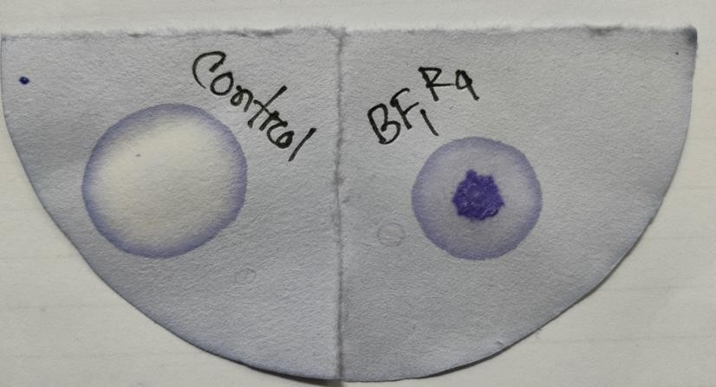

Figure 2: Oxidase Test

    - Methyl Red (MR) Test results

The Methyl Red (MR) Test is performed to identify bacteria capable of producing acidic end products through the mixed acid fermentation pathway. In this test, the MR-VP broth is used, and after the addition of the methyl red indicator, a color change from yellow to red is observed if the bacteria produce a significant amount of acidic end products. This occurs because the acidic end products overpower the phosphate buffer present in the MR-VP broth. Upon addition of methyl red, if acidic end products are present, the indicator will turn red within 5 minutes. Conversely, if no acidic end products are produced, the solution will remain yellow after the addition of the methyl red indicator. As seen in Fig 3. identified Strain Serratia sp. HSTU- BF1R4 showed reddish color on the surface of the medium compared with control. That means it showed positive activity.
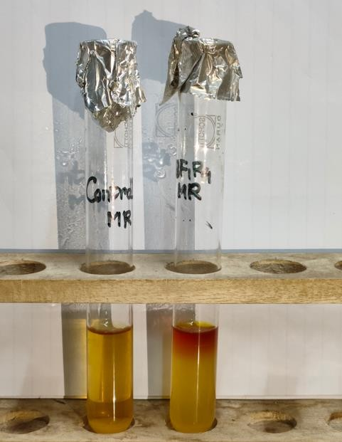

Figure 3: Methyl Red (MR) Test

    - Methyl Red (MR) Test results
The VP (Voges-Proskauer) test is utilized to identify organisms that utilize the butylene glycol pathway and produce acetoin. In this test, the MR-VP broth is inoculated with the organism of interest, and the VP reagents are added. If the organism uses the butylene glycol pathway, the acetoin end product undergoes oxidation in the presence of potassium hydroxide (KOH) to form diacetyl. Diacetyl further reacts to generate a pink-red or reddish color, indicating a positive result. Conversely, the presence of a yellow or copper-like color indicates a negative result. Importantly, if a bacterial strain shows a positive result for the MR test in the same medium (MR-VP broth), it will not exhibit a positive VP test result. This is because the acidic solution produced in the MR test does not overcome the phosphate buffer in the medium, rendering the organism unable to yield positive results for both the MR and VP tests on the same medium. According to statement the isolated Serratia sp. HSTU-BF1R4 VP negative results by showing yellow/copper like color that indicates the strains used mixed acid pathways rather than butylene glycol pathway(Werkman, 1930).
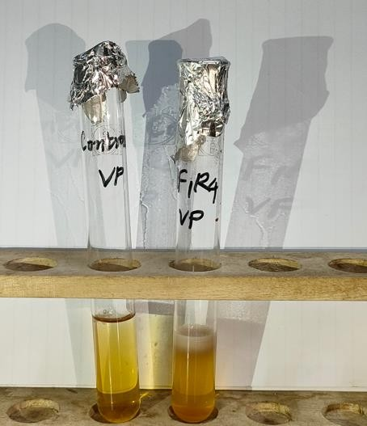
Figure 4: Voges-Proskauer (VP) Test

Triple Sugar Iron Agar (TSI) Test
The identified strain, Serratia sp. HSTU-BF1R4, exhibited a yellow color in both the butt and slant of the Triple Sugar Iron (TSI) agar, indicating fermentation of lactose and fructose among the three sugars tested. Additionally, the strain showed the presence of iron in the TSI agar. The yellow color observed in both the butt and slant is attributed to the formation of a significant amount of acids resulting from the fermentation of lactose and sucrose. If both the slant and butt had turned red, it would indicate no fermentation of sucrose, lactose, glucose, and iron in

the test. The production of a black-colored FeS would indicate fermentation of iron, but no black-colored FeS was observed in either the slant or butt. Based on these results, it can be concluded that the isolate Serratia sp. HSTU-BF1R4 is capable of fermenting glucose.
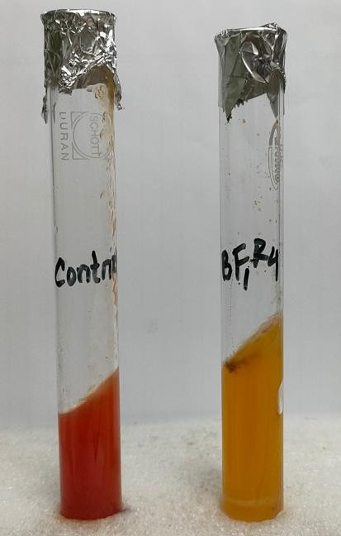

Figure 5: Triple Sugar Iron Agar (TSI) Test

Citrate Utilization test

The citrate test is a commonly employed method to differentiate between Gram-negative bacteria, specifically within the Enterobacteriaceae family, and environmental isolates based on their metabolic pathways. Gram-negative bacteria have the ability to utilize citrate as a carbon source and inorganic salts as a nitrogen source. This utilization is facilitated by the production of an enzyme called citrate-permease, which plays a role in the conversion of citrate to pyruvate. Ultimately, this metabolic process results in the formation of alkaline carbonates, bicarbonates, and ammonium salts, leading to the production of ammonium hydroxide.
One of the key indicators of a positive citrate test is a change in the color of the medium. The shift in pH caused by the bacterial metabolic activity causes the bromothymol blue indicator in the medium to transition from green to blue when the pH exceeds 7.6 (Koser, 1923). Thus, if this reaction occurs and the medium turns blue, it indicates a positive result for citrate utilization. As seen in Figure 6, Identified Strain Serratia sp. HSTU-BF1R4. Blue color formation after incubation from green colored sample indicates the positive color compare with control.

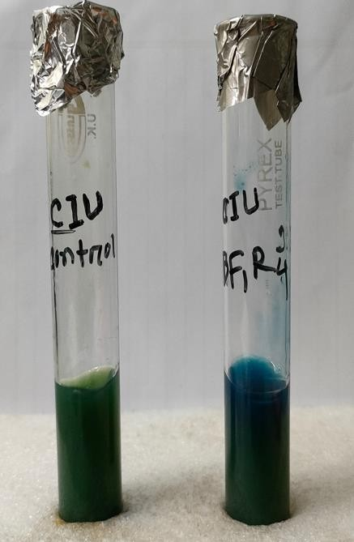

Figure 6: Citrate Utilization test

Urease test

The urease test was conducted using urea agar base, which serves as a nitrogen source for microorganisms capable of producing the urease enzyme. Those organisms containing urease have the ability to hydrolyze urea into ammonia and CO2. The isolate was examined for urease activity, and it exhibited a positive result, indicating that HSTU-BF1R4 can efficiently degrade urea.
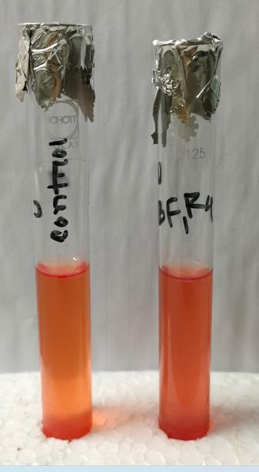

Figure 7: Urease test

Fermentation of sugar: lactose, maltose, sucrose, dextrose Results

The carbohydrate fermentation test is a method employed to assess the ability of bacteria to ferment a particular carbohydrate. During this process, microorganisms produce either acid or acid with gas as byproducts, which can be detected through a color change in the pH indicator. When bacteria ferment a carbohydrate, the medium undergoes a change in color. The formation of a yellow color indicates the fermentation of the carbohydrate, suggesting that the bacteria are capable of utilizing it for energy production. On the other hand, if the medium remains red in color, it indicates that the bacteria are unable to ferment carbohydrates, implying that they lack the necessary metabolic pathways to utilize the specific carbohydrate being tested(Rutter, 1970).
In this study, the isolated strain Serratia sp. HSTU-BF1R4 was evaluated for its ability to ferment various carbohydrates, including Dextrose, Maltose, Lactose, and Sucrose, as compared to the control. Based on the color changing indications, the identified strain showed a yellow color, indicating a positive result for fermentation (Fig -8). This is suggesting that the stain has the capability to utilize and ferment dextrose, maltose, lactose and sucrose opposed to the control samples.

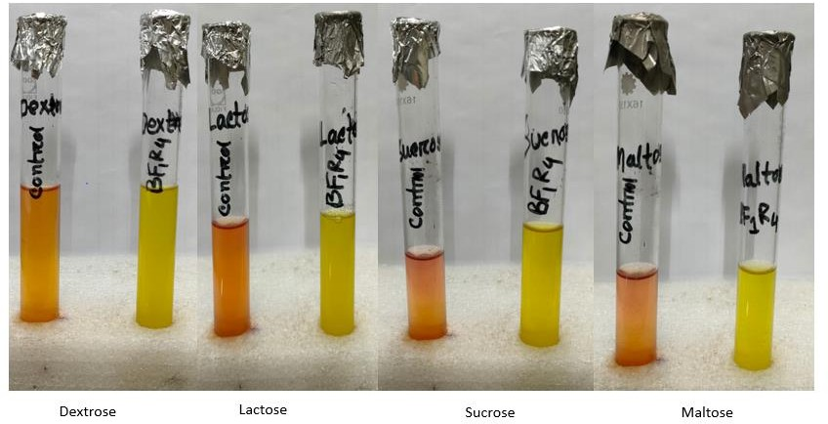

Figure 8: Fermentation test result

  - Evaluation of growth promoting activity in the laboratory by the Serratia sp. HSTU- BF1R4
    - Phosphate solubilization test

A positive phosphate solubilization test indicates that the study strain Serratia sp. HSTU- BF1R4 has the ability to solubilize phosphate compounds in its environment. The growth and hollow zone observed on the PVK plate further support this finding.
The strain Serratia sp. HSTU-BF1R4 has shown a hollow zone to confirming the test result is positive.
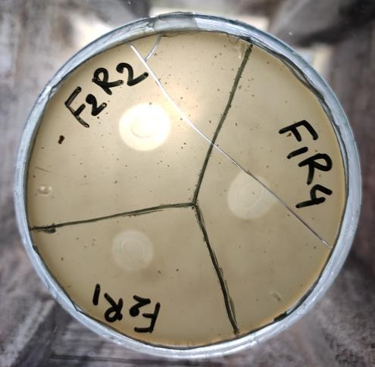

Figure 9: Phosphate solubilization test

Nitrogen fixation test

The nitrogen fixation test yielded a positive result as indicated by the growth of the Serratia sp. HSTU-BF1R4 strain on the Jensen's medium plate. This signifies that the study strain has the capability to fix atmospheric nitrogen. Nitrogen fixation is a vital process carried out by certain microorganisms, such as bacteria and some archaea. These organisms possess the enzyme nitrogenase, which enables them to convert atmospheric nitrogen into ammonia, a form of nitrogen that plants can readily utilize. This conversion process plays a crucial role in enhancing soil fertility and providing plants with a vital nutrient for their growth. The strain Serratia sp. HSTU-BF1R4 growth the Jensen’s medium plate indicate the test result is positive.

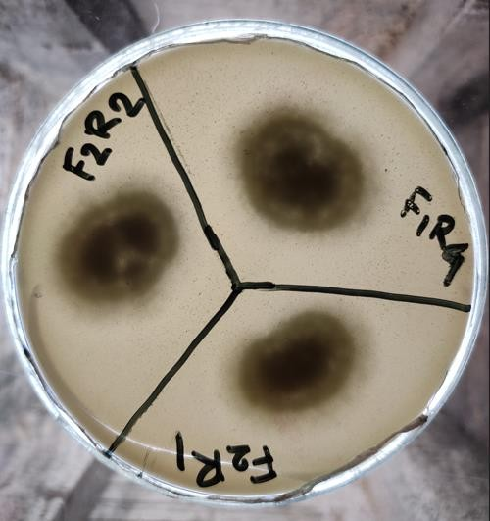

Figure 10: Nitrogen fixation test

Indole-3-acetic acid (IAA) test

The LB medium containing the strain exhibited a reddish-pink color, whereas the control remained yellow. This color difference indicates that the strain is capable of producing indole- 3-acetic acid (IAA). In the (Figure-11) the LB medium with strain was reddish pink color but the control was yellow in color indicated the strain was capable to produce IAA.
.
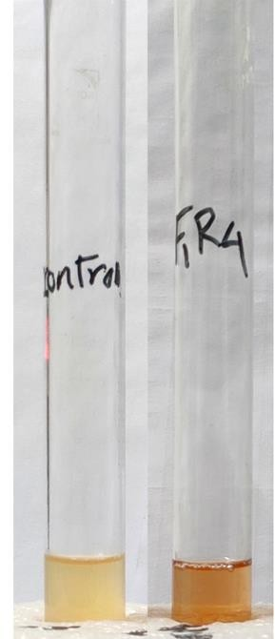

Figure 11: Indole-3-acetic acid (IAA) test

Growth promoting results

    - Seed germination effect on tomato seeds

The tomato seeds were collected and germinated in a filter paper containing petri-dish. The study bacterium liquid broth was applied three times to the seeds. After 7 days the germination percentage, root length, shoot length, seedling length were observed. In germination percentage the strain containing seeds were 89.33% germinated. On the other hand, without strain containing seeds germination percentage were only 69.66%. The root length, shoot length and seedling length were 3.36 cm, 5.10 cm and 8.46 cm respectively for the treatment of the study strain. But the control treatment results were 2.50 cm, 3.03cm and 5.33 cm sequentially.
Table 3: Germination percentage, root length, shoot length and seedling length of tomato plant with the strain at 7 days of seed plantation

Name of isolate | Germination percentage | Root length (cm) | Shoot length (cm) | Seedling Length (cm)
TC(Control) | 69.66±1.52^{b} | 2.50±0.43^{b} | 3.03±0.20^{b} | 5.33±0.35^{b}
BF1R4 | 89.33±1.15ª | 3.36±0.37ª | 5.10±0.65ª | 8.46±1.02ª

Field experimentation results

The root length, shoot length, leaf length, anther and flower of tomato plant were represented in Table-3 which was observed after 30 ,45 and 60 days of plantation. After 30 days of plantation, it was seen that the root length, shoot length, leaf length, no of branch, flower, fruits
22.03 cm, 35.33 cm, 21.03 cm, 7.66,25.33 and 5.33 respectively were observed in BF1R4
+30% Urea treatment group. And the lowest root length, shoot length, leaf length, no of branch, flower and fruits 16.56 cm, 24.66 cm, 16.93 cm, 3.66,11, and 1.00 respectively in TC (Recommended dose of urea) treatment group. After 45 days the root length, shoot length, leaf length, no of branch, flower, fruits 25.16 cm, 50 cm, 24.03 cm, 11,85 and 41.66 respectively were observed in BFIR4+30% urea treatment group. And the lowest root length, shoot length, leaf length, no of branch, flower, fruits 18.00 cm, 35.66 cm, 19.33 cm, 5.33,42.33 and 13.33 respectively in TC (Recommended dose of urea) treatment group. After 60 days of plantation, it was seen that the root length, shoot length, leaf length, no of branch, flower, fruits 27.10 cm,
80.33 cm, 27.96 cm, 13,159.33 and 138.33 respectively were observed in BF1R4+30% Urea treatment group. And the lowest root length, shoot length, leaf length, no of branch, flower,

fruits 19.93 cm, 50.66 cm, 22.60 cm, 6.33,70.33 and 57.33 respectively in TC (Recommended dose of urea) treatment group. The p value was observed >0.05. We comparing TC (recommended dose of urea) with BF1R4 treatment group there were found a statistically significant result. BF1R4 treatment on all growth parameters compared to the control, suggesting its potential as a growth-promoting agent in tomato cultivation.

Table 4: Effect of bacterium and fertilizer in different time period among different treatment group

Collection of data | Treatment | Root length (cm) | Shoot length (cm) | Leaf length (cm) | Branch no | Flower no | Fruits no
30 (DAT) | T1 | 22.03±0.45^{c} | 35.33±0.57^{cd} | 21.03±0.45^{c} | 7.66±0.57^{c} | 25.33±1.52e | 5.33±1.52^{cd}
30 (DAT) | TC | 16.26±0.68^{f} | 24.66 ±0.57^{d} | 16.93±0.51e | 3.66±0.57^{d} | 11.00±1^{f} | 1.00±1^{d}
45 (DAT) | T1 | 25.16±0.57^{b} | 50.00±2.64^{b} | 24.03±0.45^{b} | 11.00±1^{b} | 85.00±3^{b} | 41.66±3.51^{bc}
45 (DAT) | TC | 18.00±0.86e | 35.66±1.52^{c} | 19.33±0.76^{d} | 5.33±0.57^{cd} | 42.33±2.51^{d} | 13.33±1.52^{cd}
60 (DAT) | T1 | 27.10±0.36ª | 80.33±4.16ª | 27.96±0.56ª | 13.00±1.ª | 159.33±5.85ª | 138.33±6.11ª
60 (DAT) | TC | 19.93±0.51^{d} | 50.66±2.30^{b} | 22.60±0.17^{bc} | 6.33±0.57^{bc} | 70.33±1.52^{c} | 57.33±5.50^{b}
DAT: Days after transplantation
T1: Serratia sp. HSTU-BF1R4+30%Urea TC: Recommended dose of urea

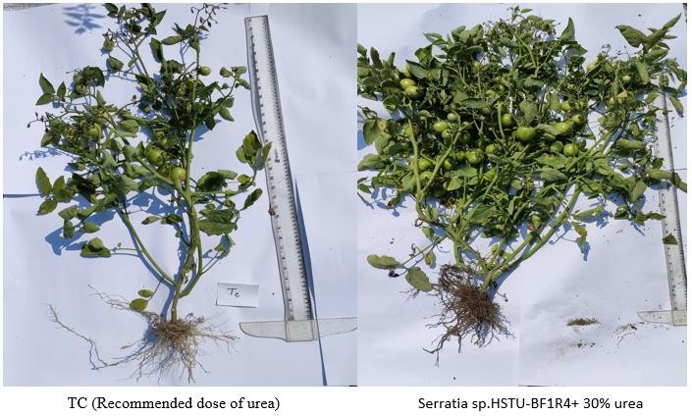
Figure 12: After 80 days of plantation enhancement of vegetative growth of tomato plant by
Serratia sp. HSTU-BF1R4 application.

Genomic features of strain Serratia sp. HSTU-BF1R4

According to the genome of Serratia sp. HSTU-BF1R4 consists of a single circular chromosome of 5,134,367 bp. The fast QC analysis of the raw sequence file reported 59.6%. Depending on the PGAP annotation it was observed that the genome size of Serratia sp.BF1R4 was 4.8mbp with total genes 4,864 where 4,736 were protein coading gene, 97 RNA, and 31 were CDSs without protein. It was also observed that the genome consists of 9 rRNA, 5 complete rRNA, one additional (partial) 4S rRNA, 77 tRNA, 11 ncRNA, respectively. In conformity with the RAST annotation it was found that the genome composed of N50 value 317020, L50 value 5, and 4922 coding sequences (Table-4). It was also seen that the strain Serratia sp. HSTU-BF1R4 genome was conducted and described in the subsections below (Figure-12). The subsystems described that in subsystem total 1421 proteins (29%) are present among them 1360 are non-hypothetical and 61 are hypothetical. In particularly, not in subsystem total 3501 proteins (71%) are present where 2363 are non-hypothetical and 1138 are hypothetical. Including 399 proteins are involved for amino acid and derivatives metabolism, 333 proteins are involved for carbohydrate metabolism as well as 160 proteins are involved for

protein metabolism which were distributed in subsystem and not in subsystem of the strain genome.
Table 5: Genome features and annotation statistics of Serratia sp. HSTU-BF1R4

Features | Annotation statistics
Genome | Serratia sp.-BF1R4
Domain | Bacteria
Taxonomy | Bacteria; Serratia sp.-BF1R4
Size | 5,134,367
GC content | 59.6
N50 | 317020
L50 | 5
Number of contigs (with PEGs) | 43
Number of subsystems | 369
Number of coding’s sequences | 4922
Number of RNAs | 86

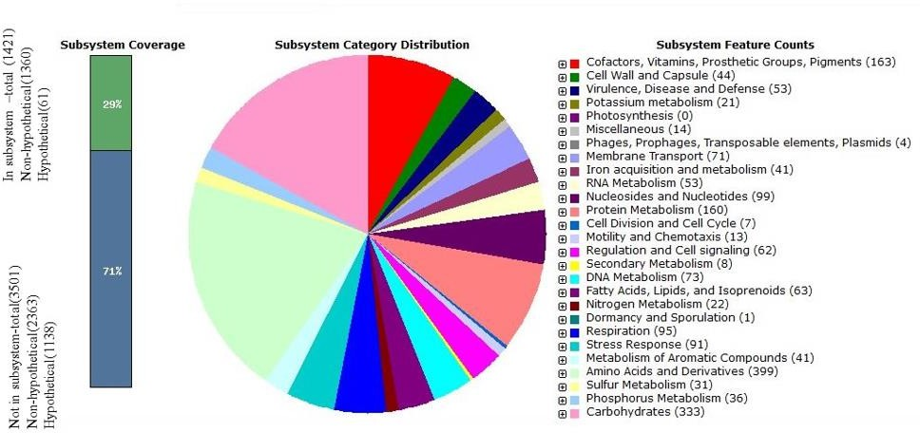

Figure 13: Subsystem of the RAST annotation

As seen in figure the CGview analysis shows all the proteins of a bacterium in a proper genomic map. We hereby transcribed the Serratia sp. HSTU-BF1R4 bacterial protein into a genomic map where 4922 protein coding sequence (CDS), 77 tRNAs were shown in 5,134,367 bp sequences length. In figure, the GC-skew positive indicates that the CDS is present in downstream and GC-skew negative indicates that the CDS is present in upstream. The GC skew is observed in local genomic regions primarily introduced by RNA synthesis, but the analysis of GC skew was first utilized for the computational prediction of ori and ter positions by examining available genome sequences

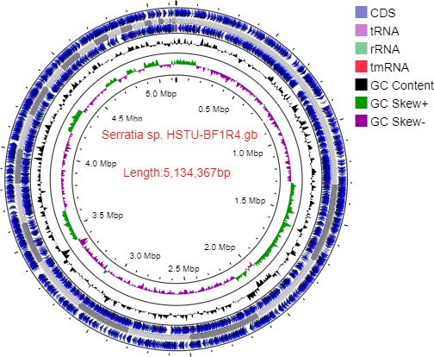

Figure 14: The genomic map of the strain Serratia sp. HSTU-BF1R4

Venn diagram analysis

Venn diagram was showing the Serratia sp. HSTU-BF1R4 predicted essential amino acid sequence in different studies. Serratia sp. HSTU-BF1R4 strain was showed total 191581

numbers of amino acid sequence present in this genome in which 147598 amino acid sequences were showed unique and 43983 numbers of amino acid sequence were common among each other. In addition to maximum 34901 amino acid sequence were matched with reference genome (CP041132).
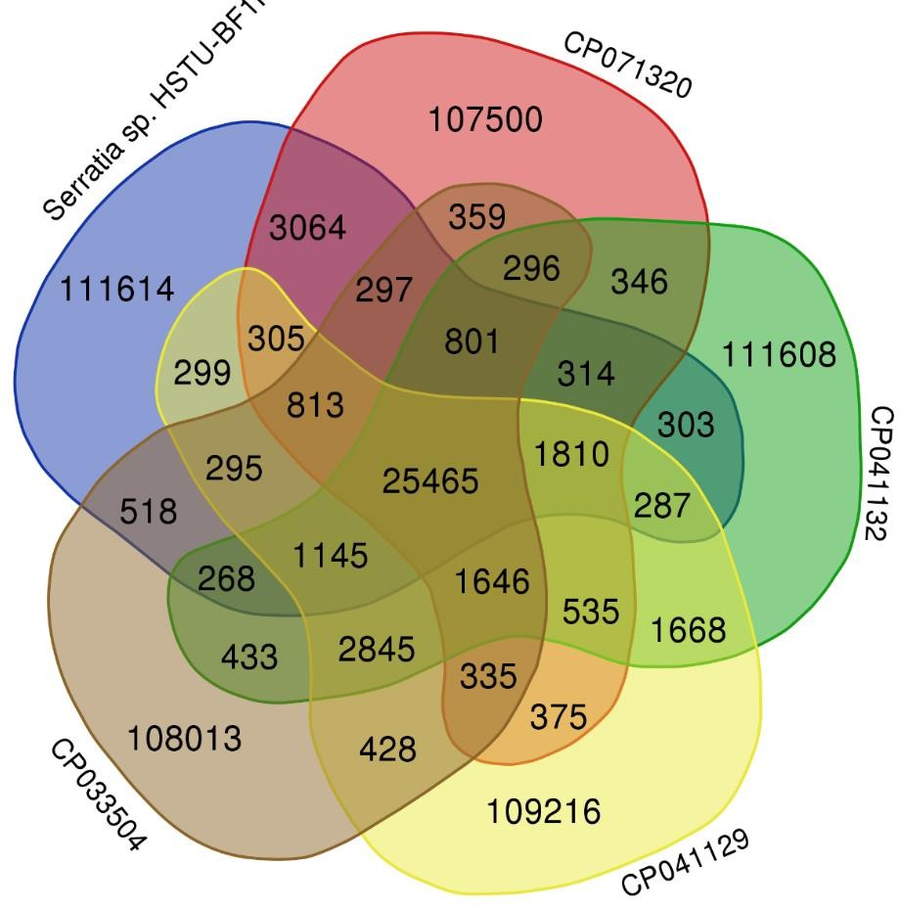

Figure 15: Venn diagram of Serratia sp. HSTU-BF1R4 predicted essential amino acid sequence

Taxonomic classification
    - Phylogenetic tree

Here in figure no-15 A phylogenetic tree of Serratia sp. HSTU-BF1R4 with others 24 nearest species were showed homoplasy (character appears at different brunch) and homology (similarity due to same ancestor) brunches. Nine monophyletic group and seven polyphyletic group were shown in the phylogenetic diagram. Where our studied Serratia sp. HSTU-BF1R4 got root of ancestors from and brunched as polyphyletic group with CP019926.1 serratia marcescens strain UMH6 and CP028947.1 serratia marcescens strain AR0130 sister ancestor group. So examined Serratia sp. HSTU-BF1R4 mostly near ancestor of serratia marcescens.

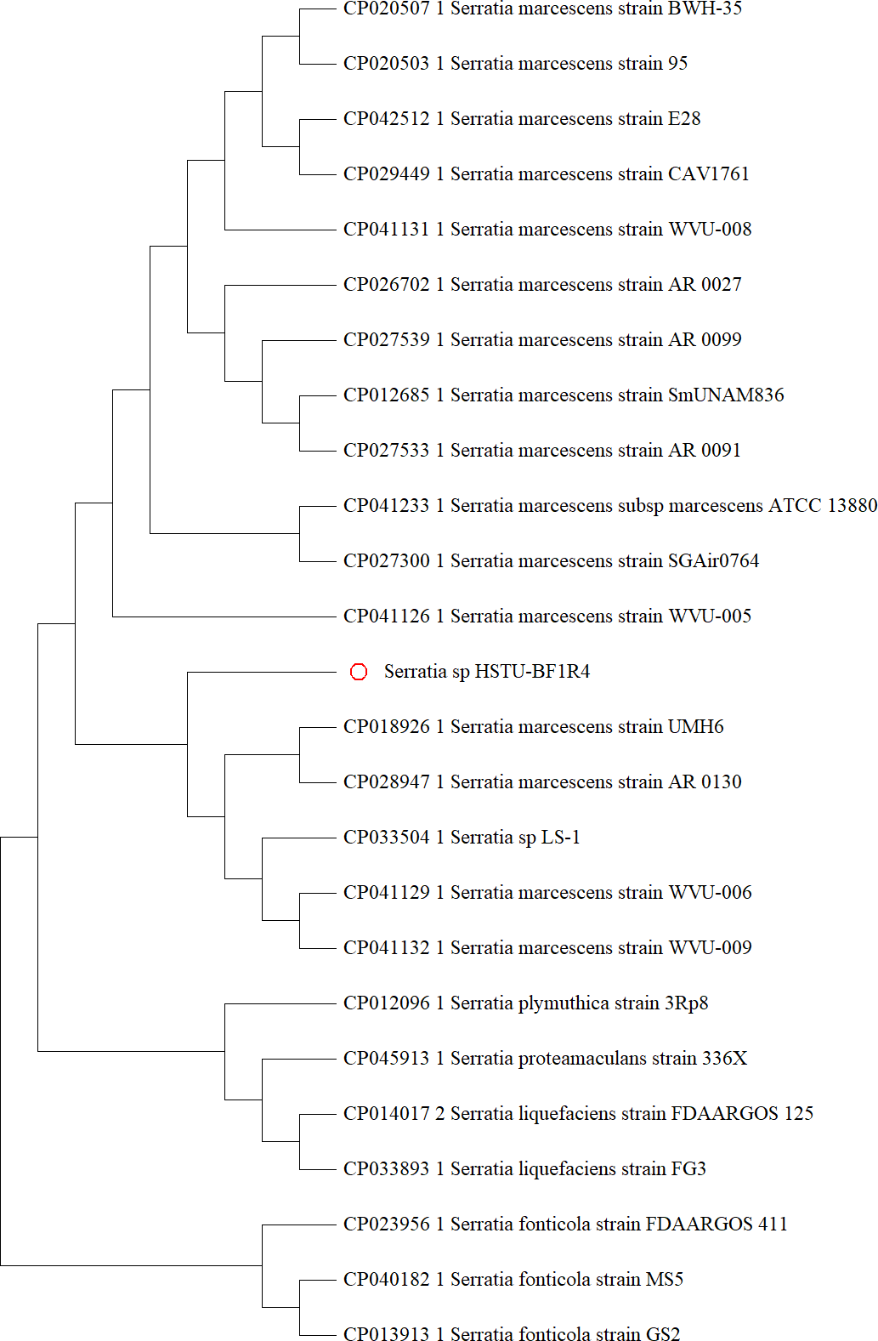

Figure 16: The phylogenetic tree based on whole genome of Serratia sp. HSTU-BF1R4 strain with closely related whole genome strains

Average nucleotide identity (ANI)
Average nucleotide identity measurement defines the comparison of closer relativity among Serratia sp. HSTU-BF1R4 and other 14 bacterial species collected from NCBI, inputted in the identification method. ANI performed in two different programme – ANI b (ANI blast) and ANI m (ANI mammber). The similarity check in programme ANI b showed in table. where Serratia sp. HSTU-BF1R4 with CP012639.1 Serratia marcescens strain RSC-14, indicates higher value of 98.96%, could be granted as highest close relative species undertaking the investigation cutoff score of same species belonging &gt; 95%. Respectively, CP041132.1 Serratia marcescens strain WVU-009, CP025698.1 Serratia marcescens strain SOLR4, CP033504.1 Serratia sp. LS-1 CP041129.1 Serratia marcescens strain WVU-006, CP123616.1 Serratia sp. B1 chromosome, CP018919.1 Serratia marcescens strain UMH7 showed 98.93,98.92,98.94%,98.89% 98.85%,98.85% ANI score and the other remaining strain showed 94%-97% likeness value.

Table 6: Average Nucleotide Identity (ANI) (%) based on whole genome alignments

 | Serratia sp. HSTU-BF1R4.fa | CP123616.1 Serratia sp. B1 chromosome, complete genome.fasta | CP070508.1 Serratia ureilytica strain AM923 chromosome, complete | CP063354.1 Serratia marcescens strain SCQ1 chromosome, complete | CP053286.1 Serratia marcescens strain FZSF02 chromosome, complete | CP041132.1 Serratia marcescens strain WVU-009 chromosome, complete | CP041129.1 Serratia marcescens strain WVU-006 chromosome, complete | CP033504.1 Serratia sp. LS-1 chromosome, complete genome.fasta | CP028947.1 Serratia marcescens strain AR 0130 chromosome, complete | CP025698.1 Serratia marcescens strain SOLR4 chromosome.fasta | CP018926.1 Serratia marcescens strain UMH6 chromosome, complete | CP018924.1 Serratia marcescens strain UMH2 chromosome, complete | CP018919.1 Serratia marcescens strain UMH7 chromosome, complete | CP012639.1 Serratia marcescens strain RSC-14, complete genome.fasta | CP003424.1 Serratia sp. SCBI, complete genome.fasta
Serratia sp. HSTU- BF1R4.fa | * | 98.36 | 98.85 | 94.77 | 95.22 | 98.93 | 98.89 | 98.94 | 98.40 | 98.92 | 98.48 | 98.84 | 98.85 | 98.96 | 98.45
CP123616.1 Serratia sp. B1 chromosome, complete  genome.fasta | 98.32 | * | 98.29 | 94.65 | 95.24 | 98.36 | 98.35 | 98.31 | 98.94 | 98.21 | 98.74 | 98.26 | 98.26 | 98.27 | 99.16
CP070508.1 Serratia ureilytica strain AM923 chromosome, complete  genome.fasta | 98.77 | 98.19 | * | 94.72 | 95.11 | 98.82 | 99.25 | 98.75 | 98.18 | 98.66 | 98.25 | 98.76 | 98.82 | 98.94 | 98.27
CP063354.1 Serratia marcescens strain SCQ1 chromosome, complete  genome.fasta | 94.92 | 94.72 | 94.85 | * | 96.37 | 94.93 | 94.92 | 94.88 | 94.67 | 94.91 | 94.79 | 94.93 | 94.89 | 94.96 | 94.73
CP053286.1 Serratia marcescens strain FZSF02  chromosome,  complete genome.fasta | 95.19 | 95.14 | 95.13 | 96.24 | * | 95.22 | 95.19 | 95.19 | 95.00 | 95.14 | 95.13 | 95.20 | 95.16 | 95.23 | 95.12

CP041132.1 Serratia marcescens strain WVU-009  chromosome,  complete genome.fasta | 98.76 | 98.23 | 98.70 | 94.70 | 95.24 | * | 99.01 | 98.78 | 98.24 | 98.59 | 98.31 | 98.74 | 98.80 | 98.84 | 98.38
CP041129.1 Serratia marcescens strain WVU-006  chromosome,  complete genome.fasta | 98.76 | 98.19 | 99.19 | 94.78 | 95.18 | 99.06 | * | 98.81 | 98.20 | 98.68 | 98.28 | 98.76 | 98.83 | 98.94 | 98.32
CP033504.1 Serratia sp. LS-1  chromosome,  complete genome.fasta | 98.98 | 98.33 | 98.89 | 94.80 | 95.33 | 98.98 | 98.94 | * | 98.31 | 98.89 | 98.46 | 99.03 | 98.99 | 98.98 | 98.41
CP028947.1 Serratia marcescens strain  AR 0130  chromosome,  complete genome.fasta | 98.43 | 98.98 | 98.28 | 94.69 | 95.18 | 98.37 | 98.32 | 98.34 | * | 98.29 | 98.88 | 98.30 | 98.31 | 98.34 | 99.02
CP025698.1 Serratia marcescens strain SOLR4  chromosome.fasta | 98.86 | 98.15 | 98.70 | 94.76 | 95.13 | 98.78 | 98.78 | 98.77 | 98.15 | * | 98.24 | 98.79 | 98.77 | 98.85 | 98.27
CP018926.1 Serratia marcescens strain UMH6 chromosome, complete  genome.fasta | 98.55 | 98.80 | 98.34 | 94.73 | 95.25 | 98.45 | 98.41 | 98.46 | 98.85 | 98.36 | * | 98.40 | 98.37 | 98.40 | 98.87
CP018924.1 Serratia marcescens strain UMH2 chromosome, complete  genome.fasta | 98.72 | 98.18 | 98.68 | 94.73 | 95.20 | 98.82 | 98.74 | 98.80 | 98.18 | 98.67 | 98.29 | * | 98.85 | 98.82 | 98.26
CP018919.1 Serratia marcescens strain UMH7 chromosome, complete  genome.fasta | 98.83 | 98.23 | 98.84 | 94.76 | 95.21 | 98.92 | 98.90 | 98.94 | 98.30 | 98.82 | 98.35 | 98.92 | * | 98.90 | 98.37
CP012639.1 Serratia marcescens strain RSC-14, complete  genome.fasta | 98.94 | 98.21 | 98.97 | 94.82 | 95.33 | 98.99 | 99.00 | 98.89 | 98.22 | 98.89 | 98.28 | 98.91 | 98.87 | * | 98.32
CP003424.1 Serratia  sp. SCBI, complete genome.fasta | 98.47 | 99.23 | 98.36 | 94.71 | 95.27 | 98.48 | 98.44 | 98.39 | 99.04 | 98.32 | 98.89 | 98.43 | 98.41 | 98.38 | *

    - DNA-DNA hybridization (DDH) test

In the depiction of relatedness among prokaryotic organism could determine by the DNA-DNA hybridization method. We analysed the quantitative connection between DDH values and genome arrangement determined boundaries of Serratia sp. HSTU-BF1R4 with fourteen different bacterial strains, in table no.6 all results are manifested. We found Serratia sp. HSTU- BF1R4 and CP012639.1+ CP033504.1 bacterial strain showed highest similarity DNA hybridization value in three formulae of this programmed chronologically 96, 91.8 and 97.1%&96,92.4,97.1. On the other hand, CP025698.1 had showed second highest value in three formula were – 95.1,91.8,96.5 and probability 98.69,96.36,99.9 %. And CP041129.1 had showed third highest DDH and probability value of likeness among others inputted strains. Appealingly, all 14 referred strain of bacillus sp. Had crossed the connection cut-off score.
Table 7: Digital DNA-DNA hybridization (dDDH) for species determination depends on whole genome sequences BF1R4

 |  | Formula 1 |  | Formula 2 |  | Formula 3 |  | G+C  difference
Query genome | Reference  genome | DDH | Model C.I. | DDH | Model C.I. | DDH | Model C.I.
Serratia_sp._HSTU-  BF1R4.fa | CP003424.1 | 91.4 | [88.4 - 93.7%] | 89.6 | [87.2 - 91.5%] | 93.5 | [91.3 - 95.2%] | 0.01
Serratia_sp._HSTU-  BF1R4.fa | CP012639.1 | 96 | [94 - 97.4%] | 91.8 | [89.7 - 93.5%] | 97.1 | [95.7 - 98%] | 0.03
Serratia_sp._HSTU-  BF1R4.fa | CP018919.1 | 94.6 | [92.2 - 96.3%] | 91.7 | [89.5 - 93.4%] | 96.1 | [94.4 - 97.3%] | 0.11
Serratia_sp._HSTU-  BF1R4.fa | CP018924.1 | 93.8 | [91.2 - 95.7%] | 91.3 | [89.1 - 93.1%] | 95.5 | [93.7 - 96.8%] | 0.25
Serratia_sp._HSTU-  BF1R4.fa | CP018926.1 | 90.1 | [86.9 - 92.6%] | 89.7 | [87.3 - 91.6%] | 92.6 | [90.2 - 94.4%] | 0.12
Serratia_sp._HSTU-  BF1R4.fa | CP025698.1 | 95.1 | [92.9 - 96.7%] | 91.8 | [89.7 - 93.5%] | 96.5 | [94.9 - 97.6%] | 0.09
Serratia_sp._HSTU-  BF1R4.fa | CP028947.1 | 90.2 | [87 - 92.7%] | 89.7 | [87.4 - 91.7%] | 92.7 | [90.3 - 94.5%] | 0.16
Serratia_sp._HSTU-  BF1R4.fa | CP033504.1 | 96 | [94 - 97.4%] | 92.4 | [90.3 - 94%] | 97.1 | [95.8 - 98.1%] | 0.04
Serratia_sp._HSTU-  BF1R4.fa | CP041129.1 | 95 | [92.6 - 96.6%] | 91.6 | [89.5 - 93.4%] | 96.3 | [94.7 - 97.5%] | 0.1
Serratia_sp._HSTU-  BF1R4.fa | CP041132.1 | 93.7 | [91.1 - 95.6%] | 91.9 | [89.8 - 93.6%] | 95.5 | [93.7 - 96.8%] | 0.16
Serratia_sp._HSTU-  BF1R4.fa | CP053286.1 | 78.3 | [74.3 - 81.8%] | 65.2 | [62.3 - 68%] | 78.5 | [75.1 - 81.6%] | 0.58

Serratia_sp._HSTU-  BF1R4.fa | CP063354.1 | 82.9 | [79.1 - 86.2%] | 62.7 | [59.8 - 65.5%] | 81.8 | [78.4 - 84.7%] | 0.12
Serratia_sp._HSTU-  BF1R4.fa | CP070508.1 | 93.8 | [91.3 - 95.7%] | 91.7 | [89.6 - 93.4%] | 95.6 | [93.8 - 96.9%] | 0.18
Serratia_sp._HSTU-  BF1R4.fa | CP123616.1 | 90.9 | [87.8 - 93.3%] | 89.2 | [86.8 - 91.2%] | 93.1 | [90.8 - 94.9%] | 0.1

Comparative genomics study
    - Multiple genome alignment

Furthermore, to understood genomic features of Serratia sp. HSTU-BF1R4 elaborately, multiple genome alignment investigation conducted by contrasted with four bacterial strain of CP028947.1 Serratia marcescens strain AR_0130, CP041129.1 Serratia marcescens strain WVU-006, CP041132.1 Serratia marcescens strain WVU-009, CP071320.1 Serratia ureilytica strain T6. Each genome is organized horizontally with homologous segment outlined as colored rectangles. Each same color block represents a locally collinear block (LCB) or homologous region shared among genomes. The locally collinear block (LCB) of Serratia sp. HSTU- BF1R4 genome is not totally meet with locally collinear blocks (LCBs) of genomes taken for genomic comparison. Rearrangement of genomic regions was observed between the two genomes in terms of collinearity. As seen in figure 16 It was seen that the study strain shared highest homologous region with CP071320.1. It was also observed that Serratia sp. HSTU- BF1R4 shared almost similar LCBs as like CP071320.1 strain with SGAir0282.

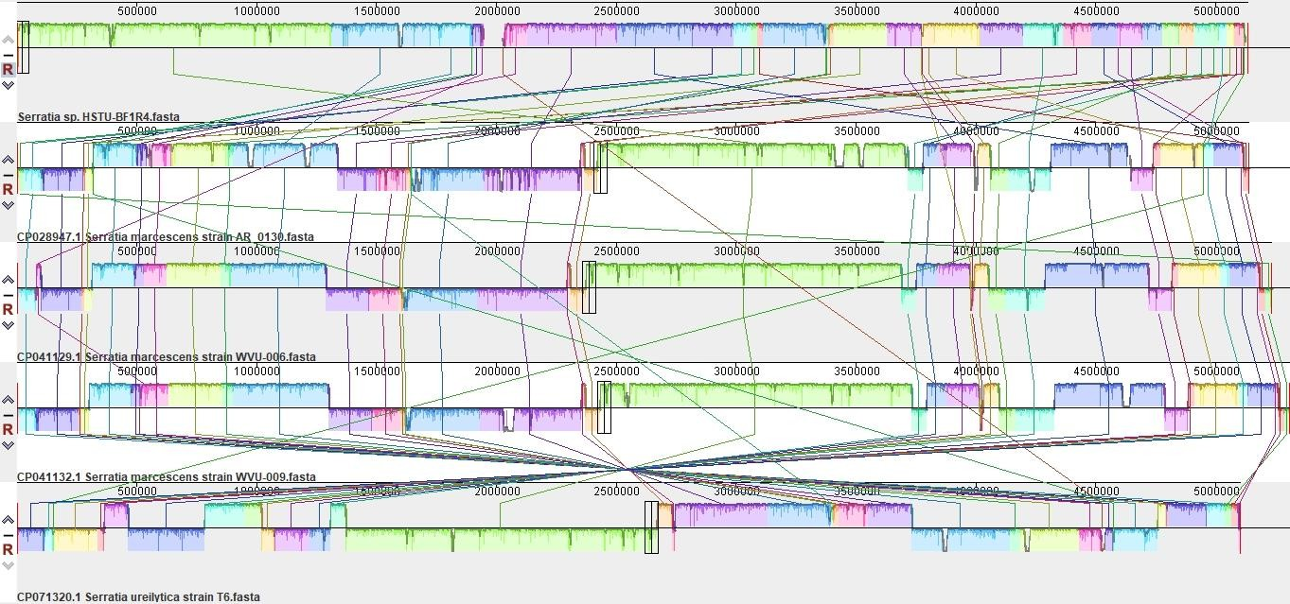

Figure 17: Multiple genome analysis of Serratia sp. HSTU-BF1R4 with other closely related strains. The same color module represents the homologs region. Good homology of the strain Serratia sp. HSTU-BF1R4 and other serratia-sp. were shown.

4.8.2 Pan-genomic analysis

We performed pan-genomic analysis of Serratia sp. HSTU-BF1R4 strain with five nearest homologs to further investigate the genomic variance of Serratia sp. HSTU-BF1R4. As seen in figure -17 in circular plot the blue color slot identified as pan-genome and white space indicates a region missing in the specified genome. The circular plot clearly intimate that a several portions of the genome sequence of Serratia sp. HSTU-BF1R4 were not similar compared with other five closest strains.

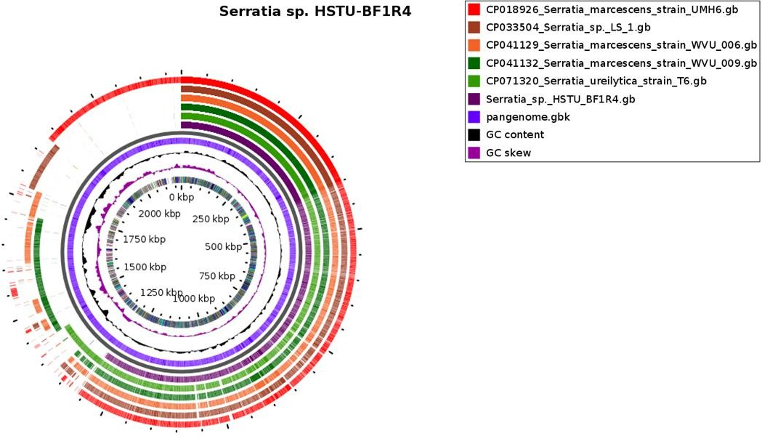

Figure 18: Pangenome analysis of Serratia sp. HSTU-BF1R4 strain with nearest homologs strain for genomic comparison

List of some identified plant growth promoting genes traits from RAST

    - Effective gene of phosphate metabolism

Phosphate, an essential macronutrient for plants, constitutes approximately 0.2% of a plant's dry weight. ADP and ATP, which contain high-energy phosphate, serve as crucial sources of energy for various chemical reactions within the plant. One significant process in these reactions involves the transfer of high-energy phosphate from ADP and ATP to other molecules through phosphorylation. This process plays a vital role in numerous chemical reactions occurring in plants. Moreover, inorganic phosphates play a pivotal role in plant growth, and certain microbes can aid plants by converting complex phosphates into more soluble forms. Bacteria such as Gluconobacter oxydans, Pseudomonas fluorescens, Azospirillum spp., and Mesorhizobium mediterraneum have demonstrated their ability to solubilize phosphates. These phosphate-solubilizing bacteria can assist plants by mobilizing complex forms of phosphates into more readily available and soluble forms, thereby promoting plant growth and nutrient uptake (de Werra et al., 2009).The pst operon of E. coli and B. subtilis is composed of pstS,

pstC, pst A, and pstB as well as a two- component signal transduction system consisting of phoP/phoR for phosphate uptake (Xie et al., 2016).In the present study, genomic analysis of Serratia sp. HSTU-BF1R4 revealed that it carries the pst operon pstA, pstB. pstC, and pst genes as well as phoB and phoR genes for phosphate transport. others ugpB, ugpE pntA pntB etc are alo present.
Table 8: phosphate metabolism gene and their locus tag, CDS &product

PGP  activities description | Gene Name | Locus Tag | CDS | Product | E.C.  number
Phosphate  metabolism | pitA | NW219_18745 | 155727..157229 | Inorganic phosphate  transporter PitA | -
 | pstS | NW219_14645 | 260882..261922 | phosphate ABC  transporter substrate- binding protein PstS | 7.3.2.1
 | pstC | NW219_14640 | 259834..260790 | phosphate ABC transporter permease  PstC | 7.3.2.1
 | pstA | NW219_14635 | 258942..259832 | phosphate ABC  transporter permease PstA | 7.3.2.1
 | pstB | NW219_14630 | 258117..258893 | phosphate ABC  transporter ATP-binding protein PstB | 7.3.2.1
 | phoU | NW219_14625 | 257371..258105 | phosphate signaling  complex protein PhoU | -
 | ugpA | NW219_13605 | 35396..36283 | sn-glycerol-3-phosphate ABC transporter permease  UgpA | 7.6.2.-
 | ugpB | NW219_13610 | 36362..37681 | sn-glycerol-3-phosphate ABC transporter substrate-binding protein  UgpB | 7.6.2.-

 | ugpE | NW219_13600 | 34554..35399 | sn-glycerol-3-phosphate ABC transporter permease  UgpE | 7.6.2.-
 | phoA | NW219_20700 | 31998..33425 | alkaline phosphatase | 3.1.3.1
 | phoB | NW219_06750 | 128099..128788 | phosphate response regulatortranscription factor PhoB | -
 | phoR | NW219_06755 | 128813..130129 | phosphate regulon sensor  histidine kinase PhoR | 2.7.13.3
 | phoH | NW219_03055 | 669253..670041 | phosphate starvation-  inducible protein PhoH | -
 | pntA | NW219_01235 | 285597..287126 | Re/Si-specific NAD(P)(+)transhydroge  nase subunit alpha | 1.6.1.2
 | pntB | NW219_01230 | 284192..285586 | Re/Si-specific NAD(P)(+)  transhydrogenase  subunit beta | -
 | phoQ | NW219_11110 | 209061..210518 | two-component  systemsensor histidine kinase PhoQ | 2.7.13.3

Effective genes of IAA production

Indole acetic acid (IAA) is a highly active auxin that plays a significant role in plant physiology. It is produced by various microorganisms, including Plant Growth-promoting Rhizobacteria (PGPR), as a byproduct of L-tryptophan metabolism (Lynch, 1985). These microorganisms, which possess common characteristics such as the production of plant growth regulators (like auxin, gibberellin, and ethylene), siderophores, HCN, and antibiotics, synthesize auxins to manipulate the physiological processes of host plants for their own benefit (Bolton Jr, Fredrickson and Elliott, 1992) .
During our research, we isolated Serratia sp. HSTU-BF1R4 from plant roots and discovered its ability to produce Indole acetic acid as a secondary metabolite due to an abundant supply of substrates. Indole acetic acid plays a vital role in the development of longer roots, increased

root hair density, and the formation of lateral roots, all of which contribute to enhanced nutrient uptake (Datta and Basu, 2000).IAA promotes cell elongation through various mechanisms, including increasing the osmotic content of cells, enhancing water permeability into cells, reducing wall pressure, stimulating cell wall synthesis, and inducing specific RXA and protein synthesis. To validate our findings, we conducted field experiments, which confirmed that the application of Serratia sp. HSTU-BF1R4 resulted in improved plant growth, particularly in terms of root and shoot length.
Furthermore, our confirmation was supported by a whole genome analysis of Serratia sp. HSTU-BF1R4, revealing the presence of tryptophan-producing genes within its genome, further highlighting its ability to produce IAA. In this study. We found Serratia sp. HSTU- BF1R4 contains most of the genes. they are given below in the table 8.
Table 9: Genes of IAA production

PGP  activities description | Gene Name | Locus Tag | CDS | Product | E.C.  number
IAA  production | trpC | NW219_0 1850 | 428149..42951  0 | bifunctional indole-3- glycerol-phosphate synthaseTrpC/phosphoribos ylanthranilate isomerase  TrpF | 4.1.1.48,  5.3.1.24
 | trpS | NW219_1 | 40648..41655 | tryptophan--tRNA ligase | 6.1.1.2
 |  | 8240
 | trpB | NW219_0  1855 | 429537..43074  2 | tryptophan synthase subunit beta | 4.2.1.20
 | trpD | NW219_0 1845 | 426549..42814  5 | bifunctional anthranilate synthase glutamateamidotransferasec omponent TrpG/anthranilate phosphoribosyltransferase  TrpD | -

Effective genes of trehalose metabolism

Salinity poses a significant challenge for farmers as it negatively affects plant growth and productivity in agricultural soils. The presence of soluble salts reduces soil fertility and leads to osmotic stress, disrupting water balance and ion homeostasis. Consequently, this disturbance alters the hormonal status of plants, affecting processes such as transpiration, nutrient uptake, and photosynthesis, among others (Munns and Tester, 2008). Plants possess various mechanisms to cope with salt stress, and their microbiome, including the rhizosphere, phyllosphere, and endosphere, plays a crucial role in this regard(del Carmen Orozco-Mosqueda et al., 2018). Within the plant microbiome, a group of beneficial bacteria known as plant growth-promoting bacteria (PGPB) stands out. Examples of such bacteria include Azospirillum, Arthrobacter, Azotobacter, Bacillus, Burkholderia, Enterobacter, and Pseudomonas, which have demonstrated the ability to improve salt tolerance in various crop plants (Forni, Duca and Glick, 2017). One mechanism employed by PGPB to alleviate stress and promote plant growth under drought and high-salt conditions is the production of trehalose (Suárez et al., 2008). Trehalose is a non-reducing disaccharide composed of two glucose units linked by an a,a-(1,1)-glycosidic bond. This disaccharide is found in all domains of life, including plants, animals, fungi, yeast, archaea, and bacteria (Avonce et al., 2006). Trehalose also has industrial applications and is utilized in the food, cosmetics, and pharmaceutical industries (Lee et al., 2005). In biological cells, trehalose serves various important roles, such as a signaling molecule, reserve carbohydrate, and protector against different stresses like drought, cold, and salt stress (Fernandez et al., 2010). Notably, the presence of trehalose has been strongly associated with the ability of certain microorganisms to survive in harsh environments. In the present study, genomic analyses of Serratia sp. HSTU-BF1R4 revealed that it carries some trehalose metabolic genes. The genes that carried by Serratia sp. HSTU- BF1R4 are treB, treC, treR respectively.

Table 10: Genes of trehalose metabolism

PGP  activities description | Gene Name | Locus Tag | CDS | Product | E.C.  number
Trehalose metabolism | treB | NW219_09015 | 184088..185503 | PTS trehalose transporter subunit IIBC | 2.7.1.201
Trehalose metabolism | treC | NW219_09010 | 182356..184020 | alpha,alpha- phosphotrehalase | 3.2.1.93
Trehalose metabolism | treR | NW219_09020 | 185633..186580 | trehalose operon repressor TreR | -

Effective genes of H2S production & sulfur assimilation

Sulfur is an essential macronutrient required for the growth and development of plants. It plays a crucial role in various physiological processes, particularly in protein and enzyme synthesis, as cystine and methionine amino acids contain sulfur and are functionally important for plant growth and development(De Kok et al., 2005). Sulfur also contributes to root growth, seed production, nodule formation in legume plants, and enhances winter hardiness(Grill, Tausz and De Kok, 2001). Additionally, sulfur is necessary for the formation of chlorophyll, the green pigment in leaves that facilitates photosynthesis. Through photosynthesis, plants produce starch, sugars, oils, fats, vitamins, and other vital compounds (Allen, 1995).
Sulfur deficiency can have detrimental effects on crops, leading to reduced yield and compromised quality. In the case of sulfur deficiency, the younger leaves of plants tend to become pale green, followed by the overall appearance of the plant turning light yellow. Therefore, ensuring an adequate supply of sulfur is crucial to promote healthy crop production, increase yields, and enhance market value. In this study, we found some H₂S production and sulphate assimilation genes which given below in the Table 10.

Table 11: H2S production and sulfur assimilation genes and their location

PGP  activities description | Gene Name | Locus Tag | CDS | Product | E.C.  number
Sulfur assimilation | cysZ | NW219_23290 | 41822..42580 | sulfate transporter CysZ | -
Sulfur assimilation | cysK | NW219_23285 | 40668..41636 | cysteine synthase A | 2.5.1.47
Sulfur assimilation | cysM | NW219_23255 | 34457..35338 | Cysteine synthase CysM | 2.5.1.47
Sulfur assimilation | cysA | NW219_23250 | 33288..34376 | sulfate/thiosulfate ABC transporter  ATP-binding protein CysA | 7.3.2.-
Sulfur assimilation | cysW | NW219_23245 | 32423..33298 | sulfate/thiosulfate ABC transporter permease CysW | 7.3.2.-
Sulfur assimilation | cysC | NW219_16900 | 191742..192431 | adenylyl-sulfate kinase | 2.7.1.25
Sulfur assimilation | cysN | NW219_16895 | 190376..191803 | sulfate adenylyltransferase subunit CysN | 2.7.7.4
Sulfur assimilation | cysD | NW219_16890 | 189456..190364 | sulfate adenylyltransferase  subunit CysD | 2.7.7.4
Sulfur assimilation | cysI | NW219_16870 | 184104..185819 | assimilatory sulfite reductase (NADPH) hemoprotein subunit | 1.8.1.2
 | cysJ | NW219_16865 | 182305..184104 | NADPH-dependent  assimilatory sulfite reductase flavoprotein subunit | 1.8.1.2
 | cysT | NW219_23240 | 31584..32423 | sulfate/thiosulfate ABC transporter permease CysT | 7.3.2.-

Effective genes of superoxide dismutase

Environmental stresses pose significant limitations to plant productivity, often resulting in injury. One of the primary causes of plant damage under various environmental stresses is oxidative damage, which occurs when the production of reactive oxygen species exceeds the physiological levels, leading to oxidative stress. To mitigate such damage, plants rely on antioxidative enzymes, which play a crucial role in preventing oxidative stress (Allen, 1995). Key antioxidative enzymes found in plants include catalase, superoxide dismutase (SOD), and

glutathione reductase. Among these, superoxide dismutase (SOD) is particularly important as it facilitates the dismutation of the superoxide anion (O2-) into hydrogen peroxide and molecular oxygen. This enzyme is considered a vital defense mechanism against oxidative damage (Yu and Rengel, 1999). The levels of superoxide dismutase (SOD) may increase in response to elevated oxidative stress, although the specific response can vary depending on factors such as the plant species, developmental stage, and severity of the stress conditions (Sen Raychaudhuri and Deng, 2000).
In this study, we have found some superoxide dismutase gene. Serratia sp. HSTU-BF1R4 genome contains the superoxide dismutase genes such sodA, sodB, sodC. The CDS of these genes with locus tag shows table
Table 12: Genes of superoxide dismutase

PGP  activities description | Gene Name | Locus Tag | CDS | Product | E.C.  number
Superoxide dismutase | sodA | NW219_14305 | 190919..191539 | superoxide dismutase [Mn] | 1.15.1.1
Superoxide dismutase | sodB | NW219_10185 | 26718..27296 | superoxide dismutase [Fe] | 1.15.1.1
Superoxide dismutase | sodC | NW219_10120 | 14041..14562 | superoxide dismutase [Cu-Zn] SodC | 1.15.1.1

Effective genes of chemotaxis

Motility plays a significant role in the behavior of plant-associated bacteria and endophytes, enabling them to actively move and colonize plants as well as spread systematically within the plant. In our study, we identified three specific genes related to chemotaxis and biosynthesis. The bacterial chemotaxis signaling pathway commonly involves a conserved set of signaling genes, which includes cheA/cheY, methyl-accepting chemoreceptor proteins (MCP), and an adaptor protein called CheW. Chemotaxis and motility allow bacteria to sense and respond to changes in their environment, particularly in relation to chemical gradients, which aids them in locating favorable niches within the plant (Adler, 1975). The presence of genes involved in chemotaxis and biosynthesis suggests that the bacteria we studied possess the capability to navigate towards specific signals and synthesize required compounds for their survival and interaction with plants. Consistently with its chemotactic nature, we found that Serratia sp.

HSTU-BF1R4 is able to synthetize the cheY, which genes present in locus tag; NW219_03330. We also found chemotaxis genes coding (rbsB and malE, cheW , rbsB etc.)
Table 13: Chemotaxis genes with locus tag.

PGP  activities description | Gene Name | Locus Tag | CDS | Product | E.C.  number
Chemotaxis | cheZ | NW219_03325 | 721523..722167 | protein phosphatase CheZ | 3.6.1.-
Chemotaxis | cheY | NW219_03330 | 722178..722567 | chemotaxis response regulator CheY | 2.1.1.80
Chemotaxis | cheR | NW219_03340 | 723719..724591 | protein-glutamate O- methyltransferase CheR | 2.1.1.80
Chemotaxis | cheW | NW219_03355 | 728187..728687 | chemotaxis protein CheW | -
Chemotaxis | cheA | NW219_03360 | 728720..730741 | chemotaxis protein CheA | -
Chemotaxis | malE | NW219_21870 | 41936..43129 | maltose/maltodextrin ABC transporter substrate-binding protein MalE | 7.5.2.1
Chemotaxis | rbsB | NW219_14760 | 286840..287727 | ribose ABC transporter substrate-  binding protein RbsB | -

Effective genes of heavy metal resistance

Genomic analysis of Serratia sp. HSTU-BF1R4 unveiled the presence of a gene associated with heavy metal resistance. The annotated genomes of Serratia sp. HSTU-BF1R4 revealed the existence of numerous putative proteins involved in multiple heavy metal resistance mechanisms. These proteins encompass resistance factors, transporters, and metal reductases, indicating the potential ability of the bacterium to withstand and mitigate the toxic effects of various heavy metals. In the genome of Serratia sp. HSTU-BF1R4, several proteins associated with copper and zinc resistance, as well as homeostasis and transport, were identified. These proteins include copper resistance protein CopD, Cu(I)-responsive transcriptional regulator CueR, Blue copper oxidase CueO precursor, Zinc resistance-associated protein, Cobalt-zinc- cadmium resistance-ZitB, and Cobalt/zinc/cadmium efflux RND transporter, membrane fusion protein(Pitondo-Silva, Gonçalves and Stehling, 2016).

Furthermore, sequence analysis of the genome revealed the presence of magnesium and cobalt efflux protein CorC, Mg/Co/Ni transporter MgtE, Molybdenum cofactor guanine dinucleotide biosynthesis protein MobA, and molybdenum ABC transporter ATP-binding protein. These genes indicate that Serratia sp. HSTU-BF1R4 has adapted to thrive in environments contaminated with metal(loid)s.
The presence of these specific genes suggests that Serratia sp. HSTU-BF1R4 possesses a unique mechanism of heavy metal resistance. This bacterium shows promising potential for bioremediation in heavy metal-contaminated environments, thanks to its ability to withstand and potentially detoxify these harmful substances.
Table 14: Heavy metal genes with locus tag

Heavy metals | Gene Name | Locus Tag | CDS | Product | E.C.  number
Copper resistance | copD | NW219_11450 | 273892..274773 | copper homeostasis membrane protein CopD | --
Cu(I)-  responsive transcriptiona l regulator | cueR | NW219_07355 | 260013..260414 | Cu(I)-responsive transcriptional regulator | --
Copper homeostasis | cueO | NW219_12205 | 47678..49354 | multicopper oxidase CueO | 1.16.3.1
Cobalt-zinc- cadmium resistance protein | zitB | NW219_19760 | 177960..178922 | CDF family zinc transporter ZitB | --
Magnesium and cobalt efflux protein | corC | NW219_07770 | 338922..339800 | CNNM family magnesium/cobalt transport protein CorC | --
Magnesium transport | mgtE | NW219_22435 | 68775..70208 | magnesium transporter | --
Molybdenum cofactor guanine dinucleotide biosynthesis protein | mobA | NW219_21705 | 118393..118983 | molybdenum cofactor guanylyltransferase MobA | 2.7.7.77

Effective genes of nitrogen fixation

Nitrogen-fixing bacteria are microorganisms that have the ability to convert atmospheric nitrogen into fixed nitrogen, which is inorganic compounds that can be utilized by plants. These bacteria are responsible for more than 90 percent of nitrogen fixation, making them crucial contributors to the nitrogen cycle.
In the case of symbiotic nitrogen-fixing bacteria, they establish a symbiotic relationship with host plants. These bacteria invade the root hairs of the plants, where they multiply and stimulate the formation of root nodules. These nodules are enlargements of plant cells that provide an intimate association between the bacteria and the plant (Pitondo-Silva, Gonçalves and Stehling, 2016).
In a recent study, nitrogen-fixing bacteria were isolated from the roots of egg plants. These bacteria exhibited nitrogen-fixing activity when grown in Rhizobium medium, confirming their ability to fix nitrogen. Subsequently, these bacteria were applied in a field experiment involving plants. The results of the experiment showed highly significant effects compared to the control group, indicating that the nitrogen-fixing genes are indeed present in these bacteria. This finding highlights the potential of these bacteria to enhance nitrogen availability and promote
plant growth through nitrogen fixation. A complete set of genes encoding enzymes involved in nitrogen fixation was found in the genomic analysis of Serratia sp. HSTU-BF1R4.

Table 15: Effective genes of nitrogen fixation

PGP  activities description | Gene Name | Locus Tag | CDS | Product | E.C.  number
Nitrogen fixation | iscU | NW219_17430 | 79225..79611 | Fe-S cluster assembly scaffold IscU | -
Nitrogen fixation | nifJ | NW219_01350 | 310482..314015 | pyruvate:ferredoxin (flavodoxin) oxidoreductase | -
Nitrogen fixation | iscA | NW219_17425 | 78847..79170 | iron-sulfur cluster  assembly protein IscA | -
Nitrogen fixation | iscR | NW219_17440 | 80905..81399 | Fe-S cluster assembly transcriptional regulator IscR | -
Nitrogen fixation | iscS | NW219_17435 | 79636..80850 | cysteine desulfurase | 2.8.1.7
Nitrogen fixation | sufA | NW219_10285 | 45084..45455 | Fe-S cluster assembly scaffold SufA | -
Nitrogen fixation | sufB | NW219_10280 | 43573..45069 | Fe-S cluster assembly protein  SufB | -
Nitrogen fixation | sufC | NW219_10275 | 42783..43529 | Fe-S cluster assembly ATPase SufC | -
Nitrogen fixation | sufD | NW219_10270 | 41522..42808 | Fe-S cluster assembly protein SufD | -
Nitrogen fixation | sufS | NW219_10265 | 40299..41525 | cysteine desulfurase SufS | 2.8.1.7
Nitrogen fixation | sufE | NW219_10260 | 39847..40263 | cysteine desulfuration protein SufE | -
Nitrogen fixation | fdx | NW219_17410 | 76042..76377 | ISC system 2Fe-2S type ferredoxin | -
Nitrogen fixation | iscX | NW219_17405 | 75809..76009 | Fe-S cluster assembly protein IscX | -
Nitrogen fixation | hscA | NW219_17415 | 76380..78230 | Fe-S protein assembly chaperone HscA | 3.6.4.-
Nitrogen fixation | hscB | NW219_17420 | 78263..78784 | co-chaperone HscB | -

Effective genes of siderophore production

Iron is an essential microelement for the proper functioning of living cells. Despite its abundance in the earth's crust and soils, iron availability is often limited due to the low solubility of the dominant ferric iron (Fe3+) form in soil, making it inaccessible to plants as a micronutrient (BETTIS SR, COOPER and KELLISON, 2009).
Certain bacteria possess the capability to produce small, low molecular weight (500-1000 Da) metal-chelating compounds known as siderophores, specifically for iron. Siderophores are molecules that chelate iron from mineral phases, forming soluble Fe3+ complexes that can be taken up by plants or bacterial cells through energy-dependent membrane transport mechanisms, thus making iron available (Ali and Vidhale, 2013). Siderophores form complexes with free iron and transport it into the cell via specific membrane receptor molecules.
In this study, the genome sequencing of Serratia sp. HSTU-BF1R4 bacteria was conducted to identify potential siderophore-producing genes such as fhuB, tonB, fepG, fhuD, fhuC, fhuA, entS, exbB, and entS. Siderophores are categorized into three main types: hydroxamates, catecholates (e.g., enterobactin), and carboxylates (e.g., rhizobactin)(Matzanke, 2017). Hydroxamate siderophores are produced by both bacteria and fungi.
Siderophore-mediated iron uptake in microorganisms is a receptor- and energy-dependent process. Siderophores are involved in a multi-component process for transporting ferric iron into a cell. This process includes specific outer membrane receptor proteins, a TonB-ExbB protein complex in the inner membrane, and a periplasmic binding protein. Under conditions of iron insufficiency, bacteria synthesize siderophores and increase the number of receptor molecules. Once the siderophore is excreted outside the cell, it binds to the iron complex and transports it into the cell via outer membrane receptors such as FecA and FepA. Inside the cell, the iron is released from the siderophore complex, possibly through hydrolytic destruction of the siderophore molecule or reduction of Fe3+ by a NAD(P)H-linked siderophore reductase or EntA, B, C, D proteins. The resulting Fe2+ does not have a high affinity for siderophores and thus dissociates from the complex(Bretscher et al., 2006), (Boos and Eppler, 2001).
In cases where plants experience iron deficiency, they secrete Fe (III)-chelating compounds called phytosiderophores. These phytosiderophores are released into the rhizosphere and

chelate iron from the soil, forming Fe (III)-phytosiderophore complexes that can be subsequently transported across the root plasma membrane(Römheld and Marschner, 1986).
Table 16: Siderophore producing genes and their location.

PGP  activities description | Gene Name | Locus Tag | CDS | Product | E.C.  number
Siderophore | fes | NW219_00705 | 158273..159580 | enterochelin | 3.1.1.-
enterobactin |  |  |  | esterase
enterobactin | entS | NW219_00690 | 148115..149398 | enterobactin | -
 |  |  |  | transporter EntS
 | fhuA | NW219_12110 | 25777..27975 | ferrichrome porin | -
 |  |  |  | FhuA
 | fhuB | NW219_12095 | 22039..24027 | Fe(3+)- | -
 |  |  |  | hydroxamate ABC
 |  |  |  | transporter
 |  |  |  | permease FhuB
 | fhuC | NW219_12105 | 24932..25729 | Fe3+-hydroxamate | 7.2.2.-
 |  |  |  | ABC transporter
 |  |  |  | ATP-binding
 |  |  |  | protein FhuC
 | fhuD | NW219_12100 | 24024..24932 | Fe(3+)- | 7.2.2.-
 |  |  |  | hydroxamate ABC
 |  |  |  | transporter
 |  |  |  | substrate-binding
 |  |  |  | protein FhuD
 | tonB | NW219_01900 | 437364..438107 | TonB system | -
 |  |  |  | transport protein
 |  |  |  | TonB
 | fepB | NW219_23375 | 60307..61314 | Fe2+-enterobactin | 7.2.2.-
 |  |  |  | ABC transporter
 |  |  |  | substrate-binding
 |  |  |  | protein
 | fepG | NW219_23365 | 57999..59036 | iron-enterobactin | 7.2.2.-
 |  |  |  | ABC transporter
 |  |  |  | permease
 | exbB | NW219_12520 | 121840..122817 | tol-pal system- | 3.1.2.-
 |  |  |  | associated acyl-
 |  |  |  | CoA thioesterase

Heat shock proteins

In the face of stress conditions such as droughts, intense rains, and flooding, endophytic bacteria have the potential to play a significant role. By harnessing their unique properties of tolerance to extreme environments, genetic diversity, and interactions with crop plants, we can develop methods to effectively utilize them in crop production.
Endophytic bacteria have developed various mechanisms to cope with stress and adapt to changing environmental conditions. One such mechanism involves the presence of heat shock proteins, which play a crucial role in the folding of newly synthesized proteins and protecting plant cells from the damaging effects of heat stress(Sung and Guy, 2003). Heat shock proteins encompass chaperones such as DnaK, DnaJ, GroES, ClpB, ClpA, ClpX, and small heat shock proteins. Chaperones are responsible for facilitating the proper folding of denatured proteins, while proteases aid in the degradation of irreversibly damaged proteins (Münchbach, Nocker and Narberhaus, 1999).
In the genome of Serratia sp. HSTU-BF1R4, several heat shock protein genes have been identified, including dnak, dnaj, rpoH, smpB, grpE, ibpA, and others. These heat shock proteins likely contribute to the bacterium's ability to withstand stressful conditions and assist in maintaining cellular protein homeostasis.
By further exploring and understanding the functions of these heat shock proteins in endophytic bacteria, we can gain insights into their stress tolerance mechanisms. This knowledge can potentially be leveraged to develop strategies for enhancing crop resilience and productivity under challenging environmental conditions.

Table 17: Respective genes of heat shock protein in the Serratia sp. HSTU-BF1R4 genome

PGP  activities description | Gene Name | Locus Tag | CDS | Product | E.C.  number
Heat Shock protein | smpB | NW219_17725 | 143418..143900 | SsrA-binding protein SmpB | -
Heat Shock protein | ibpA | NW219_14480 | 229638..230051 | heat shock chaperone IbpA | -
Heat Shock protein | ibpB | NW219_14475 | 229103..229531 | heat shock chaperone IbpB | -
Heat Shock protein | hspQ | NW219_15050 | 47874..48191 | heat shock protein HspQ | -
Heat Shock protein | dnaJ | NW219_16320 | 51368..52492 | molecular chaperone DnaJ | 1.8.4.-
Heat Shock protein | dnaK | NW219_16315 | 49348..51261 | molecular chaperone DnaK | -
Heat Shock protein | rpoH | NW219_13660 | 48143..49000 | RNA polymerase sigma factor RpoH | -
Heat Shock protein | lepA | NW219_17630 | 125197..126996 | translation elongation factor 4 | 3.6.5.n1
Heat Shock protein | grpE | NW219_17695 | 138511..139095 | nucleotide  exchange factor GrpE | -

Cold shock proteins

Cold shock proteins (Csps) are a family of small proteins that are highly conserved in structure and bind to single-stranded nucleic acids through their nucleic acid binding motifs RNPI and RNP2. Bacterial Csps are primarily induced in response to a rapid decrease in temperature, helping to regulate the adaptation to cold stress. However, they are also present under normal conditions where they play a role in regulating various biological functions (Horn et al., 2007).
The cold shock protein family consists of small, structurally related, and highly conserved nucleic acid-binding proteins that are believed to play a significant role in managing various physiological processes in microbes.
Within the genome of Serratia sp. HSTU-BF1R4, there are cold shock protein genes identified, namely espD, espA, and espE. These genes have been associated with the modulation of cold adaptive functions.

The presence of these cold shock protein genes in Serratia sp. HSTU-BF1R4 suggests that this bacterium possesses the ability to respond and adapt to cold stress. By further investigating the functions and mechanisms of these cold shock proteins, we can gain insights into how Serratia sp. HSTU-BF1R4 and other related bacteria manage and survive under cold conditions. Understanding these processes can have implications for various applications, such as improving cold tolerance in crops or optimizing microbial strains for biotechnological purposes (Horn et al., 2007).

Table 18: Respective genes of Cold shock protein in the Serratia sp. HSTU-BF1R4 genome

PGP  activities  descriptio n | Gene Nam e | Locus Tag | CDS | Product | E.C.  numbe r
Cold | cspA | NW219_1092 | 178482..17869 | RNA | -
Shock |  | 5 | 4 | chaperone/antiterminat
protein |  |  |  | or CspA
 | cspE | NW219_0763 | 312546..31275 | transcription | -
 |  | 0 | 5 | antiterminator/RNA
 |  |  |  | stability regulator
 |  |  |  | CspE
 | cspD | NW219_1544 | 145610..14583 | cold shock-like protein | -
 |  | 0 | 1 | CspD

Flagellar protein

In numerous bacterial species, the flagellum serves as a well-known virulence factor, and non- flagellated strains have often been observed to exhibit reduced virulence. The flagellum can directly act as an adhesion to host cells, but it can also influence virulence through other mechanisms. Motility towards a host cell is crucial for adhesion and invasion, and flagella play a vital role in colonization by facilitating bacterial motility, even if they are not directly involved in the adhesion or invasion process. Additionally, flagella can contribute to virulence by regulating the expression of other virulence factors, enabling bacteria to move through the soil matrix and penetrate plant tissues.
Through our investigation of Serratia sp. HSTU-BF1R4, we have confirmed the presence of numerous genes involved in flagellar function. Some of these flagella-related genes include

flip, fliY, and murJ, along with genes coding for flagellar motor proteins such as MotA, fliP, murJ, and MotB, which were found in specific loci.
The abundance of flagellar genes in the genome of Serratia sp. HSTU-BF1R4 indicates its potential for motility and suggests that flagella may play a significant role in its virulence and colonization abilities. By understanding the intricate mechanisms of flagellar function and its impact on virulence factors, we can gain valuable insights into the behavior and pathogenicity of Serratia sp. HSTU-BF1R4 and related bacterial strains. This knowledge could contribute to the development of targeted strategies for managing bacterial infections and improving crop health.
Table 19: Respective genes of Flagellar protein in the Serratia sp. HSTU-BF1R4 genome

PGP  activities description | Gene Name | Locus Tag | CDS | Product | E.C.  number
Flagellar | fliP | NW219_03210 | 702425..703186 | flagellar type III | -
protein |  |  |  | secretion system pore protein FliP
 | motA | NW219_03370 | 731799..732689 | flagellar motor | -
 |  |  |  | stator protein MotA
 | motB | NW219_03365 | 730738..731802 | flagellar motor | -
 |  |  |  | protein MotB
 | murJ | NW219_02490 | 555239..556774 | murein | -
 |  |  |  | biosynthesis
 |  |  |  | integral membrane
 |  |  |  | protein MurJ

Others Plant growth promoting and several stress tolerating genes

The whole genome sequence of Study strain was investigated to find out various types of plant growth promoting, as well as stress tolerating genes. After investigation the Serratia sp. HSTU- BF1R4 genome it was observed that this genome shelters various types of plant growth promoting genes that encode proteins namely nitrosative stress (norR, glnK), nitrogen metabolism regulatory proteins (glnD, glnB, ptsN), ammonia assimilation (gltB), ACC- deaminase (rimM), biofilm formation (tomB, luxS, efp, flgABCDGHJKLMN, motAB, hfq) sulfur metabolism (fdxH, cysACDEIJKMNQSWZ), Antimicrobial peptide(pagP,sapB) Motility (fliEGHIPQRSTZF). Furthermore, it was also detected numerous types of genes associated stress tolerant for instance drought resistance

(nhaA,chaAB,proABOVWXPS,betABT,trkAH,kdpBC), Adhesive structure were found from the genome of Serratia sp. HSTU-BF1R4 (Table 7). These genes are needed for plant to survive in harsh environment.
Table 20: Genes involved in Plant growth promoting and several stress tolerating genes

PGP  activities description | Gene Name | Locus Tag | CDS | Product | E.C.  number
Nitrosative stress | nsrR | NW219_0851  0 | 87881..88306 | nitric oxide-sensing transcriptional repressor NsrR | -
Nitrosative stress | glnK | NW219_0702  5 | 189152..18949  0 | P-II family nitrogen regulator | -
Nitrogen metabolism regulatory protein | glnD | NW219_2258 5 | 24720..27383 | bifunctional uridylyltransferase/uri dylyl-removing protein GlnD | 2.7.7.59
Nitrogen metabolism regulatory protein | glnB | NW219_1753  0 | 102141..10247  9 | nitrogen regulatory protein P-II | -
Nitrogen metabolism regulatory protein | ptsN | NW219_1314  5 | 254065..25452  6 | PTS IIA-like nitrogen regulatory protein PtsN | -
Ammonia  assimilation | gltB | NW219_1301  5 | 228923..23338  3 | glutamate synthase large subunit | 1.4.1.13
ACC  deaminase | rimM | NW219_2343  0 | 8042..8590 | ribosome maturation factor RimM | -
Biofilm formation | tomB | NW219_0715  0 | 209276..20964  4 | Hha toxicity modulator TomB | -
Biofilm formation | luxS | NW219_2340  5 | 3325..3840 | S-  ribosylhomocysteine lyase | 4.4.1.21
Biofilm formation | efp | NW219_0836  5 | 60176..60742 | elongation factor P | -
Biofilm formation | flgA | NW219_0328  5 | 715260..71591  3 | flagellar basal body P-ring formation chaperone FlgA | -

 | flgB | NW219_0328  0 | 714686..71509  9 | flagellar basal body rod protein FlgB | -
 | flgC | NW219_0327  5 | 714276..71468  0 | flagellar basal body rod protein FlgC | -
 | flgD | NW219_0327  0 | 713586..71426  3 | flagellar hook assembly protein FlgD | -
 | flgG | NW219_0325  5 | 710739..71152  1 | flagellar basal-body rod protein FlgG | -
 | flgH | NW219_0325  0 | 709954..71065  5 | flagellar basal body L-ring protein FlgH | -
 | flgJ | NW219_0324  0 | 707899..70884  3 | flagellar assembly peptidoglycan hydrolase FlgJ | -
 | flgK | NW219_0323  5 | 706043..70769  2 | flagellar hook- associated protein FlgK | -
 | flgL | NW219_0323  0 | 705024..70598  3 | flagellar hook- associated protein FlgL | -
 | flgN | NW219_0329  5 | 716395..71682  9 | flagellar export chaperone FlgN | -
 | flgM | NW219_0329  0 | 716043..71635  4 | flagellar biosynthesis anti-sigma factor FlgM | -
 | motA | NW219_0337  0 | 731799..73268  9 | flagellar motor stator protein MotA | -
 | motB | NW219_0336  5 | 730738..73180  2 | flagellar motor protein MotB | -
 | hfq | NW219_0848  0 | 81972..82280 | RNA chaperone Hfq | -
Sulfur metabolism | cysC | NW219_1690  0 | 191742..19243  1 | adenylyl-sulfate kinase | 2.7.7.4
Sulfur metabolism | cysN | NW219_1689  5 | 190376..19180  3 | sulfate adenylyltransferase subunit CysN | 2.7.7.4
Sulfur metabolism | cysD | NW219_1689  0 | 189456..19036  4 | sulfate adenylyltransferase subunit CysD | 2.7.7.4

 | cysI | NW219_1687  0 | 184104..18581  9 | assimilatory sulfite reductase (NADPH) hemoprotein subunit | 1.8.1.2
 | cysJ | NW219_1686 5 | 182305..18410  4 | NADPH-dependent assimilatory sulfite reductase flavoprotein subunit | 1.8.1.2
 | cysE | NW219_2138  5 | 51243..52064 | serine O- acetyltransferase | 2.3.1.30
 | cysQ | NW219_0860  5 | 102535..10327  5 | 3'(2'),5'-bisphosphate nucleotidase CysQ | 3.1.3.7
 | cysK | NW219_2328  5 | 40668..41636 | cysteine synthase A | 2.5.1.47
 | cysS | NW219_0742  5 | 273927..27531  2 | cysteine--tRNA ligase | 6.1.1.16
 | cysZ | NW219_2329  0 | 41822..42580 | sulfate transporter CysZ | -
 | cysM | NW219_2325  5 | 34457..35338 | cysteine synthase CysM | 2.5.1.47
 | cysA | NW219_2325 0 | 33288..34376 | sulfate/thiosulfate ABC transporter  ATP-binding protein CysA | 7.3.2.-
 | cysW | NW219_2324  5 | 32423..33298 | sulfate/thiosulfate ABC transporter permease CysW | 7.3.2.-
 | fdxH | NW219_1429  5 | 186540..18744  2 | formate  dehydrogenase subunit beta | 1.17.1.9
Antimicrobi al peptide | pagP | NW219_0652  5 | 86503..87093 | lipid IV(A) palmitoyltransferase PagP | 2.3.1.251
Antimicrobi al peptide | sapB | NW219_0148  5 | 340825..34179  0 | putrescine ABC  transporter permease SapB | 7.6.2.-
Motility | fliZ | NW219_0310  5 | 684109..68461  8 | flagella biosynthesis regulatory protein FliZ | -
Motility | fliS | NW219_0312  5 | 688356..68876  6 | flagellar export chaperone FliS | -

 | fliT | NW219_0313  0 | 688766..68913  4 | flagella biosynthesis regulatory protein FliT | -
 | fliF | NW219_0316  0 | 693517..69521  1 | flagellar basal-body MS-ring/collar protein FliF | -
 | fliE | NW219_0315  5 | 692887..69320  1 | flagellar hook-basal body complex protein FliE | -
 | fliG | NW219_0316  5 | 695208..69620  0 | flagellar motor switch protein FliG | -
 | fliH | NW219_0317  0 | 696193..69689  7 | flagellar assembly protein FliH | -
 | fliI | NW219_0317  5 | 696897..69825  8 | flagellar protein export ATPase FliI | -
 | fliP | NW219_0321  0 | 702425..70318  6 | flagellar type III secretion system pore protein FliP | -
 | fliQ | NW219_0321  5 | 703208..70347  7 | flagellar biosynthesis protein FliQ | -
 | fliR | NW219_0322  0 | 703480..70426  2 | flagellar biosynthetic protein FliR | -
Adhesive  structure | hofC | NW219_1671  0 | 144661..14586  0 | protein transport protein HofC | -
Drought resistance | nhaA | NW219_1632  5 | 52728..53894 | Na+/H+ antiporter NhaA | -
Drought resistance | chaA | NW219_0304  5 | 666975..66807  8 | sodium- potassium/proton antiporter ChaA | -
Drought resistance | chaB | NW219_0303  5 | 665506..66573  3 | putative cation transport regulator ChaB | -
Drought resistance | proA | NW219_0638  5 | 60567..61820 | glutamate-5- semialdehyde dehydrogenase | 1.2.1.41
Drought resistance | proB | NW219_0638  0 | 59454..60557 | glutamate 5-kinase | 2.7.2.11
Drought resistance | proQ | NW219_1067  5 | 128072..12878  2 | RNA chaperone ProQ | -

 | proV | NW219_1795 0 | 181275..18247  7 | glycine betaine/L- proline ABC transporter ATP- binding protein ProV | -
 | proW | NW219_1795 5 | 182470..18357  6 | glycine betaine/L- proline ABC transporter permease ProW
 | proX | NW219_1796 0 | 183646..18464  7 | glycine betaine/L- proline ABC transporter substrate- binding protein ProX | -
 | proP | NW219_1193  0 | 365496..36699  8 | glycine betaine/L-  proline transporter ProP | -
 | proS | NW219_2274  5 | 62333..64051 | proline--tRNA ligase | 6.1.1.15
 | betA | NW219_2075  0 | 44940..46607 | choline dehydrogenase | 1.1.99.1
 | betB | NW219_2075  5 | 46832..48304 | betaine-aldehyde dehydrogenase | 1.2.1.8
 | betT | NW219_2013  0 | 71046..73043 | choline BCCT transporter BetT | -
 | trkA | NW219_2392  5 | 7492..8868 | Trk system potassium transporter TrkA | -
 | trkH | NW219_1345  0 | 2543..3994 | Trk system potassium transporter TrkH
 | kdpA | NW219_0795  5 | 375906..37759  4 | potassium- transporting ATPase  subunit KdpA | 7.2.2.6
 | kdpB | NW219_0795  0 | 373810..37587  9 | potassium- transporting ATPase subunit KdpB | 7.2.2.6
 | kdpC | NW219_0794  5 | 373222..37379  1 | potassium- transporting ATPase subunit KdpC | 7.2.2.6

4.11. Pesticide degrading genes

In addition, a great number of genes whose products were responsible for pesticide degradation (ampD, glpABQ, pdeHR, pepABDQ, phnFDGHKLMP, paaC, hpxK, amidohydrolase, Alpha/beta fold hydrolase) were identified from HSTU-BF1R4 genome investigation
Table 21: Pesticide degrading associated genes

Gene Name | Locus Tag | CDS | Product | E.C.  number
ampD | NW219_16730 | 148907..149503 | 1,6-anhydro-N- acetylmuramyl-L- alanine amidase AmpD | 3.5.1.28
glpA | NW219_13755 | 65021..66670 | anaerobic glycerol-3- phosphate dehydrogenase subunit A | 1.1.5.3
glpB | NW219_13750 | 63763..65031 | glycerol-3-phosphate dehydrogenase subunit GlpB | 1.1.5.3
glpQ | NW219_13765 | 68473..69552 | glycerophosphodiester phosphodiesterase | 3.1.4.46
pdeH | NW219_23660 | 14097..14888 | cyclic-guanylate- specific phosphodiesterase | 3.1.4.52
pdeR | NW219_23630 | 5206..7200 | cyclic di-GMP phosphodiesterase | 3.1.4.52
pepA | NW219_09100 | 205883..207394 | leucyl aminopeptidase | 3.4.11.1
pepB | NW219_17400 | 74290..75585 | aminopeptidase PepB | 3.4.11.23
pepD | NW219_06360 | 55068..56528 | beta-Ala-His dipeptidase | 3.4.13.20
pepQ | NW219_13460 | 4643..5974 | Xaa-Pro dipeptidase | 3.4.13.9
phnF | NW219_08970 | 173247..173975 | phosphonate metabolism transcriptional regulator PhnF | -
phnD | NW219_19035 | 33970..34902 | phosphonate ABC  transporter substrate- binding protein | 7.3.2.2
phnG | NW219_08965 | 172803..173246 | phosphonate C-P lyase system protein PhnG | -

phnH | NW219_08960 | 172218..172799 | phosphonate C-P lyase system protein PhnH | -
phnK | NW219_08945 | 169492..170280 | phosphonate C-P lyase system protein PhnK | -
phnL | NW219_08935 | 168575..169279 | phosphonate C-P lyase system protein PhnL | -
phnM | NW219_08930 | 167439..168575 | alpha-D-ribose 1-  methylphosphonate 5- triphosphate diphosphatase | 3.6.1.63
phnP | NW219_08915 | 165476..166258 | phosphonate metabolism protein PhnP | 3.1.4.55
paaC | NW219_03860 | 831403..832161 | phenylacetate-CoA oxygenase subunit PaaC | 1.14.13.149
hpxK | NW219_06180 | 21711..22955 | allantoate amidohydrolase | -
- | NW219_09985 | 393942..394805 | amidohydrolase family protein | -
- | NW219_14230 | 173135..174523 | amidohydrolase family protein | -
- | NW219_14230 | 173135..174523 | amidohydrolase family protein | -
- | NW219_19230 | 69620..70420 | alpha/beta fold  hydrolase | -
- | NW219_19230 | 69620..70420 | alpha/beta fold  hydrolase | -

CHAPTER V

Discussion

Endophytes are microorganisms that reside within plant tissues without causing harm (Musa et al., 2020). These beneficial microorganisms play a crucial role in agriculture by promoting plant growth. As a result, endophytes have the potential to serve as a valuable tool for sustainable agricultural development. In a recent study, the positive effects of endophytes on tomato plants were investigated through field application, leading to a reduction in urea fertilizer usage. Additionally, the study introduced a newly discovered endophyte strain from eggplant roots and exploring its plant growth-promoting activity (PGPT).
A variety of assays, including catalase, MIU, CIU, MR, VP, Oxidase, etc., were carried out on the isolate's newly created cells (Ali, Charles and Glick, 2012) (Das et al., 2022).The VP test results for the HSTU-BF1R4 strain were positive, suggesting the utilization of mixed acid pathways instead of the butylene glycol pathway (Werkman, 1930). The isolate exhibited a positive result in the Catalase test, indicating its ability to produce the Catalase enzyme. This finding aligns with the results reported by (Son et al., 2006), who conducted experiments on the isolation, identification, and screening of endophytic bacteria. Catalase is an essential enzyme that enables bacteria to counter cellular toxicity. The positive result of the Triple Sugar Iron (TSI) test indicated that the isolate can ferment three sugars: lactose, sucrose, and glucose, along with iron. Previous reports have shown that several bacteria Pantoea dispersa , Bacillus subtilis , Bacillus subtilis, Bacillus subtilis, Bacillus subtilis also ferment TSI (Salo and Novero, 2020). The strain demonstrated urease positivity, as confirmed by the urease test (Das et al., 2022), indicated by a color change from yellow-orange to red. The assessment of urease activity holds significant importance as a biochemical characteristic for endophytic bacteria because urease is an enzyme responsible for breaking down urea into simple forms of nitrogen, which can be readily absorbed by plants, thereby promoting their growth.

Among the ten isolates tested, seven isolates exhibited a positive result in the urease test. These findings align with the results obtained by(Kumaresan and Suryanarayanan, 2001), who conducted research on the occurrence and distribution of endophytic bacteria in a legume community. Pseudomonas, Serratia and Bacillus are able to synthesize IAA (Liu et al., 2010) (Sgroy et al., 2009). The HSTU-BF1R4 strain exhibited a positive result for IAA production, indicating its capability to synthesize indole-3-acetic acid, commonly known as auxin, a vital

plant hormone. IAA plays a crucial role in various aspects of plant growth and development, including cell elongation, root development, and fruit ripening. Certain microorganisms, including certain bacteria, can produce IAA through the enzymatic breakdown of tryptophan or other precursor compounds (Haque et al., 2022).

In the research by (Koo and Cho, 2009), it was demonstrated that Serratia plymuthica SY5, isolated from strongly iron-contaminated soil, had the potential to produce IAA and promote root growth. In our study, we found a direct correlation between the strain's ability to produce IAA and its plant growth-promoting effects. This suggests that the IAA-producing ability of the HSTU-BF1R4 strain contributes significantly to its positive impact on plant growth. In previous reports, it has been demonstrated that certain endophytes like Pantoea, Pseudomonas, and Serratia possess the capability of nitrogen fixation in certain plants (Loiret et al., 2004). In our current study, we analyzed the strain and found that it exhibited nitrogen-fixing abilities when cultured in the Jensen medium. During the current study, it was noted that the strain had the capability to solubilize phosphate. Phosphate-solubilizing bacteria are known for their capacity to dissolve insoluble phosphate, leading to enhanced soil fertility and improved plant
growth (Rodrı́guez and Fraga, 1999). Earlier research has also documented the phosphate solubilizing ability of strains like B. pumilus S1r1, where the primary mechanism contributing to plant growth promotion is their nitrogen fixation activity (Kuan et al., 2016).
After 7 days of seed germination, results were statistically significant when compared to the control group. Treatment of BF1R4 increase the germination percentage of tomato compared to control group. The Enterobacter sp. HSTU-ASh6 effect on seed germination is higher than treatment of BF1R4 (Haque et al., 2022). After field testing, statistical analysis revealed significant differences in root, shoot, leaf length, no of flower, branch, fruits of the HSTU- BF1R4 treatment group vs the Tc treatment, with a p value greater than 0.05. When we compared the HSTU-BF1R4 treatments to the Tc groups, we saw a statistically significant difference. This noteworthy result demonstrated that the bacterium had growth-promoting effects on tomato plants. The strain HSTU-BF1R4 enhanced the germination rate and increased tomato plant growth at vegetative and reproductive stages when using 70 % reduced doses of urea. These results indicated that the strain could fix nitrogen in the tomato plant and assist its growth by providing phosphate solubilization, IAA. Tomato plants was observed in 30% urea
+ HSTU-BF1R4 increase the branch no, flower no, shoot length, root length, leave length.

HSTU-BF1R4 strain treatment Based on these results, it was confirmed that the bacterium exerted robust growth-promoting effects on tomato plants.
As per the predictions made by (Rodríguez-Medina et al., 2020), the quality of the genome sequence was assessed based on the GC% of the strain's DNA. In research, a GC% of at least 40-70% is considered acceptable (Abdullah-Al-Mamun et al., 2022). Upon conducting fast QC analysis, our study strain revealed a GC% of 59.6%, which confirms the excellent quality of the sequence. The species declaration based on the ANI (Average Nucleotide Identity) cut-off value is set at >96%. Utilizing the ANI program "ANI b," a similarity check was performed, comparing Serratia sp. HSTU-BF1R4 with CP012639.1 Serratia marcescens strain RSC-14, yielding a significantly high value of 98.96%. Considering the investigation cutoff score for belonging to the same species is >95%, the observed similarity suggests that Serratia sp. HSTU-BF1R4 can be confidently identified as the closest relative species, specifically Serratia marcescens strain RSC-14 (Das et al., 2022). According to GGDC web server DDH value
>70% observe the strain belongs to same species and >79% based on formula: 2 (identities / HSP length) indicates the strain belongs to same subspecies. Comparing the LCBs of the four genomes that were closest to their LCB genome research, Serratia sp. HSTU-BF1R4 discovered a number of additions, subtractions, distortions, rearrangements, or retransmissions to the genome. They were also compared with a type of study with five different homologes by pangenomic analysis and concluded that the genome sequence of the study was different from the genome of the five adjacent homologues. After further mauve and pangenomic analysis similar results were obtained and it was confirmed that the HSTU-BF1R4 genus was also completely different from its adjacent strains, reflecting its evolutionary features.

CHAPTER-VI CONCLUSION
The endophytic strain Serratia sp. HSTU- BF1R4 isolated from Eggplant root has a substantial effect on plant growth. Several growth-promoting activity tests, including phosphate solubilization, nitrogen fixation, and IAA, show that the stain improves plant growth in the field. Serratia sp. HSTU- BF1R4 was identified as a novel species of the Enterobacteriaceae family using a whole genome phylogenetic tree, ANI, and DDH genomic analysis. The presence of genes involved in plant growth promotion, stress tolerance, nitrogen fixation, sulfur absorption, IAA synthesis, phosphorus metabolism, abiotic stress tolerance, and other processes was confirmed by whole genome sequencing. The use of this remarkably adaptable PGPB could be a significant eco-friendly option for enhancing crop development.

References

Abdullah-Al-Mamun, M. et al. (2022) ‘Unveiling lignocellulolytic trait of a goat omasum inhabitant Klebsiella variicola strain HSTU-AAM51 in light of biochemical and genome analyses’, Brazilian Journal of Microbiology, 53(1), pp. 99–130.
Abegunde, V.O., Sibanda, M. and Obi, A. (2019) ‘The dynamics of climate change adaptation in Sub-Saharan Africa: A review of climate-smart agriculture among small-scale farmers’, Climate, 7(11), p. 132.
Adler, J. (1975) ‘Chemotaxis in bacteria’, Annual review of biochemistry, 44(1), pp. 341–356.
Afzal, I. et al. (2019) ‘Plant beneficial endophytic bacteria: Mechanisms, diversity, host range and genetic determinants’, Microbiological research, 221, pp. 36–49.
Aghdam, S.A. and Brown, A.M.V. (2021) ‘Deep learning approaches for natural product discovery from plant endophytic microbiomes’, Environmental microbiome, 16(1), pp. 1–20.
Ahmad, M. et al. (2019) ‘Appraising endophyte–plant symbiosis for improved growth, nodulation, nitrogen fixation and abiotic stress tolerance: An experimental investigation with chickpea (Cicer arietinum L.)’, Agronomy, 9(10), p. 621.
Ali, S., Charles, T.C. and Glick, B.R. (2012) ‘Delay of flower senescence by bacterial endophytes expressing 1-aminocyclopropane-1-carboxylate deaminase’, Journal of Applied Microbiology, 113(5), pp. 1139–1144.
Ali, S.S. and Vidhale, N.N. (2013) ‘Bacterial siderophore and their application: a review’, Int J Curr Microbiol App Sci, 2(12), pp. 303–312.
Allen, R.D. (1995) ‘Dissection of oxidative stress tolerance using transgenic plants.’, Plant physiology, 107(4), p. 1049.
Arshad, M. and Frankenberger Jr, W.T. (1997) ‘Plant growth-regulating substances in the rhizosphere: microbial production and functions’, Advances in agronomy, 62, pp. 45– 151.
Ashraf, M. and Foolad, M.R. (2005) ‘Pre-sowing seed treatment—A shotgun approach to improve germination, plant growth, and crop yield under saline and non-saline conditions’, Advances in agronomy, 88, pp. 223–271.
Avonce, N. et al. (2006) ‘Insights on the evolution of trehalose biosynthesis’, BMC evolutionary biology, 6(1), pp. 1–15.
Bach, E. et al. (2016) ‘Evaluation of biological control and rhizosphere competence of plant growth promoting bacteria’, Applied soil ecology, 99, pp. 141–149.
Bacon, C. and Hinton, D. (2006) ‘Bacterial endophytes: the endophytic niche, its occupants, and its utility’, Plant-associated bacteria, pp. 155–194.

Bashan, Y. (1998) ‘Inoculants of plant growth-promoting bacteria for use in agriculture’,
Biotechnology advances, 16(4), pp. 729–770.
Bergey, D.H. (1994) Bergey’s manual of determinative bacteriology. Lippincott Williams & Wilkins.
Bertels, F. et al. (2014) ‘Automated reconstruction of whole-genome phylogenies from short- sequence reads’, Molecular biology and evolution, 31(5), pp. 1077–1088.
BETTIS SR, J.L., COOPER, A.W. and KELLISON, R.C. (2009) ‘A MEASURE OF NUTRIENT AVAILABILITY IN A POCOSIN PLANTATION’, Journal of the North
Carolina Academy of Science, pp. 61–69.
Bolton Jr, H., Fredrickson, J.K. and Elliott, L. (1992) ‘Microbial ecology of the rhizosphere.’,
Soil microbial ecology: applications in agricultural and environmental management.,
pp. 27–63.
Boos, W. and Eppler, T. (2001) ‘Prokaryotic binding protein-dependent ABC transporters’,
Microbial transport systems, pp. 77–114.
Bretscher, L.E. et al. (2006) ‘Purification and characterization of the L-Ara4N transferase protein ArnT from Salmonella typhimurium’, Protein expression and purification, 46(1), pp. 33–39.
del Carmen Orozco-Mosqueda, M. et al. (2018) ‘Microbiome engineering to improve biocontrol and plant growth-promoting mechanisms’, Microbiological research, 208,
pp. 25–31.
Chen, M.-S. et al. (2021) ‘Phycicoccus avicenniae sp. nov., a novel endophytic actinomycete isolated from a branch of Avicennia mariana’, Antonie van Leeuwenhoek, 114, pp. 1431–1442.
Coico, R. (2006) ‘Gram staining’, Current protocols in microbiology, (1), p. A-3C.
Darling, A.E., Mau, B. and Perna, N.T. (2010) ‘progressiveMauve: multiple genome alignment with gene gain, loss and rearrangement’, PloS one, 5(6), p. e11147.
Das, S.R. et al. (2022) ‘Organophosphorus insecticides mineralizing endophytic and rhizospheric soil bacterial consortium influence eggplant growth-promotion’, Archives of Microbiology, 204(3), p. 199.
Datta, C. and Basu, P.S. (2000) ‘Indole acetic acid production by a Rhizobium species from root nodules of a leguminous shrub, Cajanus cajan’, Microbiological research, 155(2),
pp. 123–127.
De Kok, L.J. et al. (2005) ‘Pathways of plant sulfur uptake and metabolism-an overview’,
Landbauforschung Völkenrode, Special Issue, 283, pp. 5–13.
Delgado, M. et al. (2014) ‘Characterization of phosphate-solubilizing bacteria isolated from the arid soils of a semi-desert region of north-east Mexico’, Biological agriculture & horticulture, 30(3), pp. 211–217.

Dunbar, J. et al. (1999) ‘Levels of bacterial community diversity in four arid soils compared by cultivation and 16S rRNA gene cloning’, Applied and environmental microbiology, 65(4), pp. 1662–1669.
Fernandez, O. et al. (2010) ‘Trehalose and plant stress responses: friend or foe?’, Trends in plant science, 15(7), pp. 409–417.
Forni, C., Duca, D. and Glick, B.R. (2017) ‘Mechanisms of plant response to salt and drought stress and their alteration by rhizobacteria’, Plant and Soil, 410, pp. 335–356.
Gao, R. et al. (2016) ‘Genome sequence and characteristics of plasmid pWH12, a variant of the mcr-1-harbouring plasmid pHNSHP45, from the multi-drug resistant E. coli’, Virulence, 7(6), pp. 732–735.
Glick, B.R. (1995) ‘The enhancement of plant growth by free-living bacteria’, Canadian journal of microbiology, 41(2), pp. 109–117.
Goris, J. et al. (2007) ‘DNA–DNA hybridization values and their relationship to whole-genome sequence similarities’, International journal of systematic and evolutionary microbiology, 57(1), pp. 81–91.
Grant, J.R. and Stothard, P. (2008) ‘The CGView Server: a comparative genomics tool for circular genomes’, Nucleic acids research, 36(suppl_2), pp. W181–W184.
Grill, D., Tausz, M. and De Kok, L.J. (2001) Significance of glutathione to plant adaptation to the environment. Springer Science & Business Media.
Guo, J.-H. et al. (2004) ‘Biocontrol of tomato wilt by plant growth-promoting rhizobacteria’,
Biological control, 29(1), pp. 66–72.
Hallmann, J. et al. (1997) ‘Bacterial endophytes in agricultural crops’, Canadian journal of microbiology, 43(10), pp. 895–914.
Haque, M.A. et al. (2022) ‘Unveiling chlorpyrifos mineralizing and tomato plant-growth activities of Enterobacter sp. strain HSTU-ASh6 using biochemical tests, field experiments, genomics, and in silico analyses’, Frontiers in Microbiology, 13, p. 1060554.
Haque, Md Azizul et al. (2023) ‘Enhanced rice plant (BRRI-28) growth at lower doses of urea caused by diazinon mineralizing endophytic bacterial consortia and explorations of relevant regulatory genes in a Klebsiella sp. strain HSTU-F2D4R’, Archives of Microbiology, 205(6), p. 231.
Hardoim, P.R. et al. (2015) ‘The hidden world within plants: ecological and evolutionary considerations for defining functioning of microbial endophytes’, Microbiology and molecular biology reviews, 79(3), pp. 293–320.
Horn, G. et al. (2007) ‘Structure and function of bacterial cold shock proteins’, Cellular and molecular life sciences, 64, pp. 1457–1470.
James, E.K. (2000) ‘Nitrogen fixation in endophytic and associative symbiosis’, Field crops research, 65(2–3), pp. 197–209.

Kao, C.M. et al. (2003) ‘Detection of Burkholderia pseudomallei in rice fields with PCR-based technique’, Folia microbiologica, 48, pp. 521–524.
Khan, A.A. et al. (2009) ‘Phosphorus solubilizing bacteria: occurrence, mechanisms and their role in crop production’, J. agric. biol. sci, 1(1), pp. 48–58.
Khan, M.H.R. (2008) ‘Enumeration, isolation and identification of nitrogen-fixing bacterial strains at seedling stage in rhizosphere of rice grown in non-calcareous grey flood plain soil of Bangladesh’, 岡山大学環境理工学部研究報告, 13(1), pp. 97–101.
Khanna, A., KhAnnA, M. and AggArWAl, A. (2013) ‘Serratia marcescens-a rare opportunistic nosocomial pathogen and measures to limit its spread in hospitalized patients’, Journal of clinical and diagnostic research: JCDR, 7(2), p. 243.
Koo, S.-Y. and Cho, K.-S. (2009) ‘Isolation and characterization of a plant growth-promoting rhizobacterium, Serratia sp. SY5’, Journal of Microbiology and Biotechnology, 19(11),
pp. 1431–1438.
Koser, S.A. (1923) ‘Utilization of the salts of organic acids by the colon-aerogenes group’,
Journal of bacteriology, 8(5), pp. 493–520.
Kuan, K.B. et al. (2016) ‘Plant growth-promoting rhizobacteria inoculation to enhance vegetative growth, nitrogen fixation and nitrogen remobilisation of maize under greenhouse conditions’, PloS one, 11(3), p. e0152478.
Kumar, V. et al. (2013) ‘Legume nodule endophytes more diverse than endophytes from roots of legumes or non legumes in soils of Haryana, India’, J. Microbiol. Biotech. Res, 3(3),
pp. 83–92.
Kumaresan, V. and Suryanarayanan, T.S. (2001) ‘Occurrence and distribution of endophytic fungi in a mangrove community’, Mycological Research, 105(11), pp. 1388–1391.
Kusari, P. et al. (2013) ‘Endophytic fungi harbored in Cannabis sativa L.: diversity and potential as biocontrol agents against host plant-specific phytopathogens’, Fungal diversity, 60, pp. 137–151.
Lafi, F.F. et al. (2017) ‘Draft genome sequence of Enterobacter sp. Sa187, an endophytic bacterium isolated from the desert plant Indigofera argentea’, Genome Announcements, 5(7), pp. 10–1128.
Lee, J.-H. et al. (2005) ‘Cloning and expression of a trehalose synthase from Pseudomonas stutzeri CJ38 in Escherichia coli for the production of trehalose’, Applied microbiology and biotechnology, 68, pp. 213–219.
Li, P. et al. (2015) ‘Comparative genome analyses of Serratia marcescens FS14 reveals its high antagonistic potential’, PLoS One, 10(4), p. e0123061.
Liu, X. et al. (2010) ‘Biocontrol potential of an endophytic Serratia sp. G3 and its mode of action’, World Journal of Microbiology and Biotechnology, 26, pp. 1465–1471.
Loiret, F.G. et al. (2004) ‘A putative new endophytic nitrogen-fixing bacterium Pantoea sp. from sugarcane’, Journal of applied microbiology, 97(3), pp. 504–511.

Lugtenberg, B. (2016) Principles of plant-microbe interactions. Springer.
Lumley, S.F. et al. (2021) ‘The duration, dynamics, and determinants of severe acute respiratory syndrome coronavirus 2 (SARS-CoV-2) antibody responses in individual healthcare workers’, Clinical Infectious Diseases, 73(3), pp. e699–e709.
Luna, B. et al. (2012) ‘Effects of incubation temperature on seed germination of Mediterranean plants with different geographical distribution ranges’, Folia Geobotanica, 47, pp. 17– 27.
Lynch, J.M. (1985) ‘Origin, nature and biological activity of aliphatic substances and growth hormones found in soil’, in Soil organic matter and biological activity. Springer, pp. 151–174.
Macdonald, R.M. (1989) ‘overview of crop inoculation’, Special publications of the Society for General Microbiology [Preprint].
Mahaffee, W.F. and Kloepper, J.W. (1994) ‘Applications of plant growth-promoting rhizobacteria in sustainable agriculture.’, Soil biota: management in sustainable farming systems., pp. 23–31.
Matos, A.D. et al. (2017) ‘Phosphate solubilization by endophytic bacteria isolated from banana trees’, Anais da Academia Brasileira de Ciências, 89, pp. 2945–2954.
Matzanke, B.F. (2017) ‘Structures, coordination chemistry and functions of microbial iron chelates’, in Handbook of Microbial Iron Chelates (1991). CRC Press, pp. 15–64.
Münchbach, M., Nocker, A. and Narberhaus, F. (1999) ‘Multiple small heat shock proteins in rhizobia’, Journal of bacteriology, 181(1), pp. 83–90.
Munns, R. and Tester, M. (2008) ‘Mechanisms of salinity tolerance’, Annu. Rev. Plant Biol., 59, pp. 651–681.
Musa, Z. et al. (2020) ‘Diversity and antimicrobial potential of cultivable endophytic actinobacteria associated with the medicinal plant Thymus roseus’, Frontiers in microbiology, 11, p. 191.
Nadin-Davis, S.A. and Fehlner-Gardiner, C. (2019) ‘Origins of the arctic fox variant rabies viruses responsible for recent cases of the disease in southern Ontario’, PLoS neglected tropical diseases, 13(9), p. e0007699.
Pandey, Shivangi, Pandey, Saumya and Alam, A. (2022) ‘Isolation and characterization of endophytic bacteria associated with gametophytes of bryophytes in Mount Abu (Rajasthan)’, Rhizosphere, 24, p. 100592.
Pitondo-Silva, A., Gonçalves, G.B. and Stehling, E.G. (2016) ‘Heavy metal resistance and virulence profile in Pseudomonas aeruginosa isolated from Brazilian soils’, Apmis, 124(8), pp. 681–688.
Rangjaroen, C. et al. (2014) ‘Comparative study of endophytic and endophytic diazotrophic bacterial communities across rice landraces grown in the highlands of northern Thailand’, Archives of Microbiology, 196, pp. 35–49.

Richter, M. et al. (2016) ‘JSpeciesWS: a web server for prokaryotic species circumscription based on pairwise genome comparison’, Bioinformatics, 32(6), pp. 929–931.
Robert, L.-E. et al. (2018) ‘Landscape host abundance and configuration regulate periodic outbreak behavior in spruce budworm Choristoneura fumiferana’, Ecography, 41(9),
pp. 1556–1571.
Rodríguez-Medina, N. et al. (2020) ‘A Klebsiella variicola plasmid confers hypermucoviscosity-like phenotype and alters capsule production and virulence’, Frontiers in Microbiology, 11, p. 579612.
Rodrı́guez, H. and Fraga, R. (1999) ‘Phosphate solubilizing bacteria and their role in plant growth promotion’, Biotechnology advances, 17(4–5), pp. 319–339.
Römheld, V. and Marschner, H. (1986) ‘Evidence for a specific uptake system for iron phytosiderophores in roots of grasses’, Plant physiology, 80(1), pp. 175–180.
Ruchhoft, C.C. et al. (1931) ‘Coli-aerogenes Differentiation in Water Analysis: II. The Biochemical Differential Tests and Their Interpretation’, Journal of bacteriology, 22(2), pp. 125–181.
Rutter, J.M. (1970) ‘A study of the carbohydrate fermentation reactions of Clostridium oedematiens (Cl. novyi)’, Journal of Medical Microbiology, 3(2), pp. 283–289.
Salo, E.N. and Novero, A. (2020) ‘Identification and characterisation of endophytic bacteria from coconut (Cocos nucifera) tissue culture’, Tropical life sciences research, 31(1), p. 57.
Santoyo, G. et al. (2016) ‘Plant growth-promoting bacterial endophytes’, Microbiological research, 183, pp. 92–99.
Sen Raychaudhuri, S. and Deng, X.W. (2000) ‘The role of superoxide dismutase in combating oxidative stress in higher plants’, The Botanical Review, 66, pp. 89–98.
Sgroy, V. et al. (2009) ‘Isolation and characterization of endophytic plant growth-promoting (PGPB) or stress homeostasis-regulating (PSHB) bacteria associated to the halophyte Prosopis strombulifera’, ApplIed microbiology and Biotechnology, 85, pp. 371–381.
Smieszek, T. et al. (2018) ‘Potential for reducing inappropriate antibiotic prescribing in English primary care’, Journal of Antimicrobial Chemotherapy, 73(suppl_2), pp. ii36–ii43.
Son, H.-J. et al. (2006) ‘Solubilization of insoluble inorganic phosphates by a novel salt-and pH-tolerant Pantoea agglomerans R-42 isolated from soybean rhizosphere’, Bioresource technology, 97(2), pp. 204–210.
Strobel, G. (2018) ‘The emergence of endophytic microbes and their biological promise’,
Journal of Fungi, 4(2), p. 57.
Suárez, R. et al. (2008) ‘Improvement of drought tolerance and grain yield in common bean by overexpressing trehalose-6-phosphate synthase in rhizobia’, Molecular Plant-Microbe Interactions, 21(7), pp. 958–966.

Sung, D.Y. and Guy, C.L. (2003) ‘Physiological and molecular assessment of altered expression of Hsc70-1 in Arabidopsis. Evidence for pleiotropic consequences’, Plant Physiology, 132(2), pp. 979–987.
Tarrand, J.J. and Gröschel, D.H. (1982) ‘Rapid, modified oxidase test for oxidase-variable bacterial isolates’, Journal of clinical microbiology, 16(4), pp. 772–774.
Tejera, N. et al. (2005) ‘Isolation and characterization of Azotobacter and Azospirillum strains from the sugarcane rhizosphere’, Plant and soil, 270, pp. 223–232.
Ullah, I. et al. (2013) ‘Analysis of phytohormones and phosphate solubilization in Photorhabdus spp.’, Food Science and Biotechnology, 22, pp. 25–31.
Ulrich, K., Stauber, T. and Ewald, D. (2008) ‘Paenibacillus—a predominant endophytic bacterium colonising tissue cultures of woody plants’, Plant Cell, Tissue and Organ Culture, 93(3), pp. 347–351.
Unemo, M. and Shafer, W.M. (2014) ‘Antimicrobial resistance in Neisseria gonorrhoeae in the 21st century: past, evolution, and future’, Clinical microbiology reviews, 27(3), pp. 587–613.
Vacheron, J. et al. (2013a) ‘Plant growth-promoting rhizobacteria and root system functioning’,
Frontiers in plant science, 4, p. 356.
Vacheron, J. et al. (2013b) ‘Plant growth-promoting rhizobacteria and root system functioning’, Frontiers in plant science, 4, p. 356.
Vessey, J.K. (2003) ‘Plant growth promoting rhizobacteria as biofertilizers’, Plant and soil, 255, pp. 571–586.
Wei, G. (1996) ‘Induced systemic resistance to cucumber diseases and increased plant growth by plant growth-promoting rhizobacteria under field conditions’, Phytopathology, 86(2), p. 221.
Werkman, C.H. (1930) ‘An improved technic for the Voges-Proskauer test’, Journal of Bacteriology, 20(2), pp. 121–125.
de Werra, P. et al. (2009) ‘Role of gluconic acid production in the regulation of biocontrol traits of Pseudomonas fluorescens CHA0’, Applied and Environmental Microbiology, 75(12), pp. 4162–4174.
Xie, J. et al. (2016) ‘Comparative genomic and functional analysis reveal conservation of plant growth promoting traits in Paenibacillus polymyxa and its closely related species’, Scientific reports, 6(1), p. 21329.
Yu, Q. and Rengel, Z. (1999) ‘Micronutrient deficiency influences plant growth and activities of superoxide dismutases in narrow-leafed lupins’, Annals of Botany, 83(2), pp. 175– 182.

